FastForward High Level Design
E068 RTL Baseline
Document Control | Baseline Information
Document ID | FF-HLD-E068
Document Version | 1.1
Baseline Branch | codex/e068-e067-dynamic-bkpr-credit
RTL Commit | c6092b9185710eaedbcbfcaeee78e3db0e76f6c2
Branch Head Reviewed | 848bfb669744cbdb2e2000b56a6a414758849dba
Date | 2026-09-17
Status | Design baseline Real STA and power signoff pending

本文档定义 FastForward E068 的结构、接口、处理流程、模块实现、性能约束、低功耗和 DFX 边界。设计采用 32 项统一 ROB、四个 Forwarding Engine、按延时类别的分层选择以及本拍真实进度驱动的动态反压 credit。

Document Revision History
Version | Date | Baseline | Description
1.0 | 2026-09-17 | E068 | Initial HLD generated from reviewed RTL and experiment log
1.1 | 2026-09-17 | E068 | Added document summary, abbreviations and structured module implementation descriptions

Document Summary

Abstract
FastForward 接收四路随机并行报文，在四个 Forwarding Engine 之间完成寄存、依赖解析、乱序发射、结果保存和按序退休。E068 使用 32 项统一 ROB 保存输入数据与转发结果，并以本拍确定发生的 retirement 和 oldest-unissued advance 为动态反压 credit。本文档给出接口契约、功能流程、模块实现、性能证据以及低功耗和 DFX 边界。

Keywords
FastForward, ROB32, dependency tracking, out-of-order issue, in-order retirement, backpressure credit

Abbreviations
Abbreviation | Full spelling | 中文说明
FF | FastForward | 转发调度模块
ROB | Reorder Buffer | 重排序缓冲与统一状态存储
FE | Forwarding Engine | 转发单元
BKPR | Backpressure | 输入反压
PKTIN | Packet Input | 四路输入报文接口
PKTOUT | Packet Output | 四路输出报文接口
DFX | Design for X | 面向测试与可观测性的设计
PPA | Power Performance Area | 功耗性能面积

Figures and Key Tables

List of Figures
Figure | Title
Figure 1 | FastForward top level architecture
Figure 2 | Input sampling and processing pipeline
Figure 3 | External and internal interface timing overview
Figure 4 | E068 same cycle backpressure credit
Figure 5 | Ingress implementation structure
Figure 6 | ROB storage state and backpressure structure
Figure 7 | Hierarchical picker and issue read path
Figure 8 | Result scheduler and in order egress

List of Key Tables
Subject | Content
Interface tables | Direction, width and protocol meaning for PKTIN, PKTOUT, BKPR and FE ports
Requirement table | Functional requirement identifiers and E068 behavior
Module tables | Control unit, data path and storage structure for each E068 module
Performance tables | Cycle, proxy timing, proxy cell and design tradeoff results
Verification matrix | Feature-level test and assertion coverage

Table of Contents
1 Overview 7
1.1 Scope and Baseline 7
1.2 Design Goals 7
1.3 Top Level Block Diagram 8
1.4 External Interaction 8
1.4.1 Sampling Flow 8
1.5 Configuration Summary 9
2 Interface 10
2.1 FF IN IF 10
2.1.1 Features 10
2.1.2 Signals Detailed Description 10
2.1.3 Timing Diagram 11
2.2 FF OUT IF 11
2.2.1 Features 11
2.2.2 Signals Detailed Description 11
2.2.3 Timing Diagram 12
2.3 FF BP IF 12
2.3.1 Features 12
2.3.2 Signals Detailed Description 12
2.3.3 Timing Diagram 12
2.4 FF FE IF 12
2.4.1 Features 12
2.4.2 Signals Detailed Description 12
2.4.3 Timing Diagram 13
2.5 Clock and Reset Interface 13
3 Functional Description 14
3.1 Main Features 14
3.2 Processing Flow 14
3.2.1 DR Sample Process 15
3.2.2 Dependency Resolve 15
3.2.3 Select and Issue 15
3.2.4 FE Completion and Writeback 15
3.2.5 In Order Retirement 15
3.2.6 Same Cycle Backpressure Credit 16
3.3 Ordering and Dependency Rules 16
3.4 Unsupported or Constrained Behavior 17

Table of Contents continued
4 Module Design Description 18
4.1 Clock and Reset 18
4.2 ff ingress 18
4.3 ff rob 20
4.4 ff pick 22
4.5 ff issue 23
4.6 ff sched 25
4.7 Forwarding Engine 26
4.8 ff egress 27
4.9 ff Top Integration 28
5 Performance Requirement and Design Analysis 29
5.1 Performance Requirement 29
5.2 Pipeline and Bandwidth Analysis 29
5.3 E068 Cycle Results 29
5.4 Timing Analysis 30
5.5 Area and Power Status 30
5.6 Design Tradeoffs 30
6 Low Power 32
6.1 Clock Gating Strategy 32
6.2 Data Toggle Reduction 32
6.3 Low Power Signoff Requirements 32
7 DFX Design 33
7.1 Existing Verification Observability 33
7.2 Scan and Clock Gating Recommendations 33
7.3 Production DFX Gaps 33
8 Total Resource 35
8.1 Structural Resource Summary 35
8.2 Synthesis Proxy Summary 35
8.3 Signoff Open Items 35
Appendix A Signal Glossary 37
Appendix B Verification Matrix 37
Appendix C Source Baseline 38

1 Overview
FastForward 位于四路 packet 输入与四个 Forwarding Engine 之间。它对输入报文进行寄存、压缩和依赖解析，将报文保存在 32 项统一 ROB 中，允许按依赖就绪状态乱序发射，并保证最终按原始序列顺序输出。E068 的核心改进是在不提高固定安全阈值的前提下，将本拍确定发生的退休和 oldest-unissued 前进作为反压 credit，从而减少不必要的输入停顿。

1.1 Scope and Baseline
Item | Definition
Design scope | ff top and ff_ingress ff_rob ff_pick ff_issue ff_sched ff_egress plus four integrated FE instances
ROB configuration | D 32 AW 5 SW 6 NFE 4
Default profile | REG_FEIN 0 WAKE_BYPASS 0 DUAL_STEAL 0
External boundary | Only PKTIN PKTOUT BKPR clock and reset are exposed FEIN and FEOUT remain internal
RTL baseline | c6092b9185710eaedbcbfcaeee78e3db0e76f6c2
Excluded conclusions | No claim of 0.4 ns timing closure or final power signoff is made from proxy synthesis

1.2 Design Goals
- 每周期最多接收四个有效输入 lane，并保持有效报文之间的原始顺序。
- 依赖距离编码支持回看前 1 到 7 个报文；无依赖或目标已完成的报文可进入 ready 状态。
- 最多四个报文可在同一周期分别送入四个 FE；每个 FE 支持每周期接收一个报文。
- 允许内部乱序发射和乱序完成，但 PKTOUT 必须严格按全局序列顺序退休。
- 通过 32 项统一 ROB 复用输入数据和 FE 结果存储，避免为输入和结果分别设置宽数据缓冲。
- 反压必须覆盖两拍响应延迟及最多八个在途输入，同时尽量避免保守停顿。
- 时钟周期目标为 0.400 ns，时钟 uncertainty 为 0.045 ns；该目标需要真实 STA 签核。

1.3 Top Level Block Diagram
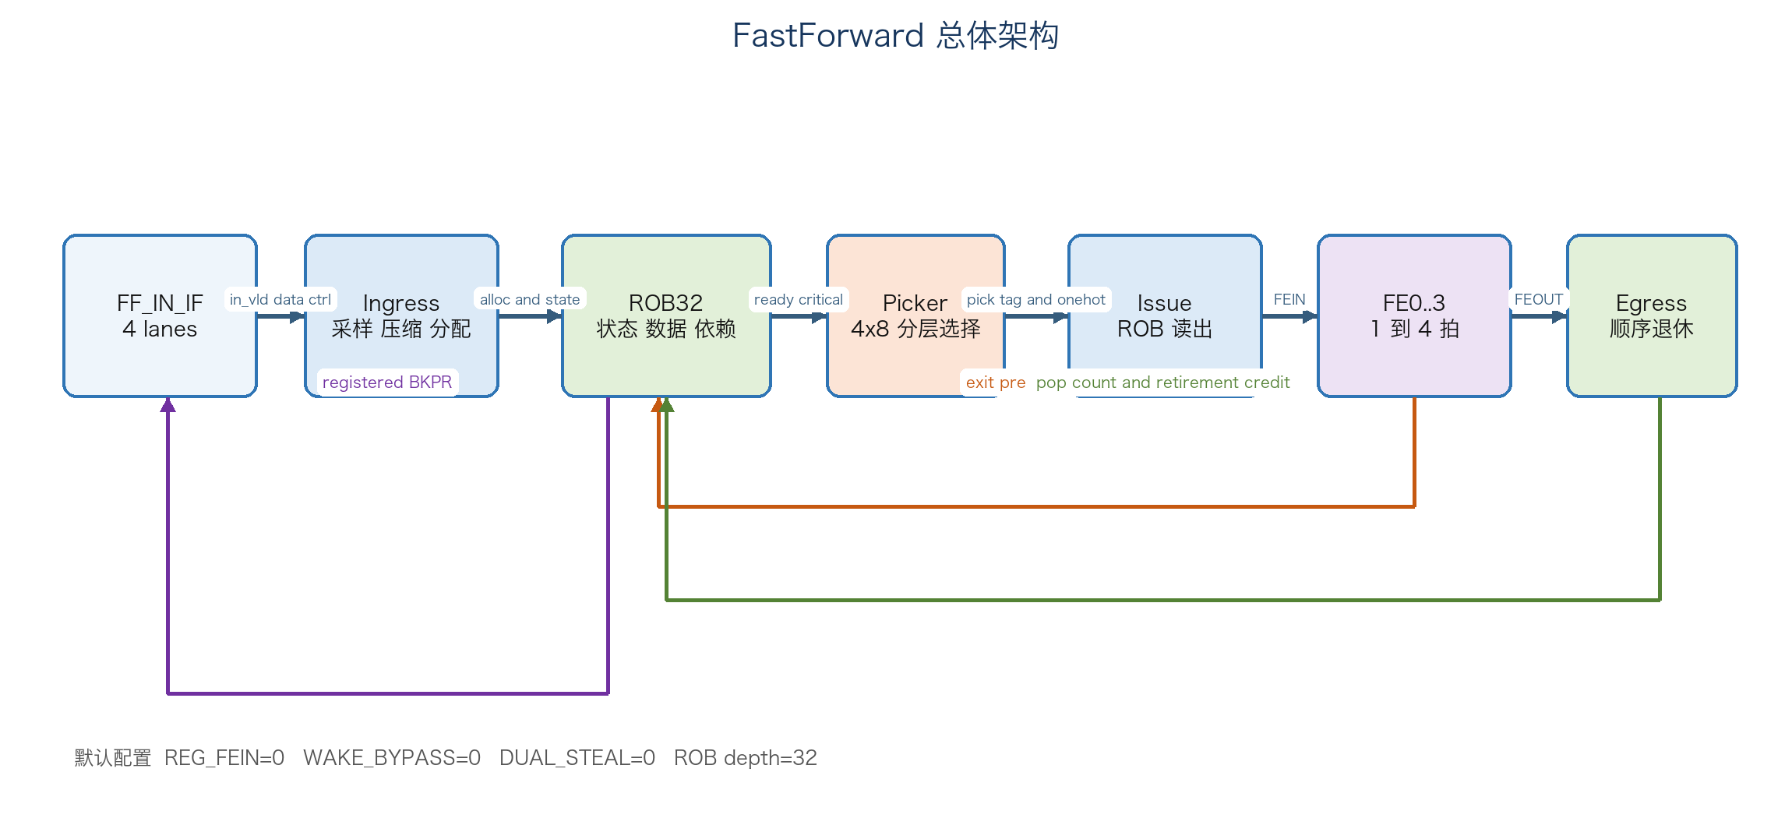
Figure 1 FastForward top level architecture

1.4 External Interaction
上游在 `pkt_in_bkpr` 为低时通过四个独立 lane 提供 valid data ctrl。FastForward 不向每个 lane 返回 ready；上游必须遵守集中式反压。下游没有输出 ready，FastForward 在任意周期最多输出四个连续序列报文。四个 FE 位于 ff 顶层内部，协议由 fixed port contract 定义。

1.4.1 Sampling Flow
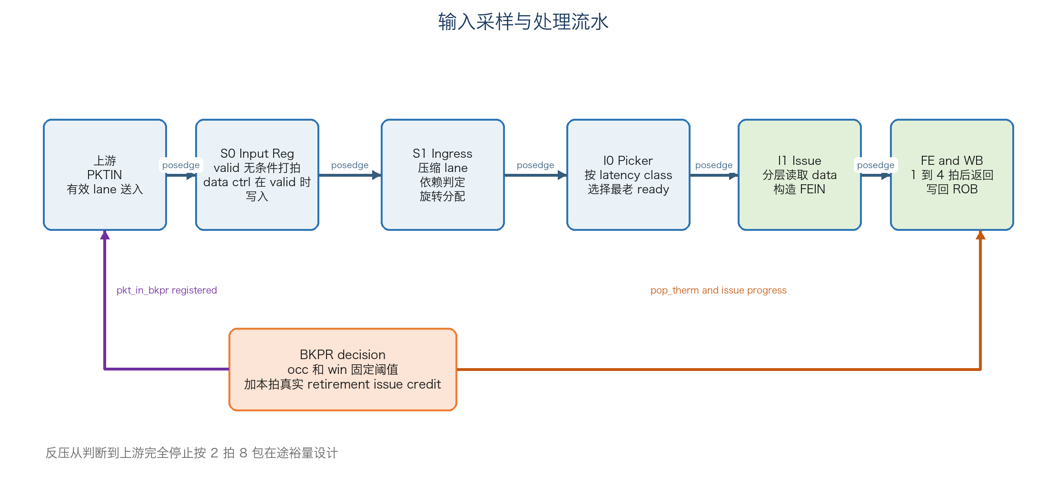
Figure 2 Input sampling and processing pipeline
所有原始输入首先进入 S0 寄存器。`in_vld` 每周期无条件打拍，data 和 ctrl 仅在对应 valid 为高时写入。组合逻辑只使用寄存后的 `in_vld_q in_data_q in_ctrl_q`，因此外部刚到达的 valid 不会直接进入 ROB 分配或反压组合条件。

1.5 Configuration Summary
Parameter | E068 default | Effect
REG_FEIN | 0 | No extra register between I1 read logic and FE input
WAKE_BYPASS | 0 | Dependent waits until target result is stored in ROB live FEOUT bypass is compiled out
DUAL_STEAL | 0 | Timing safe selector uses one primary candidate per latency class work stealing logic is disabled
D | 32 | Physical ROB entries
AW | 5 | Physical ROB index width
SW | 6 | Sequence number includes one wrap epoch bit
NFE | 4 | Number of integrated forwarding engines

2 Interface
FastForward 的外部数据接口采用 valid-only 传输；输入流量由单独的 BKPR 接口控制。所有信号均属于同一个时钟域。除 clock reset 外，外部端口按四个 lane 展开。

2.1 FF IN IF

2.1.1 Features
- 四个独立输入 lane，每周期每 lane 最多一个 128 bit packet。
- lane valid 可以形成任意稀疏组合；Ingress 会按 lane0 到 lane3 的顺序压缩。
- ctrl 低两位编码 latency class 0 到 3，对应 FE 延时 1 到 4 拍。
- ctrl 高三位编码 dependency distance 0 到 7；0 表示无依赖。
- 没有逐 lane ready；当 `pkt_in_bkpr` 有效时，上游不得继续送入新报文。

2.1.2 Signals Detailed Description
Signal | Dir | Width | Description
lane0_pkt_in_vld to lane3_pkt_in_vld | Input | 1 each | Input lane valid sampled on rising edge
lane0_pkt_in_data to lane3_pkt_in_data | Input | 128 each | Packet payload or FE source data
lane0_pkt_in_ctrl to lane3_pkt_in_ctrl | Input | 5 each | Bits 1 to 0 latency class bits 4 to 2 dependency distance

2.1.3 Timing Diagram
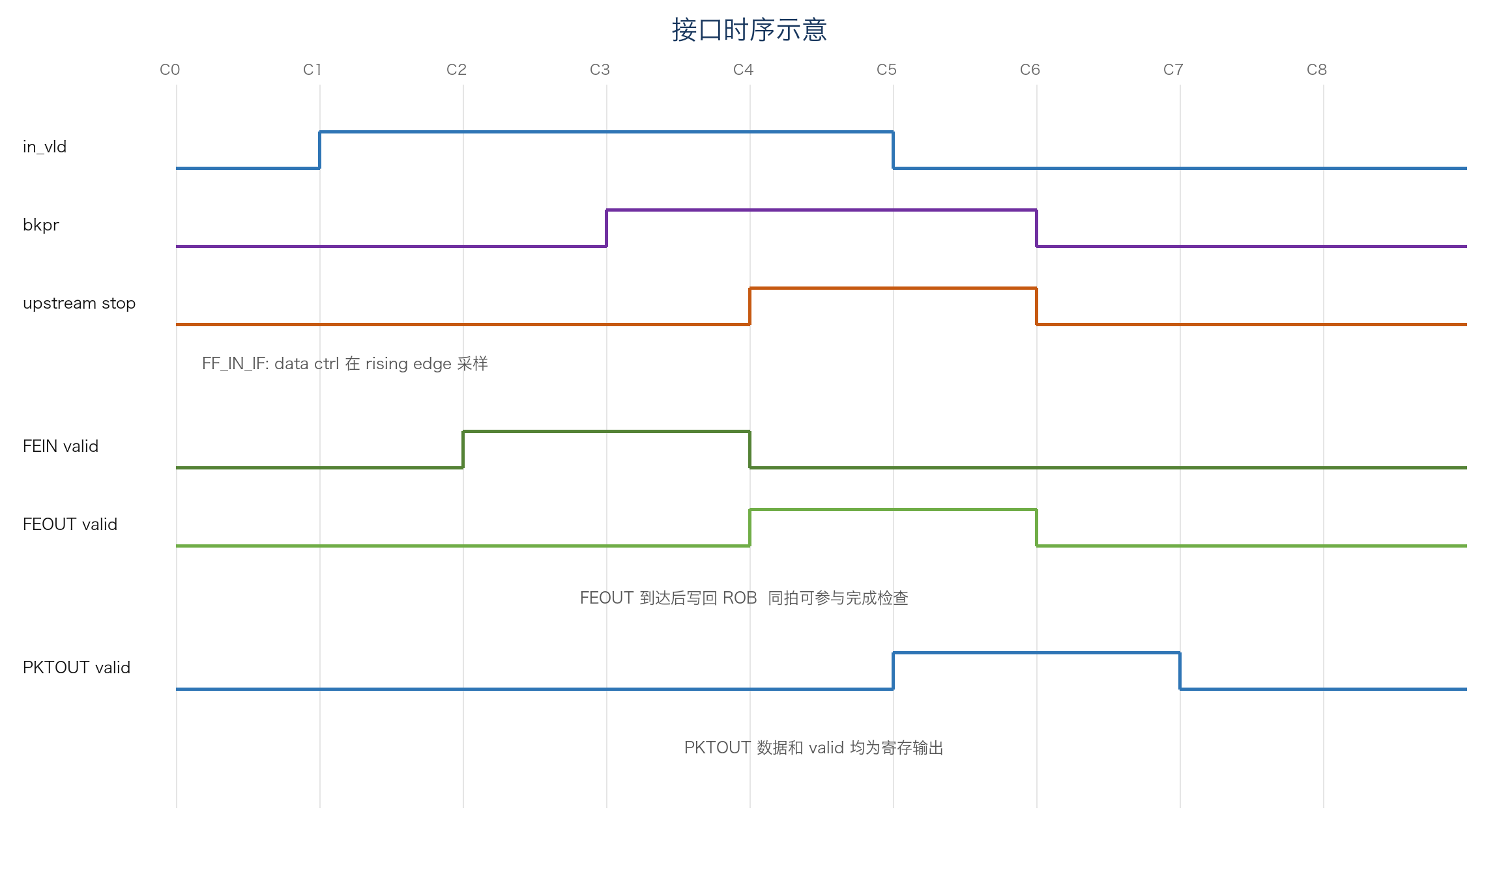
Figure 3 External and internal interface timing overview
valid data ctrl 必须在同一上升沿满足建立保持时间。Ingress 在该边沿寄存输入，下一周期根据 `in_vld_q` 压缩和分配。若 BKPR 拉高，上游按系统约定最多仍可能有两拍输入在途；E068 的阈值为这八个潜在报文预留空间。

2.2 FF OUT IF

2.2.1 Features
- 四路寄存输出，每周期最多退休四个连续序列报文。
- 物理 lane 由 sequence low two bits 决定，因此一组连续输出可能跨 lane3 到 lane0 回绕。
- 没有输出 backpressure；接收端必须能够接收任意合法 valid 组合。
- 同拍到达的 FEOUT 结果可以旁路到输出数据，但 PKTOUT data valid 在边沿寄存后对外可见。

2.2.2 Signals Detailed Description
Signal | Dir | Width | Description
lane0_pkt_out_vld to lane3_pkt_out_vld | Output | 1 each | Registered output valid for the physical lane
lane0_pkt_out_data to lane3_pkt_out_data | Output | 128 each | Registered forwarded packet result

2.2.3 Timing Diagram
当 `out_seq mod 4` 等于 2 且可连续退休 3 项时，有效物理 lane 为 lane2 lane3 lane0；接收端按 sequence rotation 解释，而不是按物理 lane 编号重新排序。
out_seq mod 4 = 2
pop_count = 3
valid order = lane2 -> lane3 -> lane0

2.3 FF BP IF

2.3.1 Features
- `pkt_in_bkpr` 为高表示上游应停止发送新报文。
- 反压为寄存输出，复位时清零。
- 判断同时覆盖 ROB occupancy 与 oldest-unissued issue window。
- E068 只使用本拍确定发生的 retirement 和 issue progress 解除反压，不预测未来完成。

2.3.2 Signals Detailed Description
Signal | Dir | Width | Description
pkt_in_bkpr | Output | 1 | Registered aggregate input backpressure active high

2.3.3 Timing Diagram
反压判断使用本周期 `alloc_nxt occ win pop_therm adv_therm`，在上升沿写入 `bkpr_r`。系统假设上游观察到 BKPR 后最多再发送两拍，每拍最多四包，因此安全阈值额外保留八包。

2.4 FF FE IF

2.4.1 Features
- 四份相同 FE 接口完全位于 ff 顶层内部。
- 每个 FE 每周期最多接收一个报文，latency 由报文携带。
- 依赖报文通过 dp_vld dp_data 提供目标报文结果。
- FE 不提供 input ready；ff_sched 必须保证同一 FE 的结果不会在同一周期冲突。

2.4.2 Signals Detailed Description
Signal per FE | Dir from ff | Width | Description
fwd_pkt_data_vld | Output | 1 | FE input valid
fwd_pkt_data | Output | 128 | Selected packet data
fwd_pkt_lat | Output | 2 | Latency class actual return delay is class plus 1 cycles
fwd_pkt_dp_vld | Output | 1 | Packet has dependency payload
fwd_pkt_dp_data | Output | 128 | Forwarded result of dependency target
fwded_pkt_data_vld | Input | 1 | FE result valid
fwded_pkt_data | Input | 128 | FE result data

2.4.3 Timing Diagram
FE 在接收 FEIN 后 `latency class plus 1` 拍产生 FEOUT。ff_sched 在接收 FEIN 的同一拍记录 entry index 与到期槽位，slot1 驱动 `exit`，slot2 驱动下一拍完成预测 `pre`。

2.5 Clock and Reset Interface
Signal | Dir | Width | Description
clk | Input | 1 | Single positive edge design clock
rst_n | Input | 1 | Active low asynchronous reset for control valid and pointer state

3 Functional Description

3.1 Main Features
Requirement ID | Feature | Design behavior
LRS.FUNC.FF.00 | Input capture | All PKTIN fields used by allocation logic must first pass through S0 registers
LRS.FUNC.FF.01 | Dependency handling | Dependency distance 1 to 7 selects an earlier sequence dependent issues only after target result is available
LRS.FUNC.FF.02 | Out of order issue | Ready entries may issue by latency class before older blocked entries
LRS.FUNC.FF.03 | In order retirement | PKTOUT sequence must exactly match allocation sequence
LRS.FUNC.FF.04 | FE collision freedom | Per FE result slots prevent two issued packets from maturing in the same cycle
LRS.FUNC.FF.05 | Retained result reuse | Result data remains in ROB after output until physical entry reallocation
LRS.FUNC.FF.06 | Backpressure safety | No active or dependency needed entry may be overwritten despite two cycle upstream stop latency
LRS.FUNC.FF.07 | Dynamic credit | BKPR may be released only by same edge progress that is provably occurring

3.2 Processing Flow
- S0 captures input lane valid and captures data ctrl only for valid lanes.
- Ingress compacts sparse lanes while preserving lane order and computes packet sequence target and initial ready waiting state.
- Up to four entries are allocated into the 32 entry ROB according to alloc_seq and slot rotation.
- Picker examines ready entries by latency class and registers at most one primary pick for each FE in the default profile.
- Issue reads packet data and optional dependency result from the ROB and drives FEIN.
- Scheduler books the result cycle and later maps FEOUT to the exact ROB entry.
- FE result overwrites the entry data field and sets result valid.
- Egress retires up to four contiguous completed head entries and produces registered PKTOUT.
- Retirement and guaranteed issue progress feed the next BKPR decision as same cycle credit.

3.2.1 DR Sample Process
对每个 lane，valid 在每个上升沿写入 `in_vld_q`。只有 valid 为高时，128 bit data 和 5 bit ctrl 才更新。无效 lane 的宽数据寄存器保持原值，但其内容不会被 `in_vld_q` 选择。随后 compactor 根据四位 valid pattern 把有效报文稳定压缩到 packet order 0 到 3。

3.2.2 Dependency Resolve
报文 k 的全局 sequence 为 `alloc_seq plus k`，目标 sequence 为 `sequence minus dependency distance`。如果目标位于同一输入批次，则目标尚未完成，报文直接进入 waiting；如果目标位于历史窗口，则查询 `res_known`。`res_known` 包含已经存储的结果、本拍返回结果和下一拍预测结果，但默认 `WAKE_BYPASS=0` 时 Picker 不使用 wake bypass，依赖报文在目标结果存入 ROB 后再发射。

3.2.3 Select and Issue
默认配置为每个 latency class 建立一个候选集合，每个集合使用 4 bank by 8 entry 的分层优先编码器，以 `old_u` 为循环年龄基准选择最老 ready entry。若存在 critical target，critical 候选可插队，但窗口头本身为候选时仍保持 head priority。选择结果、target、latency 以及 bank local onehot 在 I0 边沿寄存，I1 使用这些信息读出宽数据。

3.2.4 FE Completion and Writeback
Issue 同时向 ff_sched 提交 `issue_v issue_idx issue_lat`。调度器把 tag 写入 `latency plus 1` 对应槽并逐拍向 slot1 移动。FEOUT valid 必须与 slot1 valid 一致。ROB 根据 `exit_idx` 置位 `res_now`，并使用该 entry 的 `rob_src` 选择唯一 FE 数据写回。

3.2.5 In Order Retirement
Egress 从 `out_seq` 开始检查最多四个物理 entry。只有 live count 足够且对应 `resv or res_now` 连续为真时才可退休。`pop_therm` 天然形成 thermometer code，`pop_cnt` 为 0 到 4。输出数据优先使用本拍 FEOUT，否则使用 ROB 已保存结果。

3.2.6 Same Cycle Backpressure Credit
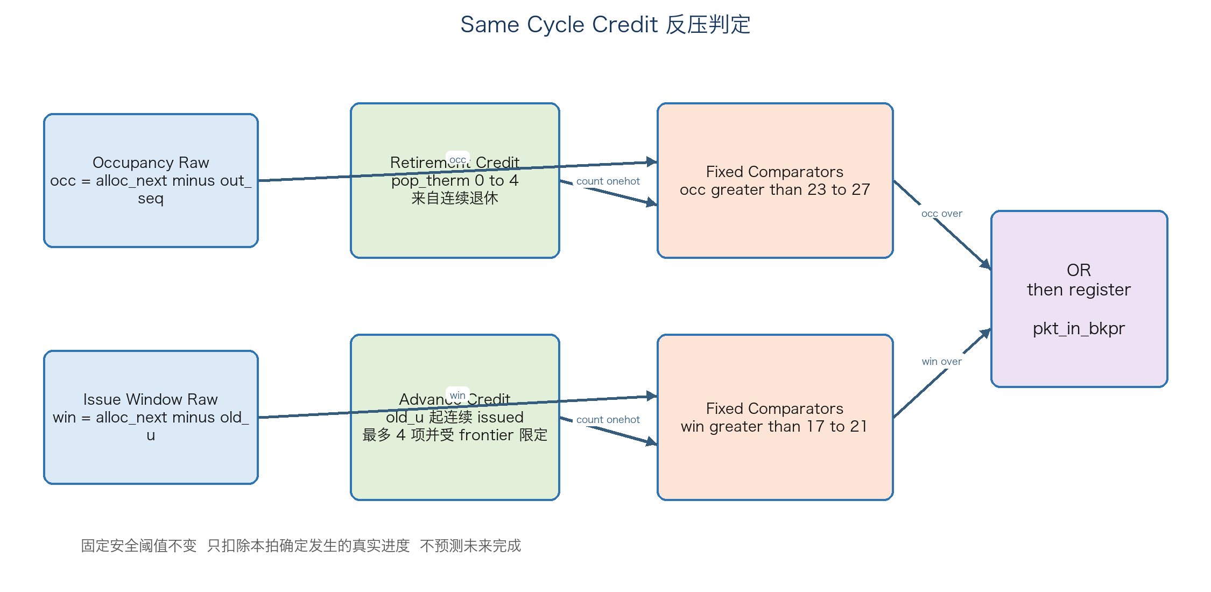
Figure 4 E068 same cycle backpressure credit
E068 不提高固定安全阈值，而是将本拍必然发生的进度从 raw distance 中扣除。retirement credit 直接来自 `pop_therm`；issue credit 只检查从 `old_u_q` 开始的最多四个连续 `iss_eff` entry，并受 `alloc_seq minus old_u` 限定。实现使用 count onehot 和五组固定阈值比较，避免把通用减法器或完整 oldest search 连接到 BKPR 寄存器输入。
occ_raw = alloc_next - out_seq
win_raw = alloc_next - old_u
occ_over = occ_raw - retirement_credit > 23
win_over = win_raw - guaranteed_advance > 17
pkt_in_bkpr_next = occ_over OR win_over

3.3 Ordering and Dependency Rules
Rule | Requirement
Allocation order | Valid input lanes are compacted in lane0 to lane3 order
Issue order | May differ from allocation order when dependencies or latency class queues differ
Completion order | May differ across FEs and within mixed latency FE streams
Retirement order | Must exactly follow allocation sequence
Dependency visibility | Dependent FEIN must carry the completed forwarded result of its target
Result lifetime | Stored result survives retirement until the entry is safely reused

3.4 Unsupported or Constrained Behavior
- 上游在 BKPR 有效后继续无限发送不受支持；设计只保证两拍、最多八包的既定响应窗口。
- PKTOUT 没有 ready，因此外部不能阻塞输出。
- default E068 不启用 DUAL_STEAL，也不启用同拍 wake-to-pick bypass。
- FE 必须遵守 latency plus 1 返回契约；返回 valid 与 scheduler 预订不一致属于集成错误。
- reset 期间宽数据寄存器内容不定义，只有相应 valid state 清零后才能被安全忽略。

4 Module Design Description

4.1 Clock and Reset
全部模块使用同一个 `clk` 的上升沿，不包含 clock domain crossing。`rst_n` 为低有效异步复位，主要用于 valid bitmap、ROB 状态、sequence pointer、scheduler valid 和 BKPR。128 bit 数据阵列不复位，以减少 reset tree 面积和功耗；其可见性始终由已复位的 valid control 限定。
Register class | Reset behavior | Reason
Control valid and state | Asynchronously cleared | Guarantees no stale data is consumed after reset
Sequence pointers | Asynchronously cleared | Establishes empty ROB state
Wide packet data | No reset | Avoids reset distribution and unnecessary switching
Small timing critical payload registers | Often unconditional write | Prevents large selection cone from becoming an inferred ICG enable path

4.2 ff ingress

Overview
`ff_ingress` 完成外部输入寄存、稀疏 lane 压缩、dependency target 计算、ready waiting 判定、ROB slot rotation 和 allocation onehot 生成。

Feature List
- All externally supplied valid conditions are registered before combinational use.
- 128 bit data compaction and 5 bit control compaction use separate cones.
- Direct ready logic operates on original registered lanes and prefix rank.
- Each ROB physical entry receives data from a fixed slot selected by entry low two bits.
- Every newly allocated dependency marks its target critical.

Interface
Group | Inputs | Outputs | Purpose
Raw input | in_vld in_data_f in_ctrl_f |  | Four lane registered capture
ROB context | alloc_seq res_known |  | Sequence and prior result visibility
Allocation |  | acnt alloc_oh slot_dat slot_lat slot_tgt slot_rdy slot_wtg slot_isdep | Allocate up to four ROB entries
Critical mark |  | kw_vld k_tgt | Mark dependency targets for picker priority

Implementation Description
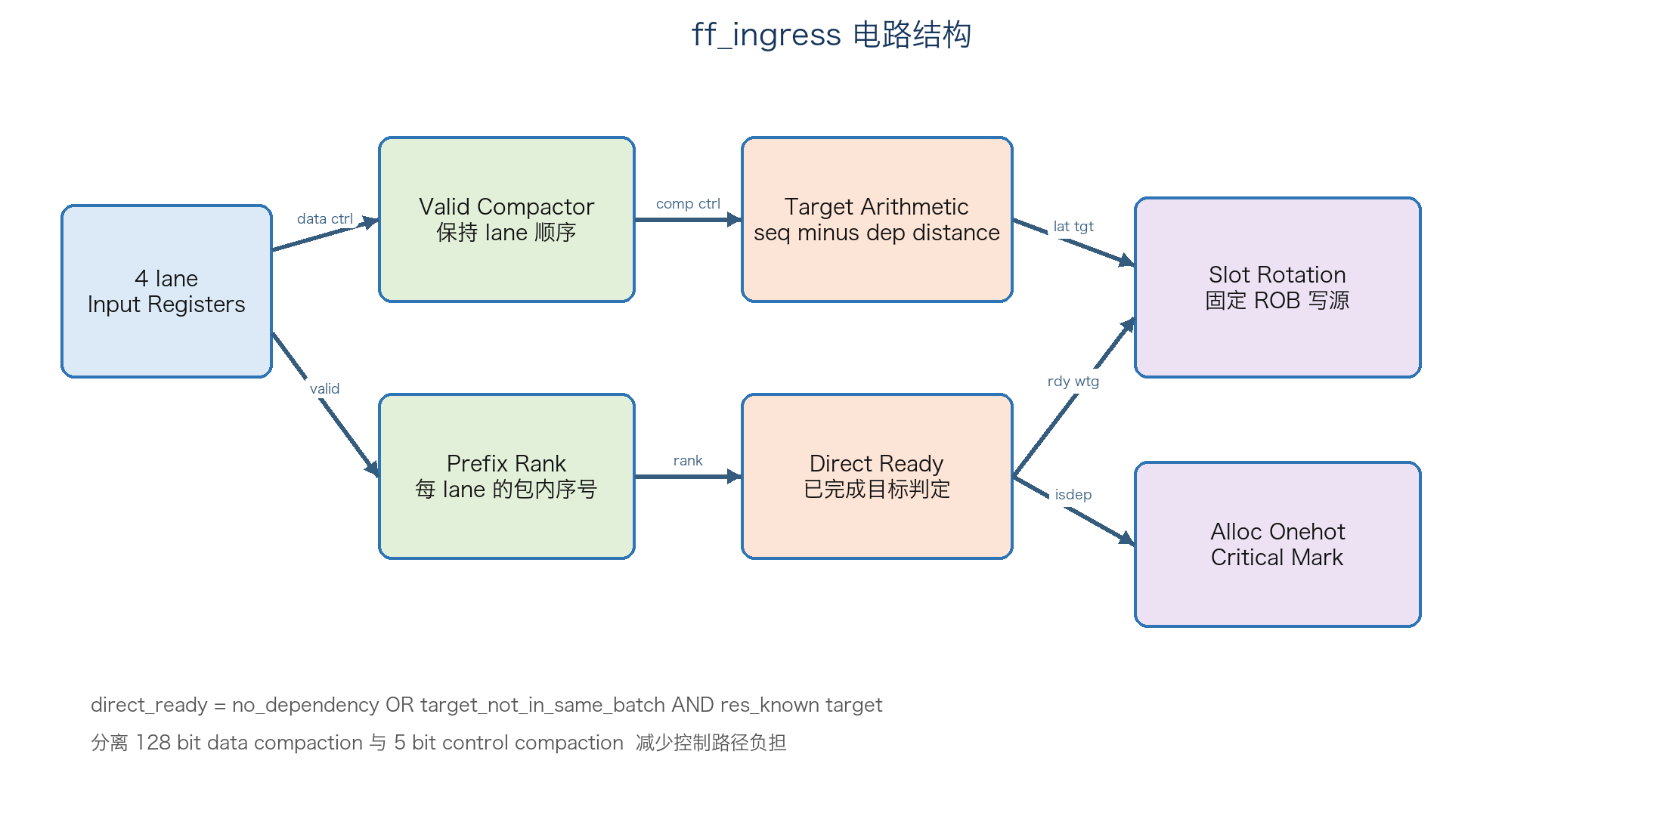
Figure 5 Ingress implementation structure
`lane_rank` 等于该 lane 之前有效 lane 的数量。物理 slot 为 `alloc_seq low two bits plus lane_rank`，因此同一 physical entry 始终从固定 slot 接收数据。对于 dependency distance d，若 d 不大于 lane rank，则 target 位于同一批次并进入 waiting；否则只有 `res_known target` 为真才直接 ready。
Implementation part | E068 realization | Design reason
Control Unit | Registered valid drives lane compaction, allocation count, direct-ready and critical-target marking. | External valid never enters the allocation cone without an S0 register boundary.
Data Path | A stable four-lane compactor separates 128 bit data selection from 5 bit control and target arithmetic. | Separating wide and narrow cones reduces fanout and unnecessary wide-data switching.
Storage Structure | Four input data and control registers feed fixed slot-rotation write sources into ROB32. | A physical ROB entry always receives one fixed slot source, avoiding a full crossbar.

4.3 ff rob

Overview
`ff_rob` 是系统的核心状态和数据存储。32 个 entry 统一保存原始 packet data 和 FE result，并维护依赖、发射、完成、critical 以及三个 sequence frontier。

Feature List
- Unified 128 bit storage is overwritten by the corresponding FE result.
- Results remain retained after retirement until reallocation.
- Wake logic maps predicted target completion to waiting dependents.
- Oldest unissued search uses four 8 entry banks.
- Registered BKPR combines occupancy and issue window safety conditions.
- E068 adds bounded same cycle retirement and issue credits.

Interface
Group | Representative inputs | Representative outputs
Allocation | acnt alloc_oh slot fields kw_vld k_tgt | alloc_seq
FE tracking | exit pre indexes and fe data | res_now res_pred res_known wake_now
Pick feedback | picked rob_src | rdy crit rob data lat target isdep old_u
Retirement | pop_cnt pop_therm | out_seq
Flow control | all frontiers and same edge credits | pkt_in_bkpr

Implementation Description
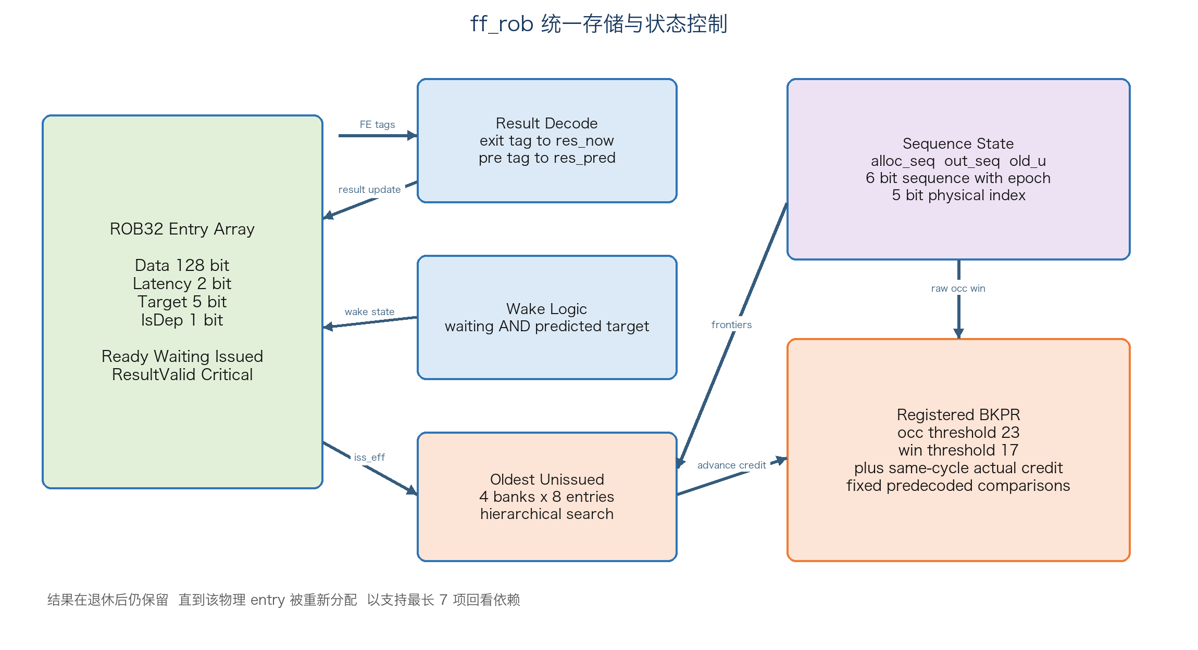
Figure 6 ROB storage state and backpressure structure
Event | State update
Allocate | Set ready or waiting clear issued and result valid write packet metadata
Wake | Clear waiting and set ready
Picked | Clear ready and set issued
FE exit | Set result valid and overwrite data with selected FE result
Retire | Advance out_seq only result valid is retained
Reuse | New allocation clears stale result valid and replaces metadata

`alloc_seq out_seq old_u` 均为 6 bit，低 5 bit 选择物理 entry，最高位表示一次 32 entry 回绕 epoch。BKPR 保证活动窗口小于物理深度，因此相邻 epoch 的同一 physical index 不会同时被解释为有效。
Implementation part | E068 realization | Design reason
Control Unit | Allocation, wake, pick, completion, retirement and same-cycle credit update the entry state and three sequence frontiers. | Explicit event priority keeps one coherent state machine for dependency and lifetime control.
Data Path | Result decode writes FE data by exit tag; wake compares predicted target tags; egress reads contiguous head entries. | Tag-based state updates support out-of-order completion while retirement remains ordered.
Storage Structure | Thirty-two unified 128 bit entries plus latency, target, dependency, ready, waiting, issued, result-valid and critical metadata. | Input and result storage are reused, and retired results remain available until safe reallocation.

4.4 ff pick

Overview
`ff_pick` 在 I0 阶段从 ready bitmap 中为四个 latency class 选择候选，并把选择结果寄存到 I1 边界。E068 默认 timing-safe 配置关闭 work stealing。

Feature List
- One primary candidate per latency class in the default profile.
- Circular age order begins at oldest unissued physical index.
- Four 8 entry banks reduce flat 32 entry rotate and priority depth.
- Critical target can override normal candidate unless the window head is ready.
- Bank and local onehot coordinates are registered with binary index.
- Optional dual work stealing remains parameterized but is disabled in E068 default.

Interface
Input group | Signals | Output group | Signals
ROB state | rdy wake crit lat target | Commit | picked bitmap
Age base | rbase old_u low bits | I0 register | pk valid index target latency
Schedule booking | sched valid | Read coordinates | bank onehot local onehot
Configuration | WAKE_BYPASS REG_FEIN DUAL_STEAL | Result route | rob_src per entry

Implementation Description
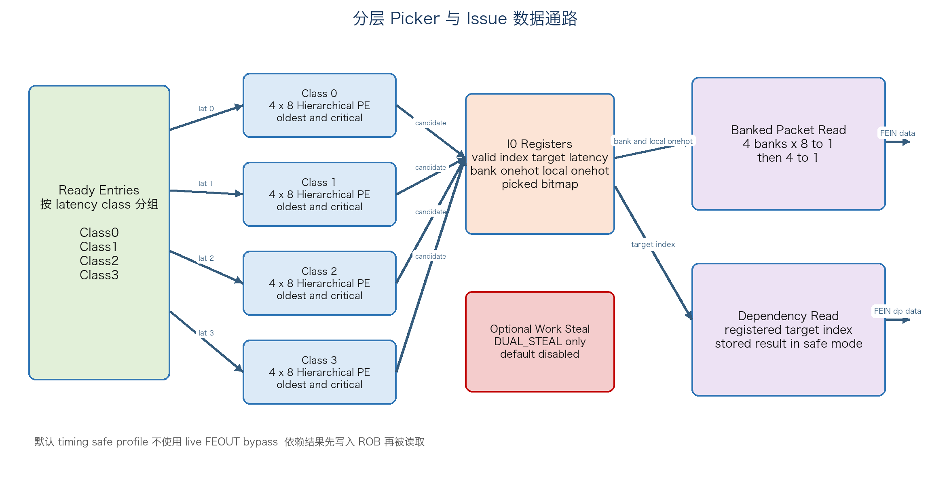
Figure 7 Hierarchical picker and issue read path
每个 bank 先执行 8 entry local priority encoder，bank-valid 再按循环年龄顺序选择目标 bank。base bank 被拆成 base 之后和回绕前两段，以保持严格年龄顺序。safe selector 同时携带 target 和 onehot 坐标，避免 I1 再从 binary index 解码或级联读取 target。
Implementation part | E068 realization | Design reason
Control Unit | Ready entries are masked by latency class, scheduler availability and critical priority before commit. | The default timing-safe profile selects one primary candidate per FE without work stealing.
Data Path | Four local 8-entry priority encoders produce bank candidates; a second level selects by circular age. | The hierarchy shortens the flat 32-entry rotate and priority path.
Storage Structure | I0 registers hold valid, binary index, target, latency, bank onehot and local onehot. | Registered coordinates move decode work out of the I1 wide-data read path.

4.5 ff issue

Overview
`ff_issue` 使用 I0 寄存的 bank local onehot 读取 packet data，并使用寄存 target index 读取 dependency data，随后形成四组 FEIN。

Feature List
- Packet data read is split into local 8 to 1 reads and a bank 4 to 1 merge.
- Target index is retimed across the I0 I1 boundary.
- In default WAKE_BYPASS 0 mode dependency data always comes from retained ROB data.
- REG_FEIN can add a timing fallback register but is disabled by default.
- Issue tag outputs remain aligned to the cycle in which FE accepts the packet.

Interface
Group | Inputs | Outputs
Pick | pk valid index target latency bank onehot local onehot
ROB view | rob data rob source rob isdep
Live bypass | res_now FE output data | Used only when WAKE_BYPASS 1
FEIN |  | fwd valid data latency dp valid dp data
Schedule tag |  | issue valid index latency

Implementation Description
对于每个 FE，32 entry ROB data 被物理划分为四组 8 entry。`pk_local_oh` 在每组内部选择数据，`pk_bank_oh` 再选择四组结果。由于 onehot 已在 I0 生成并寄存，宽数据路径不包含 5-to-32 decoder。默认配置下依赖结果必须先写入 ROB，因此 FEOUT live mux 被 generate 条件完全移除。
Implementation part | E068 realization | Design reason
Control Unit | Registered pick-valid and dependency attributes qualify FEIN and issue tags. | Control remains aligned with the selected ROB data and FE booking cycle.
Data Path | Packet data uses four local 8-to-1 onehot reads followed by a 4-to-1 bank merge; dependency data uses the registered target index. | Banked selection replaces a monolithic 32-entry wide mux.
Storage Structure | No independent payload buffer is added; I0 metadata registers and the unified ROB supply all read data. | This avoids duplicating 128 bit packet and dependency storage.

4.6 ff sched

Overview
`ff_sched` 为每个 FE 保存四个未来结果槽，记录每个已经发射报文的返回周期和 ROB index。

Feature List
- Four slots per FE represent results due in one to four cycles.
- Issue latency class c books slot c plus 1.
- Slots shift toward slot1 every cycle.
- slot1 exports exit and slot2 exports pre completion prediction.
- Booking bitmap is returned to picker for collision checks in optional stealing profiles.

Interface
Inputs | Outputs | Meaning
issue_v issue_idx issue_lat | exit_v exit_idx | Current FE result tag
issue_v issue_idx issue_lat | pre_v pre_idx | Next cycle result prediction
 | sched_v | Four slot occupancy per FE

Implementation Description
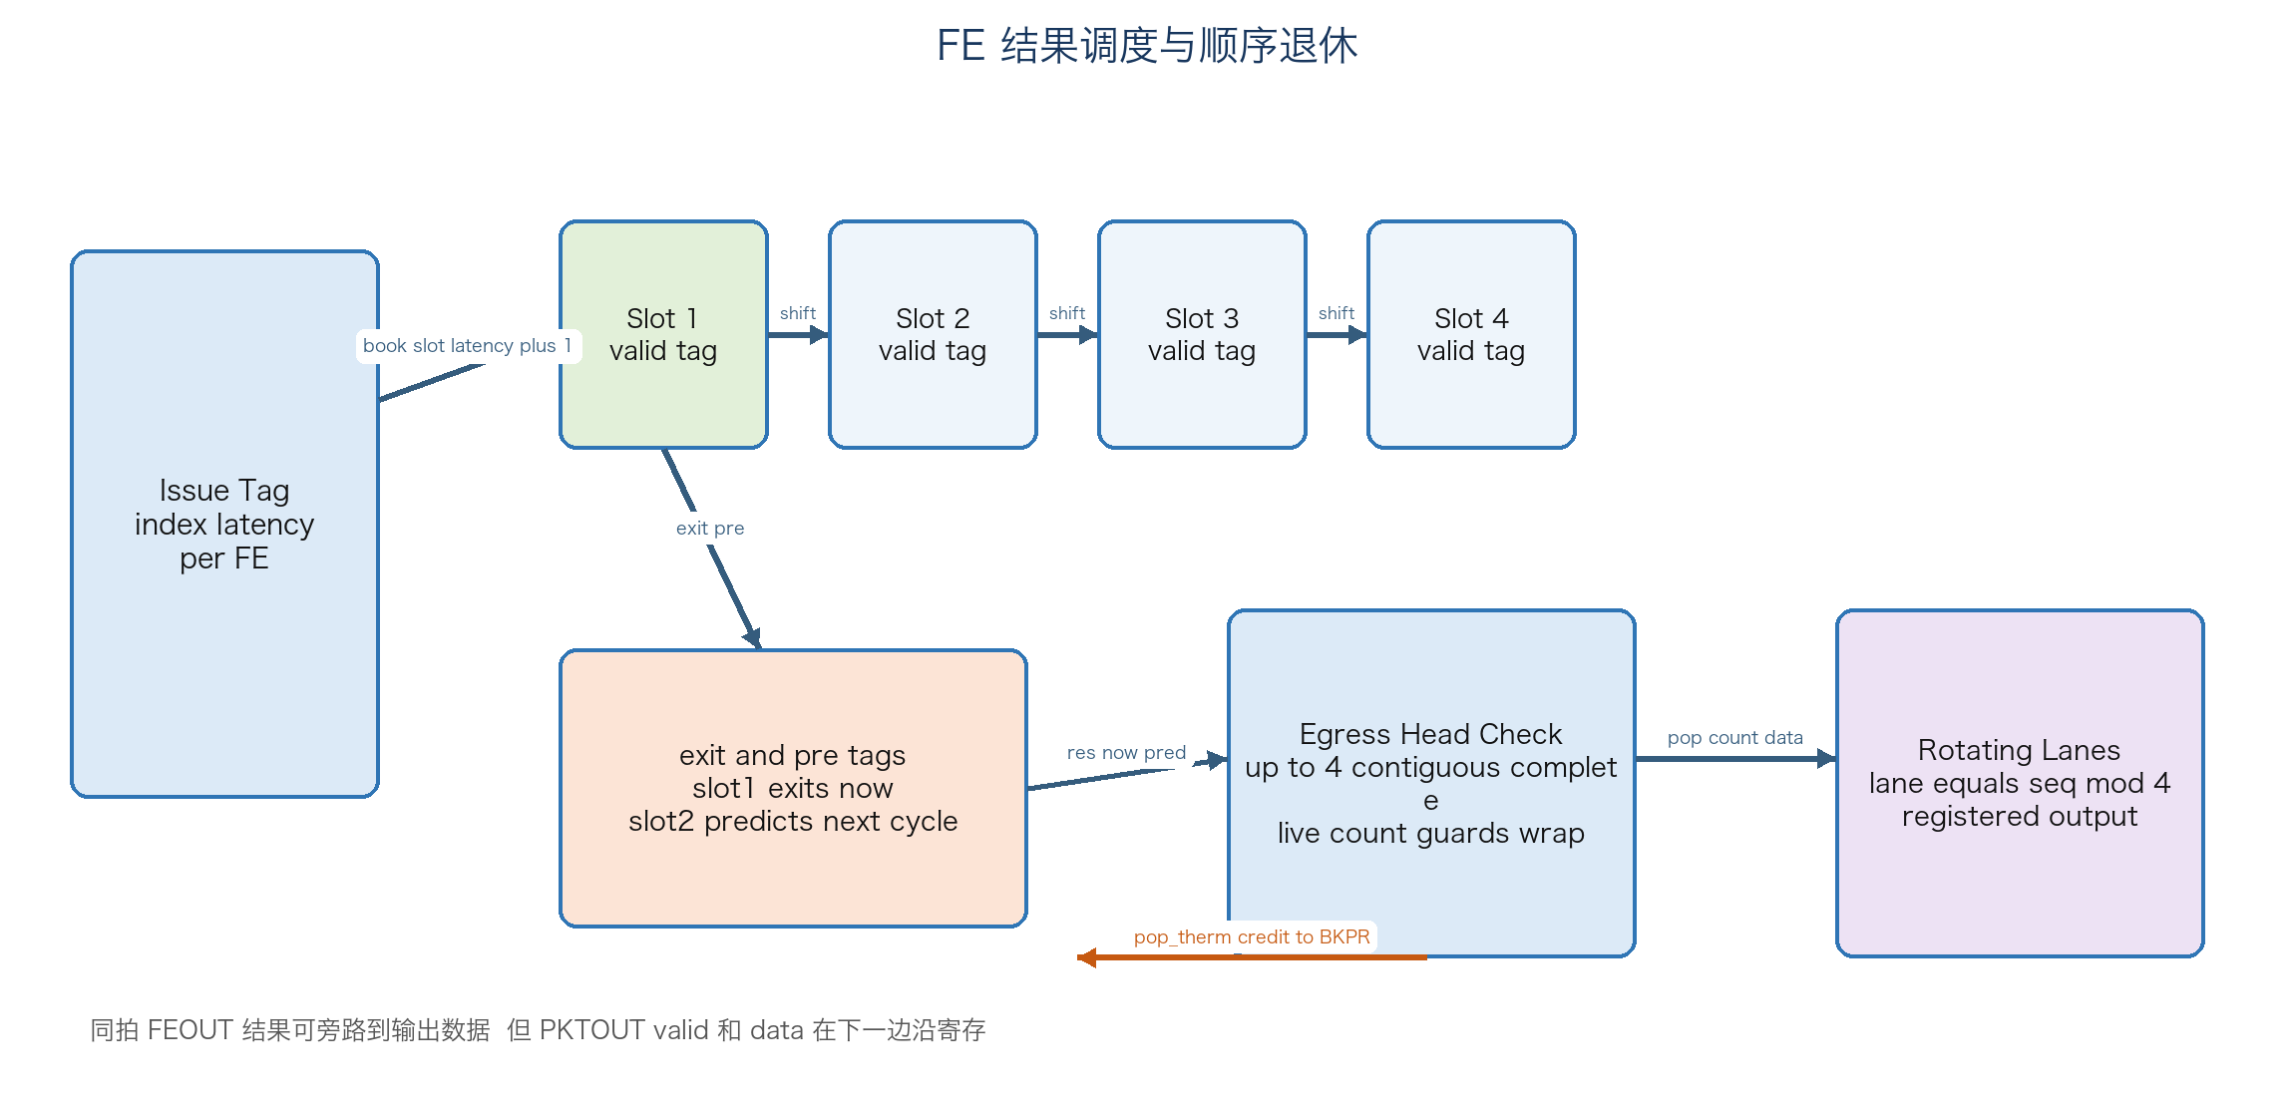
Figure 8 Result scheduler and in order egress
Implementation part | E068 realization | Design reason
Control Unit | Issue valid and latency book one future slot; occupied slots prevent conflicting issue in optional profiles. | The scheduler guarantees that a single FE never produces two results in one cycle.
Data Path | Each cycle shifts valid tags toward slot1; slot1 exports exit and slot2 exports pre-completion information. | Prediction and actual completion use the same registered tag pipeline.
Storage Structure | Four valid-tag slots are instantiated for each of four FEs. | The maximum FE delay is four cycles, so deeper storage is unnecessary.

4.7 Forwarding Engine

Overview
四个 FE 由 ff 顶层直接例化。生产环境使用真实 FE；本地验证使用 `fe_model`，其数据变换只用于端到端通路检查，不属于 FastForward 功能定义。

Feature List
- One packet accepted per FE per cycle.
- Per packet latency class determines one to four cycle result delay.
- Dependency payload is consumed only when dp valid is asserted.
- No input ready is provided scheduler must avoid output collision.
- FE implementation area power and timing are external to this RTL HLD unless included by integration synthesis.

Interface
Port | Direction | Width | Contract
fwd_pkt_data_vld | ff to FE | 1 | Input transaction valid
fwd_pkt_data | ff to FE | 128 | Packet data
fwd_pkt_lat | ff to FE | 2 | Return delay class
fwd_pkt_dp_vld | ff to FE | 1 | Dependency data valid
fwd_pkt_dp_data | ff to FE | 128 | Dependency result
fwded_pkt_data_vld | FE to ff | 1 | Result valid at booked cycle
fwded_pkt_data | FE to ff | 128 | Forwarded result

Implementation Description
本地 `fe_model` 使用长度四的 valid data shift slots，接收报文时写入 `latency plus 1` 槽。如果目标槽已经被占用，模型报 output collision。真实 FE 必须在相同 latency contract 下替换该模型。
Implementation part | E068 realization | Design reason
Control Unit | FastForward supplies valid, latency and optional dependency-valid; the FE owns packet transformation. | A fixed contract permits the local model and production FE to share the same integration boundary.
Data Path | The FE consumes 128 bit packet data and optional 128 bit dependency data and returns one 128 bit result. | The data transformation itself is intentionally outside FastForward architecture.
Storage Structure | The verification model uses four result slots; production FE storage is implementation-defined. | Only the one-to-four-cycle latency and collision-free output contract is required by FastForward.

4.8 ff egress

Overview
`ff_egress` 从全局 `out_seq` 开始检查连续完成状态，产生最多四项退休、按序 lane 映射和寄存 PKTOUT。

Feature List
- Completion combines stored result valid and same cycle result arrival.
- Live count prevents retained stale results from being retired after empty or wraparound.
- Natural thermometer code directly feeds E068 retirement credit.
- Output lane equals sequence low two bits.
- Output data selects live FEOUT on same cycle completion otherwise retained ROB data.

Interface
Input group | Signals | Output group | Signals
Frontiers | alloc_seq out_seq | Retirement | pop_cnt pop_therm
Completion | resv res_now | PKTOUT | lane valid lane data
Data | rob data rob source FE output

Implementation Description
`can0` 到 `can3` 由 live count 和 completion 联合限定，`pop_therm[n]` 只有在所有更老候选均可退休时才为真。物理 lane 通过 `lane minus out_seq low bits` 得到相对顺序，保证跨 lane3 到 lane0 的连续输出。
Implementation part | E068 realization | Design reason
Control Unit | Live occupancy and contiguous completion generate can0 to can3, pop thermometer and pop count. | Retirement cannot consume a retained stale result after empty or sequence wrap.
Data Path | Four head candidates select live FEOUT on same-cycle completion or retained ROB data otherwise, then rotate to physical lanes. | The output remains globally ordered while allowing lane3-to-lane0 wrap.
Storage Structure | Four registered 128 bit PKTOUT lanes and valid bits form the external output boundary. | Registered outputs isolate internal completion logic from the external interface.

4.9 ff Top Integration
`ff` 负责外部端口 flatten unflatten、七个 FastForward 子模块和四个 FE 的实例化，并在非综合环境检查 scheduler 预测的 `exit_v` 与真实 FEOUT valid 一致。顶层固定 `D 32 AW 5 SW 6 NFE 4`。
Implementation part | E068 realization | Design reason
Control Unit | Top-level wiring distributes clock, reset, parameters and interface vectors and checks the FE latency contract in simulation. | Centralized integration keeps submodules focused on one pipeline responsibility.
Data Path | Flattened external lane ports are packed into internal vectors; FEIN and FEOUT remain internal between issue, FE and ROB. | Packing regularizes four-lane logic and reduces repetitive control code.
Storage Structure | The top level owns no large data buffer beyond submodule registers and the four FE instances. | All packet lifetime storage is intentionally concentrated in ROB32.

5 Performance Requirement and Design Analysis

5.1 Performance Requirement
Item | Requirement or target | E068 status
Peak ingress | 4 packets per cycle | Structurally supported when BKPR low
Peak issue | 4 packets per cycle | One per FE per cycle
Peak retirement | 4 packets per cycle | Four contiguous completed entries
FE latency | 1 to 4 cycles | Encoded by latency class 0 to 3
Clock period | 0.400 ns | Not signed off by available proxy flow
Clock uncertainty | 0.045 ns | Must be applied in real STA
Optimization metric | Minimize unified testcase execution time T then power and area | Local cycle and proxy PPA results available

5.2 Pipeline and Bandwidth Analysis
输入、选择、发射和输出均有清晰寄存边界。默认配置中，S0 输入寄存后进行分配，I0 picker 结果寄存，I1 组合读取后进入 FE。每个 latency class 理论上每拍选择一个报文，因此稳定 workload 在四类均衡时可接近四包每拍；实际性能受依赖链、ROB32 容量、按序退休和 BKPR 窗口限制。

5.3 E068 Cycle Results
Workload | E066 cycles | E068 cycles | Change | Notes
Heavy seed7 20k | 9567 | 9070 | minus 5.20 percent | Default safe profile
Heavy 9 seed average | 9540.889 | 9052.333 | minus 5.12 percent | Seeds 3 5 7 11 13 17 19 23 29
Mid seed11 20k 50 percent | 10961 | 10667 | minus 2.68 percent | Input limited plus BKPR effect
Sparse seed11 20k 20 percent | 24907 | 24907 | no change | BKPR rarely active
Dependency heavy 3 seed average | 15199.000 | 14904.667 | minus 1.94 percent | 7 of 8 packets dependent
Dual steal seed7 | 9512 | 9018 | minus 5.19 percent | DUAL_STEAL 1 not default
Full seed7 | 8432 | 7949 | minus 5.73 percent | WAKE_BYPASS 1 and DUAL_STEAL 1

以上 cycles 是固定本地回归的代理指标，不等同于统一用例最终执行时间 T。默认 heavy seed7 吞吐约为 2.205 packet per cycle。

5.4 Timing Analysis
Proxy corner | E066 max arrival ns | E068 max arrival ns | Change
Low | 0.8100 | 0.7950 | Improved
Nominal | 0.8875 | 0.8675 | minus 2.25 percent
High | 0.9650 | 0.9400 | Improved

E068 代理关键路径转为 `exit_idx to out_seq_q`。代理 arrival 保持与 E067 相同并低于配对 E066，但仍明显大于 0.400 ns 目标；该流程也没有应用完整工艺库、布线寄生和 0.045 ns uncertainty。因此 E068 不能据此宣称完成 0.4 ns timing closure。

5.5 Area and Power Status
Design | Proxy total cells | Relative note | Power
Paired E066 | 148338 | Comparison baseline used for paired resynthesis | E066 external result reported about 10 percent increase full archive pending
E067 | 147988 | minus 350 cells versus paired E066 | Not signed off
E068 | 148066 | plus 78 versus E067 and minus 272 versus paired E066 | Not measured with final activity and library

Proxy cell count 只用于同一流程的相对比较，不是工艺库面积。E068 动态 credit 可能提高单位时间活动率，因此不能从 cell count 推导功耗改善。

5.6 Design Tradeoffs
Decision | Benefit | Cost or constraint
ROB64 to ROB32 | Smaller storage and selection cones | Higher capacity pressure and more BKPR cycles
WAKE_BYPASS 0 | Removes wake picker live FEOUT timing chain | Dependent generally waits an extra cycle
Hierarchical 4 by 8 picker | Shorter select and read decode | Additional bank and local metadata registers
Retained result | Supports distance seven dependency after retirement | Result valid survives pop and needs safe reuse window
Same cycle credit | Reduces conservative BKPR without raising thresholds | Adds bounded thermometer and fixed compare logic
Unconditional small register writes | Avoids critical ICG enable cones | Can increase switching on narrow control registers

6 Low Power

6.1 Clock Gating Strategy
RTL 没有直接实例化工艺 ICG，而是通过寄存器写使能为综合提供 clock enable 推断机会。宽数据寄存器优先使用条件写；对时序敏感的小型控制寄存器则刻意无条件写，以避免完整 picker 或 result cone 被映射到 ICG enable latch。实际 ICG 插入、test enable 和门控覆盖率由综合流程决定。
Register set | RTL update style | Power intent | Timing note
Ingress packet data and ctrl | Write only when lane valid | Suppress invalid lane switching | Valid itself updates every cycle
ROB packet data | Write on allocate or result arrival | Large 4096 bit array mostly holds | No reset
ROB metadata | Write on allocate | Conditional update | State valid controls visibility
Picker index latency target onehot | Unconditional write | Narrow fields may toggle | Prevents long selection cone on clock enable
Egress lane data | Unconditional write | May toggle without valid | Removes scheduler to output data ICG path
Control valid bitmaps | Resettable state update | Small compared with data array | Functional priority dominates

6.2 Data Toggle Reduction
- 统一 ROB data field 在 input data 与 forwarded result 之间复用，避免两份 128 bit 阵列同时翻转。
- Ingress 将 wide data mux 与 narrow control mux 分离，减少 control-only 路径对宽数据锥的激活。
- 默认关闭 live FEOUT dependency bypass 和 dual stealing，删除不需要的组合选择活动。
- 无效数据不依赖复位值；只有 valid state 决定其功能可见性。

6.3 Low Power Signoff Requirements
- 使用与 E066 相同 workload、seed、SAIF or VCD capture window 和 library corner 重新测量 E068。
- 报告 clock tree、ROB data、picker、BKPR 和四个 FE 的分层功耗。
- 确认无条件写的 pk metadata 与 egress data 是否抵消动态 credit 减少 stall 的收益。
- 若 E068 功耗不通过，E068A retirement-only 是低逻辑量回退候选，但必须重新比较最终 T。

7 DFX Design

7.1 Existing Verification Observability
RTL 与 testbench 已提供面向设计正确性的可观察点和断言，但这些不等同于生产 DFT。
Check | Observed condition | Failure meaning
FE schedule match | exit_v equals FEOUT valid | FE latency contract or scheduler mismatch
No duplicate issue | Each generated sequence issues once | Picker commit or ready state error
Dependency data | dp data equals target forwarded result | Wake target route or ROB retained data error
Output order | PKTOUT matches golden sequence and rotating lanes | Retirement or lane mapping error
Reuse safety | reuse span no greater than D minus 7 | ROB entry can be overwritten while still needed
Credit bound | issue credit no greater than actual old_u advance | Speculative unsafe BKPR release
Retirement bound | pop count no greater than live occupancy | Stale retained result mistaken for live entry

7.2 Scan and Clock Gating Recommendations
- 所有 control state、sequence pointer、scheduler valid tag 和 picker registers 应进入 scan chain。
- 若综合插入 ICG，必须提供 test enable bypass，确保 scan shift 时 clock 可控。
- ROB 128 bit data 由 flops 实现时可进入 scan；若后续替换为 SRAM，应提供 MBIST 或 macro-specific test。
- 四个 FE 的 scan MBIST 边界由 FE owner 定义，顶层需保留独立 test integration hooks。
- 建议导出或绑定 debug counters，包括 BKPR cycles、occupancy cause、window cause、issue count 和 retirement count。

7.3 Production DFX Gaps
Item | Current RTL | Required action
Scan architecture | Not defined | Define chain count ordering and compression strategy
Clock gating test enable | Not explicit | Connect synthesis ICG test port
Memory BIST | Not required for flop array | Revisit if ROB data maps to SRAM
Error status | Simulation assertions only | Decide whether any protocol mismatch becomes silicon-visible status
Performance counters | TB hierarchical counters only | Add architected debug counters if required
Reset test | Single active low reset | Verify assertion deassertion and recovery across implementation corners

8 Total Resource

8.1 Structural Resource Summary
Resource | Logical quantity | Notes
ROB packet result storage | 32 by 128 equals 4096 bits | Unified input and result storage
ROB metadata | 32 by 8 equals 256 bits | latency 2 target 5 isdep 1
ROB primary state | 5 by 32 equals 160 bits | critical ready waiting issued result valid
Result source map | 32 by 2 equals 64 bits | Records actual FE for each issued entry
Sequence frontiers | 3 by 6 equals 18 bits | alloc_seq out_seq old_u
Ingress input storage | 4 by 128 data plus 4 by 5 ctrl plus 4 valid | Data and control captured only for valid lanes
Scheduler storage | 4 FE by 4 slots | 16 valid plus 80 tag bits
Output storage | 4 by 128 data plus 4 valid | Registered PKTOUT
Forwarding engines | 4 instances | External production implementation

8.2 Synthesis Proxy Summary
Metric | E068 value | Interpretation
Total proxy cells | 148066 | Same-flow paired comparison only
Delta versus E067 | +78 | Cost of full two-source dynamic credit
Delta versus paired E066 | -272 | Net reduction after E067 cleanup plus E068 credit
Nominal proxy max arrival | 0.8675 ns | Does not satisfy or sign off 0.400 ns target
Proxy worst path | exit_idx to out_seq_q | Retirement completion cone

8.3 Signoff Open Items
Open item | Required evidence | Owner or stage
0.400 ns timing | Real library STA with 0.045 ns uncertainty setup hold and all corners | Backend timing signoff
Area | Mapped cell and physical area including clock tree and routing | Synthesis and physical design
Power | Activity based dynamic and leakage under fixed workload | Power signoff
FE replacement | Production FE timing and functional contract | FE integration
DFT | Scan clock gating test and optional memory test plan | DFT owner
Unified score | Final testcase T power area and score | Project signoff

Appendix A Signal Glossary
Term | Meaning
acnt | Number of valid packets allocated from the registered input batch
alloc_seq | Sequence number of the next allocation position
out_seq | Sequence number of the first not yet retired packet
old_u | Sequence number of the oldest not issued packet
rdy | Entry can be selected by picker
wtg | Entry waits for dependency result
iss | Entry has been issued to an FE
resv | Forwarded result is stored in the entry
crit | At least one dependent refers to this target
res_now | Result returns from FE in the current cycle
res_pred | Result is predicted to return in the next cycle
pop_therm | Thermometer encoding of zero to four contiguous retirements
adv_therm | Thermometer encoding of up to four guaranteed old_u advances
rob_src | FE index that owns the result path for an issued ROB entry
BKPR | Aggregate registered input backpressure

Appendix B Verification Matrix
Feature | Test or assertion | E068 result
Input ordering | Sparse lane randomized generator and sequence scoreboard | Pass
Issue uniqueness | Per sequence issued flag | Pass
Latency propagation | FEIN latency compared with generated latency | Pass
Dependency timing | Target delivered before dependent FEIN | Pass
Dependency data | FEIN dp data compared with golden target result | Pass
FE return cycle | Per FE expected cycle queue | Pass
Output collision | Scheduler and FE model slot collision checks | Pass
In order output | Rotating lane PKTOUT golden scoreboard | Pass
Backpressure | Generator suppresses input while BKPR asserted | Pass
Reuse safety | Runtime reuse span assertion | Pass
Dynamic credit bound | Credit no greater than actual same edge progress | Pass
Long regression | Heavy mid sparse dependency heavy and 60k tests | Pass in experiment record

Appendix C Source Baseline
Source | Path or identifier
Top RTL | fe4/rtl/ff.v
Submodules | fe4/rtl/ff_ingress.v ff_rob.v ff_pick.v ff_issue.v ff_sched.v ff_egress.v
Verification | fe4/verif/tb_top.sv fe_model.sv
Design notes | fe4/docs/design_spec.md
Experiment record | fe4/docs/experiment-log.md
RTL baseline | c6092b9185710eaedbcbfcaeee78e3db0e76f6c2

