**Howework 4.4**

4.5.1

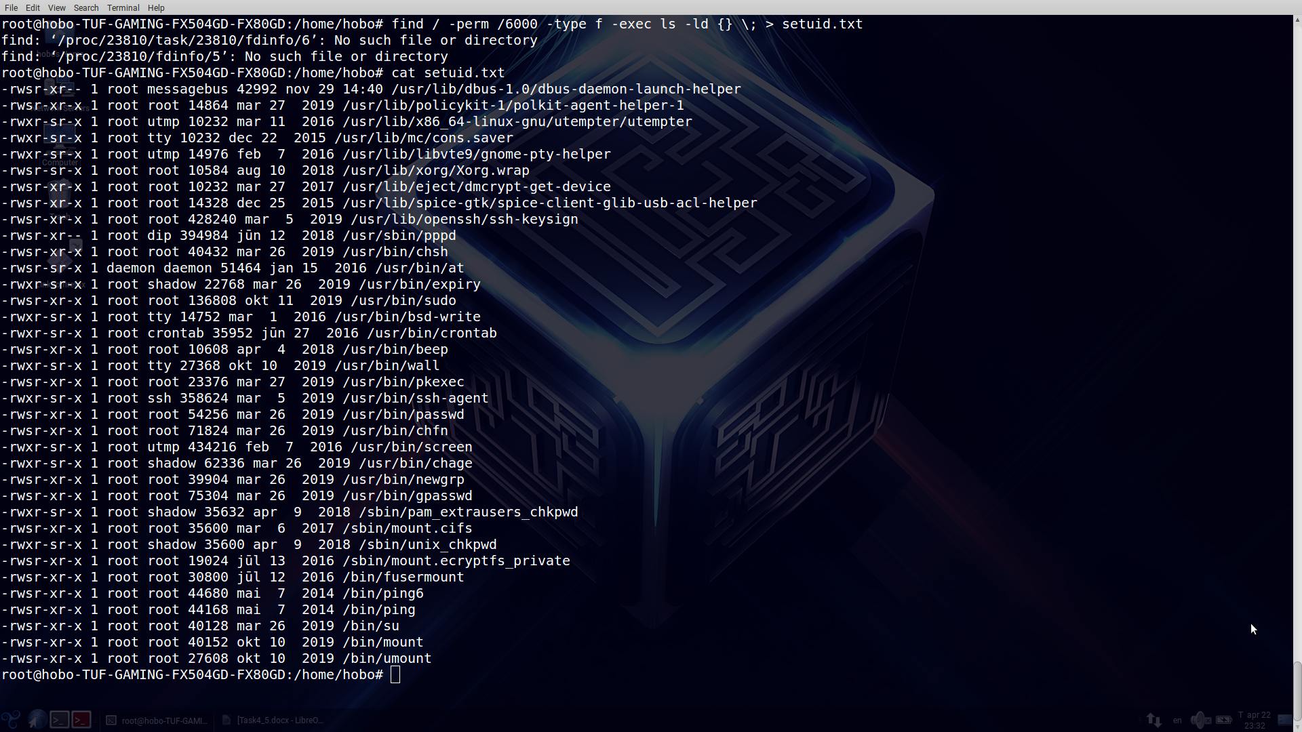

Parameters and meaning of them:

-perm -searching Linux’s files by access-mode.

6000 – binary value of rights

-type -f – kind of objects and files-kind for searching

-exec – key for executing operations with file. For this example there are output of full info about files in above directory.

2. Soft link – special file, which has link according needful file. Moving file to other directory will not change link to according one.

Hard link – every file has identifier. Name of file stays in “index-file” . Moving file is not “awful”.