Bagel Site Plan

Louis Sanchez

WDD 130

Overview

Purpose
The purpose of the Bagel Blitz website is to showcase a fast and convenient bagel sandwich shop that focuses on making fresh, delicious sandwiches in 5 minutes or less. The site will allow customers to explore menu options, learn about the brand, and find quick meal solutions.

Audience
The target audience includes busy college students, young professionals, and anyone looking for a quick and tasty meal. This includes people who value speed, convenience, and affordable food options, especially those in a fast-paced environment like Rexburg.

Branding

Website Logo
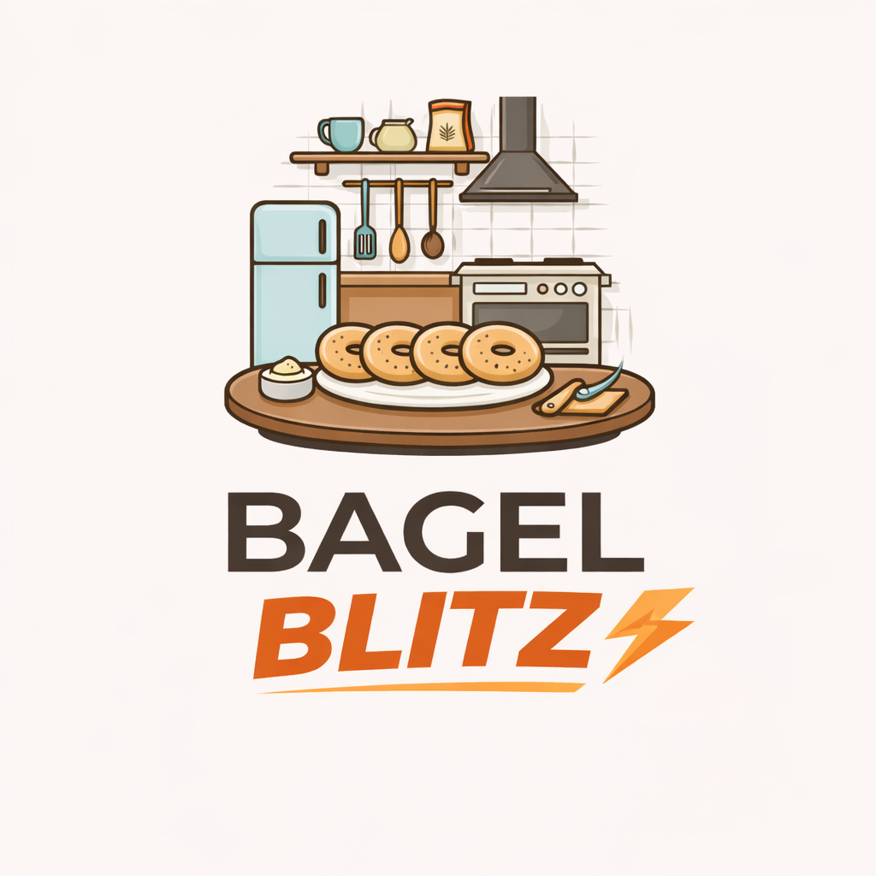

Style Guide

Color Palette
Primary | Secondary | Accent 1 | Accent 2
#F4A261 | #264653 | #E76F51 | #2A9D8F

Typography

Heading Font: poppins

Paragraph Font: Open Sans

Navigation
Home Page2 Page3

Content

Home Page
Welcome to Bagel Blitz! We specialize in making fresh, delicious bagel sandwiches in 5 minutes or less. Whether you’re on your way to class or need a quick bite, we’ve got you covered with fast service and great taste.
Includes:
- Logo + brand intro
- Featured sandwiches
- Call to action (Order Now / View Menu)

Menu Page
Our menu includes a variety of bagel sandwiches made fresh to order. Choose from breakfast, lunch, and specialty options.
Examples:
- Classic Egg & Cheese
- Bacon Breakfast Blitz
- Turkey Club Bagel
- Veggie Delight
Includes:
- Food images
- Descriptions
- Pricing (optional)

About Us Page
Bagel Blitz was created to provide fast, high-quality meals for people on the go. We believe you shouldn’t have to sacrifice quality for speed. Our mission is to deliver fresh bagel sandwiches quickly while maintaining great taste and customer satisfaction.

Wireframes

Home

--------------------------------------------------
| LOGO | Home | Menu | About |
--------------------------------------------------

| |
| HERO IMAGE / BANNER |
| "Fresh Bagels in 5 Minutes or Less" |
| [ Order Now Button ] |
| |
--------------------------------------------------

| FEATURE 1 | FEATURE 2 | FEATURE 3 |
| (Sandwich) | (Fast Service) | (Fresh) |
--------------------------------------------------

| |
| LARGE IMAGE + TEXT SECTION |
| "Why choose Bagel Blitz?" |
| - Fast service |
| - Fresh ingredients |
| - Great taste |
| |
--------------------------------------------------

| Footer: Contact | Socials | Hours |
--------------------------------------------------

--------------------------------------------------
| LOGO | Home | Menu | About |
--------------------------------------------------

| MENU TITLE |
| "Our Bagel Menu" |
--------------------------------------------------

| ITEM 1 ITEM 2 ITEM 3 |
| Image Image Image |
| Name Name Name |
| Price Price Price |
--------------------------------------------------

| ITEM 4 ITEM 5 ITEM 6 |
--------------------------------------------------

| Footer: Contact | Socials | Hours |
--------------------------------------------------

--------------------------------------------------
| LOGO | Home | Menu | About |
--------------------------------------------------

| ABOUT US TITLE |
--------------------------------------------------

| IMAGE | TEXT |
| (Kitchen) | Our story |
| | Mission |
| | Values |
--------------------------------------------------

| EXTRA SECTION (optional) |
| "Why we are different" |
--------------------------------------------------

| Footer: Contact | Socials | Hours |
--------------------------------------------------

