Socio-economic impact of micro hydropower plants and their contribution to local development.

INTRODUCTION

Since the first years of Uzbekistan's independence, the energy policy of the state leadership has been focused on ensuring the country's energy security and using national energy opportunities to solve social and economic problems of society. Although it is said that there are no settlements in Uzbekistan that are not covered by power transmission lines, but due to the outdated power generating stations and electrical network equipment, there is a shortage of electricity in remote settlements. Especially in mountain areas, where there is hydropower potential, in providing electricity to small settlements in remote areas, small power can be installed on small rivers. Environmental damage prevention of reservoirs in the construction of hydroelectric power plants, small capital costs in the construction of stations, and the possibility of quick (up to 5 years) return of capital costs accelerated the development of small energy around the world in the following decades. According to the results of 2016, we can see the hydropower of Uzbekistan in Table 1.

DISCUSSION AND RESULTS

Hydropower of Uzbekistan in numbers

Table 1
Naming | Indicator
Water arteries in Uzbekistan | 430 rivers
Total length of rivers | 12700 km
Annually produced energy | 60 mild kilowatt/soat
Electricity contributed by hydroelectric power plants | 6.5 kilowatt/hour
Hydropower potential in the medium-term perspective | 27.4 billion per year  kilowatt/hour
Increase in HPP capacity by 2026 | 1.7 times

November 2021

The main advantage of micro hydroelectric power plant is that the construction of small hydroelectric power plants does not require the creation of reservoirs at the expense of huge funds, flooding large areas. This means that it is intended for small streams, because there are many such basins in all regions of Uzbekistan. They include ditches and streams flowing at a speed of 3-5 meters per second. First of all, this is clean energy. The operation of micro-hydroelectric power plants does not harm the environment and water at all. For example, to produce 1 kW of energy in a traditional way, a lot of fossil fuel is required, and in micro-hydroelectric power plant we have an inexhaustible, renewable energy source.

The first and most important drawback is the lack of components. The most expensive part of the construction is the generator. Depletion of water in the winter, freezing, has a negative effect on the operation of the generator of the micro-gas. In its construction and design, it should be designed so that the blades attached to the generator shaft do not injure the fish when they rotate at high speed. Fish literally filter the water. In this regard, it is necessary to try to use no more than 10% of the available minimum flow when choosing a place for the construction of a micro hydropower plant. In order to determine the technical and economic criteria of the efficiency of energy supply from micro hydropower plants, it is necessary to determine the following main indicators from the area recommended for the installation of the station through the cadastre of hydropower resources:

1. The average slope of the river, DN (m/km);

2. Average amount of water flow in the summer dry season, Q (m³/s);

3. Average speed of water flow in summer dry season, v (m/s);

4. Hour of annual flow of canal or river, H.

Below,from Fig. 1 to Fig. 3, we will familiarize ourselves with the hydro turbines of the generator and the dependence of their diameter on pressure:
This turbine is used when the water pressure is more than 40m.
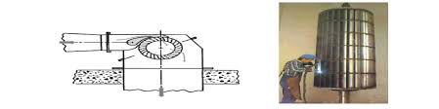
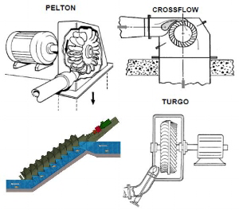

Figure 2. The structure is similar to a rotor with fixed blades around the circumference.

Figure 1. Pelton turbine.

In modern micro hydropower plants, water pressures from 2 to 100 m are used.
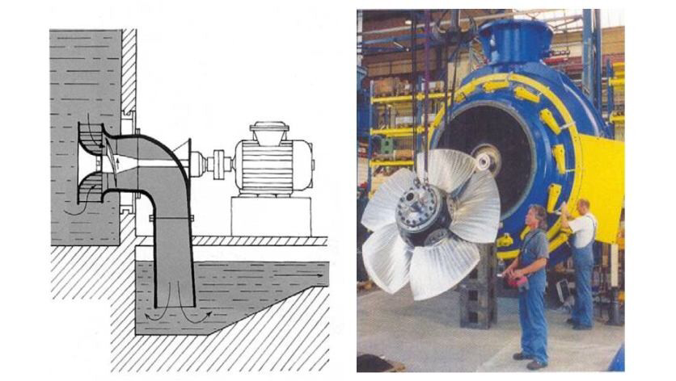
Figure 3. Kaplan propeller axial turbine.

Positive Socio-economic Impacts
Electricity supplied by MHP enhances income generation (agro-processing and small service business such as mills and shops) and enables inhabitants to make savings on expenses on kerosene, gasoline, candles and batteries. Income increase and savings as well as the possibility to use refrigeration improve the diet and thus decrease malnutrition and hunger. Moreover, women’s and children’s work load decreases, since they spend less time on energy related household tasks such as the collection of fire wood and water gathering. As mentioned above, that does not only reduce physical impairments resulting from the heavy loads, but also reduces the risk of harassment and sexual assault and thus HIV/AIDS risk. The communities’ safety in general improves due to street lighting at night. Furthermore women and children have more productive time which can be used for studying and thus education is improved. Electricity supply allows lighting at night and gives inhabitants the chance to study during evening hours. Latter also improves the communities’ social life, since community gatherings at night are possible and it benefits from electrical devices such as TV and radio. Furthermore telecommunication is enhanced. People get more aware of the outside world which gives them more knowledge. The electricity provided by the MHP has a positive impact on the communities’ health situation, since it decreases indoor air pollution and the risk of fire. Moreover it allows the use of refrigerators for medicine (keyword: vaccination) and groundwater pumps. Latter reduce water borne diseases due to contaminated surface water. Due to the enhanced technical equipment, more doctors and teachers are attracted to the mostly remote areas, which further improve health and education services.

Positive Environmental Impacts
In environmental terms, the MHP project raises the awareness of proper watershed management and reforestation to secure the sustainable use of water resources. Moreover the plants contribute to protect the environment and combat climate change through reduced use of kerosene/gasoline and small batteries. Generally it should be noted that impacts not only depend on the MHP itself, but also on what training and campaigns go along with its implementation and in what way the communities tap the full potential of the electricity supply.

Environmental Sustainability
MHP contributes to the environmental sustainability and combats climate change through reduced use of kerosene/gasoline and small batteries. Additionally there is an increased awareness of the importance of a proper watershed management and reforestation to secure long term water resources.

Negative Environmental Impacts
Since no large reservoirs are required, no resettlement programs and the along going negative impacts for the population occur. Nonetheless some scientist argue that particularly the environmental impacts of small-scale hydropower, when widely used, would be no less serious per kW generated than those from large scale hydropower plants. The impacts of hydropower schemes depend on the way they are designed. Since MHP and PHP schemes do not require a reservoir and divert only part of the stream water away from a portion of the river to power the turbine, they only have little impact on the flora and fauna of the vicinity. However they tend to create small, shallow pools which can cause problems such as sedimentation as well as eutrophication and can thus affect water quality and lead to greenhouse gas emission. Particularly a decrease of water quality can furthermore cause water borne diseases and thus affect the health situation of the population. Moreover aquatic species can be affected negatively in terms of migration and change of habitat condition. Due to the MHP and the along going electricity supply, a population growth close to the powerhouse is likely to occur. Thus the pressure on natural resources and the risk of erosion in areas close to the powerhouse is increased. The increased degradation rate can lead to an increase of sediment load of the river as well as to a reduction of the soil’s retention capacity, which can in turn result in an alternation of the discharge rate, showing in longer dry periods and an increased risk of flash floods. Consequences might be that a sustainable use of the MHP cannot be provided. Further environmental impacts might be deforestation due to the construction of access roads and grid connection power lines.

Environmental vs. Socio-economic Benefits
It should be noted, that some features might be considered positive in socio-economic terms but negative in environmental terms and vice versa. Taking the construction of access roads as an example, it has negative impacts on the environment since increased deforestation occurs but positive socio-economic effects in terms of increased access to the market and (in some areas) increased income from tourism. When constructing an MHP scheme, it is thus of great importance to be aware of complex interdependencies between positive as well as negative environmental and socio-economic impacts and benefits which can vary between population groups in terms of income and location of their households. It should be deliberated on whether the benefit of the MHP implementation exceeds possibly occurring negative impacts, taking into account environmental as well as socio-economic features. The schemes’ impacts on the health situation can be taken as an example: the plants’ environmental impacts such as decreased water quality might affect population’s health, nonetheless the electricity supply might also improve the overall health situation due to refrigeration, improved access and increased income to purchase medicine. Generally, negative impacts should be kept to a minimum by incorporating and implementing respective mitigation techniques already in the planning and construction phase of the MHP project.

References
- Socio-economic and Environmental Impacts MHP. https://energypedia.info/wiki/Socio-economic_and_Environmental_Impacts_of_MHP#cite_note-MEDER-3
- THE ROLE OF MICRO-HEPP IN THE ENERGY OF UZBEKISTAN AND THEIR STAGES OF DEVELOPMENT. https://cyberleninka.ru/article/n/o-zbekiston-energetikasida-mikro-gesning-tutgan-o-rni-va-ularning-rivojlanish-bosqichlari

