Daniel Lesser & Sagnik Rana

2/11/19

Data Science and Big Data 95-885

Assignment 4: Explorations in Visualization

The United States has always been a melting pot of different cultures and tastes. However, in recent years, consumers have become as concerned with the uniqueness of their food as the healthiness. As more and more individuals pay attention to the ingredients in the food they purchase, it is important to properly educate consumers on which ingredients are healthy and what types of products contain unhealthy ingredients.

In 2014, the Wall Street Journal published an [article](https://www.wsj.com/articles/1-000-flavors-of-banana-the-new-science-of-food-additives-1414687926?mod=pls_whats_news_us_business_f) on industry efforts to craft new flavors through “flavorings, spices, colorings, thickeners, and preservatives.” This article included a compelling interactive [diagram](http://graphics.wsj.com/food-additives-ingredients/) that displays the “Axis of Additives.” The visual informs readers of some of the most common additives found in foods today. It teaches the user what some of these cryptic ingredients are for and importantly, what product categories they are most likely to find them in. The goal is to help the user be a more informed shopper and avoid ingredients they find unsuitable to their diet.

There are hundreds of thousands of products and ingredients to choose from, so it was key for this visual to be broad enough to be comprehended, but specific enough to have some connection to the user. By including only additives rather than all types of ingredients, the writer focuses on an important trend in processed foods: the increase in artificial ingredients and enhancers. Similarly, the writer chose to present broad food categories instead of calling out specific products. Most importantly, the reader can see the relationships that these ingredients have with each food category and vice versa. By not providing too much information, the reader is kept engaged and potentially incentivized enough to find more information on their own.

The author structures the graphic with ingredients on the left side of the circle and the supermarket products on the right side. The visualization allows the reader to see one-to-many and many-to-one mappings of ingredients and products. Ingredients are simple to compare across multiple products. However, one pitfall of the graph is that the size of the relationships do not indicate what percentage of that product category have that ingredient, but rather replicate already known information: what percentage of shelf space is made up of that item. This can be confusing to the reader.

Additional features include the ability to hover over ingredients and products to see a brief explanation. Aesthetically, similar types of ingredients are grouped together and share similar colors. This makes it easier for the reader to identify trends in the data. Overall, the visualization is appealing and interactive. It should be considered as an option when displaying feature/product mapping. It makes a simpler explanation for non-technical audiences.

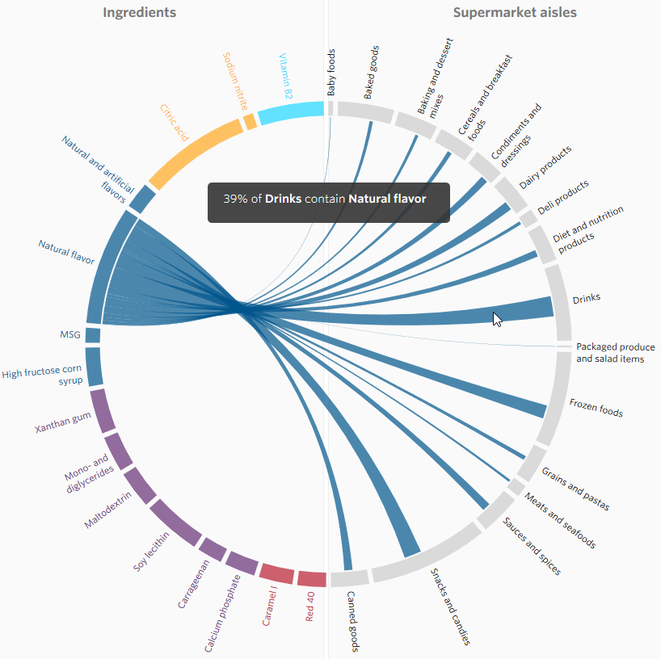

Source: <http://graphics.wsj.com/food-additives-ingredients/>