OMML conversion fixture
An inline equation $E=mc^{2}$ and a display one:
$$\int_{0}^{∞}{e^{−λt}} dt=\frac{1}{λ}.$$
A footnote survives the trip.
A table for the DOCX reader.
Method | Score
Baseline | 0.71
Ours | 0.94
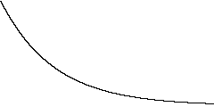
An embedded image.

Footnote text for the exporter.

