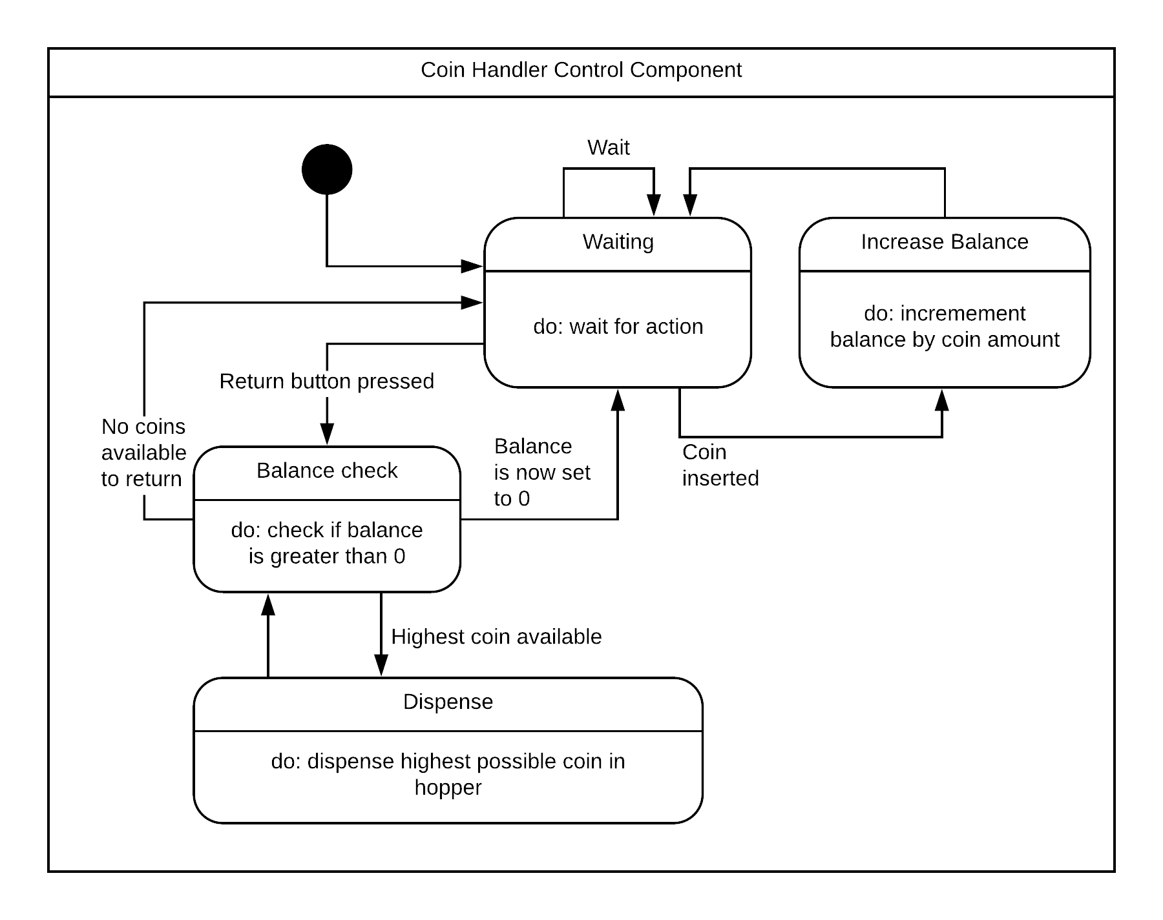

|  |  |
| --- | --- |
| Stimulus | Description |
| Waiting |  |
| Increase Balance |  |
| Balance Check |  |
| Dispense |  |

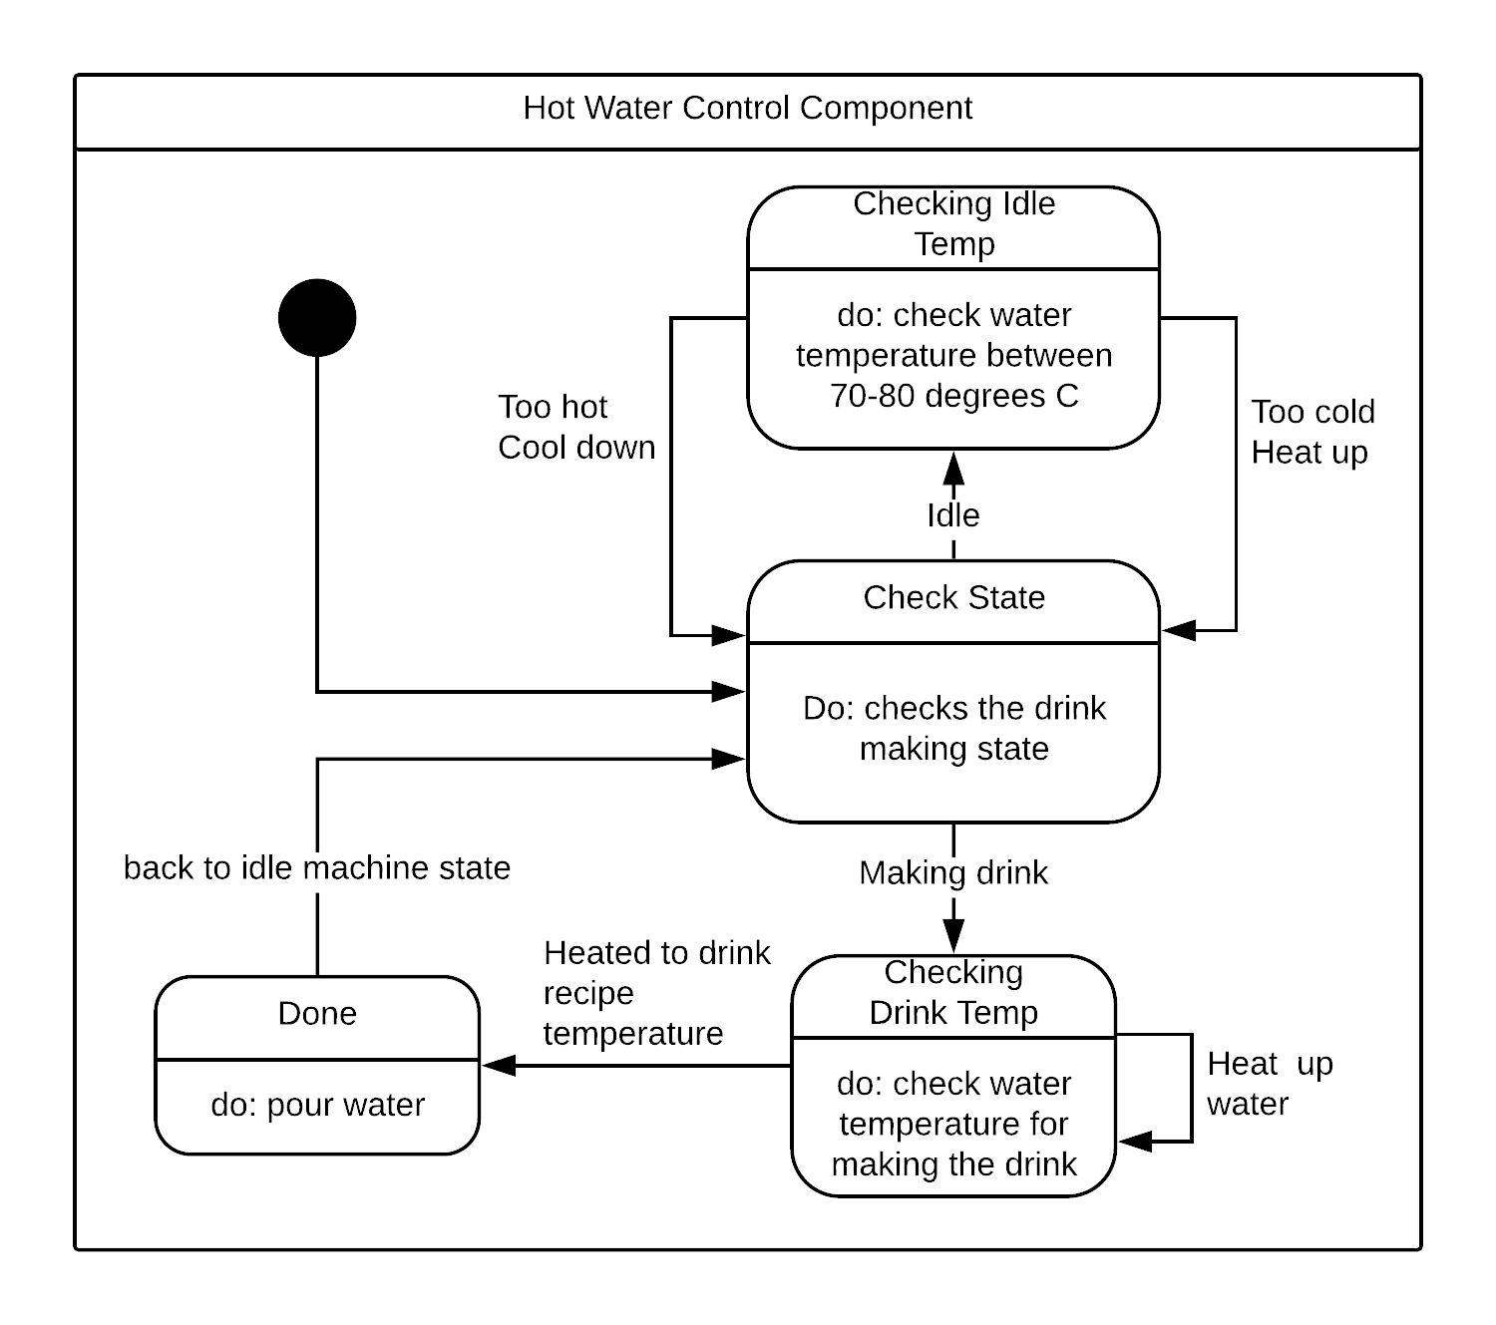

|  |  |
| --- | --- |
| Stimulus | Description |
| Check State | Checks what state the machine is on |
| Done | The heater has gone to the sufficient temperature and now is ready to pour the water. The machine then returns to its idling state until the next user wants to |
| Checking Drink Temp | Checks if the drink temperature is optimal before it starts to pour |
| Checking Idle Temp | The machine’s water temperature checks if it is between 70-80 degrees c. If it is too hot, it turns the heater off. If it is too cold, it turns the heater on. |