ЛАБОРАТОРНА РОБОТА № 3
Використання узагальнень (generics). Клонування та порівняння об'єктів.
Мета: створити міні проект Game з використанням узагальнень, клонування та порівняння об'єктів.
Хід роботи:
Завдання 1. Відкрити заготовлений проект з реалізованою базовою функціональністю.
Завдання 2. За допомогою узагальнень (generics) встановити такі обмеження: - до команди можна додавати тільки учасників, що відносяться до одної ліги (Schoolar, Student або Employee). - - грати між собою можуть тільки команди з учасниками одної ліги (тобто команда студентів може грати тільки іншою командою студентів). - продемонструвати створення команд, гравців, додавання гравців до команд, гри між ними.
Лістинг завдання:
Team.java
package com.education.ztu.game;
import java.util.ArrayList;
import java.util.List;
import java.util.Objects;
import java.util.Random;
public class Team<T extends Participant> {
private String name;
private List<T> participants = new ArrayList<>();
public Team(String name) {
this.name = name;
}
public Team(Team<T> other) {
this.name = other.name;
this.participants = new ArrayList<>();
for (T participant : other.participants) {
this.participants.add((T) participant.clone());
}
}
public static <T extends Participant> Team<T> deepClone(Team<T> original) {
return new Team<>(original);
}

public void addNewParticipant(T participant) {
participants.add(participant);
System.out.println("To the team " + name + " was added participant " + participant.getName());
}
public void playWith(Team<T> team) {
String winnerName;
Random random = new Random();
int i = random.nextInt(2);
if (i == 0) {
winnerName = this.name;
} else {
winnerName = team.name;
}
System.out.println("The team " + winnerName + " is winner!");
}
public String getName() {
return name;
}
public List<T> getParticipants() {
return participants;
}
public void setName(String name) {
this.name = name;
}
public void setParticipants(List<T> participants) {
this.participants = participants;
}
@Override
public String toString() {
return "Team{" +
"name='" + name + '\'' +
", participants=" + participants +
'}';
}
@Override
public boolean equals(Object o) {
if (this == o) return true;
if (o == null || getClass() != o.getClass()) return false;
Team<?> team = (Team<?>) o;
return Objects.equals(name, team.name) && Objects.equals(participants, team.participants);
}
@Override
public int hashCode() {
return Objects.hash(name, participants);
}
}
Game.java
package com.education.ztu.game;
public class Game {
public static void main(String[] args) {
Schoolar schoolar1 = new Schoolar("Ivan", 13);
Schoolar schoolar2 = new Schoolar("Mariya", 15);
Schoolar schoolar3 = new Schoolar("Sergey", 12);
Schoolar schoolar4 = new Schoolar("Olga", 14);
Student student1 = new Student("Mykola", 20);
Student student2 = new Student("Viktoria", 21);
Student student3 = new Student("Andriy", 22);
Student student4 = new Student("Kateryna", 19);
Employee employee1 = new Employee("Andriy", 28);
Employee employee2 = new Employee("Oksana", 25);
Employee employee3 = new Employee("Petro", 30);
Employee employee4 = new Employee("Natalia", 27);
System.out.println("=== Creating Schoolar Teams ===");
Team<Schoolar> schoolarTeam1 = new Team<>("Dragon");
schoolarTeam1.addNewParticipant(schoolar1);
schoolarTeam1.addNewParticipant(schoolar2);
Team<Schoolar> schoolarTeam2 = new Team<>("Rozumnyky");
schoolarTeam2.addNewParticipant(schoolar3);
schoolarTeam2.addNewParticipant(schoolar4);
System.out.println("\n=== Creating Student Teams ===");
Team<Student> studentTeam1 = new Team<>("Vpered");
studentTeam1.addNewParticipant(student1);
studentTeam1.addNewParticipant(student2);
Team<Student> studentTeam2 = new Team<>("Intellect");
studentTeam2.addNewParticipant(student3);
studentTeam2.addNewParticipant(student4);
System.out.println("\n=== Creating Employee Teams ===");
Team<Employee> employeeTeam1 = new Team<>("Robotyagi");
employeeTeam1.addNewParticipant(employee1);
employeeTeam1.addNewParticipant(employee2);
Team<Employee> employeeTeam2 = new Team<>("Professionals");
employeeTeam2.addNewParticipant(employee3);
employeeTeam2.addNewParticipant(employee4);
System.out.println("\n=== Games ===");
System.out.println("Schoolar teams playing:");
schoolarTeam1.playWith(schoolarTeam2);
System.out.println("\nStudent teams playing:");
studentTeam1.playWith(studentTeam2);
System.out.println("\nEmployee teams playing:");
employeeTeam1.playWith(employeeTeam2);
System.out.println("\n=== Demonstration of constraints (commented in code) ===");
System.out.println("- Cannot add participant from another league to team");
System.out.println("- Teams of different leagues cannot play with each other");
System.out.println("- All constraints are checked at compile time thanks to generics!");
}
}

Результат виконання:
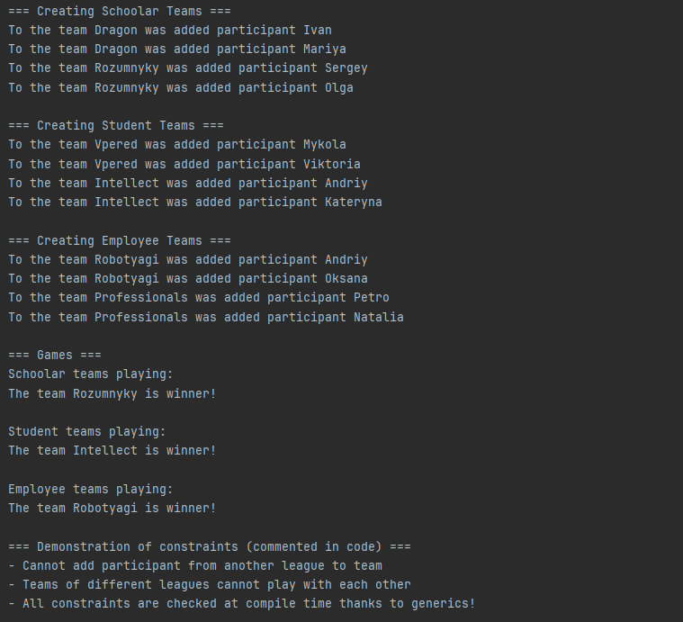
Рис. 1 Результат виконання завдання №2
Завдання 3. Клонування: - для класу Participant імплементувати інтерфейс Cloneable та перевизначити метод clone. - для класу Participant перевизначити методи hashCode та equals. - для класу Participant та його підкласів перевизначити метод toString. - для класу Team Реалізувати глибоке клонування через статичний метод або конструктор копіювання. - продемонструвати клонування та використання методів hashCode, equals та toString.
Лістинг завдання:
Schoolar.java
package com.education.ztu.game;
public class Schoolar extends Participant {
public Schoolar(String name, int age) {
super(name, age);
}
@Override
public String toString() {
return "Schoolar{" +
"name='" + getName() + '\'' +
", age=" + getAge() +
'}';
}
}
Student.java
package com.education.ztu.game;
public class Student extends Participant {
public Student(String name, int age) {
super(name, age);
}
@Override
public String toString() {
return "Student{" +
"name='" + getName() + '\'' +
", age=" + getAge() +
'}';
}
}
Employee.java
package com.education.ztu.game;
public class Employee extends Participant {
public Employee(String name, int age) {
super(name, age);
}
@Override
public String toString() {
return "Employee{" +
"name='" + getName() + '\'' +
", age=" + getAge() +
'}';
}
}
Team.java
package com.education.ztu.game;
import java.util.ArrayList;
import java.util.List;
import java.util.Objects;
import java.util.Random;
public class Team<T extends Participant> {
private String name;
private List<T> participants = new ArrayList<>();
public Team(String name) {
this.name = name;
}
public Team(Team<T> other) {
this.name = other.name;
this.participants = new ArrayList<>();
for (T participant : other.participants) {
this.participants.add((T) participant.clone());
}
}
public static <T extends Participant> Team<T> deepClone(Team<T> original) {
return new Team<>(original);
}
public void addNewParticipant(T participant) {
participants.add(participant);
System.out.println("To the team " + name + " was added participant " + participant.getName());
}
public void playWith(Team<T> team) {
String winnerName;
Random random = new Random();
int i = random.nextInt(2);
if (i == 0) {
winnerName = this.name;
} else {
winnerName = team.name;
}
System.out.println("The team " + winnerName + " is winner!");
}
public String getName() {
return name;
}
public List<T> getParticipants() {
return participants;
}
public void setName(String name) {
this.name = name;
}
public void setParticipants(List<T> participants) {
this.participants = participants;
}
@Override
public String toString() {
return "Team{" +
"name='" + name + '\'' +
", participants=" + participants +
'}';
}
@Override
public boolean equals(Object o) {
if (this == o) return true;
if (o == null || getClass() != o.getClass()) return false;
Team<?> team = (Team<?>) o;
return Objects.equals(name, team.name) && Objects.equals(participants, team.participants);
}
@Override
public int hashCode() {
return Objects.hash(name, participants);
}
}

Main.java
package com.education.ztu;
import com.education.ztu.game.*;
public class Main {
public static void main(String[] args) {
System.out.println("=== TASK 3: Cloning and Object methods ===\n");
Schoolar schoolar1 = new Schoolar("Ivan", 13);
Schoolar schoolar2 = new Schoolar("Mariya", 15);
Student student1 = new Student("Mykola", 20);
System.out.println("=== Demonstration of toString() ===");
System.out.println("Original schoolar1: " + schoolar1);
System.out.println("Original student1: " + student1);
System.out.println("\n=== Demonstration of clone() for Participant ===");
Schoolar clonedSchoolar = (Schoolar) schoolar1.clone();
System.out.println("Cloned schoolar: " + clonedSchoolar);
System.out.println("Original and clone are different objects: " + (schoolar1 != clonedSchoolar));
System.out.println("But have same values: " + schoolar1.equals(clonedSchoolar));
clonedSchoolar.setName("Ivan_Clone");
clonedSchoolar.setAge(14);
System.out.println("After modification:");
System.out.println("Original: " + schoolar1);
System.out.println("Clone: " + clonedSchoolar);
System.out.println("\n=== Demonstration of equals() ===");
Schoolar schoolar3 = new Schoolar("Ivan", 13);
System.out.println("schoolar1: " + schoolar1);
System.out.println("schoolar3: " + schoolar3);
System.out.println("schoolar1.equals(schoolar3): " + schoolar1.equals(schoolar3));
System.out.println("schoolar1 == schoolar3: " + (schoolar1 == schoolar3));
System.out.println("schoolar1.equals(clonedSchoolar): " + schoolar1.equals(clonedSchoolar));
System.out.println("\n=== Demonstration of hashCode() ===");
System.out.println("schoolar1 hashCode: " + schoolar1.hashCode());
System.out.println("schoolar3 hashCode: " + schoolar3.hashCode());
System.out.println("clonedSchoolar hashCode: " + clonedSchoolar.hashCode());
System.out.println("Equal objects have same hashCode: " +
(schoolar1.equals(schoolar3) && schoolar1.hashCode() == schoolar3.hashCode()));
System.out.println("\n=== Creating team ===");
Team<Schoolar> originalTeam = new Team<>("Young Dragons");
originalTeam.addNewParticipant(schoolar1);
originalTeam.addNewParticipant(schoolar2);
System.out.println("Original team: " + originalTeam);
System.out.println("\n=== Deep cloning via copy constructor ===");
Team<Schoolar> copiedTeam = new Team<>(originalTeam);
copiedTeam.setName("Young Dragons Copy");
System.out.println("Copied team: " + copiedTeam);
System.out.println("\n=== Checking copy independence ===");
copiedTeam.getParticipants().get(0).setName("Modified_Ivan");
System.out.println("After modifying copied team participant:");
System.out.println("Original team first participant: " +
originalTeam.getParticipants().get(0).getName());
System.out.println("Copied team first participant: " +
copiedTeam.getParticipants().get(0).getName());
System.out.println("Deep clone successful - objects are independent!");
System.out.println("\n=== Deep cloning via static method ===");
Team<Student> studentTeam = new Team<>("Smart Students");
studentTeam.addNewParticipant(student1);
studentTeam.addNewParticipant(new Student("Viktoria", 21));
System.out.println("Original student team: " + studentTeam);
Team<Student> clonedStudentTeam = Team.deepClone(studentTeam);
clonedStudentTeam.setName("Smart Students Clone");
System.out.println("Cloned student team: " + clonedStudentTeam);
clonedStudentTeam.getParticipants().get(0).setAge(25);
System.out.println("\nAfter modifying cloned team:");
System.out.println("Original team first participant age: " +
studentTeam.getParticipants().get(0).getAge());
System.out.println("Cloned team first participant age: " +
clonedStudentTeam.getParticipants().get(0).getAge());
System.out.println("\n=== equals() and hashCode() for Team ===");
Team<Schoolar> team1 = new Team<>("Test Team");
team1.addNewParticipant(new Schoolar("Test", 10));
Team<Schoolar> team2 = new Team<>("Test Team");
team2.addNewParticipant(new Schoolar("Test", 10));
System.out.println("team1: " + team1);
System.out.println("team2: " + team2);
System.out.println("team1.equals(team2): " + team1.equals(team2));
System.out.println("team1.hashCode(): " + team1.hashCode());
System.out.println("team2.hashCode(): " + team2.hashCode());
System.out.println("\n=== All methods successfully demonstrated! ===");
}
}
Результат виконання:
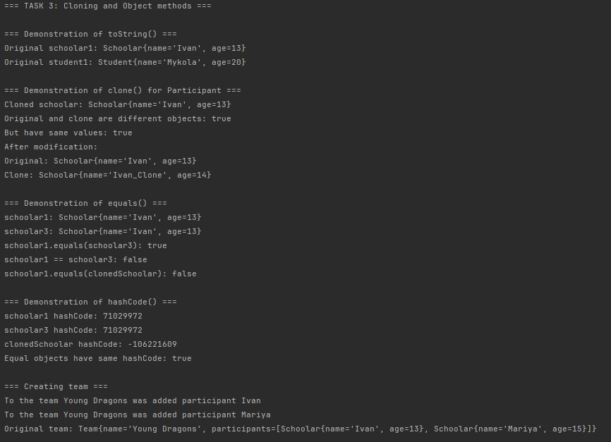
Рис. 2 Виконна завдання 3 частина №1.
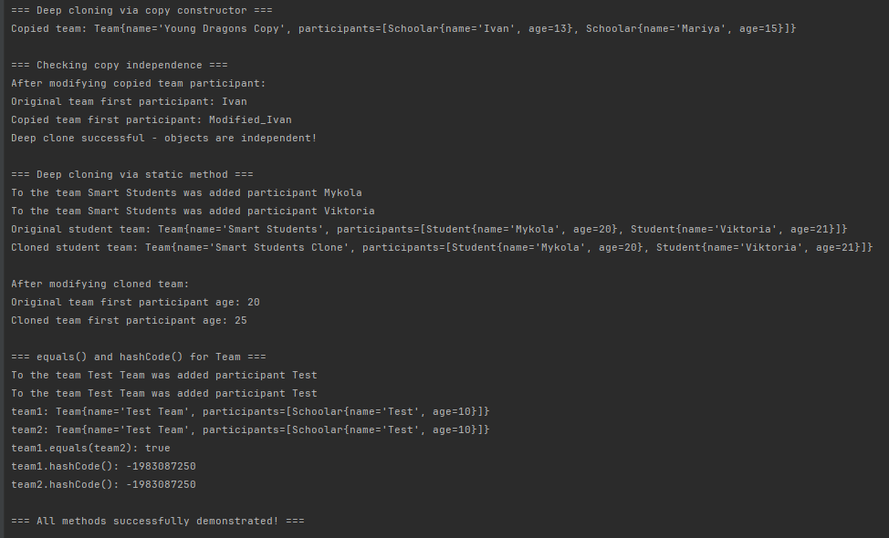
Рис. 3 Виконна завдання 3 частина №2.
Завдання 4. Порівняння: - для класу Participant імплементувати інтерфейс Comparable та перевизначити метод compareTo для сортування учасників по імені. - створити Comparator для порівняння учасників по віку. - *створити компаратор з пріорітетом використовуючи можливості Java 8 (спочатку порівняння по імені, а потім по віку). - продемонструвати роботу порівнянь на прикладі сортування учасників команд.
Лістинг завдання:
Participant.java
package com.education.ztu.game;
import java.util.Objects;
public abstract class Participant implements Cloneable, Comparable<Participant> {
private String name;
private int age;
public Participant(String name, int age) {
this.name = name;
this.age = age;
}
public String getName() {
return name;
}
public int getAge() {
return age;
}
public void setName(String name) {
this.name = name;
}
public void setAge(int age) {
this.age = age;
}
@Override
public Participant clone() {
try {
return (Participant) super.clone();
} catch (CloneNotSupportedException e) {
throw new RuntimeException("Clone not supported", e);
}
}
@Override
public boolean equals(Object o) {
if (this == o) return true;
if (o == null || getClass() != o.getClass()) return false;
Participant that = (Participant) o;
return age == that.age && Objects.equals(name, that.name);
}
@Override
public int hashCode() {
return Objects.hash(name, age);
}
@Override
public String toString() {
return "Participant{" +
"name='" + name + '\'' +
", age=" + age +
'}';
}
@Override
public int compareTo(Participant other) {
return this.name.compareTo(other.name);
}
}
Main.java
package com.education.ztu;
import com.education.ztu.game.*;
import java.util.*;
public class Main2 {
public static void main(String[] args) {
System.out.println("=== TASK 4: Comparison and sorting ===\n");
Team<Participant> team = new Team<>("Mixed Team");
Schoolar schoolar1 = new Schoolar("Dmytro", 14);
Schoolar schoolar2 = new Schoolar("Anna", 13);
Schoolar schoolar3 = new Schoolar("Boris", 15);
Student student1 = new Student("Zoryana", 20);
Student student2 = new Student("Anton", 22);
Student student3 = new Student("Mykola", 19);
Employee employee1 = new Employee("Viktor", 28);
Employee employee2 = new Employee("Olena", 25);
Employee employee3 = new Employee("Ihor", 30);
List<Participant> participants = new ArrayList<>();
participants.add(schoolar1);
participants.add(student1);
participants.add(employee1);
participants.add(schoolar2);
participants.add(student2);
participants.add(employee2);
participants.add(schoolar3);
participants.add(student3);
participants.add(employee3);
System.out.println("=== Original list of participants ===");
for (Participant p : participants) {
System.out.println(p);
}
System.out.println("\n=== Sorting using Comparable (by name) ===");
List<Participant> sortedByName = new ArrayList<>(participants);
Collections.sort(sortedByName);
for (Participant p : sortedByName) {
System.out.println(p);
}
System.out.println("\n=== Sorting using Comparator (by age) ===");
Comparator<Participant> ageComparator = new Comparator<Participant>() {
@Override
public int compare(Participant p1, Participant p2) {
return Integer.compare(p1.getAge(), p2.getAge());
}
};
List<Participant> sortedByAge = new ArrayList<>(participants);
Collections.sort(sortedByAge, ageComparator);
for (Participant p : sortedByAge) {
System.out.println(p);
}
System.out.println("\n=== Sorting with priority: name, then age (Java 8) ===");
Comparator<Participant> nameAndAgeComparator = Comparator
.comparing(Participant::getName)
.thenComparing(Participant::getAge);
List<Participant> sortedByNameAndAge = new ArrayList<>(participants);
Collections.sort(sortedByNameAndAge, nameAndAgeComparator);
for (Participant p : sortedByNameAndAge) {
System.out.println(p);
}
System.out.println("\n=== Demonstration with participants with same names ===");
List<Participant> sameNameParticipants = new ArrayList<>();
sameNameParticipants.add(new Schoolar("Ivan", 14));
sameNameParticipants.add(new Student("Ivan", 20));
sameNameParticipants.add(new Employee("Ivan", 28));
sameNameParticipants.add(new Schoolar("Ivan", 12));
System.out.println("Before sorting:");
for (Participant p : sameNameParticipants) {
System.out.println(p);
}
Collections.sort(sameNameParticipants, nameAndAgeComparator);
System.out.println("\nAfter sorting (by name, then by age):");
for (Participant p : sameNameParticipants) {
System.out.println(p);
}
System.out.println("\n=== Other sorting options (Java 8) ===");
System.out.println("\nSorting by age (descending):");
List<Participant> sortedByAgeDesc = new ArrayList<>(participants);
sortedByAgeDesc.sort(Comparator.comparing(Participant::getAge).reversed());
for (Participant p : sortedByAgeDesc) {
System.out.println(p);
}
System.out.println("\nSorting by name (reversed), then by age:");
List<Participant> sortedComplex = new ArrayList<>(participants);
sortedComplex.sort(Comparator.comparing(Participant::getName).reversed()
.thenComparing(Participant::getAge));
for (Participant p : sortedComplex) {
System.out.println(p);
}
System.out.println("\n=== Using Stream API for sorting ===");
System.out.println("Top 5 youngest participants:");
participants.stream()
.sorted(Comparator.comparing(Participant::getAge))
.limit(5)
.forEach(System.out::println);
System.out.println("\n=== All comparison methods successfully demonstrated! ===");
}
}
Результат виконання:
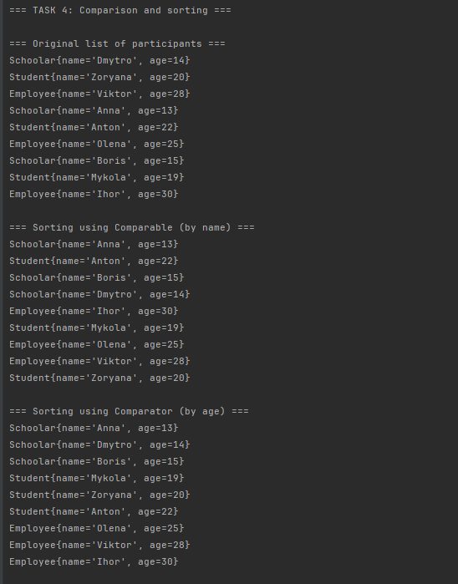
Рис. 4 Виконна завдання 4 частина №1.
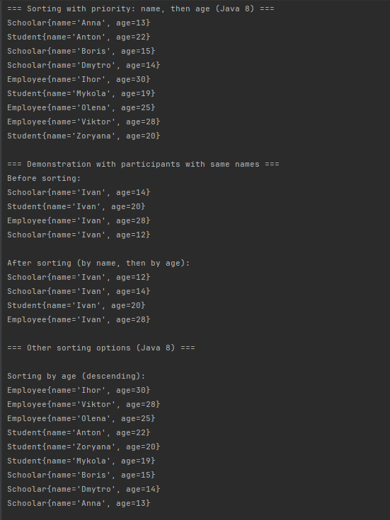
Рис. 5 Виконна завдання 4 частина №2.
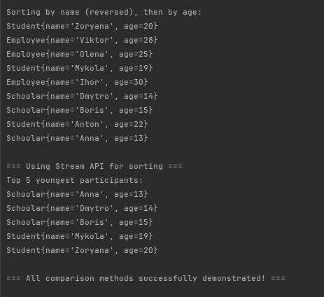
Рис. 6 Виконна завдання 4 частина №3.
Посилання на репозиторій: https://github.com/Oleg-Ischuk/Java-IPZ-23-1
Висновок: створив міні проект Game з використанням узагальнень, клонування та порівняння об'єктів.

