Project Report: VLAN Network Design

Network Topology
1.1. Network Diagram
The network topology was designed in Cisco Packet Tracer to meet and exceed the minimum design requirements. It includes one router, four switches, and nine end devices grouped by functional roles.

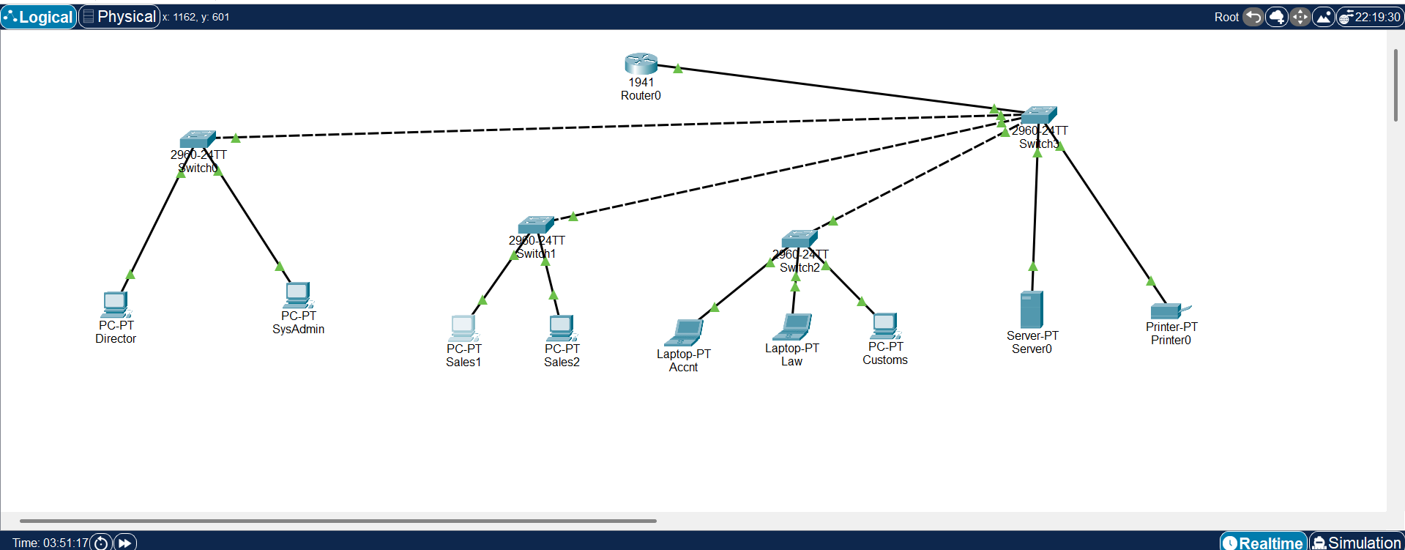
-

1.2. Topology Description
A hierarchical topology was implemented, where Switch3 acts as the central switch (distribution core). The other switches (Switch0, Switch1, Switch2) are connected to it, servicing their groups of devices.
• Router0: Acts as an inter-VLAN router (Inter-VLAN Routing) using the "Router-on-a-Stick" technology, and also serves as a gateway for applying security policies (ACL).
• Switch3 (Central): Aggregates traffic from other switches and provides communication with the router. Shared network resources are connected to it.
• Switch0, Switch1, Switch2: Access layer switches to which end devices are connected in accordance with their departments or roles.

Configuration Details
2.1 IP Addressing Scheme and VLANs
Four VLANs were created for logical network segmentation. Each VLAN was assigned its own class C subnet.
Role Device VLAN ID VLAN Name IP Address Subnet Mask Default Gateway
Director Director_PC 10 Director 192.168.10.10 255.255.255.0 192.168.10.1
SysAdmin SysAdmin_PC 30 Administration 192.168.30.10 255.255.255.0 192.168.30.1
Accountant Accnt_Laptop 30 Administration 192.168.30.11 255.255.255.0 192.168.30.1
Lawyer Law_Laptop 30 Administration 192.168.30.12 255.255.255.0 192.168.30.1
Customs Officer Customs_PC 30 Administration 192.168.30.13 255.255.255.0 192.168.30.1
Sales Officer 1 Sales1_PC 20 Sales 192.168.20.10 255.255.255.0 192.168.20.1
Sales Officer 2 Sales2_PC 20 Sales 192.168.20.11 255.255.255.0 192.168.20.1
Server Server0 40 Resources 192.168.40.10 255.255.255.0 192.168.40.1
Printer Printer0 40 Resources 192.168.40.11 255.255.255.0 192.168.40.1

2.2. Configuration of VLANs and switch ports
1. VLANs 10, 20, 30 and 40 were created on all four switches (Switch0-Switch3).
2. The ports to which the end devices are connected were configured as access ports and assigned to the corresponding VLANs.
3. The ports connecting the switches to each other and the central switch to the router were configured as trunk ports to ensure the transmission of traffic of all VLANs.

2.3. Inter-VLAN Routing Configuration
Inter-VLAN routing was configured on Router0 using subinterfaces for each VLAN. The physical port GigabitEthernet0/0 was enabled, and for each VLAN a virtual subinterface (e.g. GigabitEthernet0/0.10) was created with dot1q encapsulation and an IP address serving as a gateway for the subnet.

2.4. Custom Configuration: Access Control Lists (ACL)
To implement the security policy, an extended access control list (ACL) numbered 100 was created.
Rule logic:
1. Allow the System Administrator (192.168.30.10) to access the Director (192.168.10.10).
2. Deny all other devices access to the Director.
3. Allow all other traffic between all networks.
ACL configuration commands on Router0:

access-list 100 permit ip host 192.168.30.10 host 192.168.10.10
access-list 100 deny ip any host 192.168.10.10
access-list 100 permit ip any any
I googled these commands.
This list was applied to the output (out) of the GigabitEthernet0/0.10 subinterface, which leads to the Director network:

interface GigabitEthernet0/0.10
ip access-group 100 out

Justification and Analysis
3.1. Justification of Design Decisions
• Security: VLANs isolate traffic from different departments. For example, sales traffic (VLAN 20) is completely separated from administration traffic (VLAN 30) at the data link layer. ACL on the router adds another, network-based layer of security by granularly controlling access to the Director's critical network segment.
• Reduction of broadcast traffic: Each VLAN is a separate broadcast domain.

• Scalability: Using a hierarchical topology and VLANs allows for easy addition of new departments (VLANs) or devices.

3.2. Challenges encountered and their solution
During the project, an issue was encountered with no connectivity between VLANs after the initial setup of the router.
• Problem: Pings within the same VLAN were successful, but pings between different VLANs failed (Request timed out).
• Diagnostics: It was suspected that the problem was in the path from the router to the rest of the network. Using the show interfaces trunk command on the central switch Switch3, it was determined that the port connected to the router (FastEthernet0/4) was not set to trunk mode.
• Solution: Port FastEthernet0/4 on Switch3 was manually configured as a trunk port using the switchport mode trunk command. Inter-VLAN connectivity was then established successfully. This process demonstrated the importance of end-to-end configuration verification on all devices.

Testing and Validation
4.1 Test Results
Two rounds of testing were performed using the ping utility.
Round 1: Check basic connectivity (before applying ACLs)
• Intra-VLAN Ping (e.g. Sales1 -> Sales2): Success.
• Inter-VLAN Ping (e.g. Sales1 -> Server0): Success.
Round 2: Check security policy (after applying ACLs)
• SysAdmin -> Director (192.168.30.10 -> 192.168.10.10): Success.
• Law -> Director (192.168.30.12 -> 192.168.10.10): Failure (Destination host unreachable).
• Ping Sales1 -> Director (192.168.20.10 -> 192.168.10.10): Failed (Destination host unreachable).
• Ping Sales1 -> Server0 (192.168.20.10 -> 192.168.40.10): Successful.
• Ping Director -> Sales1 (192.168.10.10 -> 192.168.20.10): Successful.

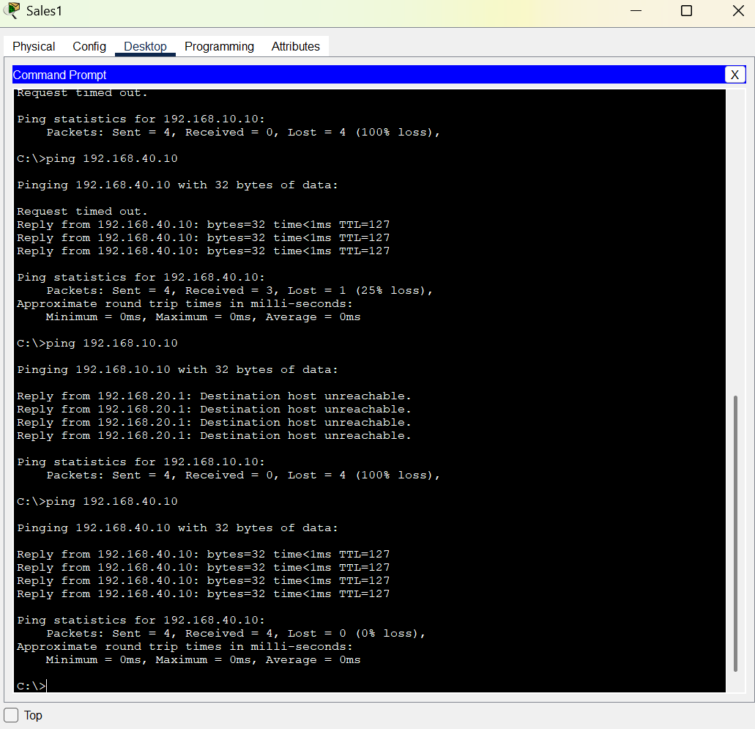
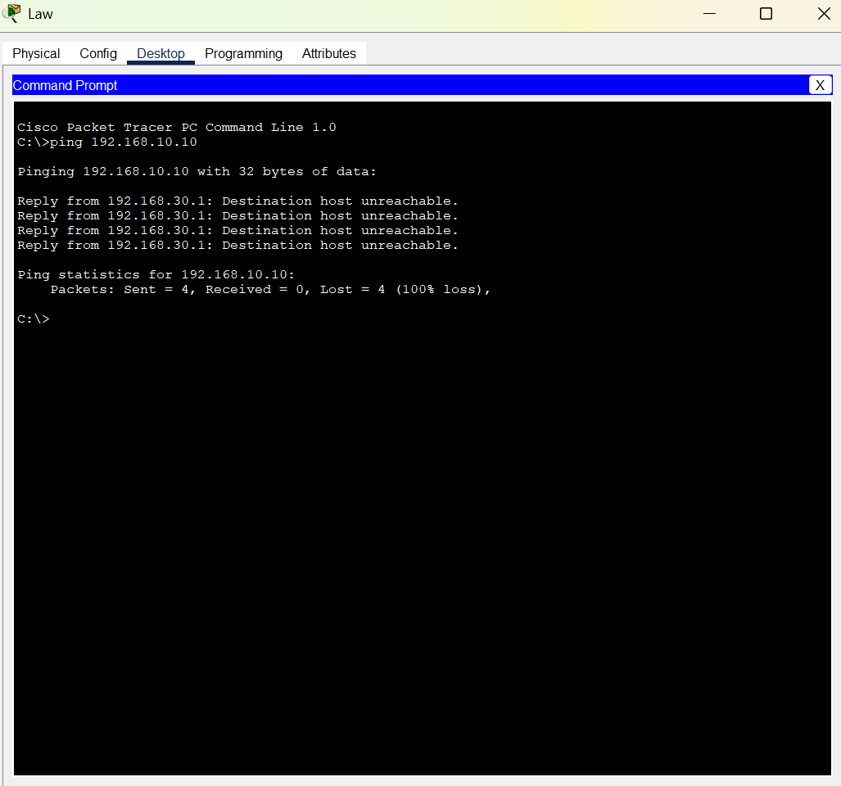
-

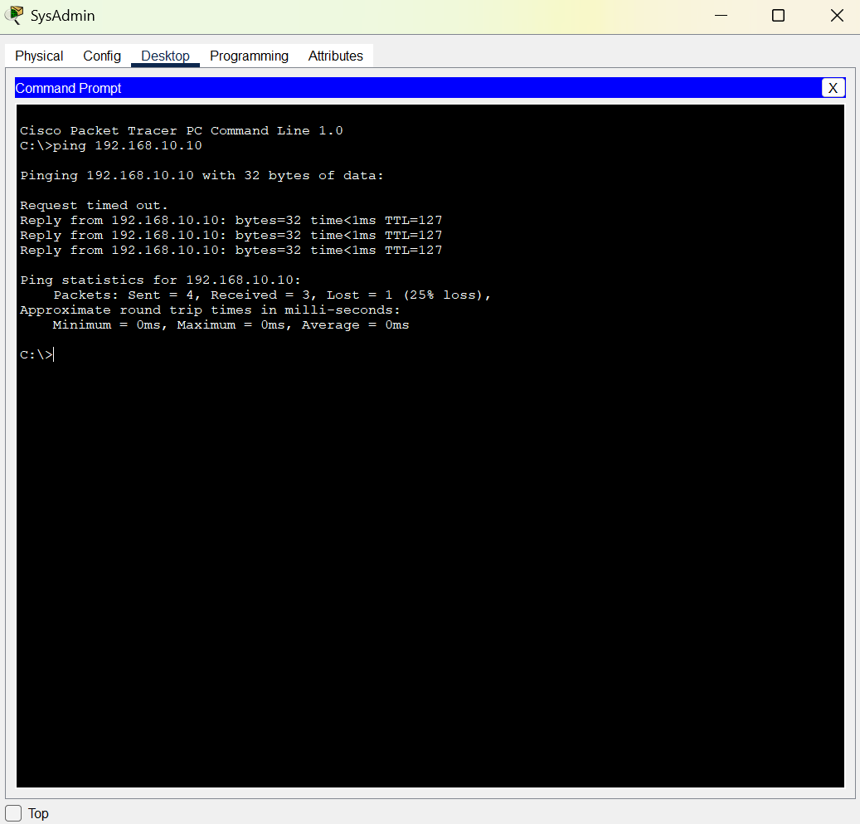
-

4.2. Test Results
The test results confirm that:
1. Logical network segmentation using VLANs is implemented correctly.
2. Inter-VLAN routing functions correctly.
3. The applied security policy (ACL) effectively blocks unauthorized access to the Director's network without disrupting legitimate traffic in the rest of the network.

