**Junior WEB Developer**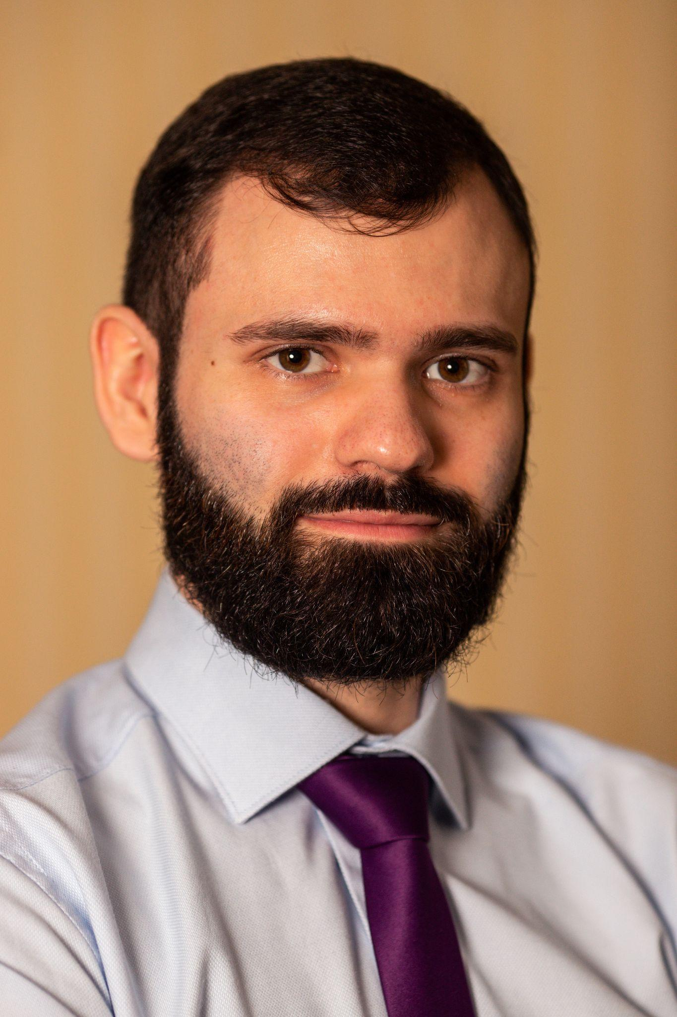

**Oleh Abramov**

30.11.1996

**Contact information**

Tel: +380960772024

E-mail: dr.khayzenberg@gmail.com

Git-Hub: https://github.com/Oleg7845

**Skills:**

-English language (developing this skill; understand 50-80% of the text I read; can talk a little)

-HTML5 + CSS3/SASS

-JavaScript

-Vue.js (little experience)

-Angular

-#C/ASP.NET Core/Unity (backend with .NET Core - database interaction and JWT little experience for Unity)

-PHP 5.0

-Python (little experience)

-JSON

-MySQL

-SQLite3 (little experience)

**Experience in working with:**

-GitHub

-Visual Studio Code

-Visual Studio

-PyCharm

-Sublime Text

-MySQL Worckbench

-Figma

-Unity

-Microsoft Office

-AutoCAD

**My projects in GitHub:**

<https://github.com/Oleg7845/Portfolio.git>

1/2

**About me**

Purposeful, like to concentrate on my work and not to be distracted, punctual in important things, I like to write concise program code and constantly improve my skills in writing code, I want to learn new things and develop in the field of WEB-development.

**Work activities**

JSC "OTP Bank" (04.2019 - 05.2022) - operator of the call center, advised clients on the bank's products, solved technical problems of clients, ensured the security of clients finances, conducted practical training for new staff, during non-working hours, in the absence of the unit management at the workplace, managed colleagues in difficult situations and technical problems.

**Education**

Bachelor Degree

“Electronic devices and systems”

Admiral Makarov National University of Shipbuilding

Learning period: 09.2015 - 06.2019

2/2