HOLLOWS
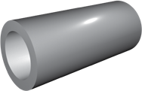
The inside diameter of our hollows is forged into the part rather than bored from a bar, which makes them an excellent option that eliminates extra time, cost and material waste. Since we forge them as a single component; we pass along several benefits to our customers by saving production time and increasing part strength.

MANUFACTURING CAPABILITIES

Range | O.D. up to 60 in
Range | I.D. up to 30 in
Range | Weight up to 55,000 lb.
Material | Carbon Steel, Alloy Steel, Tool Steel, Stainless Steel.
Heat Treat | Normalizing, Quenching, Tempering, Annealing, Solution Annealing, Spherodizing, Aging, Stress Relieving.
Testing | Destructive and Non-Destructive.
Machining | Available CNC machining capabilities: vertical & horizontal turning, milling, boring, drilling, deep drilling.
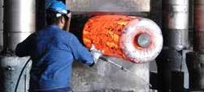

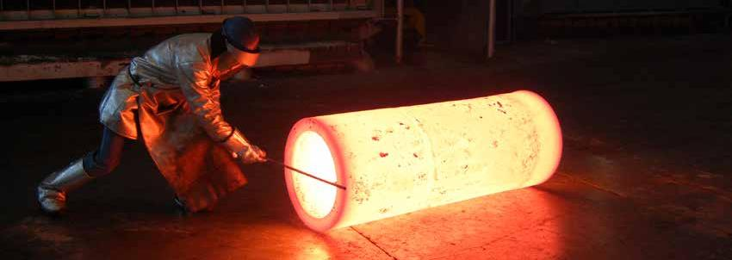

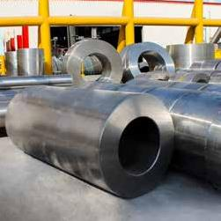
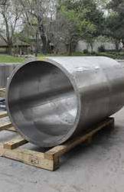
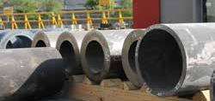
MATERIAL STOCKING GRADES


Classification

Carbon and Low
Alloy steels

Alloy Steels

Tool Steels

Stainless Steels

Superalloys

Aluminum

Titanium
Grade
A105
1010
1018
1020
1035
1045
1050
1080
1552
A350 Grade LF6
A350 Grade LF2
A694
4130
4140
4145
4320
4330
4340
52100
8620
8630
A182 Grade F5
A 182 Grade F11
A 182 Grade F22
A707 Grade L5
A707 Grade 3W
H13
P20
L6
A182 F44
A182 F51
A182 F53
A182 F60
A182 F91
15-5 PH
17-4 PH
304
304L
310
316
316L
321
347
410
420
422
431

F6NM
Alloy 718
Alloy 718 Plus
Waspaloy
Alloy 909
Alloy 907
Alloy 625
Alloy 600
Alloy 617
Alloy X
Alloy H230
Alloy 188
Alloy H242
Alloy HR120
Nimonic 80
Alloy 825
Alloy 800 H
Alloy C276
Monel 400
Alloy C263

Thermo Span
Al 6061
Al 7075
Al 2618
Al 2014
Al 2219
Al 7050
Ti-6-4
Ti 6-2-4-2
Ti 21s
Ti 834
Ti-407
UNS Number
K03504
G10100
G10180
G10200
G10350
G10450
G10500
G10800
G15520
K03011

G41300
G41400
G41450
G43200
G43400
G86200
G86300
K41545
K11597
K21590

T20813
T51620
T61206
S31254
S31803
S32750
S32205
K90901
S15500
S17400
S30400
S30403
S31000
S31600
S31603
S32100
S34700
S41000
S42000
S42200
S43100

S41500
N07718
N07001
N19909
N19907
N06625
N06600
N06617
N06002
N06230
R30188
N10242
N08120
N07080
N08825
N08800/N08810
N10276
N04400
N07263
S66286
N07041

R56400
R54620
R58210
DIN
C22.8
CK10
CK15
CK20
CK35
CK45
CK50
CK80

C22.8
E355
25CrMo4
42CrMo2

34CrNiMo6
100Cr6
21NiCrMo22
12CrMo195
13CrMo4-5
10CrMo9-10

X 40 CrMoV 5-1
40CrMnNiMo8-6-4
55NiCrMoV6
X1CrNiMoN20-18-7
X 2 CrNiMoN22-5-3
X2CrNiMoN25-7-4
X 10 CrMoVNb9-1
X5CrNiCuNb15-5
X5CrNiCuNb 17-4
X5CrNi18-10
X5CrNi18-9
X8 CrNi 25-21
X5CrNiMo17 12-2
X2CrNiMo17 12-2
X6CrNiTi18-10
X6CrNiNb18-10
X12Cr13
X46Cr13
X17CrNi16-2
X 22 CrNiMoV 12-1
X11CrMo 12-1
X 3 CrNiMo 13-4
NiCr19Fe19Nb5Mo3
NiCr20Co13Mo4Ti3Al
X4NiCo38Nb
X4NiCo38Nb
NiCr22Mo9Nb
NiCr15Fe8
NiCr23Co12Mo
NiCr22Fe18Mo
NiCo29Cr28Si
CoCr22NiW
NiFe33Cr25Co
NiCr20TiAl
NiCr 21 Mo
X8 NiCrAlTi 32-21
NiMo 16 Cr 15 W
NiCu 30 Fe
NiCo20Cr20Mo6Ti2Al
X5 NiCrTi 26-15
NiCr19Co11MoTi

TiAl6V4
TiAl6Sn2Zr4Mo2
Werkstoff Nr
1.0460
1.1121
1.1141
1.1181
1.1191

1.0460
1.0580
1.7218
1.7225

1.6582
1.3505
1.6543
1.6545
1.7362
1.7335
1.7380

1.2344
1.2311
1.2713
1.4547
1.4462
1.4410
1.4903
1.4545
1.4542
1.4301
1.4306
1.4845
1.4401
1.4404
1.4541
1.4551
1.4006
1.4034
1.4935
1.4057
1.4923
1.4313
2.4668
2.4654

2.4856
2.4816
2.4663
2.4665
2.4880
2.4683
2.4854
2.4952
2.4858
1.4876 / 1.4958
2.4819
2.4360
2.4650
1.4980
2.4973

3.7165
3.7145

