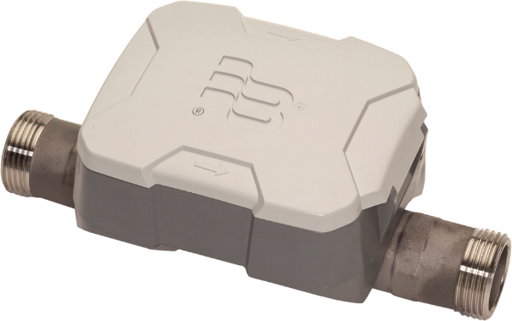

U500w Ultrasonic Meter
Cold Water Stainless Steel Meter, 5/8, 5/8 x 3/4, 3/4 and 1 inch NSF/ANSI Standard 61 Certified, Annex G

DESCRIPTION
The U500w Ultrasonic meter uses solid-state technology in a compact, totally encapsulated, weatherproof, and UV-resistant housing, suitable for building and property management submetering applications. Electronic metering provides information—such as rate of flow and reverse flow indication—and data not typically available through traditional, mechanical meters and registers. Electronic metering eliminates measurement errors due to sand, suspended particles and pressure fluctuations.
Offered in four sizes and lay lengths, the U500w meter features:
- Minimum extended low-flow rate lower than typical positive displacement meters.
- Simplified one-piece electronic meter and register that are integral to the meter body and virtually maintenance free.
- Sealed, non-removable, tamper-protected meter and register.
- Easy-to-read, 9-digit LCD display presents consumption, rate of flow, reverse-flow indication, and alarms.
- Battery powered—eliminates wiring.
- Compatible with AquaCUE® Flow Measurement Manager.

The U500w meter is available with an in-line connector for easy connection and installation to AquaCUE connectors.

APPLICATIONS
Use the U500w meter for measuring potable cold water in building/property management and industrial applications. The meter is also ideal for non-potable, reclaimed irrigation water applications or less than optimum water conditions where small particles exist.
The U500w meter complies with applicable portions of ANSI/AWWA Standard C700 and NSF/ANSI Standard 61, Annex G. There is currently no AWWA standard that specifically addresses ultrasonic meters for residential applications.
OPERATION & PERFORMANCE
As water flows into the measuring tube, ultrasonic signals are sent consecutively in forward and reverse directions of flow. Velocity
is then determined by measuring the time difference between
the measurement in the forward and reverse directions. Total volume is calculated from the measured flow velocity using water temperature and pipe diameter. The LCD display shows total volume and alarm conditions and can toggle to display rate of flow.

In the normal temperature range of 45…85° F (7…29° C), the U500w “new meter“ consumption measurement is accurate to:
- ±1.5% over the normal flow range
- ±3.0% from the extended low flow range to the minimum
flow value
CONSTRUCTION
The U500w meters feature a stainless steel, lead-free meter housing, an engineered polymer and stainless steel metering insert, a meter-control circuit board with associated wiring, LCD, and battery. Wetted elements are limited to the pressure vessel, polymer/stainless steel metering insert and the transducers.
The electronic components are housed and fully potted within
a molded, engineered polymer enclosure, which is permanently attached to the meter housing. The transducers extend through the stainless steel housing and are sealed by O-rings.
The metering insert holds the stainless steel ultrasonic reflectors in the center of the flow area, enabling turbulence-free water flow through the tube and around the ultrasonic signal reflectors. The metering insert’s patented design virtually eliminates chemical buildup on the reflectors, ensuring long-term metering accuracy.
METER INSTALLATION
The meter is completely submersible and can be installed using horizontal or vertical piping, with flow in the up direction. The meter will not measure flow when an “empty pipe“ condition is experienced. An empty pipe is defined as a condition that occurs when the pipe is partially full.

ESM-DS-02202-EN-04 (November 2018) Product Data Sheet

SPECIFICATIONS

U500w Ultrasonic Meter Size | 5/8 in. (16 mm) | 5/8 x 3/4 in. (16 x 19 mm) | 3/4 in. (19 mm) | 1 in. (25 mm)
Operating Range | 0.1…25 gpm (0.4…95 lpm) | 0.1…25 gpm (0.4…95 lpm) | 0.1…32 gpm (0.4…121 lpm) | 0.4…55 gpm (1.5…208 lpm)
Extended Low-Flow Rate | 0.05 gpm  (0.2 lpm) | 0.05 gpm  (0.2 lpm) | 0.05 gpm  (0.2 lpm) | 0.25 gpm  (95 lpm)
Maximum Continuous Operation | 25 gpm  (95 lpm) | 25 gpm  (95 lpm) | 32 gpm  (121 lpm) | 55 gpm  (208 lpm)
Pressure Loss | 4.3 psi at 15 gpm (0.3 bar @ 57 lpm) | 2.3 psi at 15 gpm (1.6 bar @ 57 lpm) | 2.0 psi at 15 gpm (0.14 bar @ 57 lpm) | 1.8 psi at 25 gpm (0.12 bar @ 95 lpm)
Reverse Flow - Maximum Rate | 4.0 gpm  (15 lpm) | 4.0 gpm  (15 lpm) | 4.0 gpm  (15 lpm) | 9.0 gpm  (34 lpm)
Operating Performance | In the normal temperature range of 45…85° F (7…29° C), new meter consumption measurement is accurate to:  - ±1.5% over the normal flow range  - ±3.0% from the extended low flow range to the minimum flow value
Storage Temperature | – 40…140° F (– 40…60° C)
Maximum Ambient Storage (Storage for One Hour) | 150° F (72° C)
Measured-Fluid Temperature Range | 34…140° F (1°…60° C)
Humidity | 0…100% condensing; meter is capable of operating in fully submerged environments
Maximum Operating Pressure of Meter Housing | 175 psi (12 bar)
Register Type | Straight reading, permanently sealed electronic LCD; digits are 0.28 in. (7 mm) high
Register Display | - Consumption (up to nine digits)  - Rate of flow (US gallons per minute or cubic meters per hour)  - Alarms  - Unit of measure factory programmed for gallons, cubic feet and cubic meters
Register Capacity | - 10,000,000 gallons  - 1,000,000 cubic feet  - 100,000 cubic meters
Totalization Display Resolution | - Gallons: 0.XX  - Cubic feet: 0.XXX  - Cubic meters: 0.XXXX
Battery | 3.6-volt lithium thionyl chloride; battery is fully encapsulated within the register housing and is not replaceable; 20-year battery life

MATERIALS

Meter Housing | 316 stainless steel
Measuring Element | Pair of ultrasonic sensors located in the flow tube
Register Housing & Lid | Engineered polymer
Metering Insert | Engineered polymer & stainless steel
Transducers | Piezo-ceramic device with wetted surface of stainless CrNiMo

PHYSICAL DIMENSIONS
U500w Ultrasonic Meter Size | 5/8 in. (16 mm) | 5/8 x 3/4 in. (16 x 19 mm) | 3/4 in. (19 mm) | 1 in. (25 mm)
Size Designation X Lay Length | 5/8 × 7-1/2 in. (16 × 191 mm) | 5/8 × 3/4 × 7-1/2 in. (16 x 19 × 1901 mm) | 3/4 × 7-1/2 in. or 3/4 × 9 in.  (19 × 191 mm or 19 × 229 mm) | 1 x 10-3/4 in. (25 × 273 mm)
Weight (without AquaCUE connector) | 2.2 lb (1 kg) | 2.1 lb (0.95 kg) | 3/4 × 7-1/2 in.: 2.1 lb  3/4 × 9 in.: 2.4 lb  (20 × 190 mm.: 0.95 kg or 20 × 229 mm: 1.08 kg)) | 3.1 lb (1.4 kg)
See illustration below for Measurement Designations.
Length (A) | 7.5 in.(190 mm) | 7.5 in.(190 mm) | 7.5 in. or 8.98 in.  (190 mm or 228 mm) | 10.745 in. (273 mm)
Height (B ) | 2.404 in. (61 mm) | 2.404 in. (61 mm) | 2.404 in. (61 mm) | 2.529 in. (64 mm)
Height (C) | 3.014 in. (76 mm) | 3.014 in. (76 mm) | 3.094 in. (79 mm) | 3.359 in. (85 mm)
Width (D) | 3.898 in. (99 mm) | 3.898 in. (99 mm) | 3.898 in. (99 mm) | 3.898 in. (99 mm)
Bore Size | 5/8 in. (16 mm) | 3/4 in. (19 mm) | 3/4 in. (19 mm) | 1 in. (25 mm)
Coupling Nut & Spud Thread | 3/4 in. × 14 NPSM | 1 in. × 11-1/2 NPSM | 1 in. × 11-1/2 NPSM | 1-1/4 in. × 11-1/2 NPSM
Tailpiece Pipe Thread (NPT) | 1/2 in. (13 mm) | 3/4 in. (19 mm) | 3/4 in. (19 mm) | 1 in. (25 mm)
Service Pipe Thread (NPT) | 1/2 in. (13 mm) | 3/4 in. (19 mm) | 3/4 in. (19 mm) | 1 in. (25 mm)

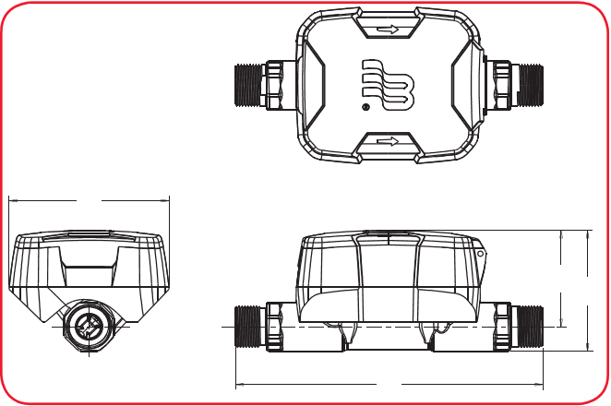
Measurement Designations

D

B C

A

PRESSURE LOSS CHART
Rate of Flow in gallons per minute (gpm)

13
12
11
10
9
8
7
6
5
4
3
2
1
0
5/8 in.

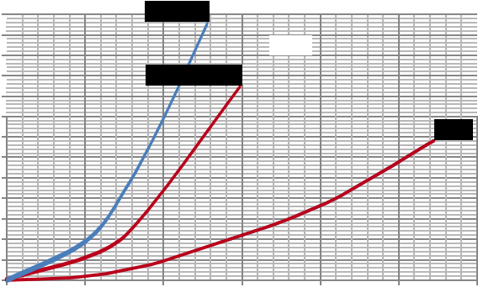
5/8 x 3/4 in.

3/4 in.

1 in.

0
10
20
30
Flow Rate in gpm
Pressure Drop in PSI
40
50
60

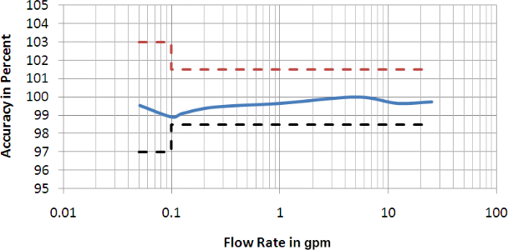
ACCURACY CHARTS
5/8 in. Meter | 5/8 x 3/4 in. Meter
1 10 Flow Rate in gpm  3/4 in. Meter | 100  1 in. Meter
Rate of Flow in gallons per minute (gpm)

105
104
103
Accuracy in Percent
102
101
100
99
98
97
96
95

0.01 0.1

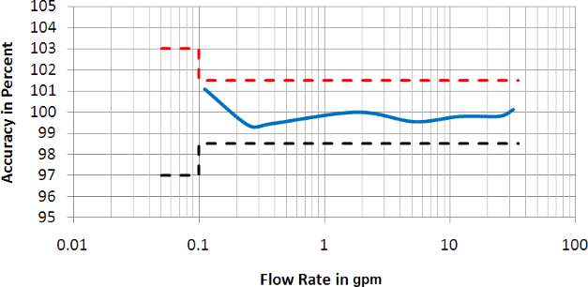

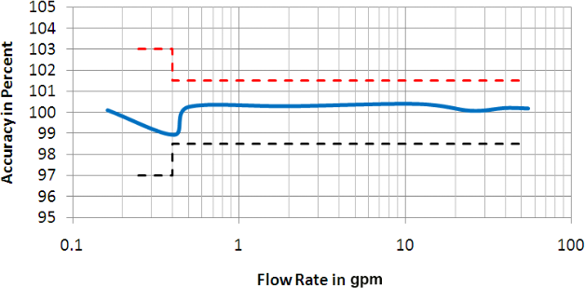
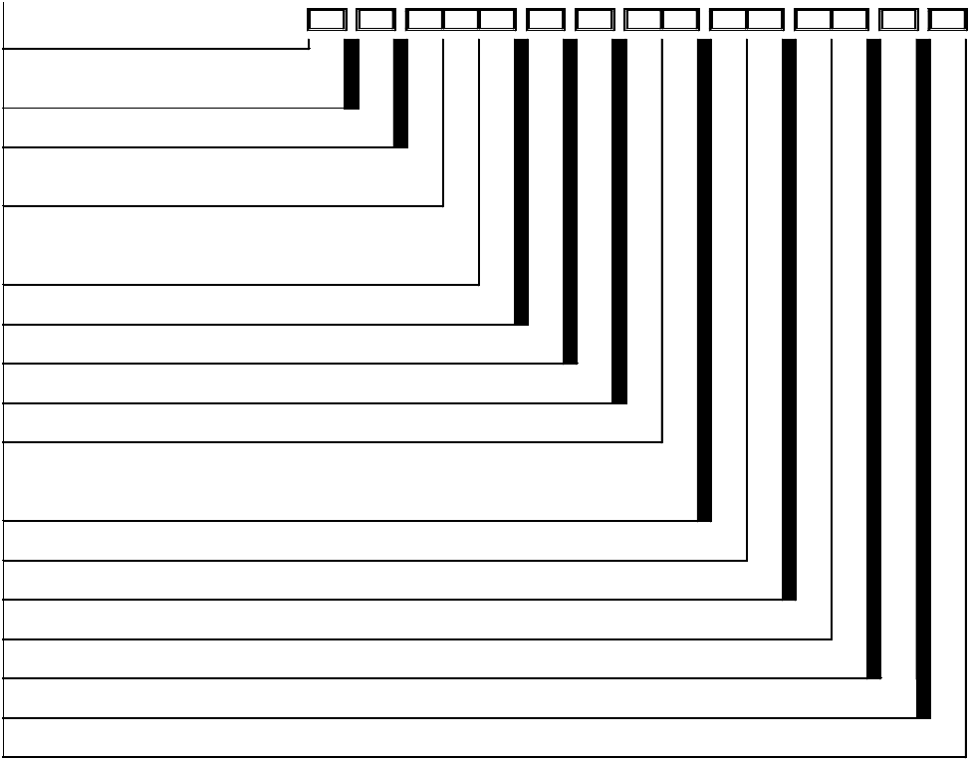
PART NUMBERS Meter 5/8 inch
Dynasonics
U500w Ultrasonic Meters
PRODUCT TYPE
Stainless Steel Meter
METER TYPE
5/8 in. (1/2 x 7-1/2 in.)
WATER APPLICATION
Potable Water
Reclaimed Water (Stainless Steel Meter Only)
CONNECTIONS / GASKETS

UB

UB

-
-

EAA

EAA

-
-

P
R

X

-
-

E5

-
-

CA

-
-

1

-
-

A1

Y3

-
-

XX

TF

-
-

XX

-
-

B0A

NL Straight - Thick Washers (Stainless Steel Meter Only) None - Thick Washers
ACCESSORIES
None
REGISTRATION
Encoder
TECHNOLOGY
Meter with Cable (No Endpoint)
REGISTRATION FACE
Standard
SC
XT

X

E5

CA

1

UNIT OF MEASURE / DIAL RESOLUTION OUTPUT / VISUAL BILLING UNITS
9 Dial - 0.01 Gallon, GPM, 1000 9 Dial - 0.001 ft3, GPM, 100
9 Dial - 0.0001 M3, GPM, 10
TESTING
BADGER STD (TS-419)
SERIALIZATION
Year of Mfg | 9 Digit S/N | Barcoded | Primary and Lid Outside
APPLICATION (See Note)
None
WIRING METHOD (See Note) Twist Tight - 5 ft (MTR, ASSY)
ENDPOINT SHIPMENT MODE
N/A
RESERVED
Standard
9AE
9FD
9MC

A1

Y3

XX

TF

XX

B0A

Meter 5/8 x 3/4 inch
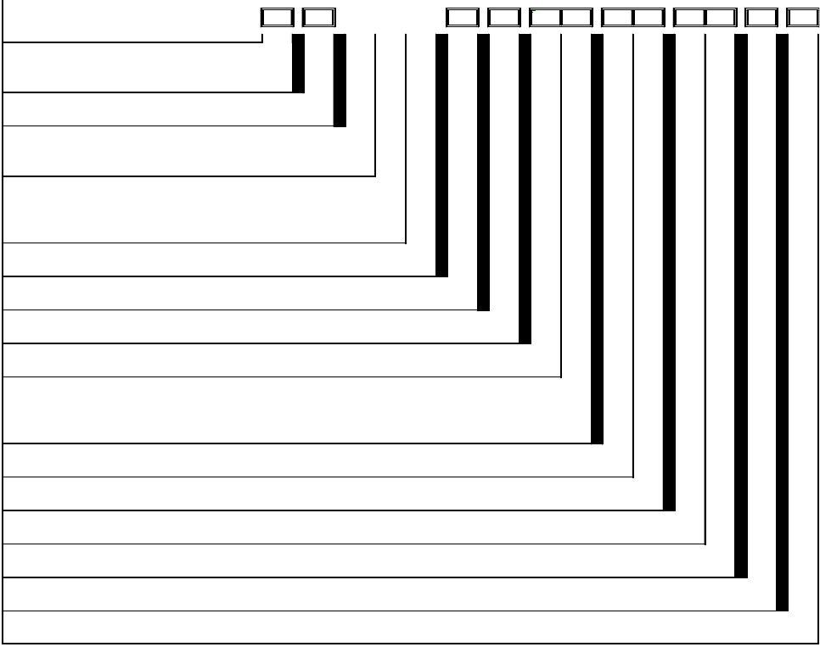
Dynasonics
X
U500w Ultrasonic Meters
PRODUCT TYPE
Stainless Steel Meter
METER TYPE
5/8 in. x 3/4 in. (3/4 x 7-1/2 in.)
WATER APPLICATION
Potable Water
Reclaimed Water (Stainless Steel Meter Only)
CONNECTIONS / GASKETS

UB

UB

-
-

EAC

EAC

-
-

P
R

-
-

E5

-
-

CA

-
-

1

-
-

A2

Y3

-
-

XX

TF

-
-

XX

-
-

B0A

NL Straight - Thick Washers (Stainless Steel Meter Only) None - Thick Washers
ACCESSORIES
None
REGISTRATION
Encoder
TECHNOLOGY
Meter with Cable (No Endpoint)
REGISTRATION FACE
Standard
SC
XT

X

E5

CA

1

UNIT OF MEASURE / DIAL RESOLUTION OUTPUT / VISUAL BILLING UNITS
9 Dial - 0.01 Gallon, GPM, 1000 9 Dial - 0.001 ft3, GPM, 100
9 Dial - 0.0001 M3, GPM, 10
TESTING
BADGER STD (TS-420)
SERIALIZATION
Year of Mfg | 9 Digit S/N | Barcoded | Primary and Lid Outside
APPLICATION (See Note)
None
WIRING METHOD (See Note) Twist Tight - 5 ft (MTR, ASSY)
ENDPOINT SHIPMENT MODE
N/A
RESERVED
Standard
9AE
9FD
9MC

A2

Y3

XX

TF

XX

B0A

NOTE: For connectivity to AquaCUE, contact your Sales Representative.

Meter 3/4 x 7-1/2 inch
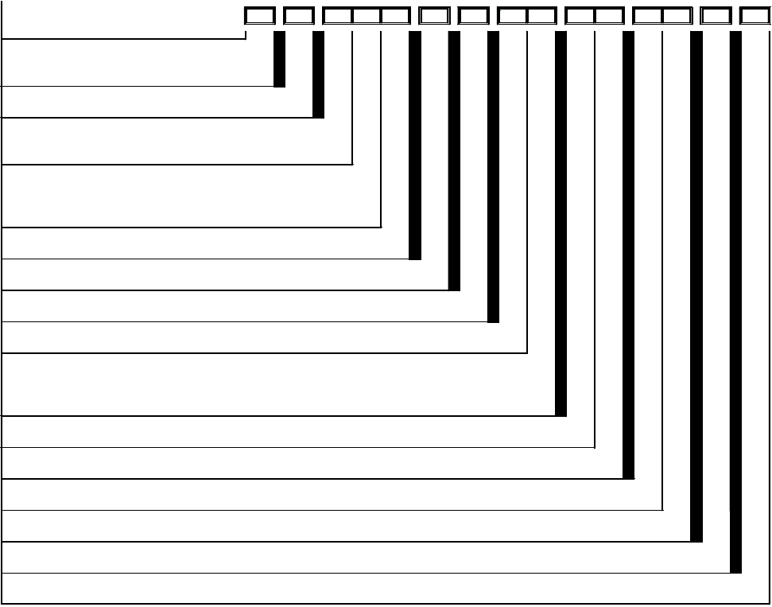
Dynasonics
U500w Ultrasonic Meters
PRODUCT TYPE
Stainless Steel Meter
METER TYPE
3/4 in. (3/4 x 7-1/2 in.)
WATER APPLICATION
Potable Water
Reclaimed Water (Stainless Steel Meter Only)
CONNECTIONS / GASKETS

UB

UB

-
-

EBA

EBA

-
-

P
R

X

-
-

E5

-
-

CA

-
-

1

-
-

A3

Y3

-
-

XX

TF

-
-

XX

-
-

B0A

NL Straight - Thick Washers (Stainless Steel Meter Only) None - Thick Washers
ACCESSORIES
None
REGISTRATION
Encoder
TECHNOLOGY
Meter with Cable (No Endpoint)
REGISTRATION FACE
Standard
SC
XT

X

E5

CA

1

UNIT OF MEASURE / DIAL RESOLUTION OUTPUT / VISUAL BILLING UNITS
9 Dial - 0.01 Gallon, GPM, 1000 9 Dial - 0.001 ft3, GPM, 100
9 Dial - 0.0001 M3, GPM, 10
TESTING
BADGER STD (TS-421)
SERIALIZATION
Year of Mfg | 9 Digit S/N | Barcoded | Primary and Lid Outside
APPLICATION (See Note)
None
WIRING METHOD (See Note) Twist Tight - 5 ft (MTR, ASSY)
ENDPOINT SHIPMENT MODE
N/A
RESERVED
Standard
9AE
9FD
9MC

A3

Y3

XX

TF

XX

B0A

Meter 3/4 x 9 inch

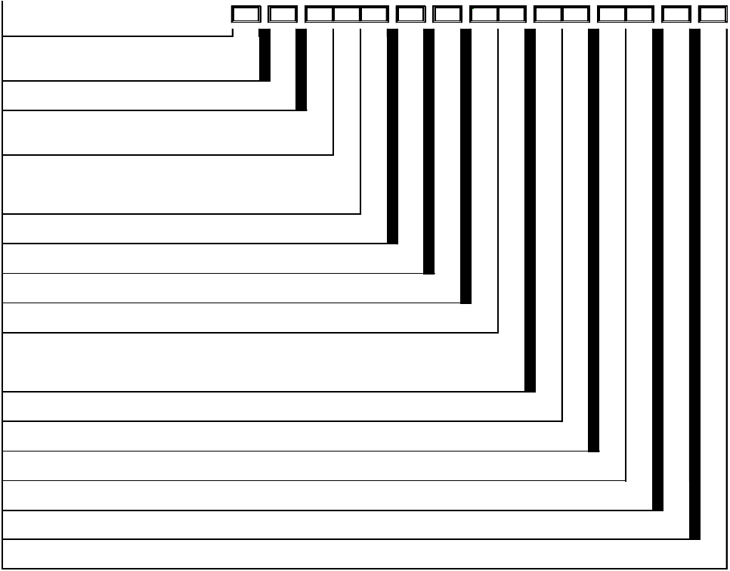
Dynasonics
U500w Ultrasonic Meters
PRODUCT TYPE
Stainless Steel Meter
METER TYPE
3/4 in. (3/4 x 9 in.)
WATER APPLICATION
Potable Water
Reclaimed Water (Stainless Steel Meter Only)
CONNECTIONS / GASKETS
UB

UB
-
-
EBB

EBB
-
-

P
R
X
-
-
E5
-
-
CA
-
-
1
-
-
A3
Y3
-
-
XX
TF
-
-
XX
-
-
B0A

NL Straight - Thick Washers (Stainless Steel Meter Only) None - Thick Washers
ACCESSORIES
None
REGISTRATION
Encoder
TECHNOLOGY
Meter with Cable (No Endpoint)
REGISTRATION FACE
Standard
SC
XT

X

E5

CA

1

UNIT OF MEASURE / DIAL RESOLUTION OUTPUT / VISUAL BILLING UNITS
9 Dial - 0.01 Gallon, GPM, 1000 9 Dial - 0.001 ft3, GPM, 100
9 Dial - 0.0001 M3, GPM, 10
TESTING
BADGER STD (TS-421)
SERIALIZATION
Year of Mfg | 9 Digit S/N | Barcoded | Primary and Lid Outside
APPLICATION (See Note)
None
WIRING METHOD (See Note) Twist Tight - 5 ft (MTR, ASSY)
ENDPOINT SHIPMENT MODE
N/A
RESERVED
Standard
9AE
9FD
9MC

A3

Y3

XX

TF

XX

B0A

NOTE: For connectivity to AquaCUE, contact your Sales Representative.

Meter 1 inch

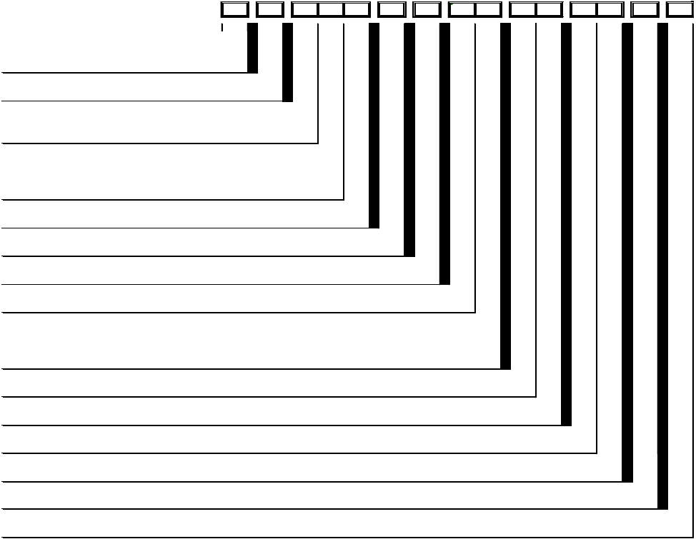
Dynasonics
U500w Ultrasonic Meters
PRODUCT TYPE
Stainless Steel Meter
METER TYPE
1 in. (1 x 10-3/4 in.)
WATER APPLICATION
Potable Water
Reclaimed Water (Stainless Steel Meter Only)
CONNECTIONS / GASKETS
UB

UB
-
-
ECA

ECA
-
-

P
R
X
-
-
E5
-
-
CA
-
-
1
-
-
A4
Y3
-
-
XX
TF
-
-
XX
-
-
B0A

NL Straight - Thick Washers (Stainless Steel Meter Only) None - Thick Washers
ACCESSORIES
None
REGISTRATION
Encoder
TECHNOLOGY
Meter with Cable (No Endpoint)
REGISTRATION FACE
Standard
SC
XT

X

E5

CA

1

UNIT OF MEASURE / DIAL RESOLUTION OUTPUT / VISUAL BILLING UNITS
9 Dial - 0.01 Gallon, GPM, 1000 9 Dial - 0.001 ft3, GPM, 100
9 Dial - 0.0001 M3, GPM, 10
TESTING
BADGER STD (TS-422)
SERIALIZATION
Year of Mfg | 9 Digit S/N | Barcoded | Primary and Lid Outside
APPLICATION (See Note)
None
WIRING METHOD (See Note) Twist Tight - 5 ft (MTR, ASSY)
ENDPOINT SHIPMENT MODE
N/A
RESERVED
Standard
9AE
9FD
9MC

A4

Y3

XX

TF

XX

B0A

NOTE: For connectivity to AquaCUE, contact your Sales Representative.

Control. Manage. Optimize.
Dynasonics is a registered trademark of Badger Meter, Inc. Other trademarks appearing in this document are the property of their respective entities. Due to continuous research, product improvements and enhancements, Badger Meter reserves the right to change product or system specifications without notice, except to the extent an outstanding
contractual obligation exists. © 2018 Badger Meter, Inc. All rights reserved. www.badgermeter.com
The Americas | Badger Meter | 4545 West Brown Deer Rd | PO Box 245036 | Milwaukee, WI 53224-9536 | 800-876-3837 | 414-355-0400
México | Badger Meter de las Americas, S.A. de C.V. | Pedro Luis Ogazón N°32 | Esq. Angelina N°24 | Colonia Guadalupe Inn | CP 01050 | México, DF | México | +52-55-5662-0882 Europe, Eastern Europe Branch Office (for Poland, Latvia, Lithuania, Estonia, Ukraine, Belarus) | Badger Meter Europe | ul. Korfantego 6 | 44-193 Knurów | Poland | +48-32-236-8787 Europe, Middle East and Africa | Badger Meter Europa GmbH | Nurtinger Str 76 | 72639 Neuffen | Germany | +49-7025-9208-0
Europe, Middle East Branch Office | Badger Meter Europe | PO Box 341442 | Dubai Silicon Oasis, Head Quarter Building, Wing C, Office #C209 | Dubai / UAE | +971-4-371 2503 Slovakia | Badger Meter Slovakia s.r.o. | Racianska 109/B | 831 02 Bratislava, Slovakia | +421-2-44 63 83 01
Asia Pacific | Badger Meter | 80 Marine Parade Rd | 21-06 Parkway Parade | Singapore 449269 | +65-63464836
Switzerland | Badger Meter Swiss AG | Mittelholzerstrasse 8 | 3006 Bern | Switzerland | +41-31-932 01 11

