

DIVISION OF ENERGY

MISSOURI ENERGY BULLETIN
Jul. 8, 2021
Note: As of Apr. 23, 2021, the Missouri Energy Bulletin Data Tool provides data previously published in the PDF version of the Missouri Energy Bulletin. The Missouri Department of Natural Resources’ Division of Energy will continue to report on prices for E-85 and B-20 twice per month, as well as on propane prices during the non-heating season (April – September).

Additional data are available from the following sources:
- Missouri Energy Bulletin Data Tool
- U.S. Energy Information Administration
- This Week in Petroleum
- Weekly Petroleum Status Report
- Gasoline and Diesel Fuel Update
- Short-Term Energy Outlook
- Natural Gas Weekly Update
- Weekly Natural Gas Storage Report
For information on how to access data previously provided through the Missouri Energy Bulletin, refer to our crosswalk file.
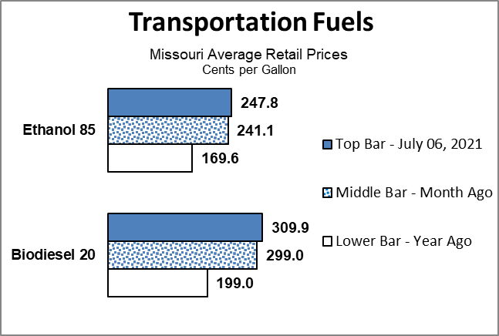
- On Jul. 6, Missouri’s average retail price for E-85 motor fuel, conventional motor fuel containing 51% to 83% ethanol, was approximately $2.48 per gallon.
- On Jul. 6, Missouri’s surveyed retail price for B-20, diesel fuel containing 6% to 20% biofuel, was approximately $3.10 per gallon.

• On Jul. 6, the
Propane - Retail Prices (cents per gallon)
07-06-21 |  | 06-01-21 | change | 07-06-20 | change
M i ssou r i | 184.5 | 178.4 | up 3% | 122.4 | up 51%
average Missouri retail
price for residential
propane was approximately $1.84 per gallon, up 6.1 cents, or 3 percent, in the past month.¹ Approximately 8.8 percent (211,908) of Missouri households use propane to heat their homes. (Data updated from the most recent five-year U.S. Census information.) Propane is also used to support commercial operations, produce goods, dry grain harvests and fuel vehicles.
For more information on propane, please visit: https://energy.mo.gov/resources/be-prepared-for-propane
To access previous issues of the Energy Bulletin, or to subscribe, please visit: https://energy.mo.gov/energy-bulletins
To learn more about Missouri energy issues, please visit: http://energy.mo.gov/energy
For more information about the Missouri State Energy Planning (MoSEP) process, please visit: https://energy.mo.gov/mo-state-energy-planning
The Missouri Energy Bulletin is distributed twice a month by the Missouri Department of Natural Resources’ Division of Energy. The Division of Energy collects E-85, B-20, and propane heating fuel prices from a sample of retail providers located throughout the state. The average price reported is based on these sample prices and may or may not reflect the actual price of a particular retail provider. To preserve confidentiality, price data are averaged if possible. The bulletin is a public resource made available to state government decision-makers and other interested individuals upon request and online at the division’s web address. The department thanks each of the following in helping to provide accurate, timely data on fuel supplies and prices: the U.S. Energy Information Administration; the National Association of State Energy Officials; and Missouri’s energy retailers. For more information, contact: MO Dept. of Natural Resources, Division of Energy, P.O. Box 176, Jefferson City, MO 65102; Phone: 573-751-2254; Fax: 573-751-6860; Email: energy@dnr.mo.gov; Web Address: https://energy.mo.gov/energy-bulletins.

¹ Note that the sample of propane distributors surveyed by the Missouri Division of Energy changed as a part of the division’s participation in the U.S. Energy Information Administration’s State Heating Oil and Propane Program. Prices provided here use simple averages.

