NEWS RELEASE
Ghent Workgroup launches Ghent PDF Output Suite 5.0 Conformance Certification worldwide
GHENT, BELGIUM – 23 November 2021 – The Ghent Workgroup (GWG) is offering a new service called Ghent PDF Output Suite 5.0 Conformance Certification. With this certificate print service providers can prove that their PDF output workflow is compliant with the PDF/X-4 standard (ISO 15930-7:2010).
The certification is based on the globally recognized Ghent PDF Output Suite which was developed to help testing PDF/X-4 compliancy of PDF output workflows. The Ghent PDF Output Suite 5.0 consists of several dozen patches each testing a specific aspect of the PDF/X-4 standard. The GWG has put together a great number of these patches into six merged test pages:

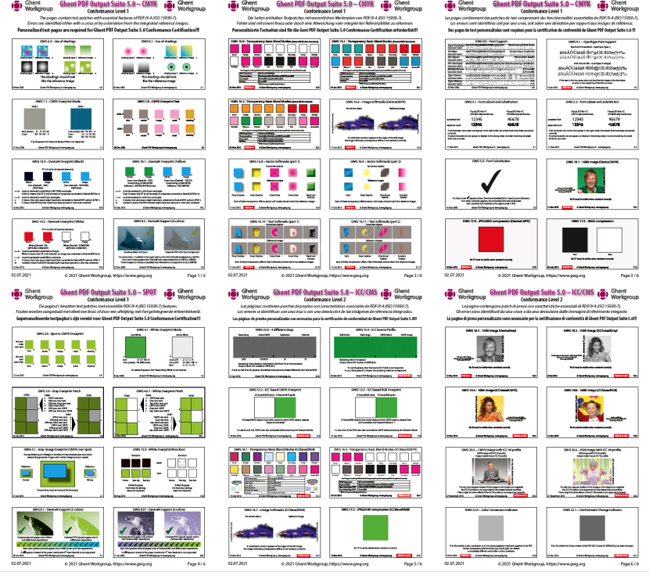

www.gwg.org



This test file is fully PDF/X-4 compliant and contains only valid PDF/X-4 features which represents what could be part of every regular PDF/X-4 print production file.
The pages of the Ghent PDF Output Suite 5.0 are grouped into two conformance levels:

- Conformance Level 1: pages 1–4 which includes CMYK and Spot color tests
- Conformance Level 1+2: pages 1–4 AND pages 5–6 which includes ICC based color tests

Conformance Level 2 involves color management and is therefore more demanding.

Certification

The GWG is offering two separate Conformance Certificates Levels:

- Ghent PDF Output Suite 5.0 Conformance Certification – Level 1
- Ghent PDF Output Suite 5.0 Conformance Certification – Level 1+2

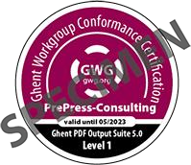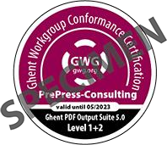

GWG has created the Ghent PDF Output Suite 5.0 Conformance Certification program in 2021. Participating GWG members can offer this program to their members, customers, community, etc. The certification program is for companies not individuals and targeted to end users (e.g., print and packaging service providers). Solution vendors, developers or system integrators who wish to participate in the Ghent PDF Output Suite 5.0 Compliancy program for their products should contact the GWG.

www.gwg.org

The certification is not directly offered by the Ghent Workgroup but by participating GWG members (associations, vendors, industry members, educational members). The GWG member manages the certification process. They also determine the cost of the certification for their candidates.
The following GWG members already expressed interest to offer this conformance certification:

- ArtOption (Germany)
- CAPT (China)
- CEC LATAM (Latin America)
- EFI (International)
- Four Pees (Europe)
- Future Schoolz (India)
- Government Institute of Printing Technology Mumbai (India)
- UiTM (Malaysia)
- University of Ljubljana (Slovenia)
- VIGC (Belgium)
In spring 2021 GWG successfully conducted a pilot project with the new GWG member CEC LATAM in Latin America. They have also included the certification in their latest PDF training program. We were able to award four Level 1 certificates and five Level 1+2 certificates: http://gwg.org/gos5/conformance-certificates/
“The Ghent PDF Output Suite 5.0 was created to check if the settings of a PDF output workflow are conform to the PDF/X-4 standard. The new Conformance Certification allows a print service provider to proof that this output workflow is able to process PDF/X-4 print files without any problems. This will help increase the reliability of PDF/X-4 workflows worldwide”, stated Stephan Jaeggi, CEO of PrePress-Consulting in Switzerland and Co-Chair of the GWG Process Control Subcommittee.

Additional information is available on https://www.gwg.org/gos5/conformance-certification.

www.gwg.org

About Ghent Workgroup
The Ghent Workgroup, formed in June 2002, is an international assembly of industry associations, suppliers, educators and industry members from around the globe. The Ghent Workgroup’s objective is to establish and disseminate process specifications for best practices in graphic arts workflows.

Since its inception almost 20 years ago, the organization has consistently produced numerous process specifications for PDF exchange, as well as developing useful tools for automating processes and testing and establishing consistent PDFs for print, publishing and packaging production – all available free atwww.gwg.org.
Members are comprised of graphic arts associations including CIP4 (Switzerland), KVGO (the Netherlands), Febelgra (Belgium), Fespa (UK), Medibel+ (Belgium), PDFX-ready (Switzerland), Printing United Alliance (USA), and VIGC (Belgium). Vendor members include Agfa, callas software, Canon, DALIM Software, EFI, Enfocus, Esko, Global Graphics, Heidelberg, HYBRID Software, Kodak, PageProof, Ricoh, Tech Research (TagG) and Ultimate Technographics. Industry members are ArtOption, Four Pees, Igepa Sagamgraphic, JP/Politikens Hus, Litografia Rosés, Prinovis, RRD and ybam. Educational members are Arteveldehogeschool Gent, CEC LATAM, Future Schoolz India, Government Institute of Printing Technology (GIPT), Media University Stuttgart, Ryerson University, the University of Ljubljana, the University of Novi Sad, Universiti Teknologi MARA (UiTM), The Regional Institute of Printing Technology Kolkata and the University of Wuppertal.

All products and services are trademarks or registered trademarks of their respective owners and are hereby acknowledged.

Press contacts:
Ghent Workgroup
Christian Blaise,
Carole Demeulemeester, marketing@gwg.org

www.gwg.org

