
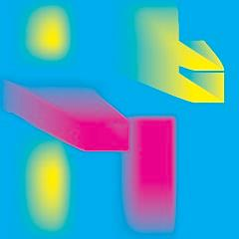

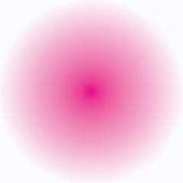
Ghent PDF Output Suite 5.0 – CMYK
GWG 6.0 - Use of shadings

shading type 7 reference image a shading type 2 reference image c

shading type 3 reference image b shading type 7 reference image d
The shadings should look like the reference image
03 Nov 2005 Ghent PDF Workgroup © www.gwg.org 6.0
GWG 6.1 - Use of shadings

shading type 3 reference image a shading type 2 reference image c

shading type 2 reference image b shading type 3 reference image d
The shadings should look like the reference image
03 Nov 2005 Ghent PDF Workgroup © www.gwg.org 6.1
Conformance Level 1
The pages contain test patches with essential features of PDF/X-4 (ISO 15930-7).
Errors are identified either with a cross or by a deviation from the integrated reference images.
Personalized test pages are required for Ghent PDF Output Suite 5.0 Conformance Certification!!!



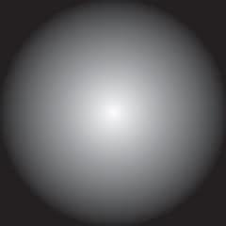

GWG 1.1 - CMYK Overprint Mode
d
e
image
shading
�







�
OPM 0
a
font
vector
image

GWG 1.0 - CMYK Overprint Test
OPM 0
OPM 1

vector
b
c
mask

Rect (overpr) 0 / 0 / 10 / 50 Cross (overpr) 90 / 10 / 90 / 0

Cross 90 / 10 / 90 / 0 Cross 0 / 0 / 10 / 50 Rect 90 / 10 / 10 / 50
f g h
mask
i j

If an X appears the Overprint Mode (OPM) is not respected.

27 Dec 2006 Ghent PDF Workgroup © www.gwg.org 1.1
font
shading
08 Dec 2005 Ghent PDF Workgroup© www.gwg.org 1.0







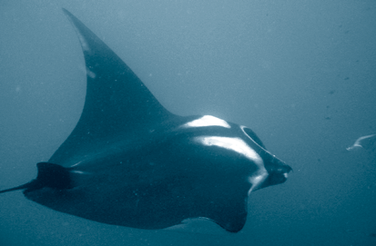



GWG 19.0 – DeviceN Overprint (Black)

OP is true for all topmost elements.

a b c d
Vector Image Vector Image
Cyan (DeviceN - 100C) Cyan (DeviceN - 100C0Y0K)
CMYK Black CMYK Black
a + b: must be rendered to solid Black (100C100K) rectangles
A faint X means, that OP is not honored (or image was converted to DeviceCMYK for b)
c + d: must be rendered to solid Cyan rectangles
c: X means, that color space might have been converted to DeviceCMYK upfront (OPM 1) d: X means, that 0% Channels might have been ignored or color was converted
12 Dec 2012 © Ghent Workgroup, www.gwg.org 19.0
GWG 19.1 – DeviceN Overprint (Yellow)

a b c d
Vector Image Vector Image
Cross: Cyan (DeviceN - 100C) Cross: Cyan (DeviceN - 100C0Y)
Overprinting: 0C0M100Y0K Overprinting: 0C0M100Y0K Reference: 100C0M100Y0K (Green) Reference: 100C0M0Y0K
a + b: must be rendered to solid Green rectangles
Cyan X means, that OP is not honored (or image was converted to DeviceCMYK for b)
c + d: must be rendered to solid Cyan rectangles
c: X means, that color space might have been converted to DeviceCMYK upfront (OPM 1) d: colored X means, that 0% Channels might have been ignored or color was converted
12 Dec 2012 © Ghent Workgroup, www.gwg.org 19.1
GWG 19.2 – DeviceN Overprint (White)

OP is true for all topmost elements.

a b c d
Vector Image Vector Image
White (DeviceN - 0K) White (DeviceN - 0C0M0Y0K) CMYK RED (100M100Y) CMYK RED (100M100Y)
a + b: must be rendered to solid Red rectangles
White X means, that OP is not honored (or image was converted to DeviceCMYK for b)
c + d: must be rendered to solid White rectangles
c: X means, that color space might have been converted to DeviceCMYK upfront (OPM 1) d: colored X means, that 0% Channels might have been ignored or color was converted
12 Dec 2012 © Ghent Workgroup, www.gwg.org 19.2
GWG 8.2 - DeviceN Support (4 colors)

Duotone (Black and Cyan) Grayscale TIFF with Cyan background
If a check mark is visible in the upper right corner then DeviceN is respected (= GOOD). If no check mark appears then DeviceN color was transformed to CMYK (= ERROR).
If the images are missing completely then DeviceN is not supported at all (= ERROR).
27 Dec 2006 Ghent PDF Workgroup © www.gwg.org 8.2
Ghent PDF Output Suite 5.0 – CMYK
Conformance Level 1
Die Seiten enthalten Testpatches mit wesentlichen Merkmalen von PDF/X-4 (ISO 15930-7).
Fehler sind mit einem Kreuz oder durch eine Abweichung vom integrierten Referenzbilder zu erkennen.
Personalisierte Testseiten sind für die Gent PDF Output Suite 5.0 Conformance Certification erforderlich!!!

GWG 16.0 - Transparency Basic Blend Modes (DeviceCMYK, Non-Knockout)

Darken Multiply Color Burn Lighten Screen Color dodge Overlay Soft Light

Hard Light Difference Exclusion Hue Saturation Color Luminosity Opacity (0%)
If an 'X' appears, rendering of Non-knockout Transparency Groups (a transparency effect) is not performed correctly.
PDF/X Output Intent ISO Coated v2 300% (ECI)
Transparency Group Non Knockout (Blend Mode Normal), TBCS*: DeviceCMYK Source object DeviceCMYK, using defined Blend Mode
Backdrop DeviceCMYK
* TBCS = Transparency Blending Color Space
05 Nov 2012 | PDF/X-4 | © Ghent Workgroup, www.gwg.org 16.0
GWG 16.1 - Transparency Basic Blend Modes (DeviceCMYK, Knockout)

Darken Multiply Color Burn Lighten Screen Color dodge Overlay Soft Light

Hard Light Difference Exclusion Hue Saturation Color Luminosity Opacity (0%)
If an 'X' appears, rendering of Knockout Transparency Groups (a transparency effect) is not performed correctly.
PDF/X Output Intent ISO Coated v2 300% (ECI)
Transparency Group Knockout (Blend Mode Normal), TBCS*: DeviceCMYK Source object DeviceCMYK, using defined Blend Mode
Backdrop DeviceCMYK
* TBCS = Transparency Blending Color Space
04 Jan 2013 | PDF/X-4 | © Ghent Workgroup, www.gwg.org 16.1

GWG 16.2 - Transparency Basic Blend Modes (DeviceCMYK, Isolated)

Darken Multiply Color Burn Lighten Screen Color dodge Overlay Soft Light

Hard Light Difference Exclusion Hue Saturation Color Luminosity Opacity (0%)
If an 'X' appears, rendering of Isolated Transparency Groups (a transparency effect) is not performed correctly.
PDF/X Output Intent ISO Coated v2 300% (ECI)
Transparency Group Isolated (Blend Mode Normal), TBCS*: DeviceCMYK Source object DeviceCMYK, using defined Blend Mode
Backdrop DeviceCMYK, using defined Blend Mode
* TBCS = Transparency Blending Color Space
05 Nov 2012 | PDF/X-4 | © Ghent Workgroup, www.gwg.org 16.2
GWG 16.6 – Image Softmasks (DeviceCMYK)
Actual test object Reference Image

If a solid black contour appears at the edges of the left image,
the Image Softmask (a transparency effect) is not rendered correctly.
11 Oct 2012 | PDF/X-4 | © Ghent Workgroup, www.gwg.org 16.6

GWG 16.8 – Vector Softmasks (part 1)
Actual test objects

Reference Images

Drop Shadow Inner Shadow Outer Glow Inner Glow Bevel and Emboss
Each of these transparency effects (vector soft masks) should match the reference images.
11 Oct 2012 | PDF/X-4 | © Ghent Workgroup, www.gwg.org 16.8
GWG 16.9 – Vector Softmasks (part 2)
Actual test objects

Reference Images

Satin Basic Feather Directional Gradient
Feather Feather
Each of these transparency effects (vector soft masks) should match the reference images.
11 Oct 2012 | PDF/X-4 | © Ghent Workgroup, www.gwg.org 16.9

GWG 16.10 – Text Softmasks (part 1)
Actual test objects
A C
Reference Images

Drop Shadow Inner Shadow Outer Glow Inner Glow Bevel and Emboss
Each of these transparency effects (Text Softmasks) should match the reference images.
11 Oct 2012 | PDF/X-4 | © Ghent Workgroup, www.gwg.org 16.10
GWG 16.11 – Text Softmasks (part 2)
Actual test objects

Reference Images

Satin Basic Feather Directional Gradient
Feather Feather
Each of these transparency effects (Text Softmasks) should match the reference images.
11 Oct 2012 | PDF/X-4 | © Ghent Workgroup, www.gwg.org 16.11







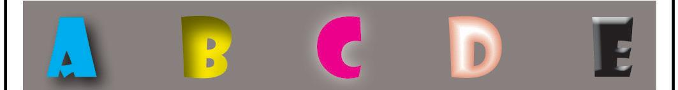


















http://www.vigc.org/vigc50-xcs/
http://www.vigc.org/vigc50-xcs/
Ghent PDF Output Suite 5.0 – CMYK
Conformance Level 1
Les pages contiennent des patches de test comprenant des fonctionnalités essentielles de PDF/X-4 (ISO 15930-7). Les erreurs sont identifiées soit par une croix, soit selon une déviation par rapport aux images de référence.
Des pages de test personnalisées sont requises pour la certification de conformité de Ghent PDF Output Suite 5.0 !!!

GWG 9.0 - Font Support
Type1 PostScript: äöüÄÖÜáâàﬁﬂ©®@ÐŒÆØæƒÿ‡‰þ½ð Expected result: |  | (NewCenturySchlbk Italic)
TrueType:  Expected result: | äöüÄÖÜáâàﬁﬂ©®@ÐŒÆØæƒÿ‡‰þ½ð | (BookAntiqua-BoldItalic)
CID (Type1):  Expected result: | äöüÄÖÜáâàﬁﬂ©®@ÐŒÆØæƒÿ‡‰þ½ð | (WarnockPro-BoldIt)
CID (TrueType):  Expected result: | äöüÄÖÜáâàﬁﬂ©®@ÐŒÆØæƒÿ‡‰þ½ð (PalatinoLinotype BoldItalic)
Multiple Master::  Expected result: | dit is een multiple master ex ponto mm dit is een multiple master ex ponto mm (ExPontoMM)  (ExPontoMM)
Type 3 Vector:  Expected result: | äöüÄÖÜáâàfifl©®@ŒÆØæƒÿ‡‰$£çABCD…XYZ (T1 / Garamond Bold)
Type 3 Bitmap:  Expected result: | QXOO IlOOW HLQ QHJDWLYHU =DKOXQJVVWURP DQ ,Q GHQ -DKUHQ HLQV ELV I QI (T10)  (T10)
03 Nov 2005 | Ghent PDF Workgroup © www.gwg.org | 9.0
GWG 9.1 – OpenType Font Support
Warnock Pro Semibold – OpenType (Type 1) äöüÄÖÜáâàfi fl©®@OEÆØæƒÿ‡‰

Arial Unicode MS – OpenType (TrueType)
äöüÄÖÜáâàfi fl©®@OEÆØæƒÿ‡‰

If the text in the line above does not look like the image in the line below an error in the rendering of the font occured.
14 jan 2012 | PDF/X-4 | © Ghent Workgroup, www.gwg.org 9.1

GWG 5.1 - Font subset and substitution

Placed EPS-ﬁle n°1 Placed EPS-ﬁle n°2 (VVLNKX+Myriad-Roman) (VVLNKX+Myriad-Roman)
subsetted font 12345 45678
expected result
- If all characters are correct and appear in the right order, the subset fonts have been processed correctly.
- If some characters do not appear or display in the wrong order, incorrect handling of subset fonts has occurred.

11 Nov 2012 Ghent PDF Workgroup © www.gwg.org 5.1
GWG 5.2 - Font subset and substitution

Placed EPS-ﬁle n°1 Placed EPS-ﬁle n°2 (FEPTUI+Myriad-Roman) (PGNBEO+Myriad-Roman)
subsetted font 12345 45678
expected result
- If all characters are correct and appear in the right order, the subset fonts have been processed correctly.
- If some characters do not appear or display in the wrong order, incorrect handling of subset fonts has occurred.

11 Nov 2012 Ghent PDF Workgroup © www.gwg.org 5.2

GWG 5.0 - Font Substitution
⊗
If a check mark appears above, then the embedded font is used (correct behavior).
If an other character appears, the embedded font was substituted
with a Symbol font installed in the system (host or RIP).
16 Nov 2005 Ghent PDF Workgroup © www.gwg.org 5.0
GWG 18.1 - 16Bit Image (DeviceCMYK)

Colorspace: DeviceCMYK Reference image (cross): 8Bit, ZIP Test image: 16 Bit, ZIP

No X must be visible when rendered correctly.
12 Nov 2015 | PDF/X-4 | © Ghent Workgroup, www.gwg.org 18.1


GWG 17.0 - JPEG2000 compression (DeviceCMYK)
GWG 17.3 - JBIG2 compression

Black White
No “X” must be visible when rendered correctly.
03 July 2012 | PDF/X-4 | © Ghent Workgroup, www.gwg.org 17.3



No “X” must be visible when rendered correctly.

19 Mar 2012 PDF/X-4 © Ghent Workgroup, www.gwg.org 17.0



© bvdm, www.roman16.com







Ghent PDF Output Suite 5.0 – SPOT

GWG 2.0 - Spot to CMYK Overprint

this row:
cmyk
over spot
a b c d e
font vector image mask shading
this row:
spot
over cmyk
f g h i j
font vector image mask shading

15 Jun 2015 Ghent PDF Workgroup© www.gwg.org 2.0
Conformance Level 1
De pagina’s bevatten test patches met essentiële PDF/X-4 (ISO 15930-7) features.
Fouten worden aangeduid met ofwel een kruis of door een afwijking met het geïntegreerde referentiebeeld.
Gepersonaliseerde testpagina's zijn vereist voor Ghent PDF Output Suite 5.0 Conformance Certification!!!

GWG 4.1 - White Overprint Mode

Spot White almost White

a
Rect

75 / 5/ 100 / 0
b
Cross (OP) .2 / .2 / .2 / 0

Cross (overpr) 0% GWG Green Cross (OP) 15 /100 / 100 / 0
Rect .2 / .2 / .2 / 10

If a visible X appears, the “Overprinting White” is not handled.

8 Apr 2008 Ghent PDF Workgroup © www.gwg.org 4.1

OPM0
GWG 3.0 - Gray Overprint Patch
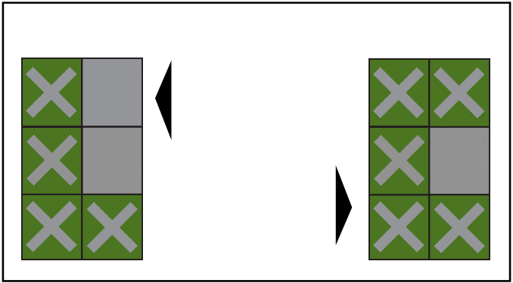
OPM0
a 50% K over spot
b 50% gray over spot
c 50% sep. black over spot d 50% K over CMYK

OPM1

OPM0
GWG 4.0.1 - White Overprint Patch
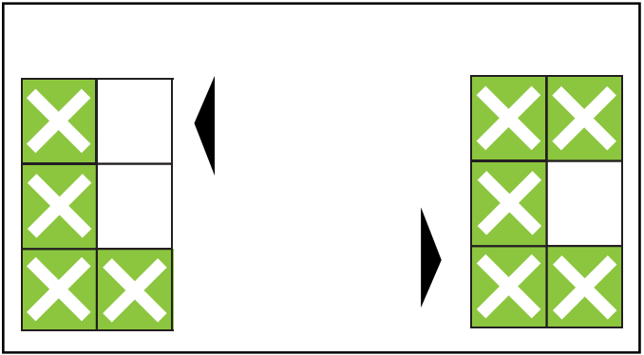
OPM0
a CMYK over spot
b Gray over spot
c Sep. black over spot d CMYK over CMYK

OPM1

a

b

c
02 Jan 2013
d

e

f
e 50% gray over CMYK
f 50% sep. black over CMYK
OPM1
50% K over spot g
50% gray over spot h
50% sep. black over spot I 50% K over CMYK j
50% gray over CMYK k
50% sep. black over CMYK l
Ghent Workgroup © www.gwg.org
g

h

i
j

k

l
3.0
a

b

c
10 Nov 2006
d

e

f
e Gray over CMYK
f Sep. black over CMYK
OPM1
CMYK over spot g
Gray over spot h
Sep. black over spot I CMYK over CMYK j Gray over CMYK k
sep. black over CMYK l
Ghent PDF Workgroup © www.gwg.org
g

h

i
j

k

l
4. 0.1

x
Overprint
Knockout
xxxxxxxxxxxxxxxxxx
CMYK
x
xxxx xxxx
x





Correct

Overprinting must be honored for the output.
Reference

Wrong

xxxx xxxx
xxxxxxxxxxxxxxxxxx
Vector Text big Text 6pt
If filled X appear
the Overprint settings were not respected.
Spot

xxxx xxxx
xxxxxxxxxxxxxxxxxx
Vector Text big Text 6pt
If filled X appear
the Knockout settings were not respected.

21 Jan 2013 Ghent Workgroup © www.gwg.org 3.1
GWG 3.1 - Gray Image Overprint (CMYK over Spot)
During flattening (in InDesign or Acrobat) of drop shadows over spot colors overprinting grayscale images with a white background are created.
GWG 12.0 - White Overprint/Knockout
xxxxxxxxxxxxxxxxxx
Reference
x
xxxx xxxx
29 Aug 2013 Ghent Workgroup © www.gwg.org 12.0



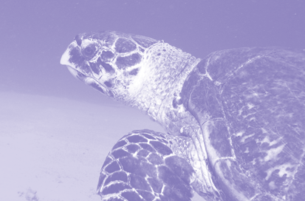
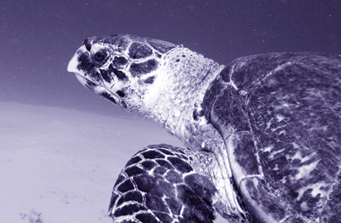
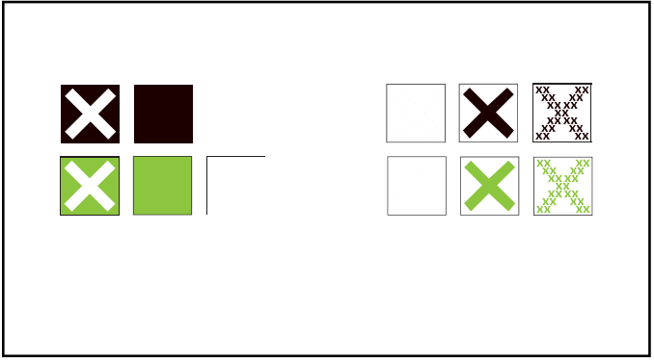
GWG 8.1 - DeviceN Support (5 colors)

Duotone (should appear only in Black Colorized TIFF (should appear only in
and GWG Green separations) GWG Green separation)

Spot color gradient (should appear only in GWG Green and Cyan separations)
If a appears instead of the green checkmarks then DeviceN is not supported!
20 Jan 2013 Ghent PDF Workgroup © www.gwg.org 8.1
GWG 8.01 - DeviceN Support (6 colors)

Duotone (should appear only in Black Colorized TIFF (should appear only in
and Pantone 265C separations) Pantone 265C separation)

Spot color gradient (should appear only in Pantone 265C and GWG Green separations)
If a appears instead of the green checkmarks then DeviceN is not supported!
11 Jan 2007 Ghent PDF Workgroup © www.gwg.org 8.01
Ghent PDF Output Suite 5.0 – ICC/CMS
GWG 13.0 - ICC Source Profile
RGB Vector RGB Image CMYK Vector CMYK Image

a b c d
Rendering Intent: Perceptual
Output Intent: ISO Coated v2 300% (ECI)
If a red X appears, then the Source ICC Profile is not respected.
In cas a faint green X is shown, the rendering intent is not respected.
03 Mai 2016 Ghent PDF Workgroup © www.gwg.org | PDF/X-4-ICC | 13.0
Conformance Level 2
Las páginas contienen parches de prueba con características esenciales de PDF/X-4 (ISO 15930-7). Los errores se identifican con una cruz o con una desviación de las imágenes de referencia integradas.
Las páginas de prueba personalizadas son necesarias para la certificación de conformidad de Ghent PDF Output Suite 5.0!!!







GWG 23.0 - 4 different Grays

DeviceGray DeviceCMYK Separation DeviceN

25%
a

0/0/0/75
b

75
c

75
d

Rendering Intent: Relative Colorimetric with Black Point Compensation Output Intent: ISO Coated v2 300% (ECI)
If an X (or half of an X) appears, the defined color space is treated differently than DeviceCMYK

12 Apr 2016 Ghent PDF Workgroup © www.gwg.org 23.0

GWG 13.2 - ICC based CMYK Overprint
ICCbasedCMYK white ICCbasedCMYK green

ICCbasedCMYK objects must never overprint other CMYK objects, despite Overprint is enabled

In case of an X, the CMYK color was converted while preserving the Overprint Mode
02 Mai 2016 Ghent PDF Workgroup © www.gwg.org | PDF/X-4-ICC | 13.2
GWG 13.3 - ICC based RGB Overprint
ICCbasedRGB white ICCbasedRGB green

ICCbasedRGB objects must never overprint other CMYK objects, despite Over-
print is enabled and Overprint Mode is 1

In case of an X, the RGB color was converted to CMYK while preserving the Overprint Mode
27 Apr 2016 Ghent PDF Workgroup © www.gwg.org | PDF/X-4-ICC | 13.3

GWG 16.4 - Transparency Basic Blend Modes (ICCBasedCMYK)
GWG 16.1 - Transparency Basic Blend Modes (ICCbasedRGB)

Darken Multiply Color Burn Lighten Screen Color Dodge Overlay Soft Light

Hard Light Difference Exclusion Hue Saturation Color Luminosity Opacity (0%)
PDF/X output intent ISO coated v2 300% (ECI)
A cleary visible X
A faint X is due to Page group blending color space DeviceCMYK indicates that this blend
differences in the CMM mode is not supported
and does not indicate Upper object ICCbasedRGB (sRGB) properly which is
a failure. Lower object ICCbasedRGB (sRGB) a failure.
Rendering intent Saturation
All group color spaces DeviceCMYK
EXAMPLE All groups Non isolated, non knockout EXAMPLE
14 July 2016 © Ghent Workgroup, www.gwg.org | PDF/X-4-ICC | 16.1

Darken Multiply Color Burn Lighten Screen Color dodge Overlay Soft Light

Hard Light Difference Exclusion Hue Saturation Color Luminosity Opacity (0%)

If an 'X' appears, rendering of Non-knockout Transparency Groups (a transparency effect) is not performed correctly.
PDF/X Output Intent | ISO Coated v2 300% (ECI)
Page Level TBCS* | Non Knockout (Blend Mode Normal), TBCS*: DeviceCMYK
Upper (object): Type, TBCS* | ICCBased CMYK (FOGRA39), using defined Blend Mode
Lower (object): Type, TBCS* | DeviceCMYK

* TBCS = Transparency Blending Color Space



15 Oct 2015 © Ghent Workgroup, www.gwg.org PDF/X-4-ICC 16.4

GWG 16.7 – Image Softmasks (ICCBasedRGB)
Actual test object Reference Image

If a solid black contour appears at the edges of the left image,
the Image Softmask (a transparency effect) is not rendered correctly.
19 Mar 2012 © Ghent Workgroup, www.gwg.org | PDF/X-4-ICC | 16.7
GWG 17.2 - JPEG2000 compression (ICCBasedRGB)

No “X” must be visible when rendered correctly.
11 Nov 2015 © Ghent Workgroup, www.gwg.org | PDF/X-4-ICC | 17.2

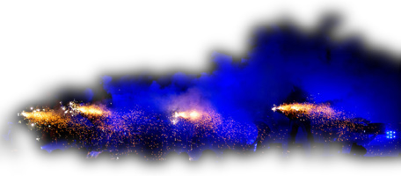
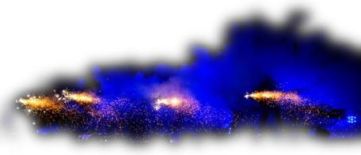

http://www.vigc.org/vigc50-xcs/
http://www.vigc.org/vigc50-xcs/




Ghent PDF Output Suite 5.0 – ICC/CMS
© bvdm, www.roman16.com
© bvdm, www.roman16.com
Conformance Level 2
Le pagine contengono patch di prova con caratteristiche essenziali di PDF/X-4 (ISO 15930-7).
Gli errori sono identificati da una croce o da una deviazione dalle immagini di riferimento integrate.
Le pagine di prova personalizzate sono necessarie per la certificazione di conformità di Ghent PDF Output Suite 5.0!!!

GWG 18.3 - 16Bit Image (DeviceGray)

Colorspace: DeviceGray Reference image (cross): 8Bit, ZIP Test image: 16 Bit, ZIP

No X must be visible when rendered correctly.
12 Nov 2015 | PDF/X-4 | © Ghent Workgroup, www.gwg.org 18.3
GWG 18.2 - 16Bit Image (ICCbasedGray)

Profile: Schwarze Druckfarbe - ISO Coated v2 (ECI) Reference image (cross): 8Bit, ZIP
Test image: 16 Bit, ZIP

No X must be visible when rendered correctly.
8 Feb 2016 © Ghent Workgroup, www.gwg.org | PDF/X-4-ICC | 18.2

GWG 18.4 - 16Bit Image (ICCbasedCMYK)

Profile: ISO Coated V2 (ECI) Reference image (cross): 8Bit, ZIP Test image: 16 Bit, ZIP

No X must be visible when rendered correctly.
12 Nov 2015 © Ghent Workgroup, www.gwg.org | PDF/X-4-ICC | 18.4
GWG 18.0 - 16Bit Image (ICCbasedRGB)

Profile: eciRGB v2
Reference image (cross): 8Bit, ZIP Test image: 16 Bit, ZIP

No X must be visible when rendered correctly.
12 Nov 2015 © Ghent Workgroup, www.gwg.org | PDF/X-4-ICC | 18.0

GWG 20.5 – CMYK Image with ICC V4 profile
CMYK image with ICC V4 profile
Output intent has an ICC V2 profile

If a red cross appears instead of the image or the image turns negative
the ICC V4 profile is not supported by this viewer/output workflow.
There might be other effects if the ICC V4 profile is not supported properly.
27 November 2015 © Ghent Workgroup, www.gwg.org | PDF/X-4-ICC | 20.5
GWG 20.6 – RGB Image with ICC V4 profile
RGB image with ICC V4 profile
Output intent has an ICC V2 profile

If a red cross appears instead of the image or the image turns negative
the ICC V4 profile is not supported by this viewer/output workflow.
There might be other effects if the ICC V4 profile is not supported properly.
27 November 2015 © Ghent Workgroup, www.gwg.org | PDF/X-4-ICC | 20.6

GWG 22.0 – Color Conversion Indicator

If an X is visible a color conversion or an ink saving operation have been applied to the PDF. Certain transparency blend modes (e.g. Hard Light) can deliver
a completely different result after a color conversion.
14 Oct 2015 | PDF/X-4 | © Ghent Workgroup, www.gwg.org 22.0
GWG 22.1 – OutPutIntent Change Indicator

If an X is visible the Output Intent of the PDF (ISO Coated v2 300% (ECI)) has been changed.
23 Dec 2016 © Ghent Workgroup, www.gwg.org | PDF/X-4-ICC | 22.1






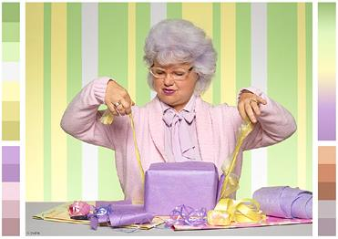
© bvdm, www.roman16.com
© bvdm, www.roman16.com
© bvdm, www.roman16.com
© bvdm, www.roman16.com

