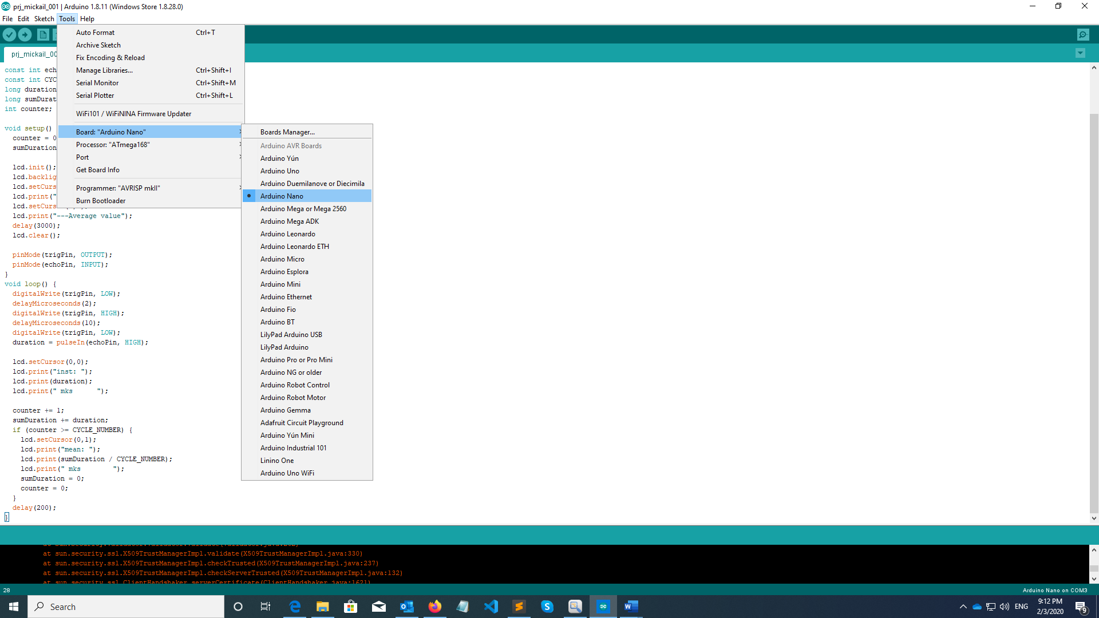

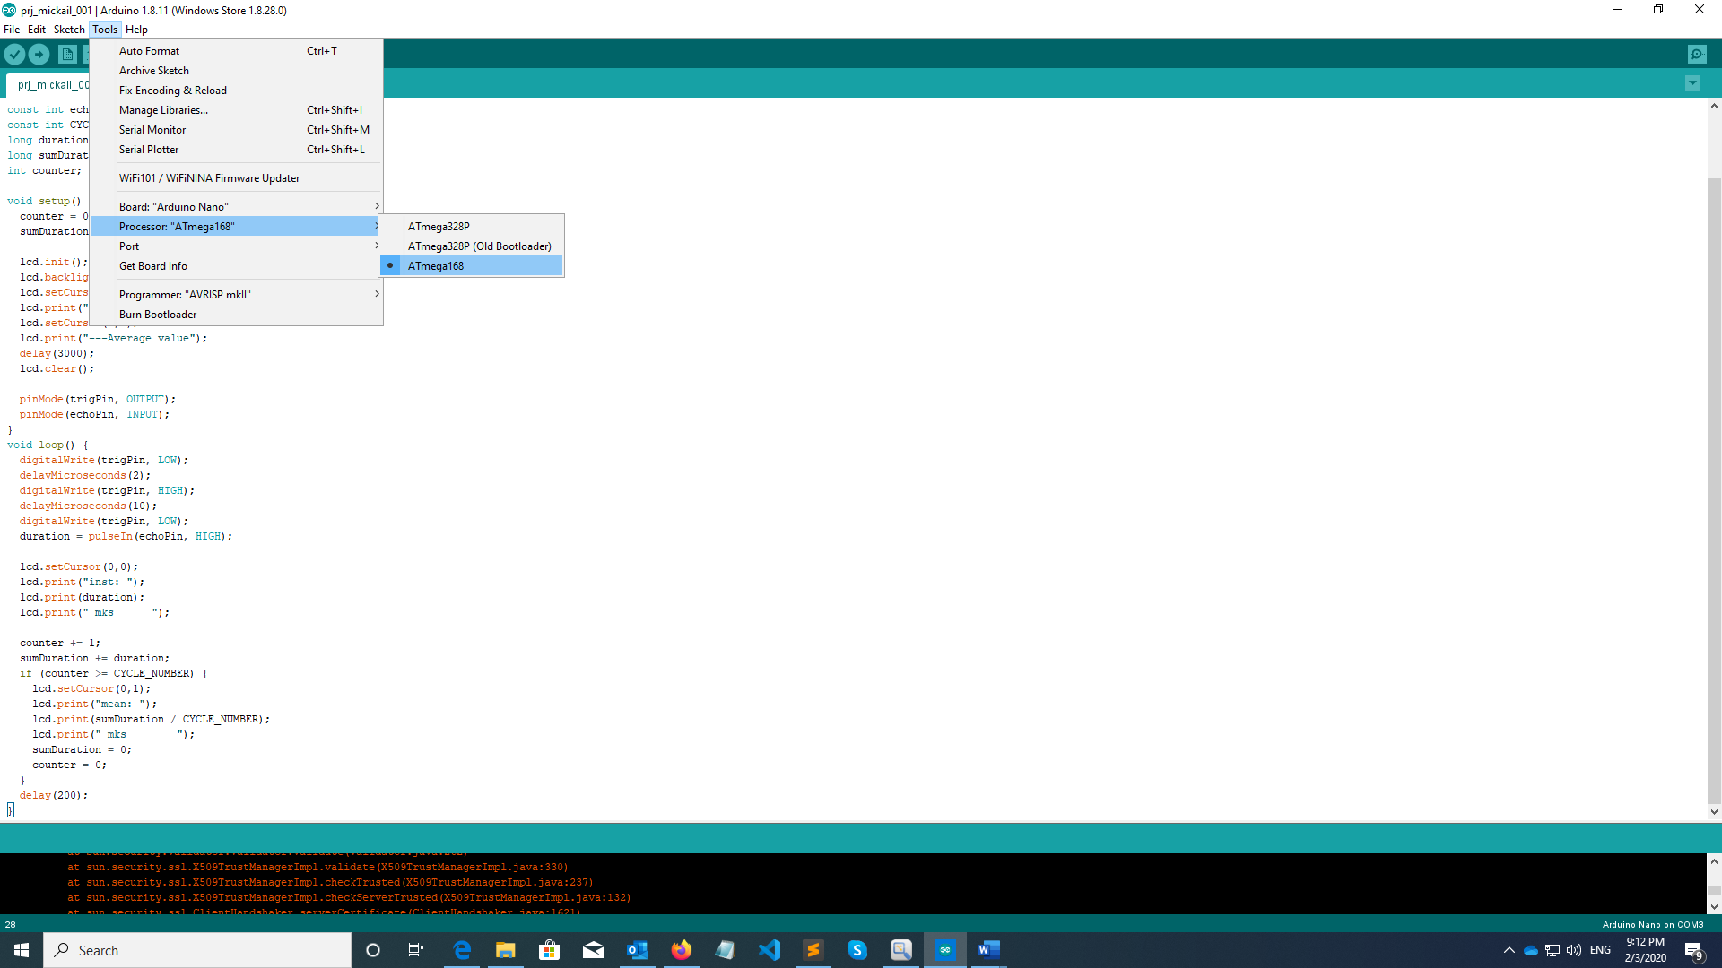

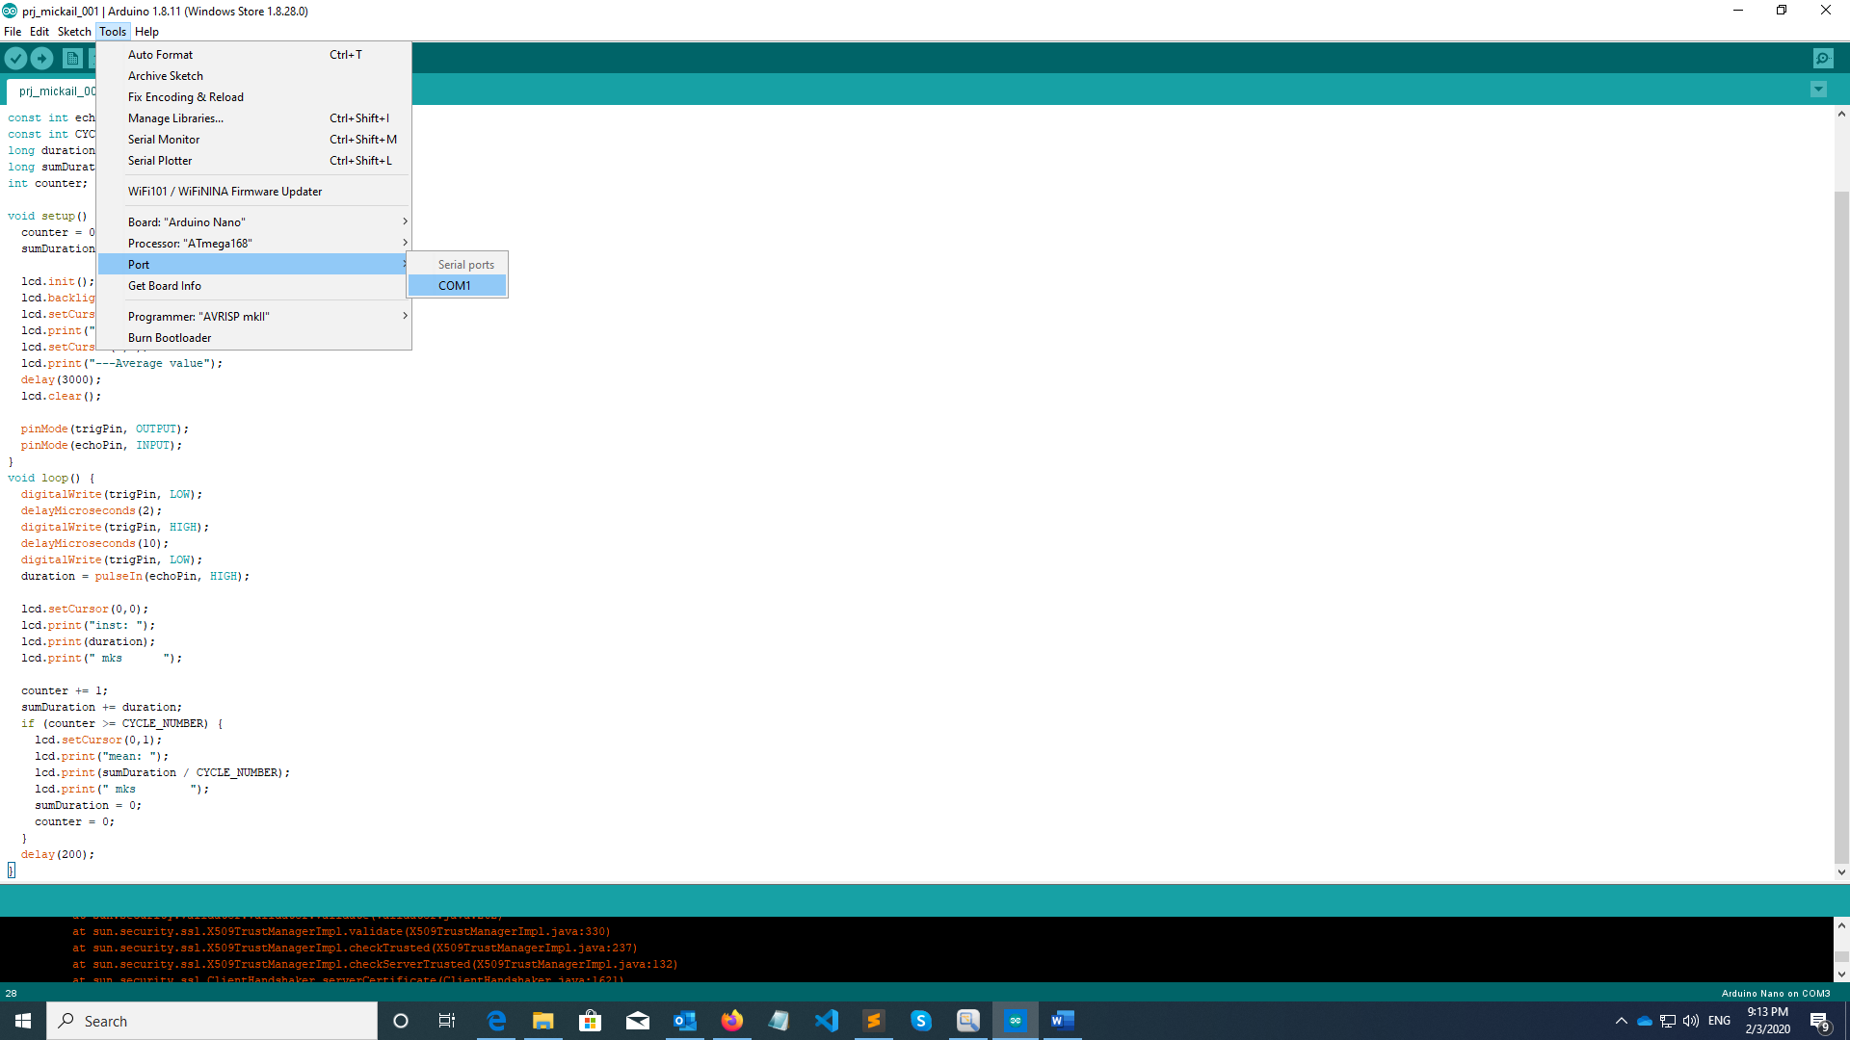

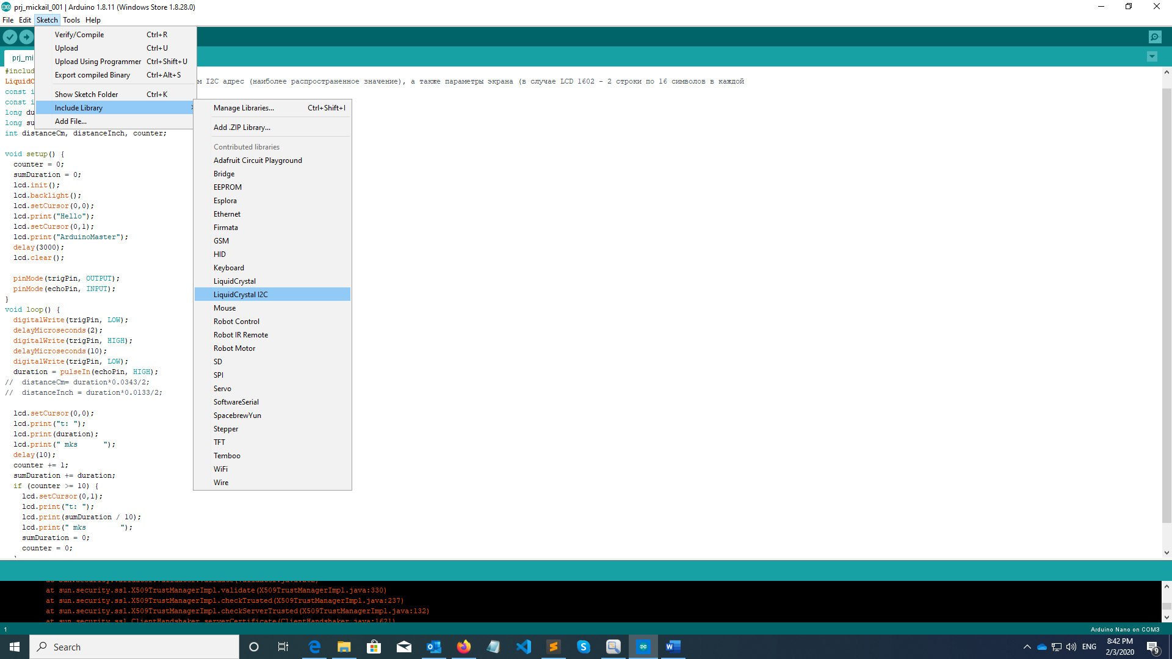

#include <Wire.h>

#include <LiquidCrystal_I2C.h>

LiquidCrystal_I2C lcd(0x3f,16,2); // Указываем I2C адрес = 0x3f,

// параметры экрана - 2 строки по 16 символов в каждой

const int trigPin = 9;

const int echoPin = 8;

const int CYCLE_NUMBER = 10;

long duration;

long sumDuration;

int counter;

**void setup()** {

counter = 0;

sumDuration = 0;

lcd.init();

lcd.backlight();

lcd.setCursor(0,0);

lcd.print("---Instant value");

lcd.setCursor(0,1);

lcd.print("Average value");

delay(3000);

lcd.clear();

pinMode(trigPin, OUTPUT);

pinMode(echoPin, INPUT);

}

**void loop()** {

digitalWrite(trigPin, LOW);

delayMicroseconds(2);

digitalWrite(trigPin, HIGH);

delayMicroseconds(10);

digitalWrite(trigPin, LOW);

duration = pulseIn(echoPin, HIGH);

lcd.setCursor(0,0);

lcd.print("inst: ");

lcd.print(duration);

lcd.print(" mks ");

counter += 1;

sumDuration += duration;

if (counter >= CYCLE_NUMBER) {

lcd.setCursor(0,1);

lcd.print("mean: ");

lcd.print(sumDuration / CYCLE_NUMBER);

lcd.print(" mks ");

sumDuration = 0;

counter = 0;

}

delay(200);

}