# ASP.NET Test Task Part3

To get an impression about your knowledge in asp.net basics as:

1. Creating and utilization of User Controls
2. Parsing XML
3. Working with standard asp.net web controls
4. Creating and utilization of Web Services.
5. Connecting and working with databases

we offer you to create an application which consists of one *Web Form* with *user web control* on it and *web service*.

*User web control* should look like as on *Pic. 1* (or similar). Use standard asp.net web controls inside it to achieve this. Grid should be sortable and editable(column “Salary”). Maximum rows per page should be less than number of Employees per Job at least in some cases to demonstrate your ability to use paginal output of data.

**Pic. 1**

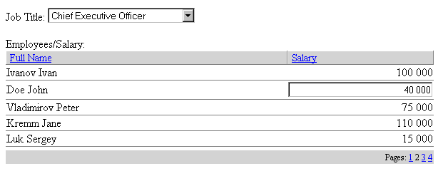

*User control* should contain one additional property: xmlConfigFile – to get name of configuration xml file (*user control* in question should be configured with this xml file and not with some other properties).

This xml file should contain all necessary information for configuring *user web control*:

1. datasource: local database or web service.
2. web service url if datasource is web service
3. number of rows per page in grid
4. is second grid column editable or not

Database should contain two tables:

Jobs:

Job_id int (primary key),

Job_nm string

Employees:

Emp_id int (primary key),

Job_id int (fkey, reference to Jobs.Job_id as many-to-one)

First_name string,

Last_name string,

Salary double

Select box should get data from the table Jobs. Depending on selected job, employees list should be built from the table Employees with the ability to sort by any of two columns and the ability to edit salary column (but this ability should be allowed or prohibited in configuration file mentioned before)

Depending on configuration settings you should get/update data from local database (connected via ado.net for example) or web service which provides the same data. Use your own configuration xml file or Web.cofig to keep and get connection string to connect database.

Please use StyleCop or ReSharper as coding standards. Please use any additional tools and libraries you familiar with. Logging, IoC, profiling tools optional but with be a plus.