**Міністерство освіти і науки України**

**Національний технічний університет**

**«Дніпровська політехніка»**



**ЗВІТ**

**Практична робота №4**

**з дисципліни**

# «Програмування в середовищі Java»

**Виконав:**

студент гр. 122-21-3

Кабаченко О. В.

**Прийняв:**

Доцент каф. САУ

Алексєєв О. М.

**м. Дніпро**

**2025  рік**

**Хід роботи**

1) Для початку в існуючому проекті було створено новий пакет «lab4», до якого додано пакети– «modelс, «view», «controller», а також файл «Run». На рисунку 1 наведено результат роботи.

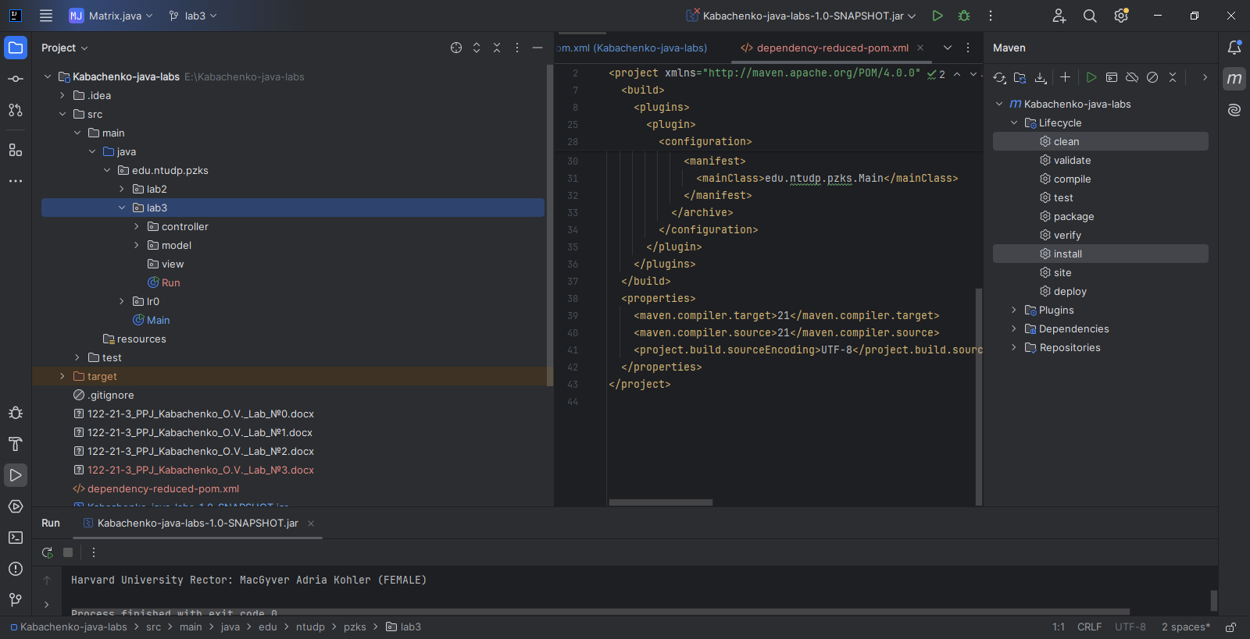

Рисунок 1 – Базова структура нового пакету

2) Далі в пакеті моделей було створено 9 файлів – «Sex», «CreatureInterface», «Department», «Faculty», «Group», «Human», «OrganizationalUnit», «Student» та «University». «OrganizationalUnit» являє собою абстрактний клас, від якого унаслідуються «Department», «Faculty», «Group» та «University». «CreatureInterface» являє собою інтерфейс, який реалізує клас «Human». Від «Human» унаслідуються клас «Student». Нижче наведено програмний код усіх файлів.

Програмний код класу Sex:

package edu.ntudp.pzks.lab4.model;  
  
public enum Sex {  
 *MALE*, *FEMALE*}

Програмний код класу CreatureInterface:

package edu.ntudp.pzks.lab4.model;  
  
public interface CreatureInterface {  
 public Sex getGender();  
 public void setGender(Sex gender);  
}

Програмний код класу Department:

package edu.ntudp.pzks.lab4.model;  
  
import java.util.ArrayList;  
import java.util.List;  
import java.util.Objects;  
  
public class Department extends OrganizationalUnit {  
 private List<Group> groups = new ArrayList<>();  
  
 public Department(String name, Human head) {  
 super(name, head);  
 }  
  
 public Department(String name, Human head, List<Group> groups) {  
 super(name, head);  
 this.groups = groups;  
 }  
  
 public void addGroup(Group group) {  
 groups.add(group);  
 }  
  
 public List<Group> getGroups() {  
 return groups;  
 }  
  
 public void setGroups(List<Group> groups) {  
 this.groups = groups;  
 }  
  
 @Override  
 public String toString() {  
 return name +" Head of department: " + head;  
 }  
  
 @Override  
 public boolean equals(Object o) {  
 if (o == null || getClass() != o.getClass()) return false;  
 if (!super.equals(o)) return false;  
 Department that = (Department) o;  
 return Objects.*equals*(groups, that.groups);  
 }  
  
 @Override  
 public int hashCode() {  
 return Objects.*hash*(name, head, groups);  
 }  
}

Програмний код класу Faculty:

package edu.ntudp.pzks.lab4.model;  
  
import java.util.ArrayList;  
import java.util.List;  
import java.util.Objects;  
  
public class Faculty extends OrganizationalUnit {  
 private List<Department> departments = new ArrayList<>();  
  
 public Faculty(String name, Human head) {  
 super(name, head);  
 }  
  
 public Faculty(String name, Human head, List<Department> departments) {  
 super(name, head);  
 this.departments = departments;  
 }  
  
 public void addDepartment(Department department) {  
 departments.add(department);  
 }  
  
 public List<Department> getDepartments() {  
 return departments;  
 }  
  
 public void setDepartments(List<Department> departments) {  
 this.departments = departments;  
 }  
  
 @Override  
 public String toString() {  
 return name +" Dean: " + head;  
 }  
  
 @Override  
 public boolean equals(Object o) {  
 if (o == null || getClass() != o.getClass()) return false;  
 if (!super.equals(o)) return false;  
 Faculty that = (Faculty) o;  
 return Objects.*equals*(departments, that.departments);  
 }  
  
 @Override  
 public int hashCode() {  
 return Objects.*hash*(name, head, departments);  
 }  
}

Програмний код класу Group:

package edu.ntudp.pzks.lab4.model;  
  
import java.util.ArrayList;  
import java.util.List;  
import java.util.Objects;  
  
public class Group extends OrganizationalUnit {  
 private List<Student> students = new ArrayList<>();  
  
 public Group(String name, Human head) {  
 super(name, head);  
 }  
  
 public Group(String name, Human head, List<Student> students) {  
 super(name, head);  
 this.students = students;  
 }  
  
 public void addStudent(Student student) {  
 students.add(student);  
 }  
  
 public List<Student> getStudents() {  
 return students;  
 }  
  
 public void setStudents(List<Student> students) {  
 this.students = students;  
 }  
  
 @Override  
 public String toString() {  
 return name + " Curator: " + head;  
 }  
  
 @Override  
 public boolean equals(Object o) {  
 if (o == null || getClass() != o.getClass()) return false;  
 if (!super.equals(o)) return false;  
 Group that = (Group) o;  
 return Objects.*equals*(students, that.students);  
 }  
  
 @Override  
 public int hashCode() {  
 return Objects.*hash*(name, head, students);  
 }  
  
}

Програмний код класу Human:

package edu.ntudp.pzks.lab4.model;  
import java.util.UUID;  
import java.util.Objects;  
  
public class Human implements CreatureInterface{  
 protected String firstName;  
 protected String middleName;  
 protected String lastName;  
 protected Sex gender;  
 protected final UUID id;  
  
 public Human(String firstName, String middleName, String lastName, Sex gender) {  
 this.firstName = firstName;  
 this.lastName = lastName;  
 this.middleName = middleName;  
 this.gender = gender;  
 this.id = UUID.*randomUUID*();  
 }  
  
 public String getFirstName() {  
 return firstName;  
 }  
  
 public String getLastName() {  
 return lastName;  
 }  
  
 public String getMiddleName() {  
 return middleName;  
 }  
  
 public Sex getGender() {  
 return gender;  
 }  
  
 public String getName() {  
 return middleName + " " + firstName + " " + lastName;  
 }  
  
 public UUID getId() {  
 return id;  
 }  
  
 @Override  
 public String toString() {  
 return middleName + " " + firstName + " " + lastName + " (" + gender + ")";  
 }  
  
 @Override  
 public boolean equals(Object o) {  
 if (o == null || getClass() != o.getClass()) return false;  
 Human human = (Human) o;  
 return Objects.*equals*(firstName, human.firstName) && Objects.*equals*(lastName, human.lastName) && Objects.*equals*(middleName, human.middleName) && Objects.*equals*(id, human.id);  
 }  
  
 @Override  
 public int hashCode() {  
 return Objects.*hash*(firstName, lastName, middleName, id);  
 }  
}

Програмний код класу OrganizationalUnit:

package edu.ntudp.pzks.lab4.model;  
  
import java.util.Objects;  
  
abstract public class OrganizationalUnit {  
 protected String name;  
 protected Human head;  
  
 public OrganizationalUnit(String name, Human head) {  
 this.name = name;  
 this.head = head;  
 }  
  
 public String getName() {  
 return name;  
 }  
  
 public Human getHead() {  
 return head;  
 }  
  
 public void setName(String name) {  
 this.name = name;  
 }  
  
 public void setHead(Human head) {  
 this.head = head;  
 }  
  
 @Override  
 public String toString() {  
 return name + " Head: " + head;  
 }  
  
 @Override  
 public boolean equals(Object o) {  
 if (this == o) return true;  
 if (o == null || getClass() != o.getClass()) return false;  
 OrganizationalUnit that = (OrganizationalUnit) o;  
 return Objects.*equals*(name, that.name) && Objects.*equals*(head, that.head);  
 }  
  
 @Override  
 public int hashCode() {  
 return Objects.*hash*(name, head);  
 }  
}

Програмний код класу Student:

package edu.ntudp.pzks.lab4.model;  
  
import java.util.Objects;  
  
public class Student extends Human {  
 private final String recordBookID;  
  
 public Student(String firstName, String middleName, String lastName, Sex gender, String recordBookID) {  
 super(firstName, lastName, middleName, gender);  
 this.recordBookID = recordBookID;  
 }  
  
 public String getStudentID() {  
 return recordBookID;  
 }  
  
 public String getRecordBookID() {  
 return recordBookID;  
 }  
  
 @Override  
 public String toString() {  
 return super.toString() + " - Student, record book id: " + recordBookID;  
 }  
  
 public boolean equals(Object o) {  
 if (o == null || getClass() != o.getClass()) return false;  
 if (!super.equals(o)) return false;  
 Student that = (Student) o;  
 return Objects.*equals*(recordBookID, that.recordBookID);  
 }  
  
 @Override  
 public int hashCode() {  
 return Objects.*hash*(super.hashCode(), recordBookID);  
 }  
}

Програмний код класу University:

package edu.ntudp.pzks.lab4.model;  
  
import java.util.ArrayList;  
import java.util.List;  
import java.util.Objects;  
  
public class University extends OrganizationalUnit {  
 private List<Faculty> faculties = new ArrayList<>();  
  
 public University(String name, Human head) {  
 super(name, head);  
 }  
  
 public University(String name, Human head, List<Faculty> faculties) {  
 super(name, head);  
 this.faculties = faculties;  
 }  
  
 public void addFaculty(Faculty faculty) {  
 faculties.add(faculty);  
 }  
  
 public List<Faculty> getFaculties() {  
 return faculties;  
 }  
  
 public void setFaculties(List<Faculty> faculties) {  
 this.faculties = faculties;  
 }  
  
 @Override  
 public String toString() {  
 return name + " Rector: " + head;  
 }  
  
 @Override  
 public boolean equals(Object o) {  
 if (o == null || getClass() != o.getClass()) return false;  
 if (!super.equals(o)) return false;  
 University that = (University) o;  
 return Objects.*equals*(faculties, that.faculties);  
 }  
  
 @Override  
 public int hashCode() {  
 return Objects.*hash*(name, head, faculties);  
 }  
}

3) На цьому кроці в пакеті контролерів було створено наступні файли: «DepartmentCreator», «FacultyCreator», «GroupCreator», «HumanCreator», «PersonCreator», «StudentCreator», «UniversityCreator». «PersonCreator» є абстрактнім класом, від якого унаслідуються такі класи як «HumanCreator» та «StudentCreator». Нижче наведено програмний код усіх файлів.

Програмний код класу DepartmentCreator:

package edu.ntudp.pzks.lab4.controller;  
  
import edu.ntudp.pzks.lab4.model.Department;  
import edu.ntudp.pzks.lab4.model.Group;  
import edu.ntudp.pzks.lab4.model.Human;  
  
import java.util.*;  
  
public class DepartmentCreator {  
 private final Random random = new Random();  
  
 private final Map<String, List<String>> departments = Map.*of*(  
 "Department of Software Engineering of Computer Systems", Arrays.*asList*("122", "121"),  
 "Department of Information Technology and Computer Engineering", Arrays.*asList*("123","126"),  
 "Department of Applied Economics, Entrepreneurship, and Public Administration", Arrays.*asList*("051", "076", "075"),  
 "Department of Management", Arrays.*asList*("073", "072"),  
 "Department of Chemistry and Chemical Engineering", Arrays.*asList*("161", "102"),  
 "Department of Oil and Gas Engineering and Drilling", Arrays.*asList*("185", "015.35", "184"),  
 "Department of Systems Analysis and Management", Arrays.*asList*("124", "125")  
 );  
  
 private Map.Entry<String, List<String>> getRandomDepartmentName() {  
 List<Map.Entry<String, List<String>>> entries = new ArrayList<>(departments.entrySet());  
 return entries.get(random.nextInt(entries.size()));  
 }  
  
 public Map.Entry<String, List<String>> getDepartmentDataByName(String departmentName) {  
 if (departments.containsKey(departmentName)) {  
 return Map.*entry*(departmentName, departments.get(departmentName));  
 } else {  
 return null;  
 }  
 }  
  
 public Department createTypicalDepartment(int groupCnt, boolean iscascadeSubdivisions) {  
 return createTypicalDepartment(getRandomDepartmentName(), groupCnt, iscascadeSubdivisions);  
 }  
  
 public Department createTypicalDepartment() {  
 return createTypicalDepartment(getRandomDepartmentName());  
 }  
  
 public Department createTypicalDepartment(Map.Entry<String, List<String>> departmentData) {  
 return createTypicalDepartment(departmentData, random.nextInt(3)+1);  
 }  
  
 public Department createTypicalDepartment(Map.Entry<String, List<String>> departmentData, int specialtiesCount) {  
 return createTypicalDepartment(departmentData, specialtiesCount, false);  
 }  
  
 public Department createTypicalDepartment(Map.Entry<String, List<String>> departmentData, int specialtiesCount, boolean iscascadeSubdivisions) {  
 String departmentName = departmentData.getKey();  
 List<String> specialties = departmentData.getValue();  
 HumanCreator humanCreator = new HumanCreator();  
 GroupCreator groupCreator = new GroupCreator();  
  
 List<Group> groups = new ArrayList<>();  
 Human head = humanCreator.createTypicalHuman();  
  
 specialtiesCount = Math.*min*(specialties.size(), specialtiesCount);  
 List<String> selectedSpecialties = new ArrayList<>();  
  
 Collections.*shuffle*(specialties);  
 for (int i = 0; i < specialtiesCount; i++) {  
 selectedSpecialties.add(specialties.get(i));  
 }  
  
 int numGroups = 1;  
 for (String specialty : selectedSpecialties) {  
 if (!iscascadeSubdivisions){  
 numGroups = random.nextInt(3) + 1;  
 }  
  
 int year = random.nextInt(6) + 20;  
 for (int i = 0; i < numGroups; i++) {  
 String groupName = (specialty +"-"+year+"-"+(i+1));  
  
 Group group = groupCreator.createTypicalGroup(groupName);  
  
 if (iscascadeSubdivisions){  
 group = groupCreator.createTypicalGroup(groupName, specialtiesCount);  
 }  
 groups.add(group);  
 }  
 }  
 return new Department(departmentName, head, groups);  
 }  
  
 public Department createDepartment(String name, Human head, List<Group> groups) {  
 return new Department(name, head, groups);  
 }  
  
 public Department createEmptyDepartment(String name, Human head) {  
 return new Department(name, head);  
 }  
}

Програмний код класу FacultyCreator:

package edu.ntudp.pzks.lab4.controller;  
  
import edu.ntudp.pzks.lab4.model.Department;  
import edu.ntudp.pzks.lab4.model.Faculty;  
import edu.ntudp.pzks.lab4.model.Human;  
  
import java.util.*;  
  
public class FacultyCreator {  
 private final Random random = new Random();  
  
 private final Map<String, List<String>> faculties = Map.*of*(  
 "Faculty of Information Technologies", Arrays.*asList*("Department of Software Engineering of Computer Systems", "Department of Information Technology and Computer Engineering", "Department of Systems Analysis and Management"),  
 "Faculty of Management", Arrays.*asList*("Department of Management", "Department of Applied Economics, Entrepreneurship, and Public Administration"),  
 "Faculty of Natural Sciences and Technologies", Arrays.*asList*("Department of Oil and Gas Engineering and Drilling", "Department of Chemistry and Chemical Engineering")  
 );  
  
 private Map.Entry<String, List<String>> getRandomFacultyName() {  
 List<Map.Entry<String, List<String>>> entries = new ArrayList<>(faculties.entrySet());  
 return entries.get(random.nextInt(entries.size()));  
 }  
  
 public Faculty createTypicalFaculty() {  
 return createTypicalFaculty(getRandomFacultyName());  
 }  
  
 public Faculty createTypicalFaculty(Map.Entry<String, List<String>> facultyData) {  
 return createTypicalFaculty(facultyData, random.nextInt(3)+1, false);  
 }  
  
 public Faculty createTypicalFaculty(int departmentsCount, boolean iscascadeSubdivisions) {  
 return createTypicalFaculty(getRandomFacultyName(), departmentsCount, iscascadeSubdivisions);  
 }  
  
 public Faculty createTypicalFaculty(Map.Entry<String, List<String>> facultyData, int departmentsCount, boolean iscascadeSubdivisions) {  
 String facultyName = facultyData.getKey();  
 List<String> departments = facultyData.getValue();  
 HumanCreator humanCreator = new HumanCreator();  
 DepartmentCreator departmentCreator = new DepartmentCreator();  
 Human head = humanCreator.createTypicalHuman();  
 Faculty faculty = new Faculty(facultyName, head);  
  
 departmentsCount = Math.*min*(departments.size(), departmentsCount);  
  
 Collections.*shuffle*(departments);  
 for (int i = 0; i < departmentsCount; i++) {  
 String departmentName = departments.get(i);  
  
 Map.Entry<String, List<String>> departmentData = departmentCreator.getDepartmentDataByName(departmentName);  
 if (departmentData != null) {  
 Department department = departmentCreator.createTypicalDepartment(departmentData);  
  
 if (iscascadeSubdivisions) {  
 department = departmentCreator.createTypicalDepartment(departmentData, departmentsCount, iscascadeSubdivisions);  
 }  
 faculty.addDepartment(department);  
 }  
 }  
 return faculty;  
 }  
  
 public Faculty createFaculty(String name, Human head, List<Department> departments) {  
 return new Faculty(name, head, departments);  
 }  
  
 public Faculty createEmptyFaculty(String name, Human head) {  
 return new Faculty(name, head);  
 }  
  
 public Map<String, List<String>> getFaculties(){  
 return faculties;  
 }  
}

Програмний код класу GroupCreator:

package edu.ntudp.pzks.lab4.controller;  
  
import edu.ntudp.pzks.lab4.model.Group;  
import edu.ntudp.pzks.lab4.model.Human;  
import edu.ntudp.pzks.lab4.model.Student;  
  
import java.util.ArrayList;  
import java.util.List;  
import java.util.Random;  
  
public class GroupCreator{  
 private final Random random = new Random();  
  
 private String generateGroupName() {  
 int facultyNumber = random.nextInt(293)+1;  
 int admissionYear = random.nextInt(6) + 20;  
 int groupNumber = random.nextInt(4)+1;  
  
 return String.*format*("%d-%d-%d", facultyNumber, admissionYear, groupNumber);  
 }  
  
 public Group createTypicalGroup() {  
 return createTypicalGroup(generateGroupName());  
 }  
  
 public Group createTypicalGroup(String groupName) {  
 return createTypicalGroup(groupName, random.nextInt(11) + 20);  
 }  
  
 public Group createTypicalGroup(int studentsInGroup) {  
 return createTypicalGroup(generateGroupName(), studentsInGroup);  
 }  
  
 public Group createTypicalGroup(String groupName, int studentCount){  
 List<Student> students = new ArrayList<>();  
 StudentCreator studentCreator = new StudentCreator();  
 HumanCreator humanCreator = new HumanCreator();  
  
 for (int i = 0; i < studentCount; i++) {  
 students.add(studentCreator.createTypicalStudent());  
 }  
  
 Human head = humanCreator.createTypicalHuman();  
  
 return new Group(groupName, head, students);  
 }  
  
 public Group createGroup(String name, Human head, List<Student> students) {  
 return new Group(name, head, students);  
 }  
  
 public Group createEmptyGroup(String name, Human head) {  
 return new Group(name, head);  
 }  
}

Програмний код класу HumanCreator:

package edu.ntudp.pzks.lab4.controller;  
  
import edu.ntudp.pzks.lab4.model.Human;  
import edu.ntudp.pzks.lab4.model.Sex;  
  
public class HumanCreator extends PersonCreator {  
 public Human createTypicalHuman() {  
 String[] names = generateRandomFullName();  
 Sex gender = getRandomGender();  
 return new Human(names[0], names[1], names[2], gender);  
 }  
  
 public Human createHuman(String firstName, String middleName, String lastName, Sex gender) {  
 return new Human (firstName, middleName, lastName, gender);  
 }  
}

Програмний код класу PersonCreator:

package edu.ntudp.pzks.lab4.controller;  
  
import com.github.javafaker.Faker;  
import edu.ntudp.pzks.lab4.model.Human;  
import edu.ntudp.pzks.lab4.model.Sex;  
  
import java.util.Random;  
  
abstract public class PersonCreator {  
 protected final Random random = new Random();  
 protected final Faker faker = new Faker();  
  
 protected Sex getRandomGender() {  
 return Sex.*values*()[random.nextInt(Sex.*values*().length)];  
 }  
  
 protected String[] generateRandomFullName() {  
 return new String[]{  
 faker.name().firstName(),  
 faker.name().lastName(),  
 faker.name().lastName()  
 };  
 }  
}

Програмний код класу StudentCreator:

package edu.ntudp.pzks.lab4.controller;  
  
import edu.ntudp.pzks.lab4.model.Student;  
import edu.ntudp.pzks.lab4.model.Sex;  
  
public class StudentCreator extends PersonCreator {  
 public Student createTypicalStudent() {  
 String[] names = generateRandomFullName();  
 Sex gender = getRandomGender();  
 String recordBookID = String.*format*("%06d", random.nextInt(1000000));  
  
 return new Student (names[0], names[1], names[2], gender,recordBookID);  
 }  
  
 public Student createStudent(String firstName, String middleName, String lastName, Sex gender, String recordBookID) {  
 return new Student (firstName, middleName, lastName, gender, recordBookID);  
 }  
}

Програмний код класу UniversityCreator:

package edu.ntudp.pzks.lab4.controller;  
  
import edu.ntudp.pzks.lab4.model.Faculty;  
import edu.ntudp.pzks.lab4.model.University;  
import edu.ntudp.pzks.lab4.model.Human;  
  
import java.util.*;  
  
public class UniversityCreator {  
 private final Random random = new Random();  
 private final List<String> universities = Arrays.*asList*(  
 "Harvard University",  
 "Stanford University",  
 "Dnipro University of Technology",  
 "Igor Sikorsky Kyiv Polytechnic Institute",  
 "Lviv Polytechnic National University"  
 );  
  
 private String getRandomUniversityName() {  
 int index = random.nextInt(universities.size());  
 return universities.get(index);  
 }  
  
 public University createTypicalUniversity() {  
 return createTypicalUniversity(getRandomUniversityName() );  
 }  
  
 public University createTypicalUniversity(String universityName) {  
 return createTypicalUniversity(universityName, random.nextInt(3)+1, false);  
 }  
  
 public University createTypicalUniversity(int facultiesCount, boolean iscascadeSubdivisions) {  
 return createTypicalUniversity(getRandomUniversityName(), facultiesCount, iscascadeSubdivisions);  
 }  
  
 public University createTypicalUniversity(String universityName, int facultiesCount, boolean iscascadeSubdivisions) {  
 HumanCreator humanCreator = new HumanCreator();  
 FacultyCreator facultyCreator = new FacultyCreator();  
  
 Human head = humanCreator.createTypicalHuman();  
 University university = new University(universityName, head);  
 Map<String, List<String>> faculties = facultyCreator.getFaculties();  
 List<Map.Entry<String, List<String>>> facultyList = new ArrayList<>(faculties.entrySet());  
  
 facultiesCount = Math.*min*(faculties.size(), facultiesCount);  
  
 Collections.*shuffle*(facultyList);  
 for (int i = 0; i < facultiesCount; i++) {  
 Faculty faculty = facultyCreator.createTypicalFaculty(facultyList.get(i));  
  
 if(iscascadeSubdivisions){  
 faculty = facultyCreator.createTypicalFaculty(facultyList.get(i), facultiesCount, iscascadeSubdivisions);  
 }  
 university.addFaculty(faculty);  
 }  
 return university;  
 }  
  
 public University createUniversity(String name, Human head, List<Faculty> faculties) {  
 return new University(name, head, faculties);  
 }  
  
 public University createEmptyUniversity(String name, Human head) {  
 return new University(name, head);  
 }  
}

4) Після попереднього кроку у файлі Run було написано код для створення університету(його наведено нижче). На рисунку 2 наведено результат виконання програми.

package edu.ntudp.pzks.lab4;  
  
import edu.ntudp.pzks.lab4.controller.UniversityCreator;  
import edu.ntudp.pzks.lab4.model.University;  
  
public class Run {  
 public static void main(String[] args){  
 UniversityCreator universitycreator = new UniversityCreator();  
  
 University university = universitycreator.createTypicalUniversity();  
 System.*out*.println(university);  
 }  
  
}

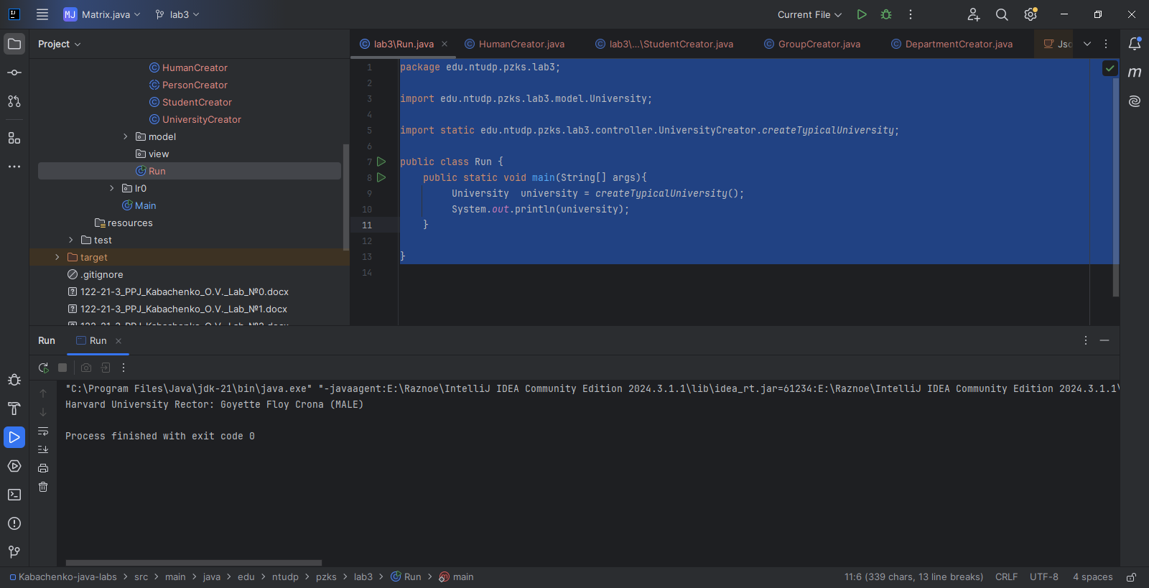

Рисунок 2 – Результат створення університету.

**Висновки**

У ході виконання лабораторної роботи розглянуто принципи ООП, а також досліджено використання абстрактних класів та інтерфейсів.