**Engineering Report for RGU-Hack2025**

**Schematic**

Here is a simple schematic that would need to be implemented to detect input from ultrasonic sensors and send the data to the Arduino board. The position of ultrasonic sensors helps to cover more range by placing them in the arch formation.

Red wire indicates the power – Supplies power

Black wire indicates the ground – Closes the circuit

Green wire indicates the trig channel – Triggers ultrasonic sound pulse

Blue wire indicates echo channel – Controls Low or High input

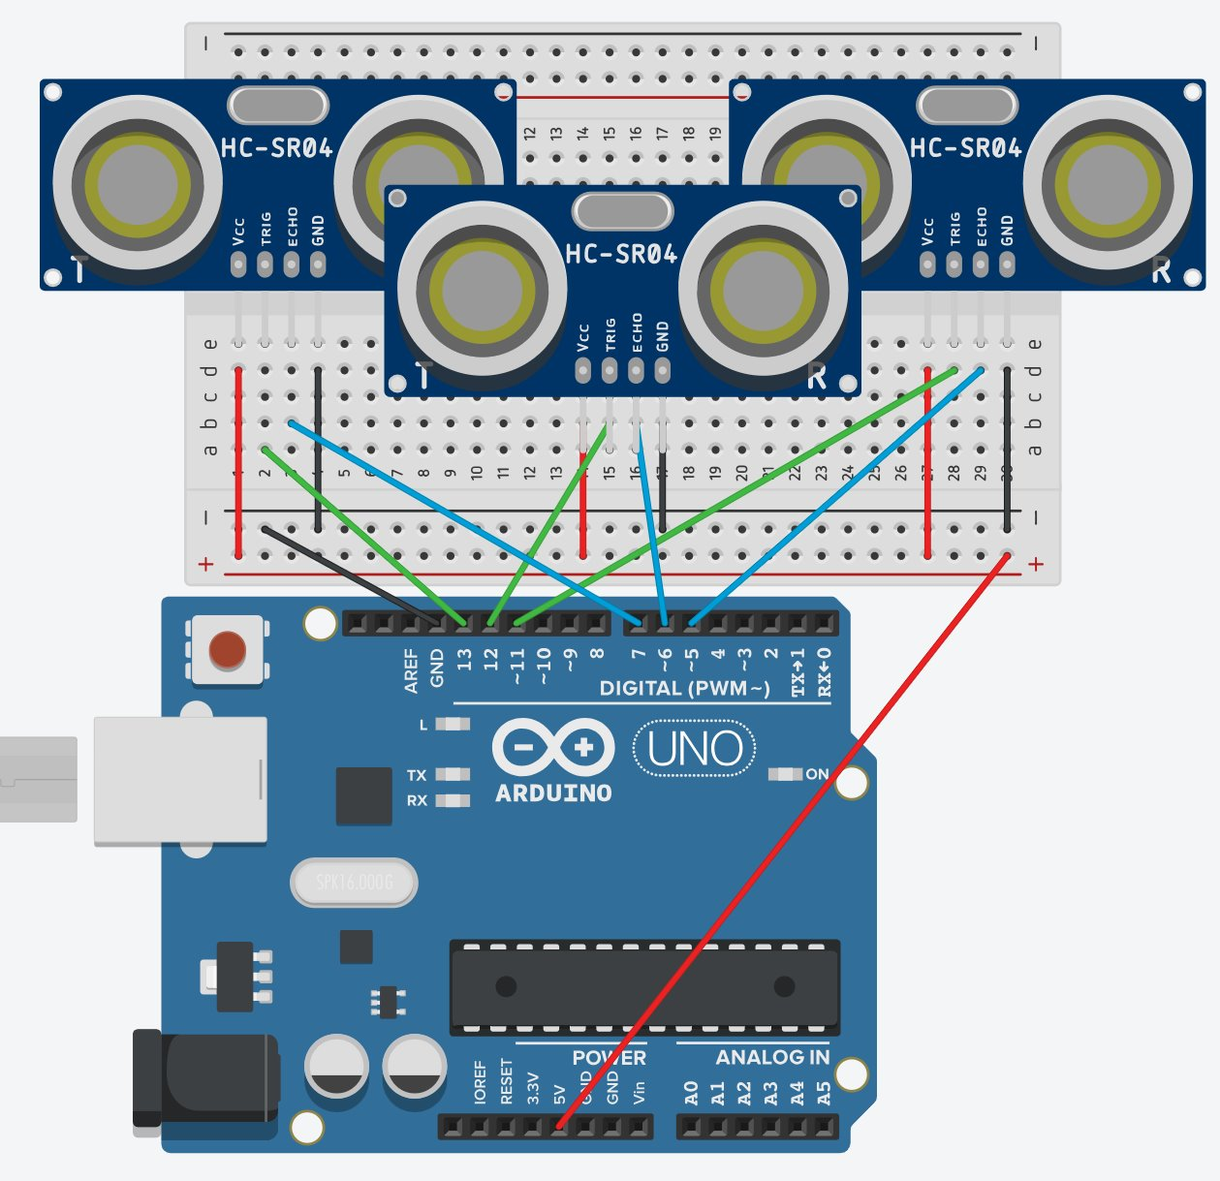

**Bill of materials and cost**

|  |  |  |
| --- | --- | --- |
| Name of device | Location of purchase | Price in GBP |
| Arduino Nano | [Amazon](https://www.amazon.co.uk/Arduino-Nano-Every-headers-mounted/dp/B07WWK29XF?source=ps-sl-shoppingads-lpcontext&ref_=fplfs&psc=1&smid=A1LKZYWRVOF5T2&gQT=2) | 14.06 |
| Raspberry Pi 3 B+ | [Amazon](https://www.amazon.co.uk/Raspberry-Pi-3-Model-B/dp/B07BDR5PDW?source=ps-sl-shoppingads-lpcontext&ref_=fplfs&psc=1&smid=AV5N289DDGKPJ&gQT=2) | 55.95 |
| HyperPixel 4.0 | [ThePiHub](https://thepihut.com/products/hyperpixel?variant=696832262161&country=GB&currency=GBP&utm_medium=product_sync&utm_source=google&utm_content=sag_organic&utm_campaign=sag_organic&https://thepihut.com/collections/pimoroni&gad_source=1&gclid=CjwKCAiAiOa9BhBqEiwABCdG826fgpPqUV_fDYsLxQITV7c3MBe2rdDLUGy8PhAhZBWzME1aVUVEehoCzZYQAvD_BwE) | 54 |
| Breadboard | [Amazon](https://www.amazon.co.uk/Breadboard-Solderless-Electronics-Projects-Half-size/dp/B0DLYTCS3J/ref=asc_df_B0DLYTCS3J?mcid=62c82503d2853bfb9795062355d1b921&tag=googshopuk-21&linkCode=df0&hvadid=710804269330&hvpos=&hvnetw=g&hvrand=2849954033800081402&hvpone=&hvptwo=&hvqmt=&hvdev=c&hvdvcmdl=&hvlocint=&hvlocphy=9046834&hvtargid=pla-2394155416694&gad_source=1&th=1) | 3.99 |
| Dupont Wire (ELEGOO) | [Amazon](https://www.amazon.co.uk/Elegoo-120pcs-Multicolored-Breadboard-arduino-colorful/dp/B01EV70C78/ref=asc_df_B01EV70C78?mcid=07c0c5e03d493d4fb3c30848e7f66576&tag=googshopuk-21&linkCode=df0&hvadid=696386561224&hvpos=&hvnetw=g&hvrand=9772785434739961620&hvpone=&hvptwo=&hvqmt=&hvdev=c&hvdvcmdl=&hvlocint=&hvlocphy=9046834&hvtargid=pla-362913641420&gad_source=1&th=1) | 6.99 |
| Piezo Buzzers | [Amazon](https://www.amazon.co.uk/Active-Continous-Buzzers-Computers-Printers/dp/B0D5QFM5XC/ref=asc_df_B0D5QFM5XC?mcid=27dbf68746bb35ae85bf5b188810755f&tag=googshopuk-21&linkCode=df0&hvadid=710804269330&hvpos=&hvnetw=g&hvrand=3931839647294934755&hvpone=&hvptwo=&hvqmt=&hvdev=c&hvdvcmdl=&hvlocint=&hvlocphy=9046834&hvtargid=pla-2373637610299&psc=1&gad_source=1) | 2.38 |
| Misc (Arduino usb-cable, RPi charger) | [Amazon](https://www.amazon.co.uk/kenable-Hi-Speed-mini-B-Cable-Power/dp/B004HTFBRW/ref=asc_df_B004HTFBRW?mcid=b1aa313fbb903e7b9883aad14bec96a2&tag=googshopuk-21&linkCode=df0&hvadid=710851831189&hvpos=&hvnetw=g&hvrand=6911557783328201019&hvpone=&hvptwo=&hvqmt=&hvdev=c&hvdvcmdl=&hvlocint=&hvlocphy=9046834&hvtargid=pla-2295245633986&gad_source=4&th=1), [ThePinHub](https://thepihut.com/products/raspberry-pi-zero-uk-power-supply?variant=41035036950723&country=GB&currency=GBP&utm_medium=product_sync&utm_source=google&utm_content=sag_organic&utm_campaign=sag_organic&gad_source=1&gclid=CjwKCAiAiOa9BhBqEiwABCdG8wpcVas-Hp0uR4CvdVeXhKaquqOHib8OMizYqdp9d_ul-bz-YReUGhoC7jsQAvD_BwE) | 10.15 |
| HC-SR04 | [Amazon](https://www.amazon.co.uk/HC-SR04-Ultrasonic-Distance-Rangefinder-Detection/dp/B0066X9V5K/ref=asc_df_B0066X9V5K?mcid=9f1cf9124b0d3a9b9a84ba1788e196bd&tag=googshopuk-21&linkCode=df0&hvadid=696451130825&hvpos=&hvnetw=g&hvrand=17296485585576928438&hvpone=&hvptwo=&hvqmt=&hvdev=c&hvdvcmdl=&hvlocint=&hvlocphy=9046834&hvtargid=pla-886395091082&psc=1&gad_source=1) | 4 |

|  |  |  |
| --- | --- | --- |
| Sum | (159.52)With 3 ultrasonic detectors | 151.52 |

**Future enhancements**

For future enhancements, there are two areas that could be improved; angle and range. For angle, adding more sensors would solve the problem, however by doing so, the price would be also increased along side complexity. For range, the ultrasonic sensor needs to have lower frequency however, in doing so, the speed would be decreased, to reduce frequency, one would need to tinkering with “ultrasonic transducer” which can be found and explored here: <https://forum.arduino.cc/t/how-to-make-and-control-ultrasound-frequency/890319>