LIBRARY USER GUIDE

Application represent a web site imitation on-line library.

**Registration:**

All visitors of the site can register themselves. Registration is necessary for taking a book, changing book quantity and viewing all available books in the library.

User can register himself by passing a simple form.

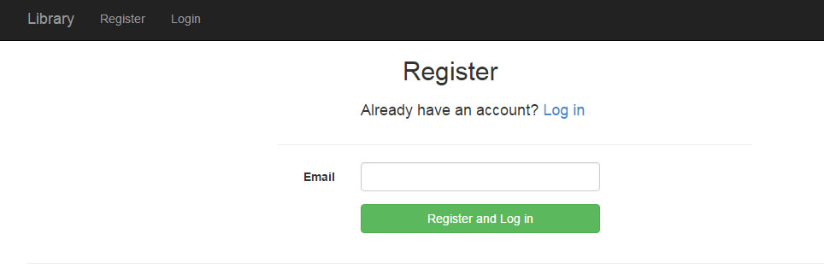(all email notification will be sent to email [sitecoresmtp@gmail.com](mailto:sitecoresmtp@gmail.com) password sitecore)

**Surfing library web site:**

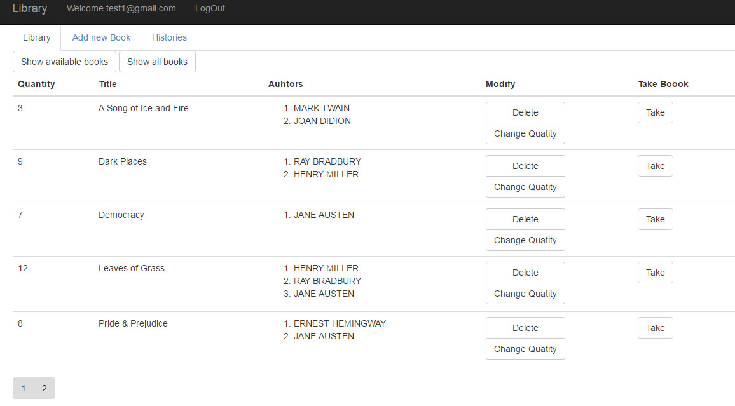After registration or logging user will be redirected to the main page of library web site.

On the main page user can get information about books that library has, sort those books by title, authors or filter them by pressing button: “Show all books”, “Show available books”.

There are five books on each page.

User can paging them by clicking on paging button in the bottom of the web site.

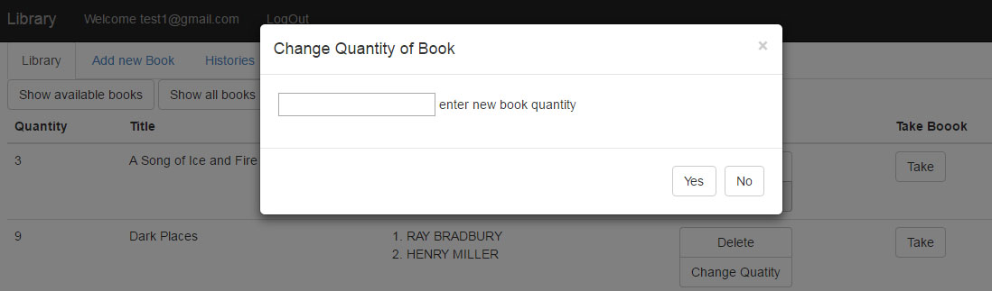In addition, user can change book quantity or even delete book, just press on appropriate button and pop-up menu will appear!

“You have always dreamt to read one of books that are represented on our library web site?!”

It is easy like taking candy from a baby. Press “Take” button that is located in front of each book, and that’s all.

After taking a book, user receive e-mail notification about book that he has taken.

**Adding new book:**

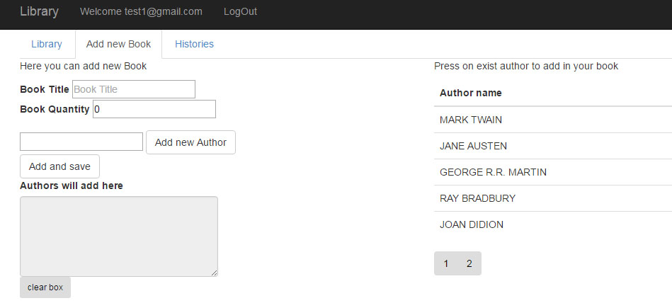In “Add new Book” tab user can easily add new book to our library web site.

In right part of the site, user needs to enter title and quantity of new book. Also user can add new author (because we are not sure that our library contains all the authors of our planet).

Left part represents list of existing authors in the library. Tap on author name and it will be added to new book automatically.

*NOTE: don’t worry about adding a few authors to your new book, this operation will be completed as one request to data base.*

**History of users operation:**

History tab represents a table of all library users operations (taking books).

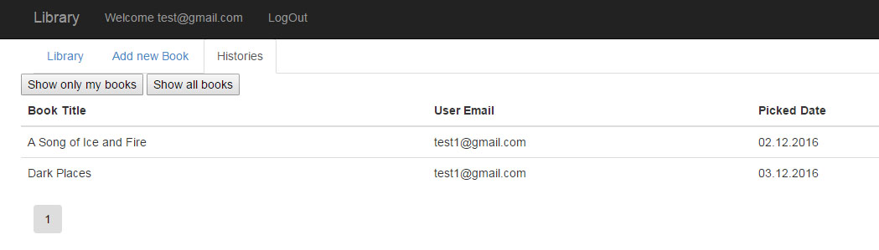

User can find books that he took in the library – button “Show only my books” or view all books taken by other users “Show all books”.

This page also contains a paging button(s).

Completed by Krotenko Oleg