
Curriculum Vitae

Oleh Mykhasiv
Cell phone: +38 (097) 792-15-59 Telegram: @olehmar1
E-Mail: mixassv11@gmail.com GitHub: github.com/OlegMar1

Experience:
Career Path in EPAM
- Junior Data DevOps Engineer: Jan 2021 – Oct 2021
- Middle Data DevOps Engineer: Oct 2021 – Jan 2025
- Senior Data DevOps Engineer: Jan 2025 - Present
Responsibilities and key achievements in EPAM:
- Designed and implemented a high-volume data transfer solution (~500 TB) from HDFS to AWS S3 using AWS DataSync, VPC S3 Interface Endpoint, and VPC DataSync Interface Endpoint, ensuring secure and efficient data migration.
- Built and maintained CI/CD pipelines using Bamboo (Java specs), GitLab CI and AWS CodePipeline enabling streamlined deployments.
- Automated deployment and configuration of Qlik Replicate on EC2 Windows servers, enhancing data ingestion workflows.
- Supported large-scale data ingestion pipelines using AWS DMS, EventBus, Kinesis, and snapshot workflows for diverse data sources.
- Led migration of Apache Airflow from EC2 to ECS Fargate, upgrading to a newer version and integrating EFS for shared storage, RDS PostgreSQL for metadata, and ElastiCache Redis for distributed task execution. Configured Application Load Balancer for secure traffic routing.
- Developed a Data Lake reconciliation framework using EventBridge, Step Functions, and ECS Fargate, improving operational efficiency.
- Architected and implemented a Databricks-based reconciliation workflow, significantly enhancing processing performance compared to legacy solutions; presented results to clients and internal EPAM teams.
- Mentored junior engineers and conducted technical interviews for the Data DevOps Campus and company-wide hiring processes.

Technical skills:
AWS (EC2, IAM, VPC, S3, Lambda, Glue, EMR, ECS, ECR, RDS, ALB, StepFunctions, Kinesis, DMS, DataSync, etc.), IaC (Terraform, AWS CDK, CloudFormation), Containers (Docker, Docker Compose, ECS), CI/CD (Bamboo, GitLab CI, AWS CodePipeline), OS (Linux), Coding and Scripting (Python, Bash), Data Engineering (Databricks, Snowflake, Apache Airflow, Kafka)

Education:
2022-2023 Master’s degree in applied mathematics, Lviv Polytechnic National University
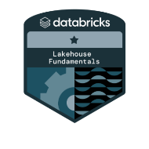
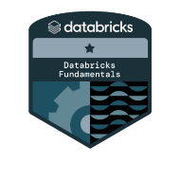
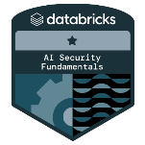
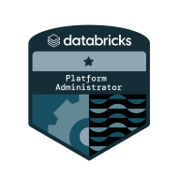
2018-2022 Bachelor’s degree in applied mathematics, Lviv Polytechnic National University
IT Certifications:

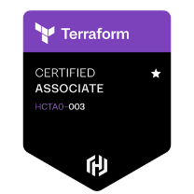
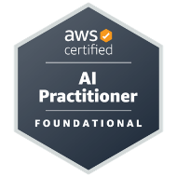
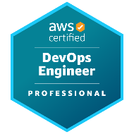
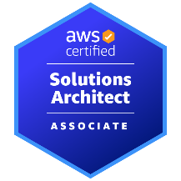
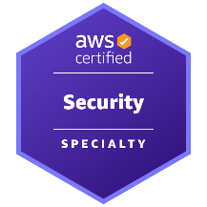
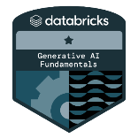

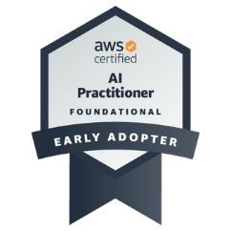
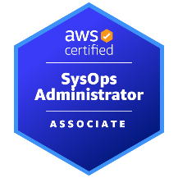
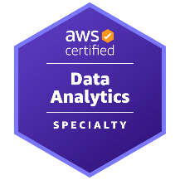
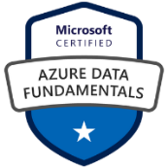
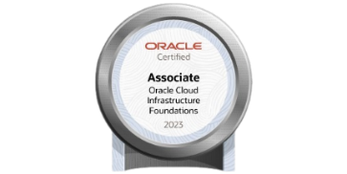
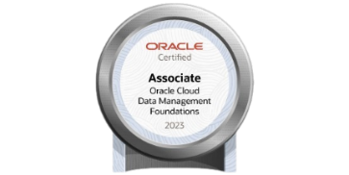
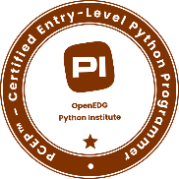
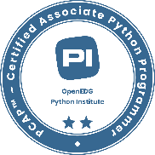

Additional Education:
Spring 2020 –SoftServe DevOps Crash Course
Summer-Autumn 2020 – EPAM DevOps Course
Autumn 2020 – Green Forest English course, A2 Level
Autumn 2022 – Green Forest English course, B1 Level
Winter 2023 – Green Forest English course, B2 Level

Spoken Languages Levels:
English – Upper-Intermediate, Ukrainian – Native

