SnapCal
High Level Requirements Document
Version 0.1
Date

Project Identification

Project: | SnapCal — Smart Nutrition & Activity Tracker
Prepared By: | GBC Student Team (Romero Garcia, Oleg Sanitskii, Jacques Antoine Vidjanagni)
Document Version: | 0.1
Published Date: | Sept 19, 2025

Contributors
The following individuals contributed to this document.
Name | Title
Oleg Sanitskii | Project Manager
Jacques Antoine Vidjanagni | Business Analyst
Omar Romero | Project Sponsor

Distribution
This document is distributed to all the following people.
Name | Title
Oleg Sanitskii | Project Manager
Jacques Antoine Vidjanagni | Business Analyst
Omar Romero | Project Sponsor
Referenced Documents
This document refers to the following materials
Version number | Title | Author | Date | Source / Location

Revision History

Version Number | Revision Date | Summary of Changes | Modified by
0.1 | 26-Sept-2025 | Initial draft | Team T11
[Note: It is recommended that drafts be numbered 0.1 to 0.9, and that the first approved version be numbered 1.0. Thereafter, new version numbers will depend upon changes: 1.01, 1.1, etc for minor updates, 2.0, 3.0 etc for major changes.]

TABLE OF CONTENTS
1. Business Context Diagram 3
2. REquirements Scope Statements 4
3. High Level Business Requirements Sign-Off 5

- Business Context Diagram
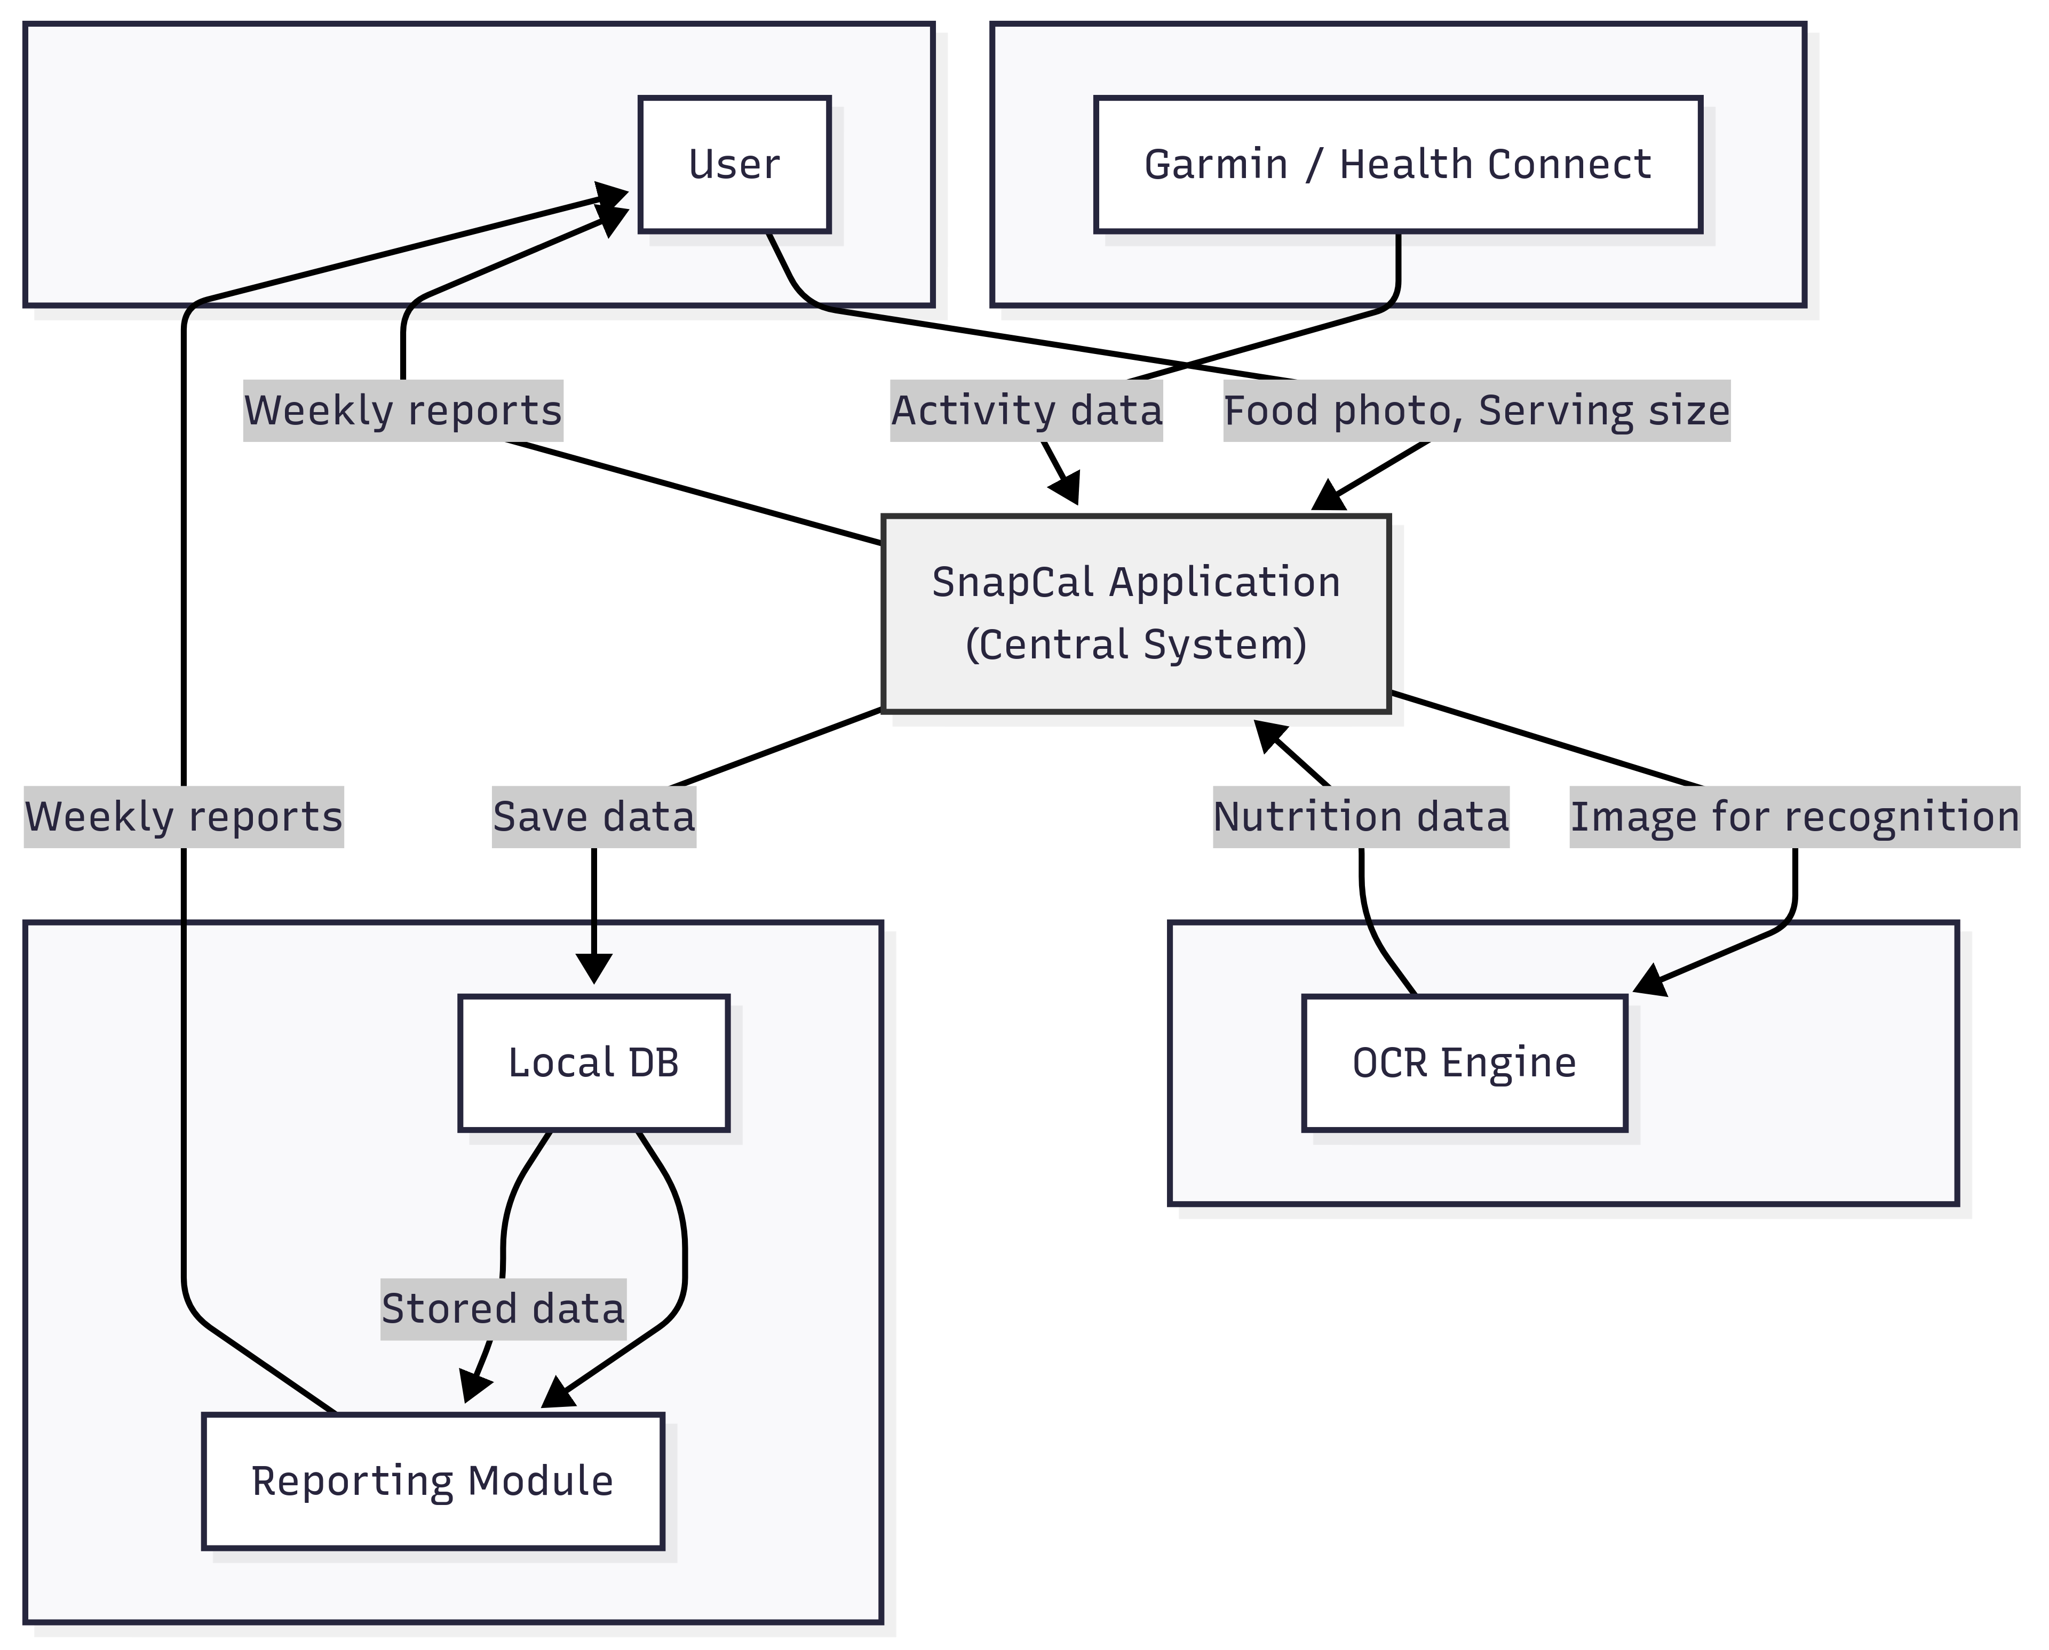

Requirement Scope Area | Description
 | SnapCal integrates nutrition logging (via OCR) and activity tracking (via Garmin/Health Connect) into a single system to produce weekly intake vs burn reports.

External Entity | Description
User | takes food label photos, enters serving size, views reports.
Garmin/Health Connect | provides activity data (steps, calories, workouts).
Local DB (SQLite/JSON) | stores data offline.

Information Flows | Description
From User → App: food label photo, serving weight.
From OCR → DB: calories/macros extracted.
From Garmin/Health Connect → App: activity data.
From DB → Reports: intake vs burn, fat change forecast.
- Requirements Scope Statements
HLR# | Description | Priority  (H, M, L)
 | The system shall allow users to capture nutrition label photos and extract calories/macros via OCR. | H
 |  | H
  The system shall allow users to input serving size (grams/ml) and calculate actual intake.
 |  | H
  The system shall import activity data (calories, steps, workouts) from Garmin/Health Connect.
HLR04 |  | M
  The system shall store all nutrition and activity data locally in SQLite/JSON for offline use.
HLR05 |  | H
  The system shall generate a weekly report (CSV/PDF) summarizing intake vs burn and fat change estimation.
HLR06 | The system shall provide visualization (graphs/charts) of nutrition and activity trends. | M
HLR07 |  | L
  The system shall allow CSV export of user records for external analysis.
HLR08 | The system shall maintain OCR accuracy of at least 90% with option for manual correction. | H

- High Level Business Requirements Sign-Off
The undersigned acknowledge their agreement with the contents of Version <x.x> of the High-Level Requirements document for <Project Name>.

Following approval of this document, requirements changes will be governed by the project’s change management process, including impact analysis and appropriate reviews and approvals, under the general control of the Project Plan and according to company policy. Approved Change Request Documents, if present, will be attached to this Requirements Document as updates.

Name | Project Role and  Functional Area | Date Signed
Oleg Sanitskii | Project Manager | Sept 26, 2025
Omar Romero Garcia | Project Sponsor | Sept 26, 2025
Jacques Antoine Vidjanagni | Business Analyst | Sept 26, 2025

* Note: physical signatures are not required. Email approvals are acceptable and should be appended to project documents.

