Studying tight-binding model with sd-interaction and on-site Coulomb repulsion and non-coplanar magnetic structure with hybrid classic-quantum VQE algorithm
O.G. Udalov
Abstract:

- Introduction
Nowadays quantum computers simulation of physical systems attracts more and more attention due to increasingly vast access to quantum computer hardware. Multiple companies provide access to their quantum computers (QC). While the computational power of the devices is well below their classical counterparts, the promise of future advantages inspires studying of novel paradigm of computation and exploration of new quantum algorithms and their limitations.
One of the most promising algorithms for the current state noisy QCs is the variational quantum eigensolger (VQE) [1-3]. It allows to simulate physical systems and find their ground and excited states. The most plausible application of the algorithms is molecules simulations. Therefore, most of the efforts is spent on improving it for this type of physical task.
In this report I study using of VQE for a different type of physical system. In particular, I study tight-binding model with on-site Coulomb repulsion and inhomogeneous sd interaction using the VQE algorithm. Ansatz choice and initial guess are curtail components for successful quantum simulations. In this report I compare few different ansatze and various initial states for VQE algorithm and define the best one for the proposed physical problem.
Effect of the noise on the simulations is considered.

- Physical model
We study a one-dimensional system described by the following Hamiltonian:
$$H=H+H_{sd}+H_{Coul}$$
$$H_{kin}=-t\sum_{<i,i+1>}{c_{i,s}^{+}c_{i+1,s}}+c.c.$$
$H_{sd}=-J\sum_{i,s,s^{'}}{({\vec{B}}_{i}⋅c_{i,s^{'}}^{+}} {\vec{σ}}_{s,s^{'}}c_{i,s})$ (1)
$$H_{Coul}=U_{c}\sum_{i,s≠s^{'}}{n_{i,s}^{}}n_{i,s^{'}}$$
Here ${\vec{B}}_{i}$ is the magnetization distribution of the localized magnetic moments. These magnetic moments interact with free (s-) electrons via sd-interaction. There is also a Coulomb on-site repulsion between free electrons. $c_{i,s}^{+}$ and $c_{i,s}$ are creation and annihilation operators for an electron at site $i$ and spin $s.$ $J$ is the sd-exchange constant, $U_{c}$ is the on-site Coulomb repulsion constant and $t$ is the nearest neighbor hopping constant. We assume that there are $n_{s}$ sites in the system. Hopping between nearest neighbours is allowed only. Number of electrons $n_{e}$ is fixed. Either open or periodic boundary conditions are considered.
  - Studied property
We study ground state of the multi electron state with the Hamiltonian (1).
2.2 Direct diagonalization
Since number of sites and number of electrons that can be treated with quantum computer is quite small nowadays, we can use direct diagonalization to the validate the results obtained with VQE.
- “Quantum” simulations
We are using VQE algorithm to find the ground state of the Hamiltonian Eq. (1). This hybrid algorithm assumes that a quantum state $Ψ$ is prepared using some parametric ansatz. The ansatz is described by parameters set $\{θ_{k}\}$. Then the energy of this quantum state is calculated $E_{Ψ}= <Ψ|H|Ψ>$. By minimizing the energy over the parameters set $\{θ_{k}\}$ one finds the system ground state.
To convert the physical Hamiltonian into the qubits Hamiltonian we use the Jordan-Wigner transformation […].
3.1. States-qubits correspondence
Electron in the problem can be place in any of $n_{st}=2⋅n_{s}$ states (2 different spin states per each node). Each state corresponds to a qubit in a quantum computer within the Jordan-Wigner transformation. We assume that states with spin-up ($s=1$) are represented by qubits ($0, …n_{s}-1$) and spin-down states are represented by qubits ($n_{s}, …{2n}_{s}-1$). If a qubit state is 1, then corresponding physical state is occupied and if the qubits state is 0, then corresponding physical state is not occupied.
  - Ansatz
We tried few various ansatzes and check which one works better. The metrics we use is the following: 1) number of CX gates in the ansatz; 2) number of iterations needed to achieve convergence of the variational procedure to the desired ground state $E_{QC}$. The state obtained by direct diagonalization $E_{DD}$is considered as a ground truth. We assume the VQE algorithm converges to the ground state if the relative difference between the $E_{QC}$ and $E_{DD}$ is below 0.1%.
3.2.1. Generic ansatz
Generic ansatz consists of rotating and entangling blocks repeated several times. Typical example of such a block is shown in Fig. 3.1. The figure shows the 4 qubits circuit corresponding a system with 2 nodes. Top 2 qubits are for the spin-up states and 2 bottom qubits are for the spin-down states. The figure is prepared by Qiskit quantum programming language. All notations are standard. $R_{x}$ is the qubit state rotation around x-axis by some angle $θ$. $R_{y}$ is rotation around y-axis. $H$ is the Hadamard gate. Double qubits operation with white cross is the $CNOT$ gate. Set of rotational angles $θ_{i}$ for each rotational gate describes the ansatz. In Fig. 3.1, 18 rotating gates are shown, so one needs 18 parameters to describe this ansatz. One can use more than one block like this.
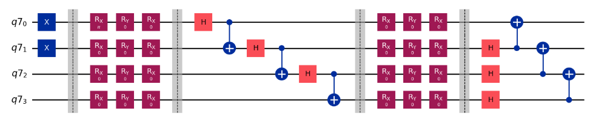
Fig. 3.1. Problem agnostic ansatz.
Note that two $X$-gates at the beginning are used to create some initial guess state. $X$-gate transform 0 qubits state to 1 qubits state. So, they can be considered as creation of 2 particles with spin-up states in nodes 1 and 2. Spin-down states are not occupied.
The problem of this generic ansatz is that it does not conserve number of particles in the system. While we create 2 electrons with spin-up states, the final state may contain contributions with different number of electrons. To solve this issue, we added a term to Hamiltonian keeping the number of electron constant:
$H_{pc}=E_{f}{\left(n_{tot}-n_{e}\right)}^{2}$ (2)
If $E_{f}$ is large, the term introduces a high cost for adding or subtracting a particle to the system.

3.2.2. Cluster ansatz
The cluster ansatz is well described in Ref. […]. This ansatz conserves number of particles and consists of single particle $c_{i,s}^{+} c_{i',s'}^{}$ and double particles $c_{i,s1}^{+} c_{j,s2}^{+}c_{k,s3}^{} c_{l,s3}^{}$ transitions. The fermionic operators are converted into the qubit operators using the same Jordan-Wigner transformation. Evolution operators are obtained based on the transition operators. So, partial transitions are possible. The “amount” of the wave function transferred from one state to the other is governed by the “rotation” angles $θ_{i}$, where $i$ indexing all kinds of single and double transitions in the system. Changing the set of angles $θ_{i}$ one can get any combination of the multi-electron states (any combination of Slater determinants).

3.2.3. Cluster ansatz by Yordanov
Yordanov et al […] proposed modified cluster ansatz using less $CX$ gates and allowing for shallower quantum circuit. In general, the Yordanov ansatz allows to make the quantum circuit 3 times shallower than classical cluster ansatz.
Yordanov ansatz includes single and double transitions applied one after another. Applying 2 single transitions one after another can be considered as double transition. So, in general we do not need to apply operators of all possible transitions. In fact, we can leave only single transitions. This would still leave us with the ansatz able to get any state. So, in our simulations we use all possible single transitions in the ansatz.

3.2.4. Simplified Yordanov ansatz
Jordan-Wigner transformation converting fermionic operators into qubits operators is designed so that the parity is conserved and the phase (sign) of the wave function after the transition is correct. Note, however, that we vary angles $θ_{i}$ that define the phase of the final state after the transition. So, keeping the sing within the transition operator is not necessary. By varying $θ_{i}$ we can still get all possible system states even though the transition operator does not change the wave function sign in the same way as the fermionic operator.
To keep the parity of the fermionic states the staircase block of CX-gates is added to transition block for the qubits states (see Fig. ). Here, we remove this block from our ansatz and test it. Removing this block allows to reduce number of CX-gates essentially and make the quantum circuit shallower.
Below is the comparison of the ansatzes in terms of number of CX-gates. Here I use a system with 3 nodes.

Ansatz type | Nodes number | Number of parameters | Number of CX gates
Generic | 3 | 72 | 33
Classic cluster | 3 | 60 | 2876
“Yordanov”, single+double, fermion | 3 | 60 | 983
“Yordanov”, single, fermion | 3 | 15 | 107
“Yordanov”, single, qubit | 3 | 15 | 86
Generic | 2 | 48 | 16
Classic cluster | 2 | 9 | 184
“Yordanov”,sing+doub, qubit | 2 | 9 | 82
“Yordanov”, single, fermion | 2
“Yordanov”, single, qubit | 2 | 6 | 32
Table 1. Comparison of the circuit dept for different ansatze. A system with 2 and 3 nodes is used as a test.

3.3. Antsatze performance comparison
3.3.1. 2-nodes system
To compare performance of various ansatze we use a test Hamiltonian for 2 nodes three different parameters sets were used with 1) $U_{c}/t=10$ ($t=1$), $J=0.2 t$; 2) $U_{c}/t=2.5$ ($t=4$), $J=0.025 t$; and 3) $U_{c}/t=0.1$ ($t=1$), $J=0.2 t$. We consider a half-filling case with 2 electrons. The parameters are chosen in a way that the ground state is not degenerate. Corresponding ground state energies are $E_{g1}= -10.4 t$, $E_{g2}= -3.2 t$, $E_{g3}= -2.002 t$. Wave functions of these free state are quite different: 1) FM state $↑↑$; 2) primarily combination of two AFM state (0.67($↑↓ + ↓↑$) + 0.23 ($↑↓_ +_ ↑↓$)), the second term has both electrons sitting on the same site, while in the first term the electrons are sitting on different sites; 3) state (0.51($↑↓ + ↓↑$) + 0.49 ($↑↓_ +_ ↑↓$)). We use 3 types of initial guesses: 1) combination of AFM states ($↑↓ + ↓↑$); 2) single AFM state $↑↓$; and 3) FM state $↑↑$. We average results over 3 problems and 3 initial guesses (9 combinations in total). The table below shows how different ansatze combined with different optimization method perform. We studied 4 different ansatze and 4 different optimization method (including both gradient based and non-gradient based): COBYLA, Powell, BFGS and SLSQP. Note that ideal simulations were used without adding noise to quantum gates. The table show relative energy deviation obtained using each method averaged over 9 mentioned tasks. Also number of iterations (and calculation time) needed to achieve the precision is shown.
Table A1. Task with 2 sites. I perform averaging over 3 initial guesses and 3 different parameters sets (9 tries in total for each line). No noise.
Ansatz | Init state | Iter | Time, s | Mean energy deviation (%) | States product | Optimizer
Yordanov, sing+doub, no stairs |  | 320 | 3.7 | 0.05 |  | COBYLA
Yordanov, sing+doub, no stairs |  | 293 | 3.5 | 0.01 |  | Powell
Yordanov, sing+doub, no stairs |  | 294 | 3.5 | 0.2 |  | BFGS
Yordanov, sing+doub, no stairs |  | 151 | 1.9 | 0.2 |  | SLSQP
Yordanov, sing, no stairs |  | 660 | 4.5 | 1 |  | COBYLA
Yordanov, sing, no stairs |  | 360 | 2.4 | 0.2 |  | Powell
Yordanov, sing, no stairs |  | 350 | 2.4 | 0.1 |  | BFGS
Yordanov, sing, no stairs |  | 90 | 0.6 | 1.8 |  | SLSQP
Classical, sing+doub |  | 402 | 10.2 | 8 |  | COBYLA
Classical, sing+doub |  | 340 | 8.8 | 0.01 |  | Powell
Classical, sing+doub |  | 305 | 7.8 | 0.2 |  | BFGS
Classical, sing+doub |  | 150 | 3.9 | 0.2 |  | SLSQP
Generic |  | 3000 | 22 | 0.2 |  | COBYLA
Generic |  | 4563 | 33 | 0.2 |  | Powell
Generic |  | 2869 | 21 | 10^-8 |  | BFGS
Generic |  | 1888 | 13.7 | 10^-5 |  | SLSQP

Based on the presented data we can conclude that Powel and BFGS optimizers perform on average better than COBYLA and SLSQP. Also, the most simple “Yordanov” ansatz with single transitions only provides the fastest calculations (similar number of iterations but shorter circuit giving shorter simulation time).

3.3.2. 3-nodes system
Table A1. Task with 3 sites. I perform averaging over 3 initial guesses and 3 different parameters sets (9 tries in total for each line). No noise.
Ansatz | Iter | Time, s | Mean energy deviation (%) | States product | Peak state prod | Optimizer
Yordanov, sing+doub, no stairs | 18000 | 2469 | 1.34 | 0.85 | 0.9999 | COBYLA
Yordanov, sing+doub, no stairs | 1970 | 24 | 2.5 | 0.66 | 0.9999 | Powell
Yordanov, sing+doub, no stairs | 2325 | 28 | 1.67 | 0.62 | 0.9999 | BFGS
Yordanov, sing+doub, no stairs | 638 | 7.7 | 1.86 | 0.51 | 0.9999 | SLSQP
Yordanov, sing, no stairs | 1000 | 91 | 4.97 | 0.54 | 0.9999 | COBYLA
Yordanov, sing, no stairs | 1740 | 21 | 3.2 | 0.63 |  | Powell
Yordanov, sing, no stairs |  |  |  |  |  | BFGS
Yordanov, sing, no stairs |  |  |  |  |  | SLSQP
Classical, sing+doub |  |  |  |  |  | COBYLA
Classical, sing+doub |  |  |  |  |  | Powell
Classical, sing+doub |  |  |  |  |  | BFGS
Classical, sing+doub |  |  |  |  |  | SLSQP
Generic |  |  |  |  |  | COBYLA
Generic |  |  |  |  |  | Powell
Generic |  |  |  |  |  | BFGS
Generic |  |  |  |  |  | SLSQP

Yordanov, sing+doub, no stairs, Cobyla
0.99999/20000 | 0.99999/13000 | 10^-6/8000
0.99/20000 | 0.997/20000 | 0.726/20000
0.98/20000 | 0.9999/20000 | 0.9999/20000

Yordanov, sing, no stairs, cobyla
0.98/1000 | 0.008/1000 | 0.01/1000
0.55/1000 | 0.62/1000 | 0.72/1000
0.08/1000 | 0.89/1000 | 0.999/1000

Yordanov, sing, no stairs, Powel
0.9999/304 | 0.93/2983 | 0.9998/892
0.003/2693 | 0.67/967 | 0.85/2080
0.999/556 | 0.21/3774 | 0.01/400

To compare performance of various ansatze we use a test Hamiltonian for 3 nodes with $U_{c}/t=10$ ($t=1$), $J=0$. We consider a half-filling case with 3 electrons. Initial guess is the combination of two AFM states ($↑↓↑ + ↓↑↓$). The ground state energy obtained via direct diagonalization for this Hamiltonian is $E_{g}/t= -15.3$.

- Simulations with IBM QC and noisy classical simulations
I performed test simulations using IBM QC (ibm_brisbane). The Hamiltonian with 2 nodes (4 qubits) was used. The simplified “Yordanov” ansatz was used (32 cx gates). One iteration takes about 14 sec of QC time. Below is the energy as a function of iteration number obtained with IBM QC. The simulation took 140 sec of QC time. Overall execution time is 250 sec. So, half of the time is used for communications with QC and probably waiting in the line.
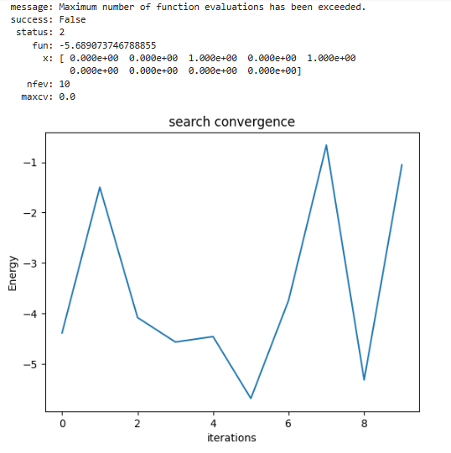
Fig. 4.1. Energy convergence for the “Yordanov” qubit ansatz with single transitions for 2 nodes system. $U_{c}=10$, $t=1$, $J=0.1$. Half-filling case. Initial state is combination of 2 degenerate AFM states ($↑↓↑ + ↓↑↓$). 10 iterations only. Obtained with IBM QC ibm_brisbane.

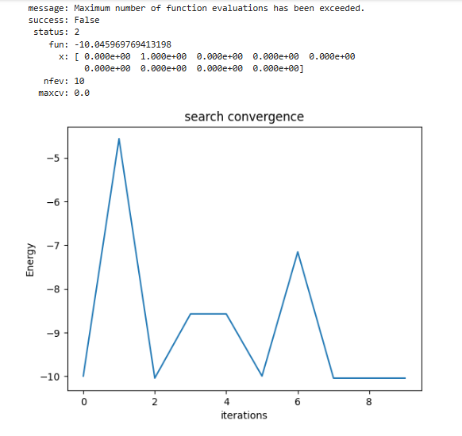
Fig. 4.2. Energy convergence for the “Yordanov” qubit ansatz with single transitions for 2 nodes system. $U_{c}=10$, $t=1$, $J=0.1$. Half-filling case. Initial state is combination of 2 degenerate AFM states ($↑↓↑ + ↓↑↓$). 10 iterations only. Obtained with classical simulations of QC (no noise added).

4.1. Comparing energy estimation procedure performed by real QC, ideal (noiseless) “classical QC simulator” and noisy “classical QC simulator”.
I used IBM QC (ibm_brisbane) in this test. As the classical simulator of the QC I used Qiskit AER simulators with and without added noise. The noise model includes a noise on CX gates only. Note that performance of the real QC depends on the transpilation process. I tuned a parameter called optimization_level. I found that optimization_level = 2 gives the best performance of the ibm-brisbane for my particular algorithm.
To compare classical simulations and real IBM QC I used the shortest ansatz, namely the simplified “Yordanov” ansatz with smaller number of CX gates. In this ansatz all the rotation angles $θ_{i}$ was set to 0. This however does not mean that no gates are applied. The same number of gates were applied as for any random set of $θ_{i}$. Initial guess is the single AFM state. No optimization was performed. Just single energy estimate.
The table below shows comparison of three simulation methods.

Table 4.1. Estimated energy for an AFM state prepared using simplified “Yordanov” ansatz. Estimating is done by various methods including ideal classical simulations, noise classical simulations and real QC estimate.
 | Energy estimate ($E/t$)
Number of nodes | Ideal “classical QC” | Real IBM QC | Noisy “Classical QC” | Noise level
1 | -4.9 | -4.87 | -4.61 | 2%
2 | -10 | -8.57 | -7.39 | 2%
3 | -14.9 | -11.38 | -8.62 | 2%
1 | -4.9 | -4.87 | -4.75 | 1%
2 | -10 | -8.57 | -8.6 | 1%
3 | -14.9 | -11.38 | -11.35 | 1%

Based on the table one can conclude that ibm_brisbane QC can be fairly well simulated by the noise model including 1% CX gate errors. One can see that the noise level of real QC is quite high. The energy estimation error for 3 nodes system with ansatz including about 80 CX gates is about 30% (~3.5t). At that the energy level spacing can be as small 0.1t.

4.2. Comparing VQE optimization using ideal and noisy simulations
Real QC optimization is quite slow comparing to classical noisy simulation of QC VQE optimization. So, here I used noisy classical simulations to check if one can expect any reasonable optimization results with high enough number of iterations. Based on the data from the previous section, one can use noisy simulations with 1% noise to see what QC can in general achieve.
I use 3 node system with 3 electrons for comparison. I use simplified “Yordanov” ansatz. The initial state is the single AFM configuration.
The noiseless optimization with 20000 iterations gives the ground state energy of $E_{g}=-15.32t$ (true ground state is $-15.4t$). The optimized wave function is:
$$\frac{Ψ_{g}}{-1+1j}=0.55\left|↑↑↑>+0.4\right|↑↓↑>+0.13\left|↓↑↑> +0.09\right|↓↓↑>+0.07|↑↑↓>$$

The optimization with noisy classical simulator gives $E_{g}=-11.87t$, with the wave function
$$\frac{Ψ_{g}^{n}}{-1+1j}=0.7|↑↑↑>$$
So, the optimization actually failed. This is expected since the energy estimation precision is too low, as was discussed in the previous section.
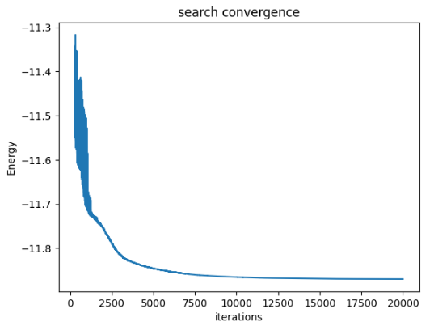
Fig. 4.2. Energy convergence for the “Yordanov” simplified ansatz with single transitions for 3 nodes system. $U_{c}=10$, $t=1$, $J=0.1$. Half-filling case. Initial state is combination of a single AFM states ($↑↓↑$). 20000 iterations only. Obtained with classical simulations of QC with noise added.

- Conclusions

References
[1] Alberto Peruzzo, Jarrod McClean, Peter Shadbolt, ManHong Yung, Xiao-Qi Zhou, Peter J Love, Alan Aspuru-Guzik, and Jeremy L O’brien. A variational eigenvalue solver on a photonic quantum processor. Nature communications, 5:4213, 2014.
[2] Jarrod R McClean, Jonathan Romero, Ryan Babbush, and Alan Aspuru-Guzik. The theory of variational hybrid quantum-classical algorithms. New Journal of Physics, 18(2):023023, 2016.
[3] Abhinav Kandala, Antonio Mezzacapo, Kristan Temme, Maika Takita, Markus Brink, Jerry M Chow, and Jay M Gambetta. Hardware-efficient variational quantum eigensolver for small molecules and quantum magnets. Nature, 549(7671):242–246, 2017.

Appendix 1
Table A2. Task with 2 sites. I perform averaging over 3 initial guesses and 3 different parameters sets (9 tries in total for each line). 1% Noise added.
Ansatz | N_f_ev | Time, s | Mean energy deviation (%) | States fidelity | Peak fid | Optimizer
Yordanov, sing+doub, no stairs | 280 | 16.2 | 43 | 0.67 | 0.9999 | COBYLA
Yordanov, sing+doub, no stairs | 1132 | 70 | 15.8 | 0.86 | 0.9999 | Powell
Yordanov, sing+doub, no stairs | 860 | 49.3 | 37.2 | 0.9999 | 0.9999 | BFGS
Yordanov, sing+doub, no stairs | 416 | 23.5 | 37.4 | 0.9999 | 0.9999 | SLSQP
Yordanov, sing, no stairs | 881 | 31 | 14.4 | 0.90 | 0.9999 | COBYLA
Yordanov, sing, no stairs | 308 | 10.7 | 14.1 | 0.89 | 0.9999 | Powell
Yordanov, sing, no stairs | 437 | 14.8 | 13.7 | 0.96 | 0.9999 | BFGS
Yordanov, sing, no stairs | 279 | 9.4 | 14.2 | 0.85 | 0.9999 | SLSQP
Classical, sing+doub | 664 | 71 | 78.1 | 0.99 | 0.9999 | COBYLA
Classical, sing+doub | 589 | 61 | 75.3 | 0.999 | 0.9999 | Powell
Classical, sing+doub | 944 | 102 | 76.7 | 0.999 | 0.9999 | BFGS
Classical, sing+doub | 474 | 48 | 78 | 0.999 | 0.9999 | SLSQP
Generic | 1000 | 48 | 43 | 0.85 | 0.997 | COBYLA
Generic | Too long |  |  |  |  | Powell
Generic | 9811 | 334 | 33 | 0.667 | 0.9999 | BFGS
Generic | 6452 | 221 | 33 | 0.667 | 0.9999 | SLSQP

