Lab 2: Operator Expressions

Oleg Zasukha
ELAC: Business Administration
CS_119_14005SU25E: Python
Professor Carlos Rodriguez
June 23, 2025

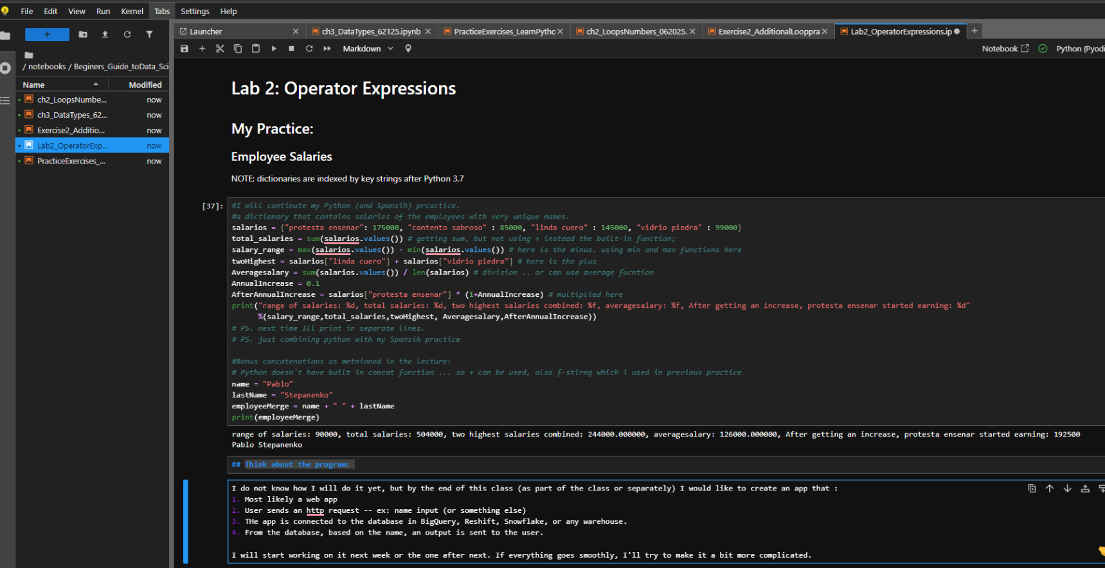
Think about the program:
I do not know how I will do it yet, but by the end of this class (as part of the class or separately) I would like to create an app that:
- Most likely a web app
- User sends an http request -- ex: name input (or something else)
- The app is connected to the database in BigQuery, Reshift, Snowflake, or any other cloud warehouse.
- From the database, based on the name, an output is sent to the user.
I will start working on it next week or the one after next. If everything goes smoothly, I'll try to make it a bit more complicated.

