- In the terminal creating a python virtual environment to privately install packages for this specific project. Packages would only be accessible by this project. This is done to ensure that different project that require different package versions don’t break. to separate the installed packes – run python -m venv .venv it will create the following folders.
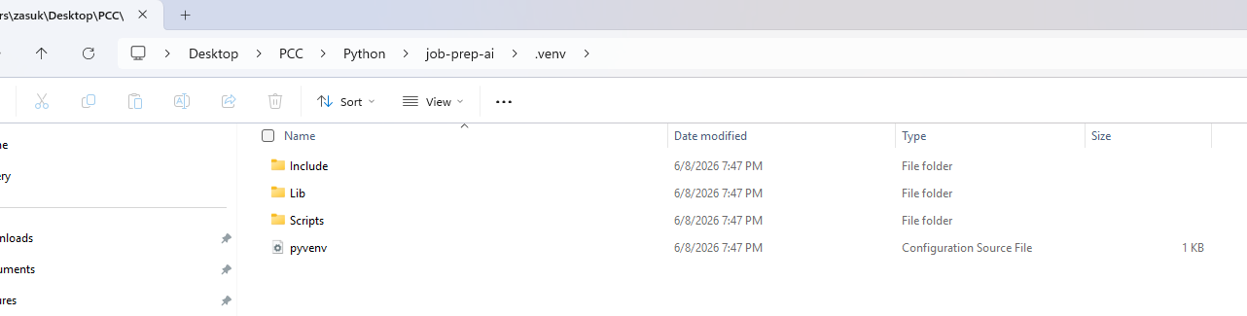
- Activate vm: .\.venv\Scripts\activate
- Create requirements.txt and add streamlit into it. Then run pip install -r requirements.txt to install the Streamlit.
- Create app.py
- streamlit run app.py – run it locally
- Create github repo and push to github:
  - git init
git add .
git commit -m "Initial Streamlit app"
git branch -M main
git remote add origin https://github.com/YOUR_USERNAME/data-prep-ai.git
git push -u origin main
- add to .gitignore
  - .venv/
__pycache__/
*.pyc
.env
.streamlit/
.DS_Store
Thumbs.db
  - COMMIT:
    - git add .
git commit -m "Add gitignore and sample docs"
git push

