**Basic Features of Matrimonial App:**

* It should provide an easy and convenient platform for connecting people.
* Matrimony app should offer an intuitive interface smoothly for guiding the users to get access to the various interesting features.
* After registration, the user should be able to get access to all the various features of the app.

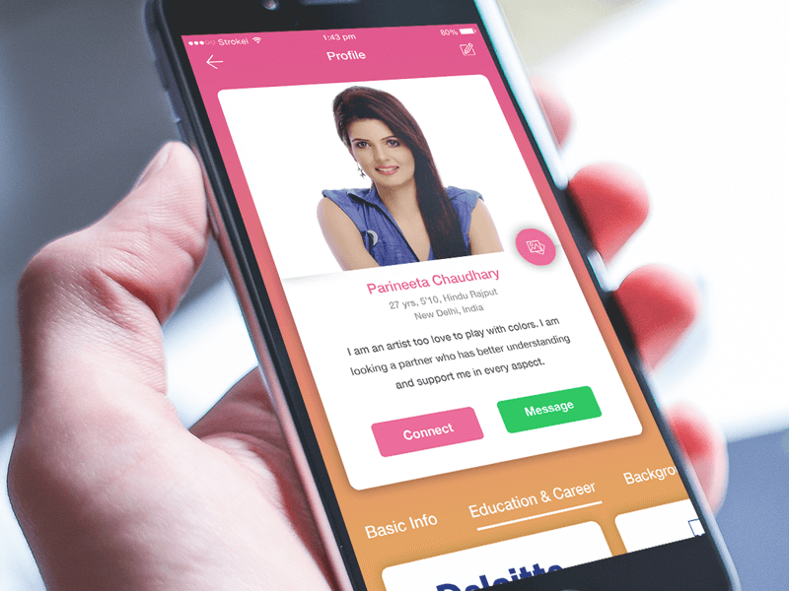

**General Features**

|  |  |
| --- | --- |
| User Panel | Admin Panel |
| Login/Register | Login |
| Profile verification by contact number, Aaadhar Number | Dashboards |
| Create desire partner profile | New Customer profile verification from Back End |
| Upload Multiple pictures – Set One image as main Image | If customer tries to edit photos or details need to be approved again with administrator |
| Add personal, educational lifestyle detail | Total Paid Members and Free Members |
| Browse profiles by category & subcategory | Admin Privileges   * Super Admin * Admin |
| Who viewed You Profile – Email Template and SMS should be sent | Earnings – Monthly and Annual Report |
| Recent Joined Profiles – Email Template | Paid to Free Members List |
| Preferred matches – Email Template should go automatically – Percentage wise – 80% preferred Match | Paid Member Ship Expiring Soon list - optional |
| New Matches to You - Email Template should go automatically – Every Week | Manage profile / Individual Profile information. |
| Who Shortlisted You – Email Template Should go with shortlisted profiles | Individual Profile Interest received list – Option to send SMS and Email Template for Reminder from Admin. |
| Who Sent Interest Request | Inactive Profiles - More than three Months list |
| Mutual Likes and Mutual Interest accepted List – Automatic SMS and Email | Find Duplicate Profiles – by Names |
| Premium Profiles | Manage success stores and user request |
| Profile Completeness – Percentage | Manage membership packages |
| Right now Online/offline Members With Green/hash colour bulb | Email & SMS marketing |
| Search profile with Basic, ID, advance search fields/filter | Manage promotions Offers and Promo Codes |
| Send interest request to other users – Mail and SMS alert should be sent | CMS – Banner Change, Content Change, Blog, Phone Number and Email ID, FAQ, About Us, Privacy Policy, Terms and Conditions, Careers |
| View contacts of the searched users – Email ID and Phone Number only for paid members | Payment gateway integration |
| Delete Profile | Third-party APIs integration – SMS and EMAIL marketing |
| View profile detail of selected user/Complete Details |  |
| -Paid Members should come first in profiles view  - Paid members should Standout with Bold Listing |  |
| View last login time of the user |  |
| Share, block and report user profile |  |
| Profile of the Day – Only Premium Members on left menu |  |
| Request for photo View and (Photo Lock option |  |
| Warning POP up with show respect towards Women. |  |
| Paid membership packages with (Offer & discount) |  |
| Multiple payment options like, Debit card, Credit card, Bar Code Scanner |  |
| Apply Coupon code – Promotional Message on Left Side |  |
|  |  |
| Customer support |  |
| View success stories |  |
| Request for showing customer success story on app |  |
| Hide/ Activate my profile |  |
| Edit Profile |  |
| Manage Photos |  |
| Edit Partner Preferences |  |
| Change Password |  |
| Logout |  |
| Set New Email ID change old email id |  |
| Your Account Type Free or Paid Member |  |
| About Us  Blog  FAQ  Privacy Policy  Terms and Conditions  Cancelation/ Refund Policy  Careers |  |
|  |  |
|  |  |
|  |  |

**General Features Brief Description:**

**Social login/Signup:**

This feature allows the users to sign-up for the application. Customers can set up their accounts just by typing an email address, contact details, and other login credential details. They can also integrate the app with their social media account to sign up quickly and receive updates.

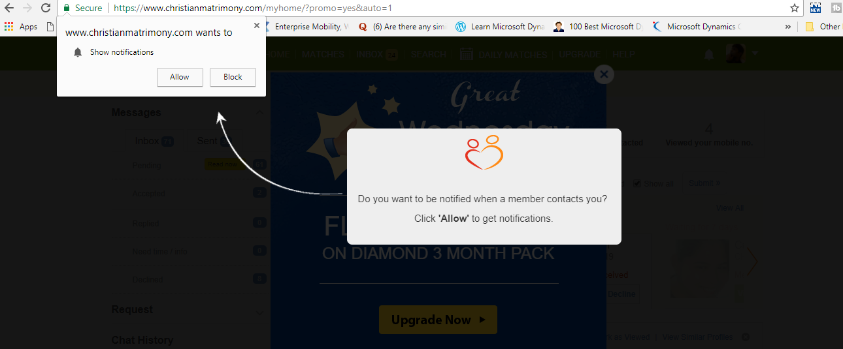

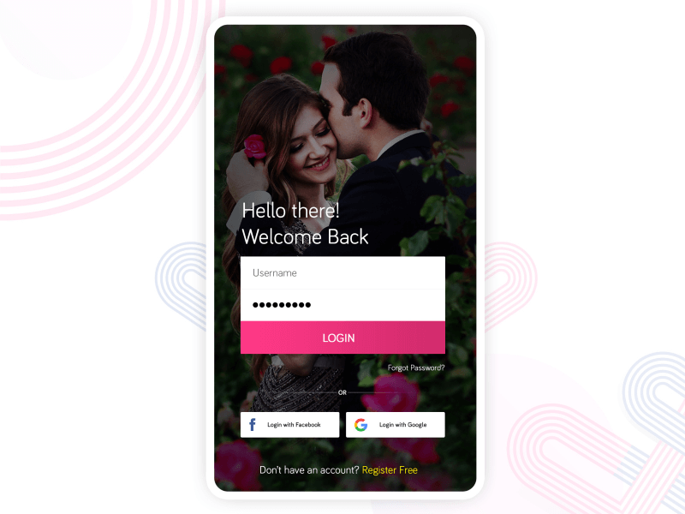

**User Privacy & User-Blocking feature:**

It is vital to ensure the privacy of the app users as well as allow the app users to block the other user profiles which might be creating an unnecessary nuisance for them.

**Warning Pop With:**

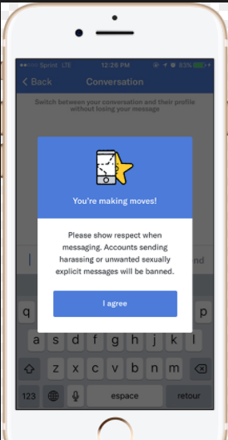

**Search & Filter:**

This feature will allow the users to search for the prospects as per their likings as interest, like their location, occupation, community, etc.

**Pin Favorite:**

Users can save their favorite profiles or interested users so that they can conveniently access them for further procedures.

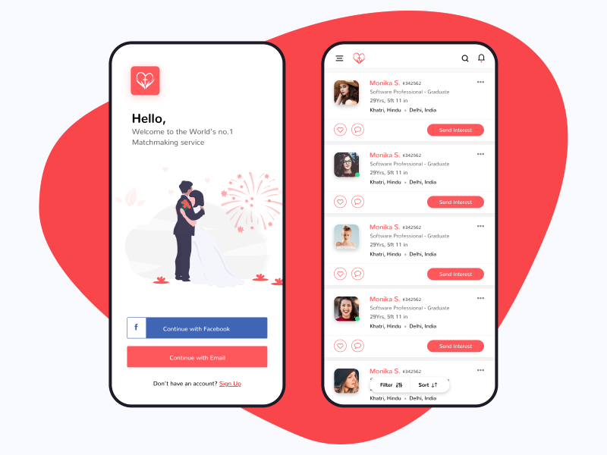

**Social Integration:**

This feature helps users to check the social profiles of interested persons to know them in a better way and it also helps them to check the other person’s daily activities.

**User Authentication:**

Users’ authenticity can be confirmed by integration OTP (one-time-password) feature into matrimony app, via SMS, call, email, etc. It is a useful feature at the time of sign up and in cases where users forget their login credentials and need to get access to their accounts back.

**POP Message With Number of Likes Received:**

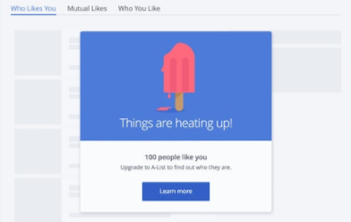

**Data Security:**

Security of user data must be ensured at all costs and this can be done easily by taking care of certain security features that keep user data safe and secure.

**Multiple payment modes:**

This feature enables app users to make easy payments by integrating multiple payment modes, such as payU, PayPal, Credit/Debit Cards, UPI, Net banking etc. as well as offer the feature of multi-currency as well. This would help people from all across the world to make payment easily in case they are keen on upgrading to premium features of matrimony application.

**CMS Integration:**

A Content Management System (CMS) allows to manage entire available digital content on the matrimonial platform.

**Role-Based Dashboards:**

This is an exclusive feature for the admin where they can monitor and analyze real-time statistics. As per the different users, the statistics and reports are available which helps in deriving the business and marketing strategies.

**App Design:**

With a matchmaking app, you must be desiring to cater to a large set of audiences. For this, you would require to make app really appealing, hence pay special attention to the app design and apart from making it appealing, and also ensure that it is easy to use. Now, integrating an attractive design will certainly add to the cost, but it will surely be worthy.