Development Error Log

Table of Contents

1. Error starting backend application 2

# Error starting backend application

**Error**

java.lang.IllegalArgumentException: Sources must not be empty

at org.springframework.util.Assert.notEmpty(Assert.java:276) ~[spring-core-4.3.4.RELEASE.jar:4.3.4.RELEASE]

at org.springframework.boot.SpringApplication.prepareContext(SpringApplication.java:365) [spring-boot-1.4.2.RELEASE.jar:1.4.2.RELEASE]

at org.springframework.boot.SpringApplication.run(SpringApplication.java:313) [spring-boot-1.4.2.RELEASE.jar:1.4.2.RELEASE]

**Analysis**

* Is [boot] shown next to C4SGSvc?

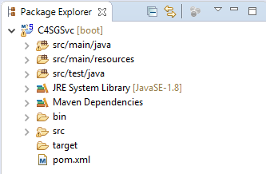

* Do you have plug-in *Spring Tool Suite (STS) for Eclipse* installed?
* Do you start the application by: Right click on project: C4SGSvc, Run as: Spring Boot App