Lema 2022-2023
“Unidos en la Amistad
para el Servicio”

Lema del Presidente
Rotary International
Jennifer E. Jones

“Imagina Rotary”

Gobernador
Distrito 4975
Edgardo Gargano

Autoridades Rotary Club de Montevideo

Presidente
Miguel Aguerre

1er. Vicepresidente
Héctor Rubio Sica

2do. Vicepresidente
Bartolomé Grillo

Secretario
César Pardiñas

Pro-Secretario
Carlos Varela

Tesorero
José Mermelstein

Pro-tesorero
Walter Ojero

Presidente 2021-2022
Santiago Conde

Presidente 2023-2024
Jorge Rosales

Comités

Administración del Club
Ernesto Argenti / Juan Aitcin

Relaciones Internacionales
Rodolfo Barbato / Fredy Mayer

Relaciones Públicas e
Imagen Pública
Jorge Rosales / Carlos Salveraglio

La Fundación Rotaria
Fredy Mayer / Lourdes Rapalin

Desarrollo Cuadro Social
Washington Corallo / Daniel Varela

Nuevas Generaciones
Matías Ferrari

Macero
Dietmar Woelke

JERRY P ZDRIL
SHIPPING MANAGER
ROTARY WORLD HELP

Dear Jerry,

We have received the material fromthe container which has been assigned to different health centers. These have all been safely conveyed. Many thanks to Rotary for having provided this valuable equipment to fulfill the needs and constraints of these beneficiary communities.

We would also like to inform you that the Rotary Club Montevideo has made the payment of the maritime freight of the container. The transfer receipt is attached, and we are thankful for the conditions that they have offered us for its cancellation.

The Rotary Club Montevideo - the first Rotary club in South America, would like to convey to you its profound gratitude. We are firm in our intentions in serving the needs of disadvantaged groups and improving the conditions of these beneficiaries which have been addressed with this much needed and relevant donation.

By this means we would also like to convey our willingness and hope to receive further possible donations, following your previous messages, as there is need for hospital beds.

Once again, we reiterate our thanks for all the support and that of Mr. Aldo Brussoni.
Yours sincerely,

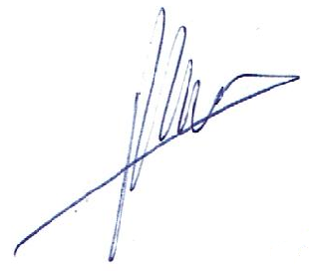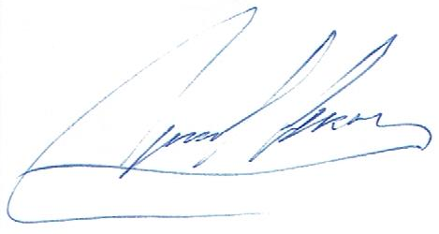
Dr. César Pardiñas Cr. Miguel Aguerre
Secretario Presidente
Rotary Club de Montevideo Rotary Club de Montevideo

