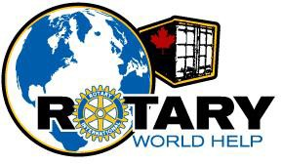

ROTARY CLUBS OF THE LOWER MAINLAND OF BRITISH COLUMBIA WORLD HELP NETWORK
(Operating as Rotary World Help)

2022
Annual Report

AGM AGENDA
Friday, May 5, 2023
Moberly Arts and Cultural Centre
7646 Prince Albert Street
Vancouver, BC
- 5:30 – 6:30 Registration and socializing
- 6:30 Introduction of guest speaker – Yashar Keramati
- Thank you to guest speaker – Jerry Zdril
- 7:00 Buffet dinner served.
- 8:15 Call AGM to order
- Welcome – Jerry Zdril
- Verification of Quorum – D’Arcy Warner
- Motion to approve 2021 AGM minutes.
- President’s report – Jerry Zdril
- Treasurer’s report – Janice Froese
- Waiver of auditors for the year – Janice Froese
- Election of Officers and Directors – D’Arcy Warner
- Presentation of 2022 “Ralphies” – Jerry Zdril, Wayne Crossen
- Motion to adjourn formal AGM.

GUEST SPEAKER
Yashar Keramati

My relationship with Rotary World Help began in 2011 while I was a Rotary Ambassadorial Scholar in South Africa, District 9350, completing my master’s thesis in gangsterism as an Alumni of the Rotary Foundation and conducting projects for my NGO Peace and Love International. RWH sent me an incredible container through which I was able to support 11 other local NGOs while developing my own projects as well. In fact, the container itself was transformed into a recording studio for at risk youth, keeping them out of gangs and off the streets.

Over a decade later I find myself in Havana, Cuba, more connected to the amazing work that RWH does. Since being here I have received 2 forty-foot containers filled with medical equipment which serve some of the city’s busiest hospitals. During my presentation I would like to show the members how they are helping save lives in the hospitals where I work and remind them how truly unique RWH is.

AGENDA/MINUTES - 2022 ANNUAL GENERAL MEETING

MINUTES -- ANNUAL GENERAL MEETING
Rotary Clubs of the Lower Mainland of BC World Help Network
Thursday May 5, 2022 7:00 pm
VIA ZOOM

Clubs Present: | Burnaby Deer Lake | Richmond Sunrise
 | Coquitlam | Semiahmoo
 | Ladner | South Surrey
 | Langley Central | Strathcona Sunrise
 | North Delta | Surrey
 | North Vancouver | Tsawwassen
 | Port Moody | Vancouver
 | PNW Passport | Vancouver Sunrise
 |  | West Vancouver Sunrise
- Welcome:
President Jerry Zdril, called the meeting to order at 7:10 pm. He welcomed all Rotarians and guests.
- Quorum:
D’Arcy Warner reported that there was a quorum present and that the AGM for the Rotary Clubs of the Lower Mainland of BC World Help Network could be conducted.
  - The number of attendees was: 25.
  - Member Clubs in attendance: 17
Quorum confirmed
- Agenda:
The motion to adopt the Agenda as amended was made by Dan Gallant and seconded by Bonnie Sutherland. Motion carried.

- Minutes of 2021 AGM for the Year Ending December 31, 2020:
Elena Agala and Dale Shea seconded that the minutes of the May 13, 2021 AGM (for the year ending December 31, 2020) be approved as circulated. Motion carried.

- President’s Report – Jerry Zdril:
President Jerry Zdril presented his Report on activities of the Society for the year ending December 31, 2021. A copy of the report had previously been circulated. Jerry reflected on the success of Rotary World Help amidst the many shipping and activity restrictions that came with the Covid Pandemic.

- Financial Statements – Janice Froese:
Janice Froese as Treasurer presented the financial statements for the year ending December 31, 2021.
Moved by Dale Shea and seconded by Dan Gallant that the financial statements for the year ending December 31, 2021 be approved as circulated. Motion carried.
- Auditors to be Waived:
Moved by Wayne Crossen and seconded by D’Arcy Warner that the appointment of an Auditor be waived for the 2020/2021 fiscal year. Motion carried.
- Nomination Committee – D’Arcy Warner:
President Jerry Zdril conveyed are heartfelt thanks to two members of the Board of Directors who would be stepping down this year, namely Wayne Crossen (Langley Central) and Ian MacPhail (Port Moody). He also welcomed two members who threw their hats in the ring to join our board, Ian Johnston, and Steve Frishling. It is always sad to see Directors move on, but President Jerry noted that we look forward to working with Ian and Steve moving forward. The following people have been nominated for election to the Board of the Society:
Director: Jerry Zdril
Director: Janice Froese
Director Bridget Jacob
Director: Dan Gallant
Director: Jim McGrandles
Director: Elena Agala
Director: Dale Shea
Director: Bonnie Sutherland
Director: D’Arcy Warner
Director: Dr. Kathleen Ross
Director: Mekdes Gete
Director:……………………………….…………………….Nathan Hesketh
Director:…………………………………………..…………….Ian Johnston
Director:……………………………………………………….Steve Frishling
D’Arcy invited other nominations from the floor (three times).
Hearing none, D’Arcy Warner moved, and Bridget Jacob seconded that the above people be elected (as indicated above) to hold office in the Society until their successors are appointed or elected. Motion carried.

- Guest Speakers:
We were joined by three speakers, who provided insight into the work that they are each involved in throughout the developing world.
The first speaker was Dr Mpoki
Dr Mpoki, High Commissioner of Tanzania to Canada and serves as Permanent Secretary at the Ministry of Health in Tanzania
Second speaker was Dr Yashar Keramati
Dr Yashar Keramati, currently working as a Physician in Cuba. His connection with Rotary began when he was a Rotary Ambassadorial Scholar
Third Speaker was Dr Joe Delvicario
Dr. Joe Delvicario, a St. Paul’s anesthesiologist, and President of Health for Humanity Service Society
Dr. Mpoki, Dr. Yashar Keramati and Dr. Joe Delvacio gave us all a fascinating look into the day-to-day work that they can and do perform through the use of the medical supplies and equipment sent in Rotary World Help containers.
- Adjournment of AGM:
Since there was no other business to come before this AGM, the meeting was adjourned. Moved by Dr. Kathleen Ross and seconded by Jim McGrandles. Carried.

2022 ANNUAL GENERAL MEETING - PRESIDENT’S REPORT

Our 25th year of operations serving the world was challenging.
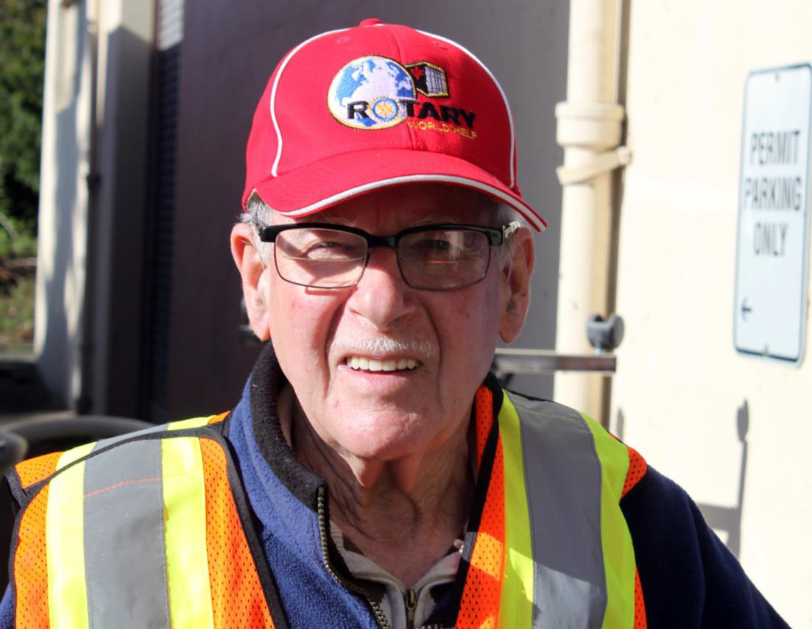
Ralph Towsley was the binding person of the group of 3 who were instrumental in putting into motion the creation of ROTARY CLUBS OF THE LOWER MAINLAND OF BC WORLD HELP NETWORK in 1997. This organization now operates as ROTARY WORLD HELP. Bill Richwa and Ted Segodnia were the other two members of the group, and all were members of the Vancouver Rotary Club.

There were strong ties between Bill Richwa and Ralph Towsley, having both worked for many years with International Packers out of Saskatoon and later in Vancouver. They traveled together with their families, they socialized together frequently, they worked together on Rotary projects one being ROTARY WORLD HELP and gave total support on an ongoing basis. Unfortunately, Bill Richwa got cancer and passed away in 2005. Ralph continued to be the strong leader after Bill's passing, giving leadership at board meetings, assisting at loadings, assisting at packing and being a strong supporter of the project with Rotary Club of Vancouver . Ralph's family has assisted over the years at loadings and his wife Sue Harald-Towsley dedicated years of packing inventory at the ROTARY WORLD HELP warehouse.
Ralph was ever the diplomat, fantastic problem solver and great practical attitude.

Ralph passed away in 2022.

Ralph is missed by his family, the housing complex where he had resided for many years, Vancouver Rotary Club, and we the members of the ROTARY WORLD HELP organization.

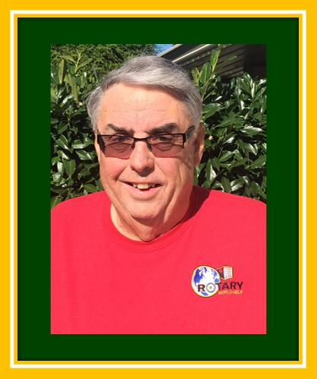
Steve Gable served as Treasurer and was instrumental in opening new relationships in the Philippines which resulted in several additional containers shipped. He was the shipping manager for many years.
Steve traveled to South Africa and the Philippines with a RWH delegation.
Steve passed away in 2022.

Since our inception, we have sent 441 containers to 61 countries for an estimated replacement value of $15 Million and it is estimated our containers have touched the lives of 12.5 million men, women, and children.

We currently have 40 paid up members clubs.

As most of you know, we get telephone calls and emails from local hospitals, clinics, seniors’ homes, and individuals who have equipment they wish to donate. We couldn’t do all we do without the wonderful support of Dan Gallant and all his great helpers with the truck. All of the volunteers who do the weekly inspection, sorting, and packing, Lorraine, Gwen, Martine, Betty Anne, Jane, Flora, Bernadette, Val, Doris, Sue.

Then there are all the of the volunteers who so faithfully show up rain, sun, or snow to load our containers. We are also so lucky to have you all.

Unfortunately, this year two of our key board members, Wayne Crossen, and Ian MacPhail, submitted their resignations.

Of course, nothing would be possible without our Board of Directors and Officers, who work so hard. Please stand and be recognized.

Thank you ever so much everyone for such a wonderful year.

Jerry Zdril President and Shipping Manager
Rotary World Help 2020-2021

TREASURER’S REPORT

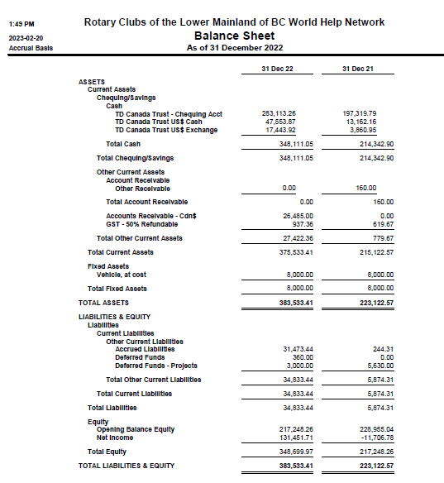

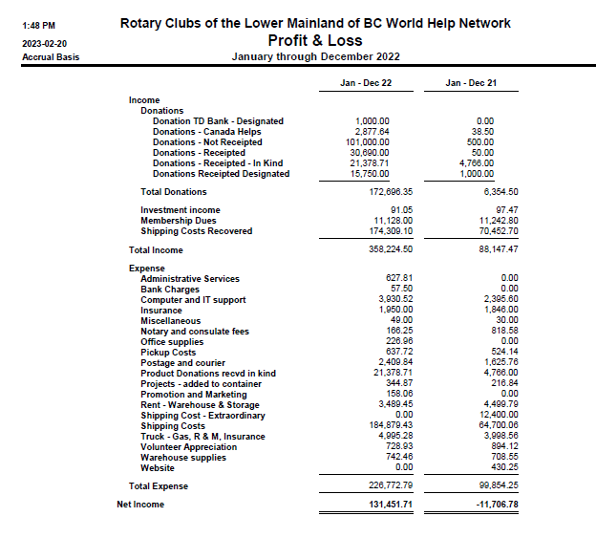

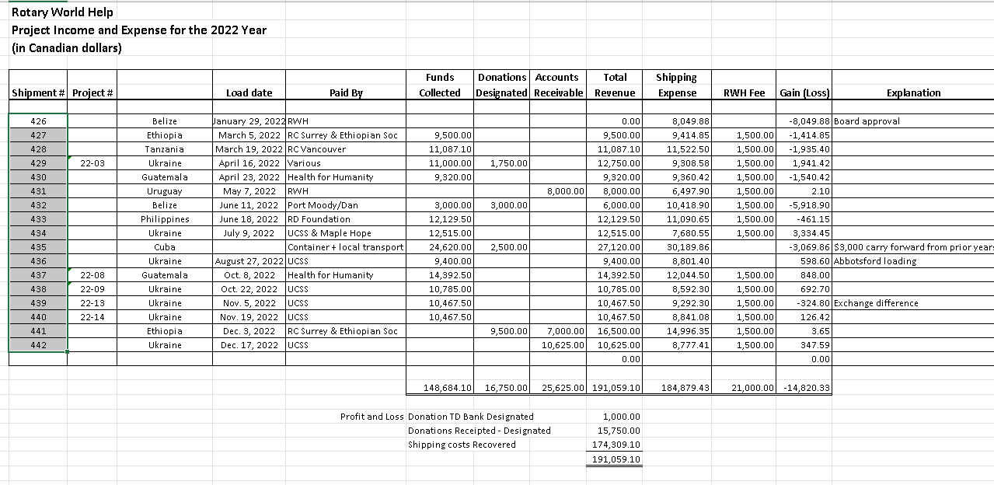

History of Rotary World Help

In 1992 District 5040 Rotarians established a Rotary Club in Kiev, Ukraine and when the Rotarians went to Kiev for the club charter, they saw the state of the medical facilities. The appalling conditions challenged them to find a way to help. In 1993, the late Ted Segodnia persuaded fellow members, the late Bill Richwa and Ralph Townsley to become involved. Together they organized the first shipment of medical supplies and equipment to Kiev and Ted, Bill and their wives went to Kiev to oversee the distribution of the supplies.

When they returned home, they found more donations waiting and the supplies kept coming. They managed to convince the Vancouver Rotary Club to carry on the project under their international service portfolio. By 1997, the project became too big for one club to handle and Bill Richwa and Ralph Townsley realized that if the project was to survive it was time for it to evolve, and thus the Rotary World Help Network was born. In September of 1997, when seven Rotary Clubs joined together to form the Network.

In 2011 the name was shortened to Rotary World Help and our new logo and website were launched.

Who Are We
Rotary World Help (RWH) is a non-profit, registered charitable organization that coordinates the shipment of educational, humanitarian, and medical supplies to countries in need. Established in 1997 by seven Rotary clubs, RWH is operated by a Board of directors made up of Rotarians from various member clubs in British Columbia.

Our mission is to help communities help themselves. We accomplish this through a coordinated effort to relocate used equipment and supplies. What’s surplus in our country is desperately needed to serve the healing and educational needs of developing countries. Our effort is made possible through generous donations of materials, money, time, and transportation.
There’s a wealth of equipment and supplies no longer in use in British Columbia. These materials can be of great use to foreign countries in need of medical and educational supplies.

Rotary volunteers throughout British Columbia gather, sort, repair, pack, inventory, and prepare the donated equipment and supplies for shipping. Acting as one central clearing- house makes the collection of usable materials donor-friendly. Basically, we act as a world- wide recycling depot.

We gather the goods for our shipments from hospitals, health care and educational facilities, and various community–minded organizations.
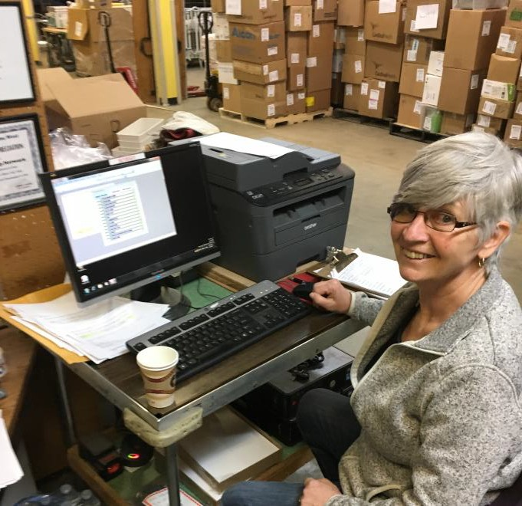
Marion Crossen, entering a manifest on loading day!

Why We Do What We Do
Hospitals are built but cannot open because they lack beds, supplies, and medical equipment. Our shipments have made it possible for many hospitals around the world to serve the people of their community more effectively.

We accept medical supplies and equipment ranging from bandages and thermometers to operating tables and wheelchairs. Many countries have schools but no school supplies. Classrooms are run without paper to write on and books to learn from. We accept school texts, writing paper, pens and pencils, educational supplies, and equipment.
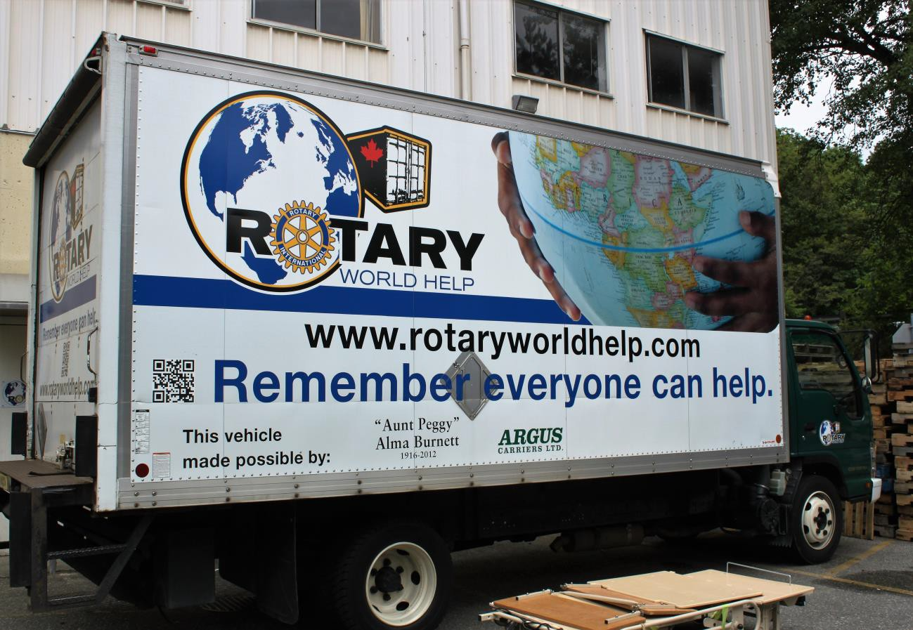

Our truck purchased with a donation from Aunt Peggy

Our Numbers as of December 31st, 2022
Containers shipped in 2022: 17.

Numbers Since Inception
Containers shipped since inception: 446 Estimated value of goods shipped: $150 Million Number of countries shipped to: 61.
Estimated number helped: 12,500,000 people.

Listing of Countries, We’ve Shipped To:

Albania | Cook Islands (4) | Grenada | Nicaragua (3) | Tanzania (6)
Antigua | Costa Rica | Guatemala (7) | Panama (16) | Thailand (3)
Argentina (4) | Cuba (5) | Guyana | Paraguay (1) | Tonga
Armenia | Dominican Republic (4) | Haiti (4) | Peru (2) | Trinidad and Tobago
Barbados | East Timor | Honduras (17) | Philippines (125) | Uganda (22)
Belize (6) | Ecuador (3) | Indonesia | Poland | Ukraine (24)
Bolivia (7) | El Salvador (12) | Kenya (28) | Romania (3) | United States (2)
Brazil (2) | Estonia (7)  Ethiopia (4) | Lesotho | Samoa | Uruguay (15)
Cambodia (2) | Fiji | Liberia (2) | Serbia | Venezuela
Chile (21) | Georgia | Malaysia | Sierra Leone | Vietnam (4)
Colombia (2) | Ghana (5) | Nepal (4) | South Africa (20) | Zambia
Congo (7) | Greece (2) | New Guinea | Tajikistan | Zimbabwe (12)

Total Shipments
(As at Dec 31/22
)
Far East
4%
Europe
8% North America
1%
Philippines
26%
Central America &
Caribbean 13%
South America
21%
Africa 25%
South Pacific 2%
Member Clubs

Membership

By joining Rotary World Help, Rotary Clubs play a part in every shipment sent by Rotary World Help and are involved in an organization that connects Rotary Clubs around the world. Clubs belong to Rotary World Help by paying annual membership dues of $10 per club member. Membership fees offset administrative, procurement, and some of the shipping costs. Being a member helps a club meet District objectives for International Service and work parties such as pick-ups, sorting and loading shipments are considered a meeting make- up. Throughout the year, hundreds of British Columbian Rotarians and often their spouses and families work together to help Rotarians in other parts of the world help people in their communities.

Through Rotary World Help, a member club can sponsor the shipment of a 40-foot container to a partnering Rotary Club in another country. Rotary Clubs can sponsor a shipment on their own or partner with one or more local clubs and split the cost of the shipment.

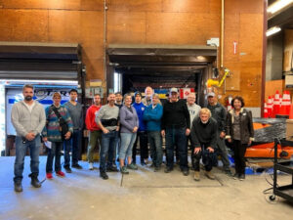

Loading the 9th container in 2022 for Ukraine.

Founding Member Clubs

Coquitlam | New Westminster
North Vancouver – Lions Gate | Richmond – Sunrise
Vancouver | Vancouver – Chinatown
West Vancouver

Current Member Clubs - 42

Arbutus | Powell River
Burnaby | Prince George Nechako
Burnaby Deer lake | Richmond
Coquitlam | Richmond Steveston
Coquitlam Sunrise | Richmond Sunrise
Cumberland Centennial | Richmond Sunset
Golden Ears Sunrise | Strathcona Sunrise
Ladner | Sechelt
Langley | South Surrey
Langley Central | Surrey
Langley Sunrise | Sunshine Coast
New Westminster | Terrace
New Westminster Royal City | Tsawwassen
North Delta | Vancouver
North Vancouver | Vancouver Fraser view
North Vancouver Lions Gate | Vancouver Mountainview
Pacific Northwest Passport | Vancouver Sunrise
Peace Arch/Peninsula | West Vancouver
Port Coquitlam Centennial | West Vancouver Sunrise
Pemberton | Whistler
Port Moody | Whistler Millennium

Last, But Not Least!

- All our club members
- All our volunteers
- Our Directors
- Our Officers
- Our Spouses

We could not do it without all of you!


