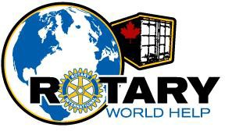

ROTARY CLUBS OF THE LOWER MAINLAND OF BRITISH COLUMBIA WORLD HELP NETWORK
(Operating as Rotary World Help)

2023
Annual Report

AGM AGENDA
Friday, May 3, 2024
Rotary Field House
14600 Rotary Way
Surrey, BC
- 5:30 – 6:30 Registration and socializing
- Welcome – Jerry Zdril
- 6:30 Buffet dinner served.
- 7:30 Call AGM to order
- Verification of Quorum – D’Arcy Warner
- Motion to approve 2023 AGM Minutes
- President’s report – Jerry Zdril
- Treasurer’s report – Janice Froese
- Waiver of auditors for the year – Janice Froese
- Election of Officers and Directors – Dan Gallant
- 8:30 Introduction of guest speaker – Elena Agala
- Thank you to guest speaker – Jerry Zdril
- Presentation of 2023 “Ralphie” – Jerry Zdril
- Motion to adjourn formal AGM.

MINUTES -- ANNUAL GENERAL MEETING
Rotary Clubs of the Lower Mainland of BC World Help Network
Thursday May 5, 2023 7:00 pm
Moberly Arts and Cultural Centre
7646 Prince Albert Street
Vancouver, BC

Clubs Present: Burnaby Richmond Sunrise
Burnaby Deer Lake Coquitlam Sunrise
Coquitlam Semiahmoo – White Rock
Ladner South Surrey
Langley Central Vancouver Arbutus
PG Nechako New Westminster
North Delta Surrey
North Vancouver Tsawwassen
Sechelt Vancouver
PNW Passport Vancouver FraserView
North Vancouver Lions Gate West Vancouver Sunrise
- Welcome:
President Jerry Zdril, called the meeting to order at 7:00 pm. He welcomed all Rotarians and guests.
- Quorum:
D’Arcy Warner reported that there was a quorum present and that the AGM for the Rotary Clubs of the Lower Mainland of BC World Help Network could be conducted.
  - The number of attendees was: 40.
  - Member Clubs in attendance: 22
Quorum confirmed.
- Agenda:
The motion to adopt the Agenda as amended was made by Jim McCrandles and seconded by Bonnie Sutherland. Motion carried.
- Minutes of 2022 AGM for the Year Ending December 31, 2022:
Elena Agala and Dale Shea seconded that the minutes of the May 13, 2022 AGM (for the year ending December 31, 2022) be approved as circulated. Motion carried.

- President’s Report – Jerry Zdril:
President Jerry Zdril presented his Report on activities of the Society for the year ending December 31, 2022. A copy of the report had previously been circulated. Jerry reflected on the success of Rotary World Help amidst the many shipping and activity restrictions that came with the Covid Pandemic.
- Financial Statements – Janice Froese:
Janice Froese as Treasurer presented the financial statements for the year ending December 31, 2022.
Moved by Dale Shea and seconded by Steve Frishling that the financial statements for the year ending December 31, 2022 be approved as circulated. Motion carried.
- Auditors to be Waived:
Moved by Wayne Crossen and seconded by D’Arcy Warner that the appointment of an Auditor be waived for the 2023/2024 fiscal year. Motion carried.
- Nomination Committee – D’Arcy Warner:
President Jerry Zdril conveyed our heartfelt thanks to two members of the Board of Directors who would be stepping down this year. The following people have been nominated for election to the Board of the Society:
Director: Jerry Zdril
Director: Janice Froese
Director Bridget Jacob
Director: Dan Gallant
Director: Jim McGrandles
Director: Elena Agala
Director: Dale Shea
Director: Bonnie Sutherland
Director: D’Arcy Warner
Director: Dr. Kathleen Ross
Director: Mekdes Gete
Director:……………………………….…………………….Nathan Hesketh
Director:…………………………………………..…………….Ian Johnston
Director:……………………………………………………….Steve Frishling
D’Arcy invited other nominations from the floor (three times).
Hearing none, D’Arcy Warner moved, and Bridget Jacob seconded that the above people be elected (as indicated above) to hold office in the Society until their successors are appointed or elected. Motion carried.

- Guest Speaker:
Yashar Keramati: A Rotary Ambassadorial Scholar in South Africa, District 9350, completing his master’s thesis in gangsterism as an Alumni of the Rotary Foundation and conducting projects for NGO Peace and Love International. RWH sent him an incredible container through which he was able to support 11 other local NGOs while developing his own projects as well. In fact, the container itself was transformed into a recording studio for at risk youth, keeping them out of gangs and off the streets.
Over a decade later he found himself in Havana, Cuba, more connected to the amazing work that RWH does. Since being here, he received 2 forty-foot containers filled with medical equipment which serve some of the city’s busiest hospitals. During his presentation showed the members how they are helping save lives in the hospitals where he works and reminded us how truly unique RWH is.
Adjournment of AGM:
Since there was no other business to come before this AGM, the meeting was adjourned. Moved by Mekdes Gete and seconded by Jim McGrandles. Carried.

2023 ANNUAL GENERAL MEETING - PRESIDENT’S REPORT

History of Rotary World Help

In 1992 District 5040 Rotarians established a Rotary Club in Kyiv, Ukraine and when the Rotarians went to Kyiv for the club charter, they saw the state of the medical facilities. The appalling conditions challenged them to find a way to help. In 1993, the late Ted Segodnia persuaded fellow members, the late Bill Richwa and Ralph Townsley to become involved. Together they organized the first shipment of medical supplies and equipment to Kyiv and Ted, Bill and their wives went to Kyiv to oversee the distribution of the supplies.

When they returned home, they found more donations waiting and the supplies kept coming. They managed to convince the Vancouver Rotary Club to carry on the project under their international service portfolio. By 1997, the project became too big for one club to handle and Bill Richwa and Ralph Townsley realized that if the project was to survive it was time for it to evolve, and thus the Rotary World Help Network was born. In September of 1997, when seven Rotary Clubs joined together to form the Network.

In 2011 the name was shortened to Rotary World Help and our new logo and website were launched.

Who Are We
Rotary World Help (RWH) is a non-profit, registered charitable organization that coordinates the shipment of educational, humanitarian, and medical supplies to countries in need. Established in 1997 by seven Rotary clubs, RWH is operated by a Board of directors made up of Rotarians from various member clubs in British Columbia.

Our mission is to help communities help themselves. We accomplish this through a coordinated effort to relocate used equipment and supplies. What is surplus in our country is desperately needed to serve the healing and educational needs of developing countries. Our effort is made possible through generous donations of materials, money, time, and transportation.
There is a wealth of equipment and supplies no longer in use in British Columbia. These materials can be of significant use to foreign countries in need of medical and educational supplies.

Rotary volunteers throughout British Columbia gather, sort, repair, pack, inventory, and prepare the donated equipment and supplies for shipping. Acting as one central clearing- house makes the collection of usable materials donor-friendly. We act as a worldwide recycling depot.

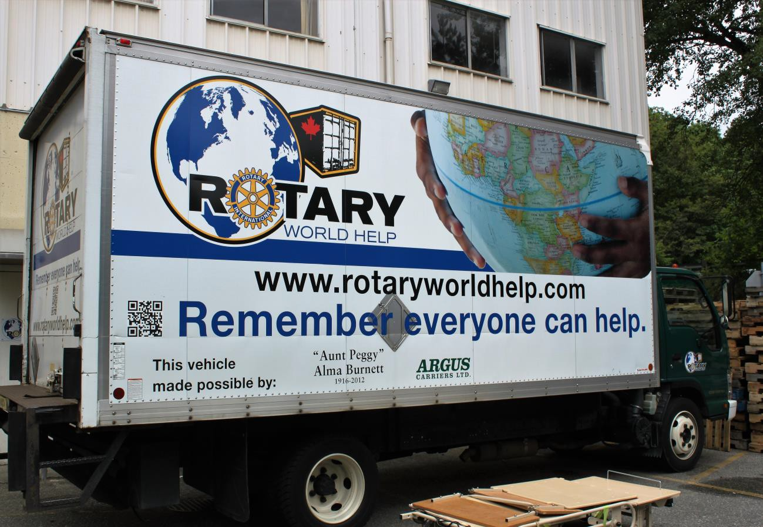
We gather the goods for our shipments from hospitals, health care and educational facilities, and various community–minded organizations.
Our truck purchased with a donation from Aunt Peggy

Why We Do What We Do
Hospitals are built but cannot open because they lack beds, supplies, and medical equipment.
We accept medical supplies and equipment ranging from bandages and thermometers to operating tables and wheelchairs. Our shipments have made it possible for many hospitals around the world to serve the people of their community more effectively.

Many countries have schools but no school supplies. Classrooms are run without paper to write on and books to learn from. We accept school texts, writing paper, pens and pencils, educational supplies, and equipment.

RWH has shipped hundreds of computers to Africa, Belize and Guatemala to rural students providing them with access to education materials that they would not otherwise have.

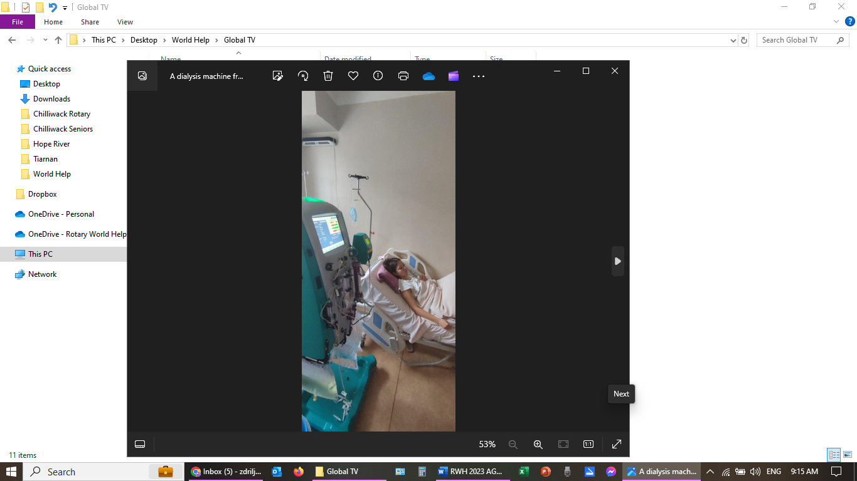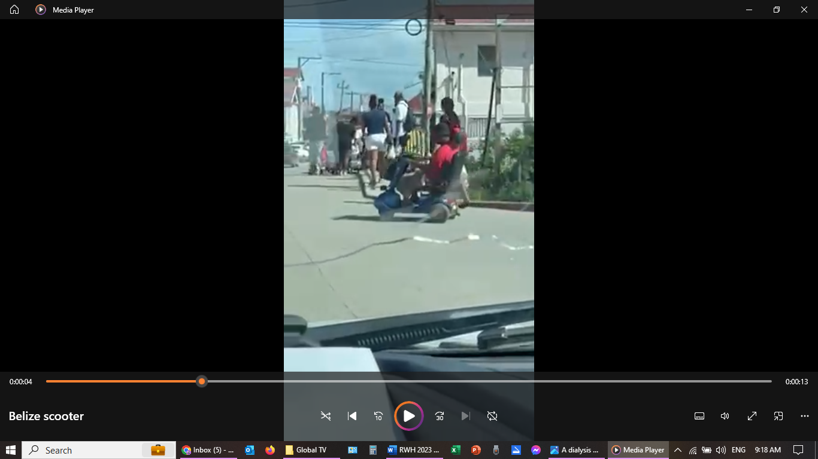
12-Year-Old Child in Ukraine Scooter for Belize

Our Numbers as of December 31st, 2023
Containers shipped in 2023: 14.

Containers shipped since inception: 456 Estimated values of goods shipped: $150 Million Number of countries shipped to: 61.
Estimated number of people helped: 13.5 Million.

Countries That We Have Sent Containers To:

Albania | Costa Rica | Grenada | Nicaragua (3) | Tanzania (6)
Antigua | Cuba (5) | Guatemala (7) | Panama (16) | Thailand (3)
Argentina (4) | Dominican Republic (4) | Guyana | Paraguay (1) | Tonga
Armenia | East Timor | Haiti (4) | Peru (2) | Trinidad and Tobago
Barbados | Ecuador (3) | Honduras (17) | Philippines (125) | Uganda (22)
Belize (6) | El Salvador (12) | Indonesia | Poland | Ukraine (24)
Bolivia (7) | Estonia (7) | Kenya (28) | Romania (3) | United States (2)
Brazil (2) | Ethiopia (5) | Lesotho | Samoa | Uruguay (15)
Cambodia (2) | Fiji | Liberia (2) | Serbia | Venezuela
Chile (21) | Georgia | Malaysia | Sierra Leone | Vietnam (4)
Colombia (2) | Ghana (5) | Nepal (4) | South Africa (20) | Zambia
Congo (7) | Greece (2) | New Guinea | Tajikistan | Zimbabwe (12)
Cook Islands (4)

TREASURER’S REPORT

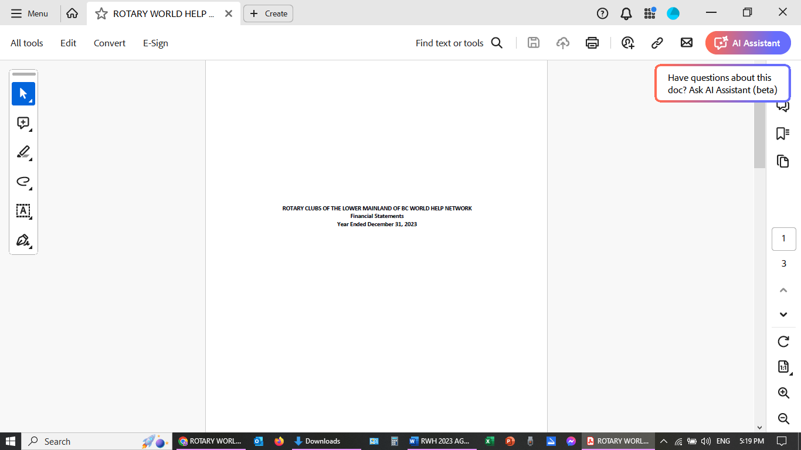

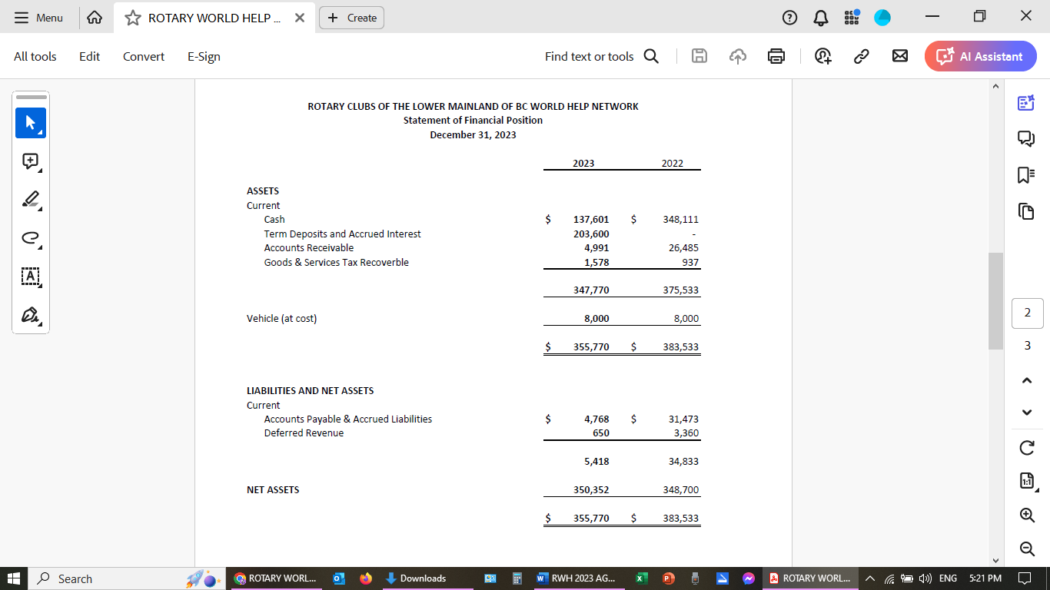

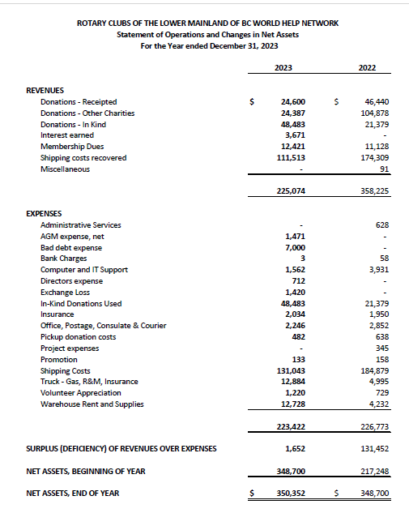

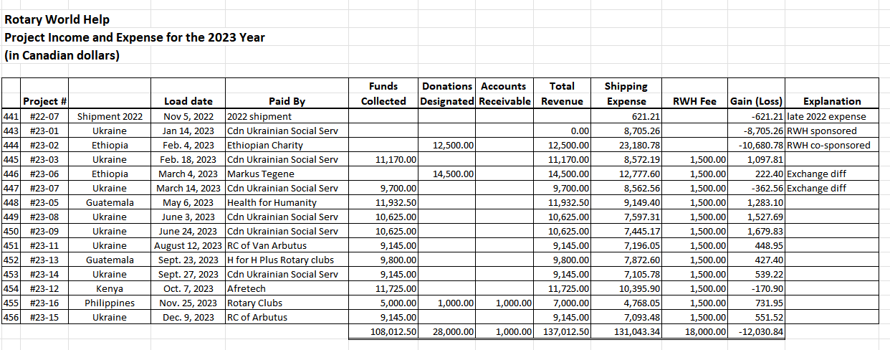

Member Clubs

We currently have 43 paid up members clubs.

By joining Rotary World Help, Rotary Clubs play a part in every shipment sent by Rotary World Help and are involved in an organization that connects Rotary Clubs around the world. Clubs belong to Rotary World Help by paying annual membership dues of $10 per club member. Membership fees offset administrative, procurement, and some of the shipping costs. Being a member helps a club meet District objectives for International Service and work parties such as pick-ups, sorting and loading shipments are considered a meeting make- up. Throughout the year, hundreds of British Columbian Rotarians and often their spouses and families work together to help Rotarians in other parts of the world help people in their communities.
Through Rotary World Help, a member club can sponsor the shipment of a 40-foot container to a partnering Rotary Club in another country. Rotary Clubs can sponsor a shipment on their own or partner with one or more local clubs and split the cost of the shipment.
Founding Member Clubs

Coquitlam | New Westminster
North Vancouver – Lions Gate | Richmond – Sunrise
Vancouver | Vancouver – Chinatown
West Vancouver

Current Member Clubs - 43

Aldergrove | Powell River
Burnaby | Prince George Nechako
Burnaby Deer lake | Richmond
Chilliwack | Richmond Steveston
Coquitlam | Richmond Sunrise
Coquitlam Sunrise | Semiahmoo White Rock
Cumberland Centennial | Strathcona Sunrise
Golden Ears Sunrise | Sechelt
Ladner | South Surrey
Langley | Surrey
Langley Central | Sunshine Coast
Langley Sunrise | Terrace
New Westminster | Tsawwassen
New Westminster Royal City | Vancouver
North Delta | Vancouver Fraserview
North Vancouver | Vancouver Arbutus
North Vancouver Lions Gate | Vancouver Sunrise
Pacific Northwest Passport | Vancouver Cambie
Pemberton | West Vancouver Sunrise
Port Coquitlam Centennial | Whistler
Port Moody | Whistler Millennium

Last, But Not Least!
- All our club members
- All our volunteers
- Our Directors
- Our Officers

- Our Spouses

As most of you know, we get telephone calls and emails from local hospitals, clinics, seniors’ homes, and individuals who have equipment they wish to donate.

We could not do all we do without the wonderful support of Dan Gallant and all his great helpers with the truck (Ron, Dale, Wayne).

All of the volunteers who do the weekly inspection, sorting, and packing, Lorraine, Gwen, Martine, Betty Anne, Jane, Flora, Bernadette, Val, Doris, Sue.

Then there are all the of the volunteers who so faithfully show up rain, sun, or snow to load our containers. We are also so lucky to have you all.

To our Board of Directors and Officers, who work so hard. Please stand and be recognized.
Jerry Zdril
We could not do it without all of you!
President and Shipping Manager
Rotary World Help 2022-2023

