Free translation from RSDN Magazine #4-2010, http://rsdn.ru/article/dotnet/NET4Security.xml

Create and launch these applications not from Windows administrator account (launch from it only if necessary).

The first of these applications is a basic and simply calls (through interoperability) unmanaged functions GetComputerName and GetVersion. Initially, the entire assembly is marked as critical, and any problems when you start does not occur. Now make the assembly "transparent" for what comment the first attribute and uncomment the second one , ie, give these lines to this form
//[assembly: SecurityCritical]
[assembly: SecurityTransparent]

->Step_1
try
{
Cl1 cl = new Cl1();
cl.GetCompName();
}
catch (Exception ex)
{
Console.WriteLine(ex.Message);
}
uint ver = GetVersion();
Console.WriteLine("Ver " + ver);
Console.WriteLine("Press any key to continue");
Console.ReadKey(true);

public class Cl1
{
[DllImport("kernel32", CharSet = CharSet.Auto)]
public static extern Int32 GetComputerName(String Buffer, ref Int32 BufferLength);

public void GetCompName()
{
Int32 bufferLength = 16;
String comName = new string(' ', bufferLength);
GetComputerName(comName, ref bufferLength);
comName = comName.Trim();
Console.WriteLine("Computer Name:");
Console.WriteLine(" {0} ({1})", comName, bufferLength);
}

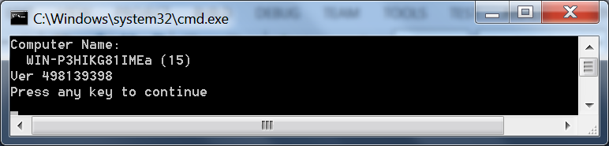

And where "in the resource" protection? What if we want to limit your code so that it has access to a single folder on drive C: \, and even read-only? Or the same for the registry key? Even a transparent code has full access to that and the other. Well, these resources are not included in the list of "restrictive" operations! What proves Step_2 - «transparent» assembly works on the C: \ drive nearly whatever it wants …

→ Step_2
using System.Runtime.InteropServices;
using System.IO;
using System.Security;

string fp1 = @"c:\Test_dir1";
string fp2 = @"c:\Test_dir2";
string fn = @"c:\Test_file.txt";
if (!Directory.Exists(fp1)) Directory.CreateDirectory(fp1);
if (!Directory.Exists(fp2)) Directory.CreateDirectory(fp2);
Console.WriteLine("2 directories were created");
try
{
if (!File.Exists(fn)) using (FileStream fs = File.Create(fn)) { }
Console.WriteLine("File was created");
if (!Directory.Exists(fp1)) Directory.CreateDirectory(fp1);
if (!Directory.Exists(fp2)) Directory.CreateDirectory(fp2);
Console.WriteLine("2 Folders were created.");
}
catch (Exception ex)
{

Console.WriteLine(ex.Message);
}

Console.WriteLine("Clear ...");
if (Directory.Exists(fp1)) Directory.Delete(fp1);
if (Directory.Exists(fp2)) Directory.Delete(fp2);
if (File.Exists(fn)) File.Delete(fn);

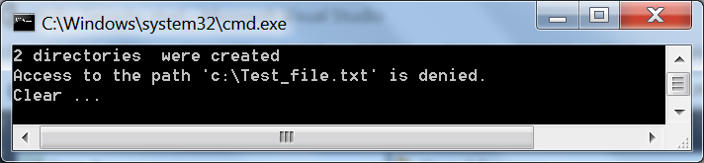

We clearly need a mechanism that will distribution rights "in assembly" and "in the resource."
The .NET Framework (since 4.0) concept offers a security mechanism in the form of a homogeneous (ie uniform) application domain (homogeneous application domain). What is the application domain? Yes, in principle, we are well familiar AppDomain. A long time ago it became homogeneous, and how it was before? Before version 4.0 that was obviously the opposite - a heterogeneous (diverse). The difference in these two types of domains is to ensure that heterogeneous domain could download as many assemblies, but each of them can have its own set of rights which is appointed (by the way - at boot assembly!) CAS-politics (obsolete politics). A homogeneous domain is available for download as many assemblies, but each of them will have an identical set of permissions. Exactly the fact that the "assigned" to the domain. And such a "unified" on the issue of permits and the domain is called a sandbox.

AppDomain:
http://msdn.microsoft.com/en-us/library/w124b5fa.aspx

public static AppDomain CreateDomain(
string friendlyName,
Evidence securityInfo,
AppDomainSetup info,
PermissionSet grantSet,
params StrongName[] fullTrustAssemblies
)
The meaning of the parameters is as follows:

friendlyName - a descriptive name for the sandbox, but in fact the domain.
securityInfo - evidence (evidence), are compared with the application domain. This parameter only stores information such as information about the publisher; very often (even almost always ) you will pass in this parameter null
info - information for initializing the sandbox. To it must be filled to at least the value of the ApplicationBase, representing the path to the partially trusted assembly. So, when the later has the final domain we call the method Load (), search for the assembly to be loaded, it will be performed in this folder.
grantSet - set of permissions for all loaded assemblies in this domain, except for two special cases, to understand further.
fullTrustAssemblies - the special circumstances,

After creating the domain, we can load the assembly into it of different origin and execute them. Assembly author can do anything to cover up the assembly attributes SecurityCritical from all sides and seek to give him the authority to perform thick. Author got exactly what we are indicated in the parameter grantSet

We want to know about our assembling two things:
place its "origin";
whether it is fully or partially trusted.

→ Step_3

Assembly asm = Assembly.GetExecutingAssembly();
Zone zn = asm.Evidence.GetHostEvidence<Zone>();
Console.WriteLine("Zone Evidence: " + zn.SecurityZone.ToString());
Console.WriteLine("\r\nIsFullyTrusted: {0}", asm.IsFullyTrusted);
Console.ReadKey();

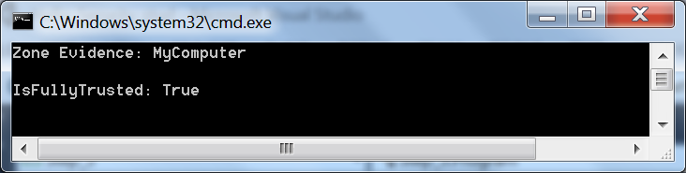

Now, proceed as follows: create any folder (eg C: \ Test_Share), open to share it, copy it Step_3.exe from the current project, within Windows Explorer, go to \\ <computername> \ Test_Share and double-click Step_3 to run the program again. Visibility:

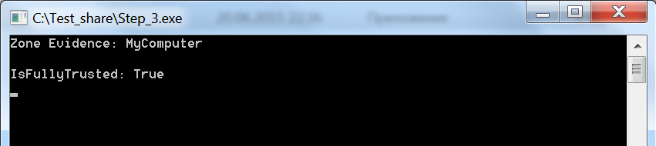

There is only one criterion for the appointment set permissions code: the domain where the code (assembly) is loaded and the permissions of this domain. We have in both cases, the domain was created directly CLR, or, equivalently, we were dealing with unhosted-application, which means that we have full trust.

So, there are two mechanisms of the new approach to the security code:

"Three-layer code"
domains sandbox
Are these approaches somehow intimately connected, or there are completely independent mechanisms? The correct answer is the second:

The idea of "layered code" is "in command" protection. We let the code to perform a set of dangerous commands . At the same time we do not care the protection of resources (folders, files, registry keys, etc.).
→ Step_4

using System;
using Microsoft.Win32;
using System.Security;

[assembly: SecurityTransparent]

namespace Step4_dll
{
public static class St4_dll
{
//[SecurityCritical]
public static void GetKeyName()
{
Console.WriteLine("Read the registry keys");
RegistryKey regk = Registry.CurrentConfig;
string[] nm_strarr = regk.GetSubKeyNames();
Console.WriteLine("Length of array: " + nm_strarr.Length.ToString());
}
}
}

using System.Security;

[assembly: SecurityTransparent]
…
Step4_dll.St4_dll.GetKeyName();

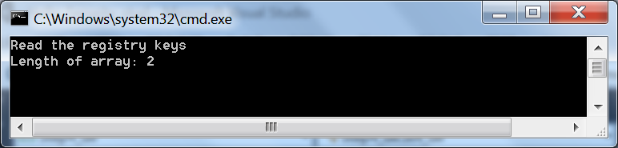

At this time, our application Step_4.exe will call the method from another assembly - Step4_dll.dll. Both the assembly originally labeled as SecurityTransparent, that does not prevent them to go to a rather sensitive system spot - the registry. This is because they are both fully trusted. Now we decide that method GetKeyName() library Step4_dll.dll must belong to the list of "dangerous command", and mark the attributes SecurityCritical, removing the comment
//[SecurityCritical]
, while commenting for the assembly attribute assembly: SecurityTransparent, because assembly can not be transparent if it has at least one member of the non-transparent.

The launch leads to the exclusion of:

->Step_4
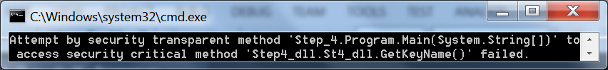
Moreover, both the assembly remained fully trusted! But - "dangerous operation", and as a consequence - an artificial barrier platform to call critical code from the transparent code.

So, if the assembly is not marked in any of the three security attributes:

When you load this assembly in the domain sandbox and, consequently, the interpretation of it by the system as partially trusted - code it becomes transparent by default (transparent) with all the consequences.
If the assembly is loaded in any domain as fully trusted - its code becomes critical (critical), except in cases where the code designation as belonging critical-layer breaks the rules of inheritance.
More universal protection mechanism (domains with a restrictive set of permissions, or, simply, the sandbox) is more difficult to use, and, one might even say much.

Step_5. This project consists of the main console of the program, as well as an auxiliary project, Step5_dll. Accordingly, the Program.cs file contains the first draft of the application code, Step5_dll.cs the second - the library code. What we seek: to CLR application must be downloaded to the main domain (refer to it as MAIN domain), must be created a sub domain, with limited rights (SANDBOX domain), and the library method GetKeyName() must be executed precisely in the latter one.

public class Program : MarshalByRefObject

The application class is declared inherits MarshalByRefObject. This is because the strategy to achieve the task we will have this:

- create a domain sandbox (SANDBOX domain);
- download it to the same assembly that contains the code for the application, ie, Step_5.exe;
- transfer control it to this second instance, the assembly must call GetKeyName() library method already inside the sandbox.

In the last point will inevitably cross the borders domain (AppDomain boundaries), that can only be achieved through the mechanism of marshalling (marshalling) (inheritance).

Try to print the main information about the starting domain, MAIN domain

static void Type_Assemblies_info()
{
Console.WriteLine("***");
AppDomain curAD = AppDomain.CurrentDomain;
Console.WriteLine("Info About MAIN domain. Is this domain Is Full Trusted: {0}", curAD.IsFullyTrusted);
Assembly[] assems = curAD.GetAssemblies();
if (assems.Length == 0) Console.WriteLine("No assemblies loaded in this domain");
else
{
Console.WriteLine("{0} assemblies loaded in this domain. Info about:", assems.Length.ToString());
foreach (Assembly a in assems)
{
string assemblySimpleName = new AssemblyName(a.FullName).Name;
Console.WriteLine("* Simple Name: " + assemblySimpleName);
Console.WriteLine("\t **Is this assembly Is Full Trusted: {0}", a.IsFullyTrusted);
}
}
string codeLayer = typeof(Program).IsSecurityTransparent ? "Transparent" : "Critical";
Console.WriteLine("Code in this domain belong to {0} layer", codeLayer);
}

IsSecurityTransparent, IsSecurityCritical, IsSecuritySafeCritical
http://msdn.microsoft.com/en-us/library/system.type.issecuritytransparent.aspx
http://msdn.microsoft.com/en-us/library/system.type.issecuritycritical.aspx
http://msdn.microsoft.com/en-us/library/system.type.issecuritysafecritical.aspx

Go to the formation of the sandbox.
Step_5 with comments

using System.Security;
using System.Reflection;
using System.Security.Permissions;
using Microsoft.Win32;

static void Main()
{
try
{

Type_Assemblies_info();

AppDomainSetup setup = new AppDomainSetup { ApplicationBase = Environment.CurrentDirectory };

PermissionSet prmts = new PermissionSet(null);
// prmts.AddPermission(new SecurityPermission(SecurityPermissionFlag.Execution));
// prmts.AddPermission(new RegistryPermission(RegistryPermissionAccess.Read, Registry.CurrentConfig.Name));

AppDomain appDomain = AppDomain.CreateDomain(
"SANDBOX domain",
null,
setup,
prmts);

Program p = (Program)(Activator.CreateInstance(appDomain, "Step_5", "Step_5.Program").Unwrap());

p.Dll_in_SndBox();
Console.ReadKey();
}
catch (Exception ex)
{
Console.WriteLine(ex.Message);
}

}

void Dll_in_SndBox()
{
Step5_dll.St5_dll.GetKeyName();
}

static void Type_Assemblies_info()
{
Console.WriteLine("***");
AppDomain cur_appD = AppDomain.CurrentDomain;
Console.WriteLine("MAIN domain info. IsFullTrusted: {0}", cur_appD.IsFullyTrusted);
Assembly[] assems = cur_appD.GetAssemblies();
if (assems.Length == 0) Console.WriteLine("No assemblies in this domain");
else
{
Console.WriteLine("{0} assemblies loaded in this domain. Info about:", assems.Length.ToString());
foreach (Assembly a in assems)
{
string assem_SimpleName = new AssemblyName(a.FullName).Name;
Console.WriteLine("Simple Name: " + assem_SimpleName);
Console.WriteLine("\t This assembly IsFullTrusted: {0}", a.IsFullyTrusted);
}
}
string codeLayer = typeof(Program).IsSecurityTransparent ? "Transparent" : "Critical";
Console.WriteLine("Code in this domain belong to {0} layer", codeLayer);
}

// Load the assembly into the new domain; create a new instance of the type 'Program' in the (new) domain

Program p = (Program)(Activator.CreateInstance(appDomain, "Step_5", "Step_5.Program").Unwrap());

We need an instance method Dll_in_SndBox() . Program class, for which we are in a new domain, create an instance of this class and immediately get the main domain proxy to that instance, in order to be able to manage it. Parameters create a remote object p:

appDomain - target domain;
"Step_5" - assembly of the class Program;
"Step_5.Program" - name of the class.
// This method will be implemented in the new (partially trusted) domain
p.Dll_in_SndBox();

And finish, there is the method call in a neighboring domain. As we know p - is a proxy to the remote object, and therefore, this method Dll_in_SndBox() is executed in a sandbox, not the MAIN domain.

Actually - the first line of the method Dll_in_SndBox() is the code with which to start the auxiliary domain

Launches the first version of the application.

We will focus on information to exclude:
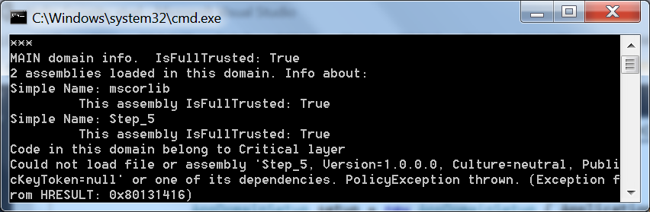

Remove a comment from the line
prmts.AddPermission(new SecurityPermission(SecurityPermissionFlag.Execution));
and get a new exception this time:

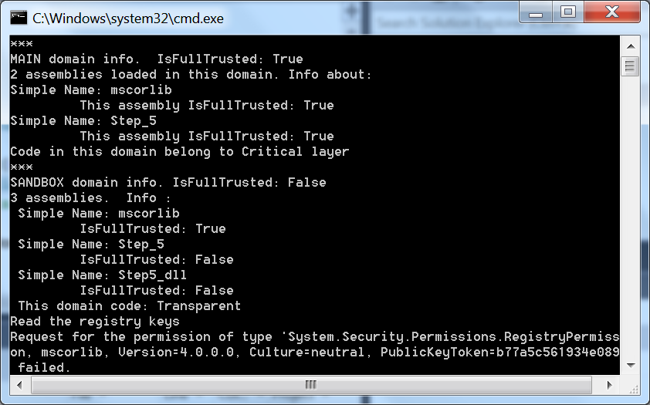

It requires at least read permission key \\ HKEY_CURRENT_CONFIG \ and plug it in. Remove the comment from the line
prmts.AddPermission(new RegistryPermission(RegistryPermissionAccess.Read, Registry.CurrentConfig.Name));
and - a complete success!
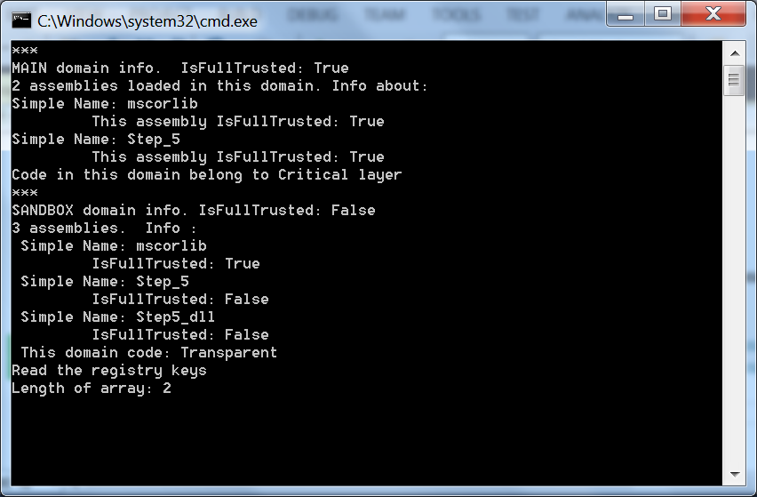
It remains to analyze the output on the console:
One and the same assembly, in the same process (not confuse processes and domains), during the same session of execution has different privileges.

