Data exploration on College Distance data

Introduction to the dataset

Cross-section data from the High School and Beyond survey conducted by the Department of Education in 1980, with a follow-up in 1986. The survey included students from approximately 1,100 high schools.
Format: A data frame containing 4,739 observations on 14 variables.
gender - factor indicating gender.
ethnicity - factor indicating ethnicity (African-American, Hispanic or other).
score - base year composite test score. These are achievement tests given to high school seniors in the sample.
fcollege - factor. Is the father a college graduate?
mcollege - factor. Is the mother a college graduate?
home - factor. Does the family own their home?
urban - factor. Is the school in an urban area?
unemp - county unemployment rate in 1980.
wage - state hourly wage in manufacturing in 1980.
distance - distance from 4-year college (in 10 miles).
Tuition - average state 4-year college tuition (in 1000 USD).
Education - number of years of education.
Income - factor. Is the family income above USD 25,000 per year?
Region - factor indicating region (West or other).

Details
Rouse (1995) computed years of education by assigning 12 years to all members of the senior class. Each additional year of secondary education counted as a one year. Students with vocational degrees were assigned 13 years, AA degrees were assigned 14 years, BA degrees were assigned 16 years, those with some graduate education were assigned 17 years, and those with a graduate degree were assigned 18 years.
Stock and Watson (2007) provide separate data files for the students from Western states and the remaining students. CollegeDistance includes both data sets, subsets are easily obtained (see also examples).

Source
Online complements to Stock and Watson (2007).

References
Rouse, C.E. (1995). Democratization or Diversion? The Effect of Community Colleges on Educational Attainment. Journal of Business & Economic Statistics, 12, 217–224.
Stock, J.H. and Watson, M.W. (2007). Introduction to Econometrics, 2nd ed. Boston: Addison Wesley.

First look at the data
Data contains 15 columns and 4739 rows which gives us over 70k cells in total. Data contains numerical data as well as categorical represented as strings.
Data also seems to be complete (no cells with null/na). It means that no pruning or filling is needed. But categorical data needs to be converted to the numerical. Also first column named “rownames” is useless, because it represents only index of the row. This will leave us with 14 features including the ‘score’ feature, which will be predicted.
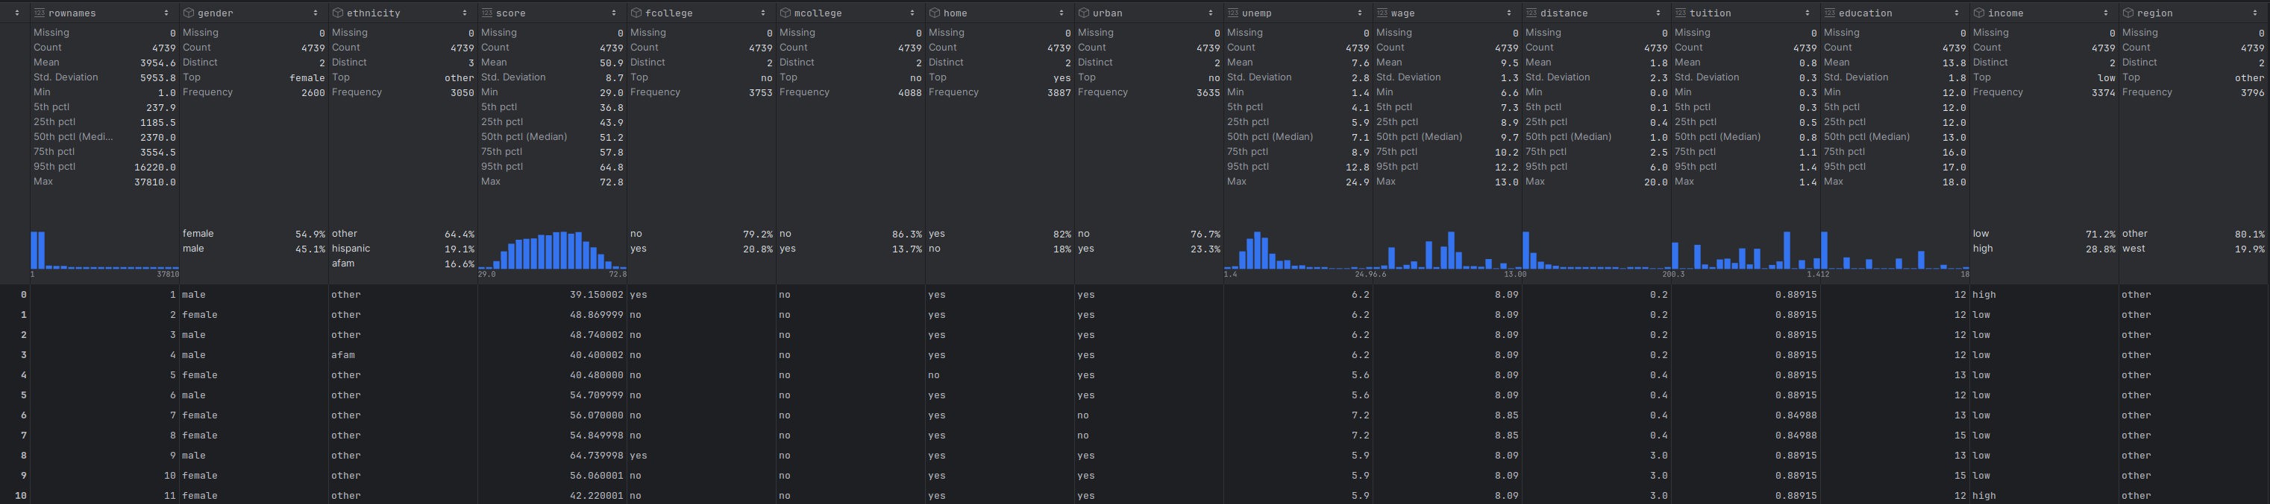Figure 1: Screenshot of the first 10 rows of raw data with primary variables statistics
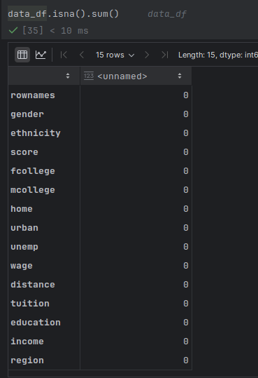Figure 2: Sum of null entries for each column
Column names that needs to be transformed from categorical to numerical: 'gender', 'ethnicity', 'fcollege', 'mcollege', 'home', 'urban', 'income', 'region'.

First actions
After transforming mentioned categorical columns to numerical and deleting column ‘rownames’ data looks like this:
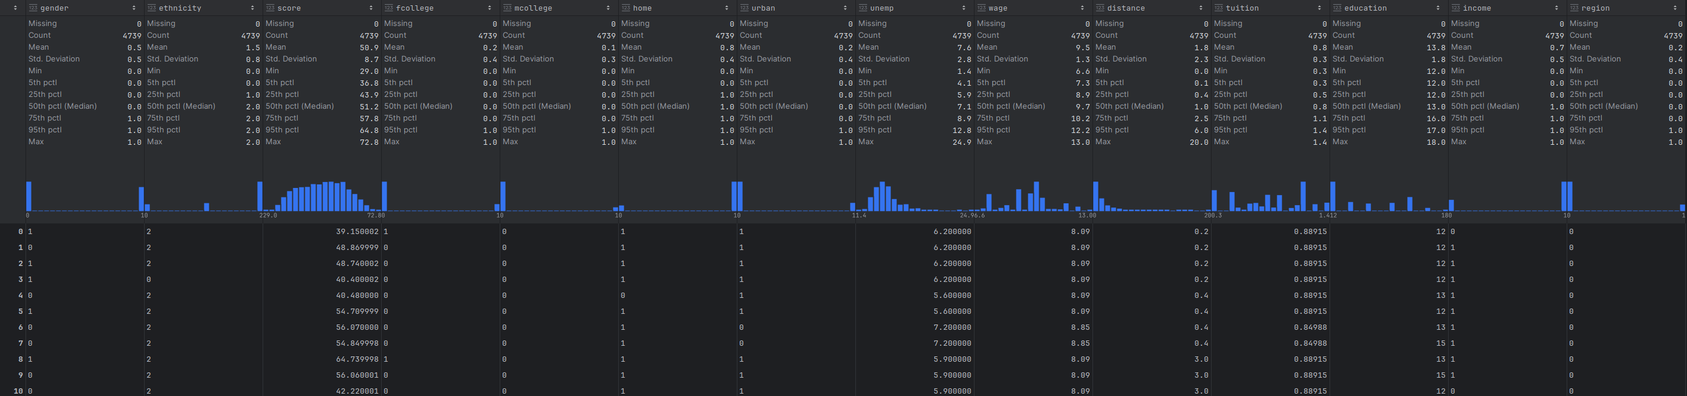Figure 3: Screenshot of the first 10 rows of transformed data with variables statistics
Worth of mentioning that the originally numerical features are not changed at this stage.
Applied changes:
gender - 0: female, 1: male
ethnicity -
fcollege -
mcollege -
home -
urban -
income -
region -

