**1. Перший рівень.**

**1. В Google docs створи 5 тест-кейсів для функціонального тестування сайту https://automoto.ua/uk/ (5 найбільш пріоритетних тестів).**

**ТС 1.**

| **Test Case ID** | | TC_001 | **Test Case Description** | | Check filtration by price | | | | | |
| --- | --- | --- | --- | --- | --- | --- | --- | --- | --- | --- |
| **Created By** | | Berezka Oleksandr | **Reviewed By** | |  | | **Version** | | 1 | |
|  |  |  |  |  |  |  |  |  |  |  |
| **QA Tester’s Log** | |  |  |  |  |  |  |  |  |  |
|  |  |  |  |  |  |  |  |  |  |  |
| **Tester's Name** | | Berezka Oleksandr | **Date Tested** | | 08.11.2022 |  | **Test Case (Pass/Fail/Not Executed)** | | Pass | |
|  |  |  |  |  |  |  |  |  |  |  |
| **S #** | **Prerequisites:** | | |  | **S #** | **Test Data** | | | | |
| 1 | open https://automoto.ua/uk/ | | |  | 1 |  | | | | |
|  |  |  |  |  |  |  |  |  |  |  |
| **Test Scenario** | Check filtration at a price in the range. |  |  |  |  |  |  |  |  |  |
|  |  |  |  |  |  |  |  |  |  |  |
| **Step #** | **Step Details** | | **Expected Results** | | **Pass / Fail / Not executed / Suspended** | | |  |  |  |
|  |  |  |
| 1 | Enter 5000 in the "Ціна від $" Input Field | | The field should display the value "5000" | | Pass | | |  |  |  |
| 2 | Enter 7000 in the "Ціна До $" Input Field | | The field should display the value "7000" | | Pass | | |  |  |  |
| 3 | Press the "поиск" button | | The page should display cars filtered by price $ 5000 - 7000 | | Pass | | |  |  |  |

**ТС 2.**

| **Test Case ID** | | TC_002 | **Test Case Description** | | Find a car by model | | | | | |
| --- | --- | --- | --- | --- | --- | --- | --- | --- | --- | --- |
| **Created By** | | Berezka Oleksandr | **Reviewed By** | |  | | **Version** | | 1 | |
|  |  |  |  |  |  |  |  |  |  |  |
| **QA Tester’s Log** | |  |  |  |  |  |  |  |  |  |
|  |  |  |  |  |  |  |  |  |  |  |
| **Tester's Name** | | Berezka Oleksandr | **Date Tested** | | 08.11.2022 |  | **Test Case (Pass/Fail/Not Executed)** | | Pass | |
|  |  |  |  |  |  |  |  |  |  |  |
| **S #** | **Prerequisites:** | | |  | **S #** | **Test Data** | | | | |
| 1 | open https://automoto.ua/uk/ | | |  | 1 | Model - Lancer | | | | |
|  |  |  |  |  |  |  |  |  |  |  |
| **Test Scenario** | Search a car by model through the filter |  |  |  |  |  |  |  |  |  |
|  |  |  |  |  |  |  |  |  |  |  |
| **Step #** | **Step Details** | | **Expected Results** | | **Pass / Fail / Not executed / Suspended** | | |  |  |  |
|  |  |  |
| 1 | Click on the "Model" dropdown list | | Search Field should appear under the dropdown | | Pass | | |  |  |  |
| 2 | Enter Lancer in Search Field | | Should display "No results found" | | Pass | | |  |  |  |

**ТС 3.**

| **Test Case ID** | | TC_003 | **Test Case Description** | | | Check the app load from Google Play | | | | | |
| --- | --- | --- | --- | --- | --- | --- | --- | --- | --- | --- | --- |
| **Created By** | | Berezka Oleksandr | **Reviewed By** | | |  | | **Version** | | 1 | |
|  |  |  |  | |  |  |  |  |  |  |  |
| **QA Tester’s Log** | |  |  | |  |  |  |  |  |  |  |
|  |  |  |  | |  |  |  |  |  |  |  |
| **Tester's Name** | | Berezka Oleksandr | **Date Tested** | | | 08.11.2022 |  | **Test Case (Pass/Fail/Not Executed)** | | Pass | |
|  |  |  |  | |  |  |  |  |  |  |  |
| **S #** | **Prerequisites:** | | | |  | **S #** | **Test Data** | | | | |
| 1 | open https://automoto.ua/uk/ | | | |  | 1 |  | | | | |
|  |  |  |  | |  |  |  |  |  |  |  |
| **Test Scenario** | Check the app download from Google Play via the icon in the footer of the site | | | |  |  |  |  |  |  |  |
|  |  |  | |  |  |  |  |  |  |  |  |
| **Step #** | **Step Details** | | | **Expected Results** | | **Pass / Fail / Not executed / Suspended** | | |  |  |  |
|  |  |  |
| 1 | Scroll down the page | | | The page should scroll | | Pass | | |  |  |  |
| 2 | Press the icon "завантажити з Google Play" | | | A new window should open with the application page on the Play store. | | Pass | | |  |  |  |

**ТС 4.**

| **Test Case ID** | | TC_004 | **Test Case Description** | | | Check the advanced search feature | | | | | |
| --- | --- | --- | --- | --- | --- | --- | --- | --- | --- | --- | --- |
| **Created By** | | Berezka Oleksandr | **Reviewed By** | | |  | | **Version** | | 1 | |
|  |  |  |  | |  |  |  |  |  |  |  |
| **QA Tester’s Log** | |  |  | |  |  |  |  |  |  |  |
|  |  |  |  | |  |  |  |  |  |  |  |
| **Tester's Name** | | Berezka Oleksandr | **Date Tested** | | | 08.11.2022 |  | **Test Case (Pass/Fail/Not Executed)** | | Pass | |
|  |  |  |  | |  |  |  |  |  |  |  |
| **S #** | **Prerequisites:** | | | |  | **S #** | **Test Data** | | | | |
| 1 | open https://automoto.ua/uk/ | | | |  | 1 |  | | | | |
|  |  |  |  | |  |  |  |  |  |  |  |
| **Test Scenario** | Check if the advanced search window is displayed when you click the button in the header | | | |  |  |  |  |  |  |  |
|  |  |  | |  |  |  |  |  |  |  |  |
| **Step #** | **Step Details** | | | **Expected Results** | | **Pass / Fail / Not executed / Suspended** | | |  |  |  |
|  |  |  |
| 1 | Click the "Розширений пошук" button in the header | | | Advanced search window should open | | Pass | | |  |  |  |

**ТС 5.**

| **Test Case ID** | | | TC_005 | | **Test Case Description** | | Check the form of feedback (not a valid test) | | | | | |
| --- | --- | --- | --- | --- | --- | --- | --- | --- | --- | --- | --- | --- |
| **Created By** | | | Berezka Oleksandr | | **Reviewed By** | |  | | **Version** | | 1 | |
|  |  | |  | |  |  |  |  |  |  |  |  |
| **QA Tester’s Log** | | |  | |  |  |  |  |  |  |  |  |
|  |  | |  | |  |  |  |  |  |  |  |  |
| **Tester's Name** | | | Berezka Oleksandr | | **Date Tested** | | 08.11.2022 |  | **Test Case (Pass/Fail/Not Executed)** | | Pass | |
|  |  | |  | |  |  |  |  |  |  |  |  |
| **S #** | **Prerequisites:** | | | | |  | **S #** | **Test Data** | | | | |
| 1 | open https://automoto.ua/uk/ | | | | |  | 1 | Tel. - word "current" | | | | |
|  |  | |  |  | |  |  |  |  |  |  |  |
| **Test Scenario** | Enter characters in input field "Ваш телефон" in the feedback form "Залишити відгук/питання" | |  |  | |  |  |  |  |  |  |  |
|  |  | |  |  | |  |  |  |  |  |  |  |
| **Step #** | **Step Details** | **Expected Results** | | | | | **Pass / Fail / Not executed / Suspended** | | |  |  |  |
|  |  |  |
| 1 | Scroll down the page | The page should scroll | | | | | Pass | | |  |  |  |
| 2 | Press the "Контакти" button | A page with a feedback form should open | | | | | Pass | | |  |  |  |
| 3 | Enter "Test" in the input field "Ваш номер" | Data entered, no error displayed | | | | | Pass | | |  |  |  |

**2. За допомогою**  [**https://reqbin.com/**](https://reqbin.com/) **протестуй наступні методи API** [**Reqres**](https://reqres.in/)**:**

LIST USERS

SINGLE USER

CREATE

UPDATE (PUT)

UPDATE (PATCH)

DELETE

REGISTER - SUCCESSFUL

LOGIN – SUCCESSFUL

Створи документ, в якому у довільному форматі, але зі скриншотами, опиши знайдені баги. Документ додай до LMS.

В api **LIST USERS** – в url, замість № сторінки, додав слово «добре» - повернуло код 200.

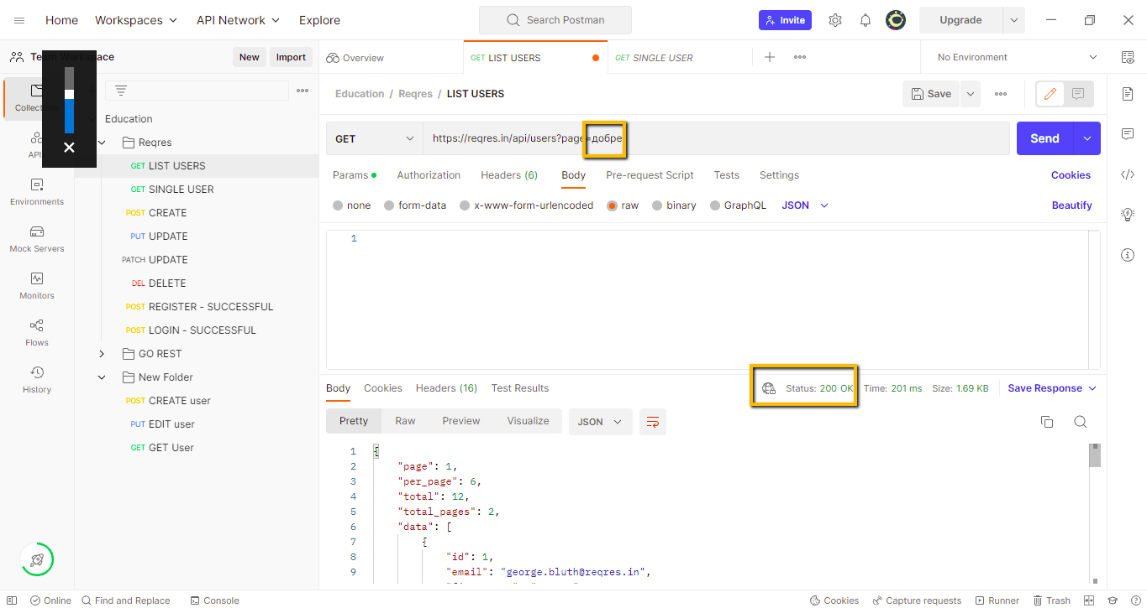

В api **SINGLE USER**, змінив метод з GET на POST – повернуло 200 код..

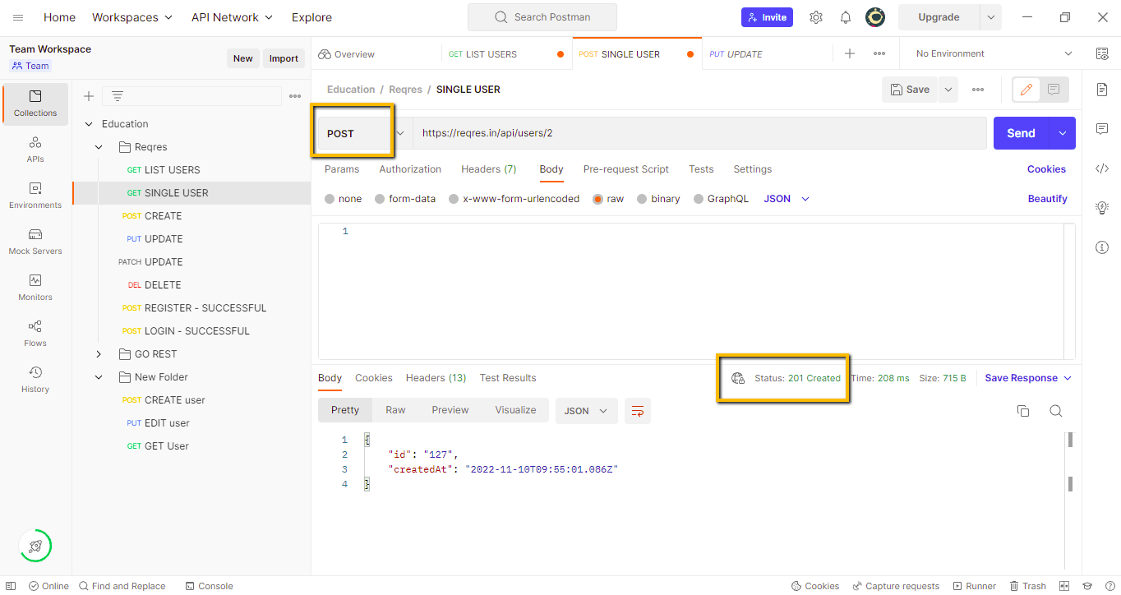

В api **CREATE** прибравз body ім’я – повернуло 201 код.

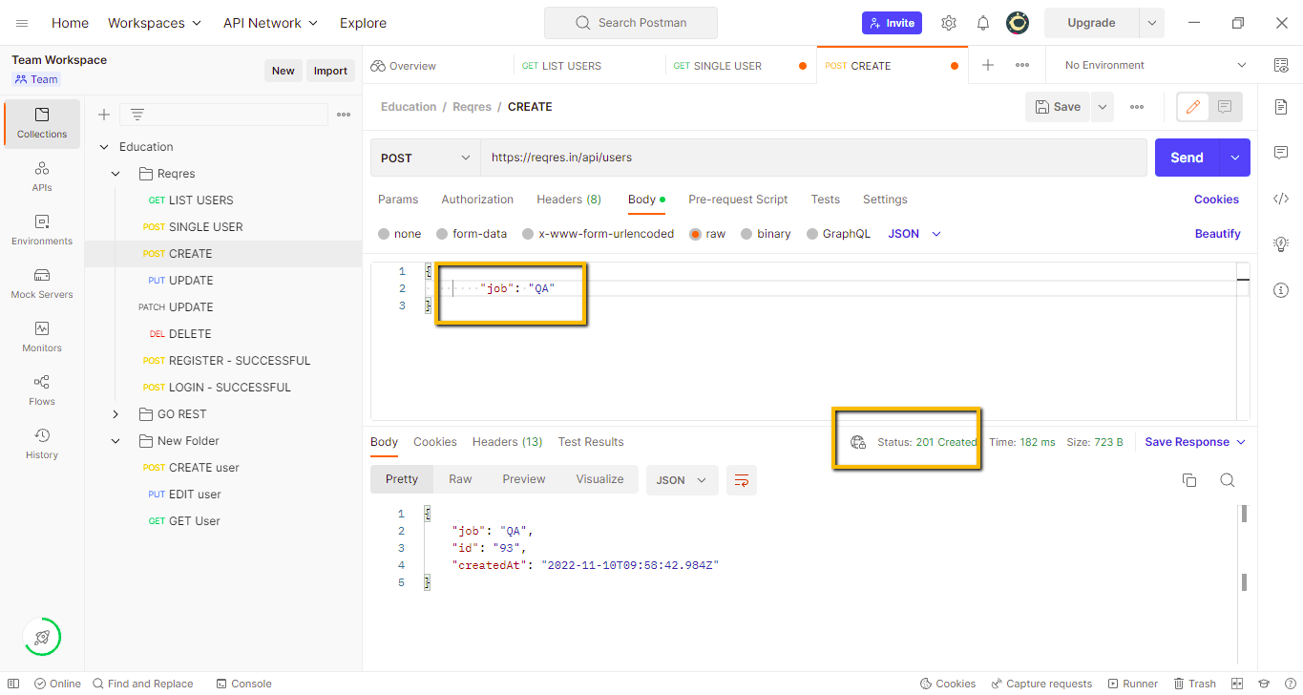

В api **UPDATE (PUT),** змінив метод на POST – повернуло 201 код, та казало нову id, хоча не мало б.

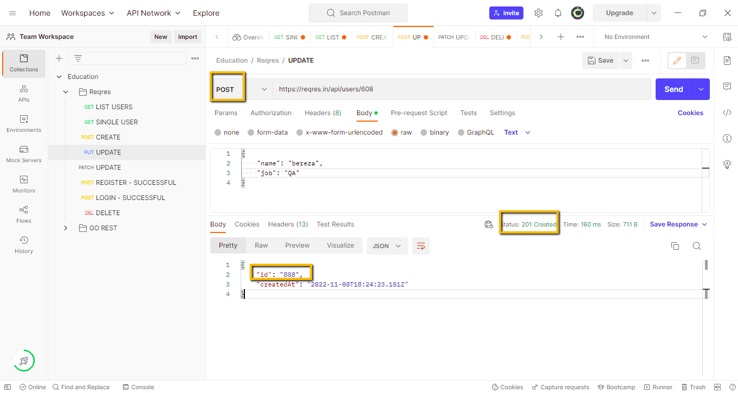

В api **UPDATE (PATCH)** прибрав тіло - повернуло 200 код. Як я розумію, мало б видати помилку, так я прибрав параметри, які необхідно змінити.

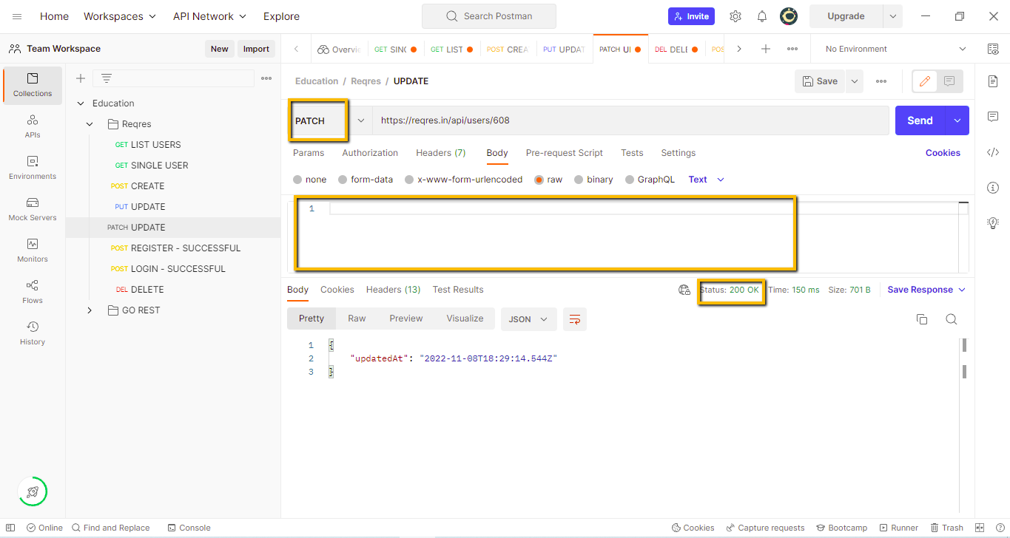

В api **DELETE,** прибрав “/та id” користувача – повернуло 200 код. Думаю, що без id, не мало б видаляти.

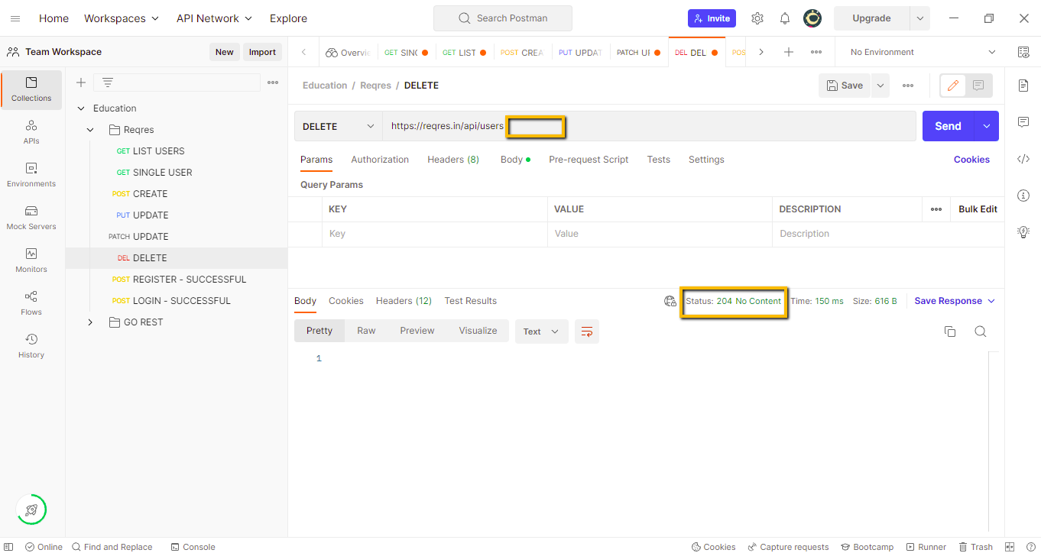

В api **REGISTER – SUCCESSFUL** та **LOGIN – SUCCESSFUL,** змінив метод на GET –повернуло 200 код та чомусь відобразило тіло з id користувачів з 1 сторінки. Інших змін не знайшов.

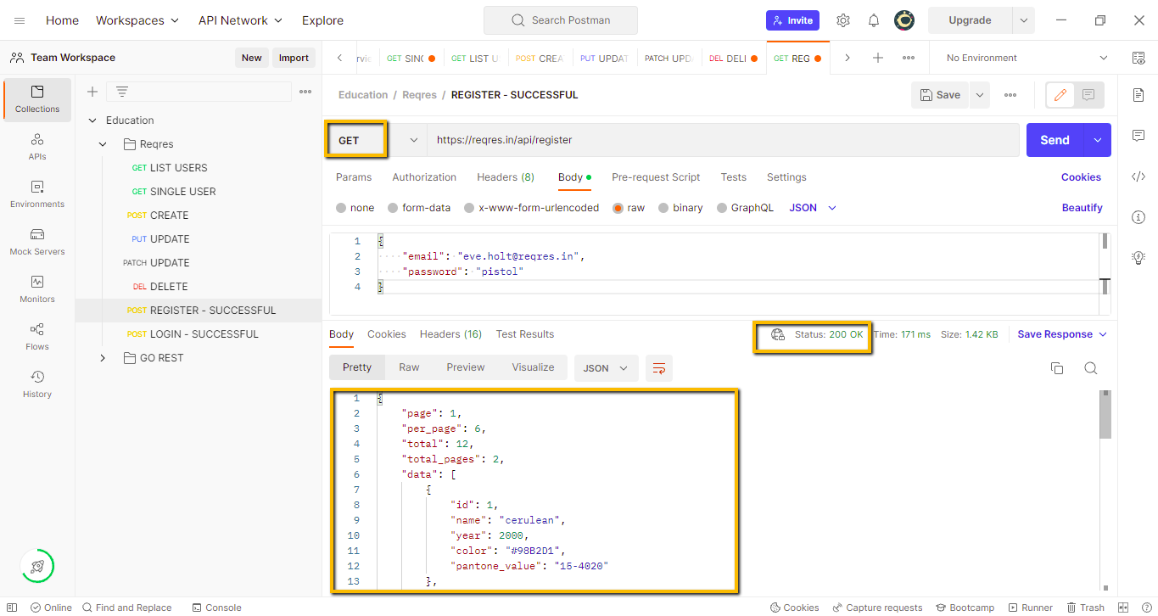

**2. Другий та третій рівні разом.**

**1. Використовуючи** [**https://reqbin.com/**](https://reqbin.com/)**, відправ по одному валідному запиту для кожного методу в** [**GO REST**](https://gorest.co.in/) **(/users endpoint).**

**1.1. За відправки кожного запиту порівняй його деталі, введені у https://reqbin.com/ і відображені в Developer Tools.**

**Create a new user.**

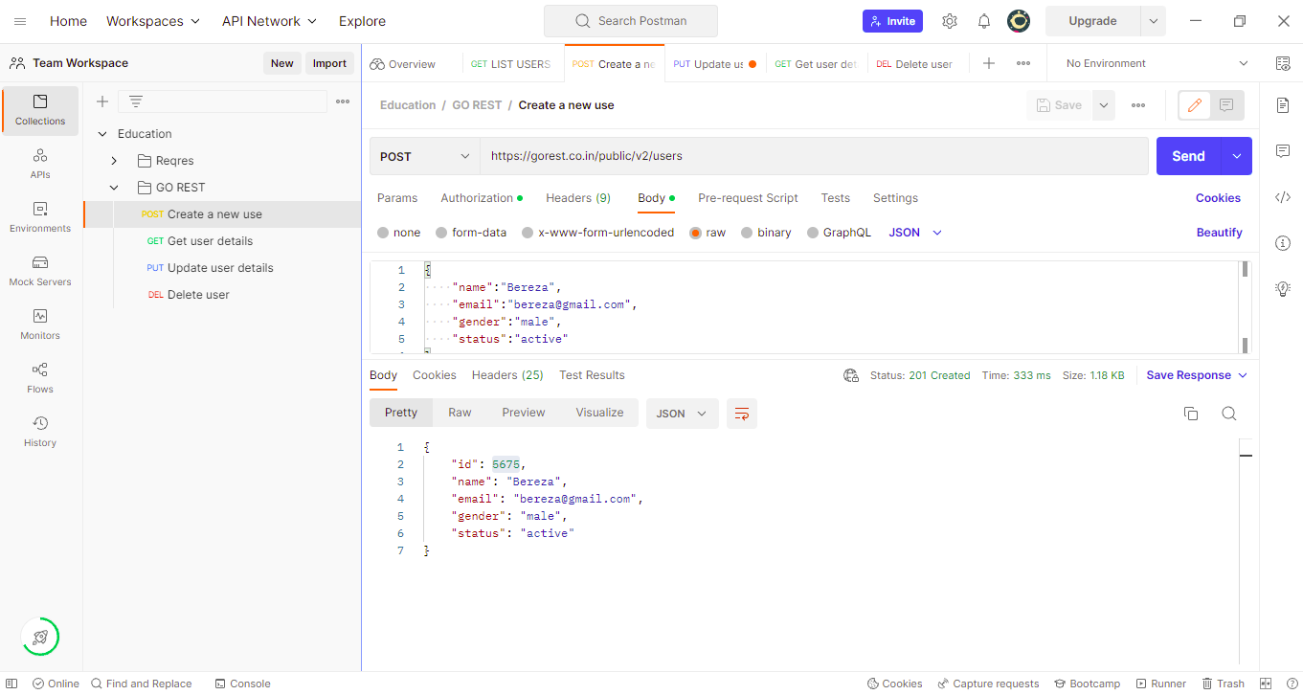

**Get user details.**

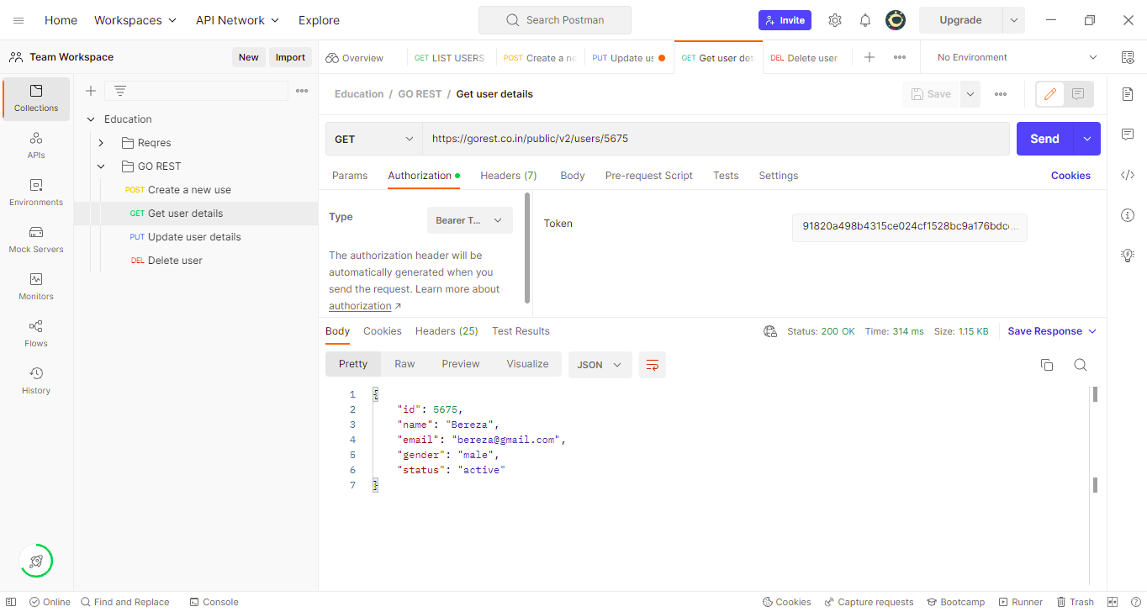

**Update user details.**

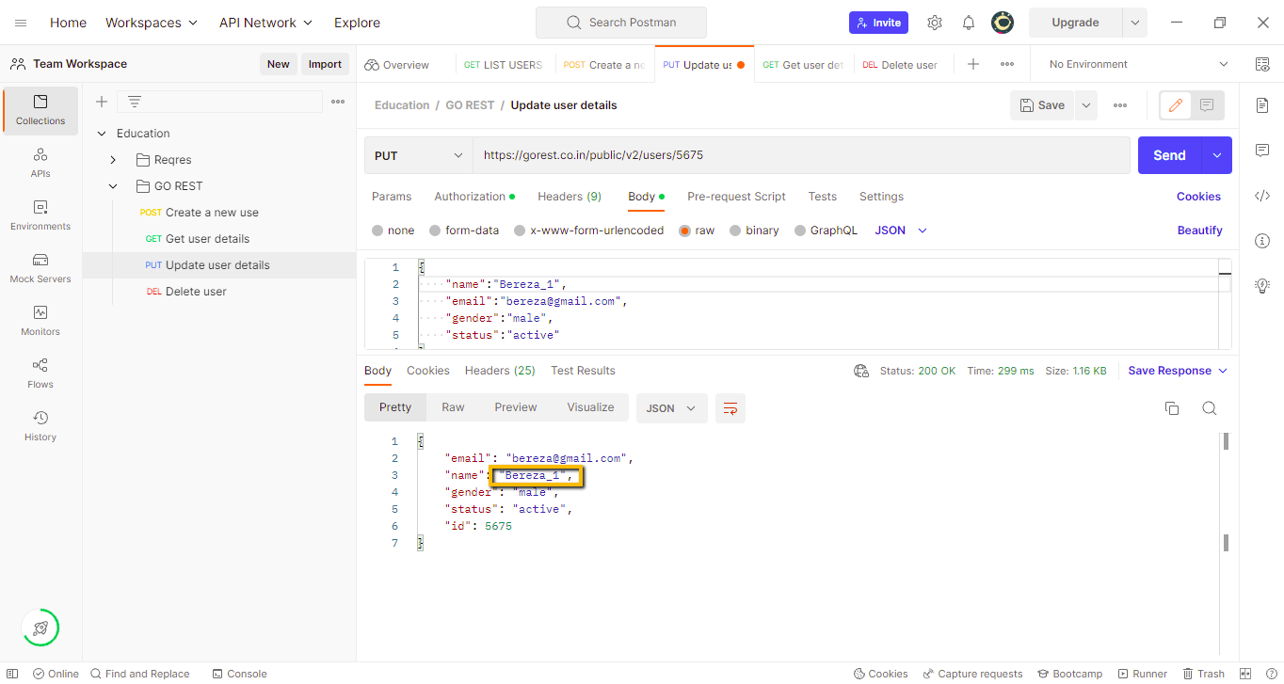

**Delete user.**

