Oleksandr Demkiv

S00251154

I will be using 2 Api endpoints and here is a sample JSON output of each of those:

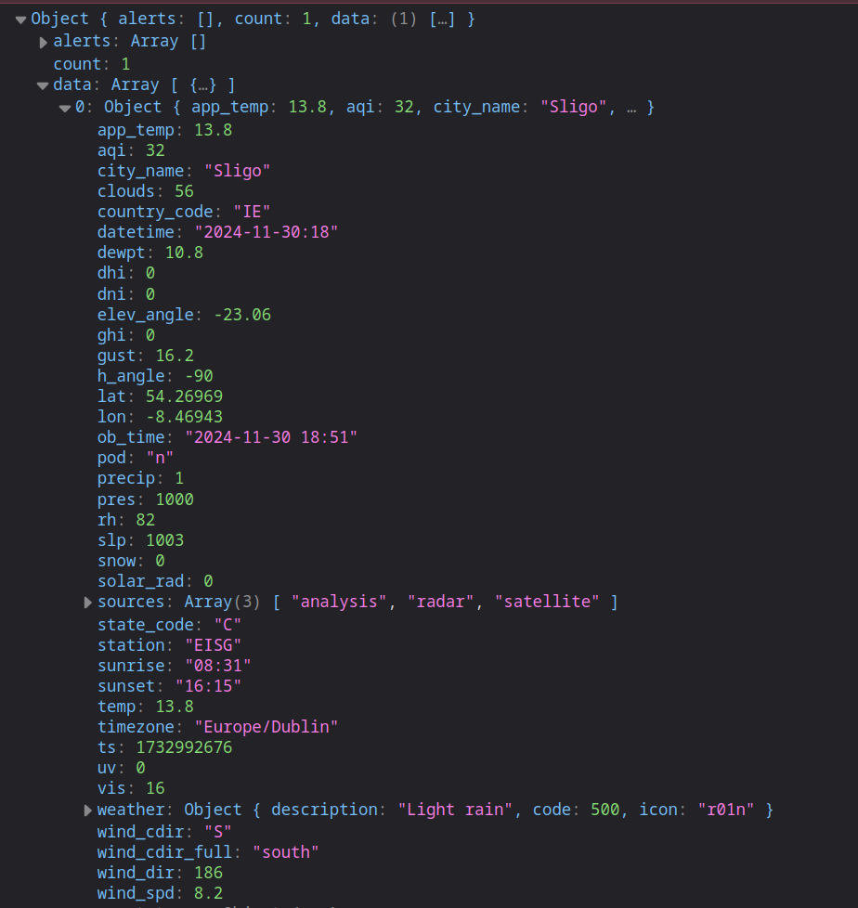

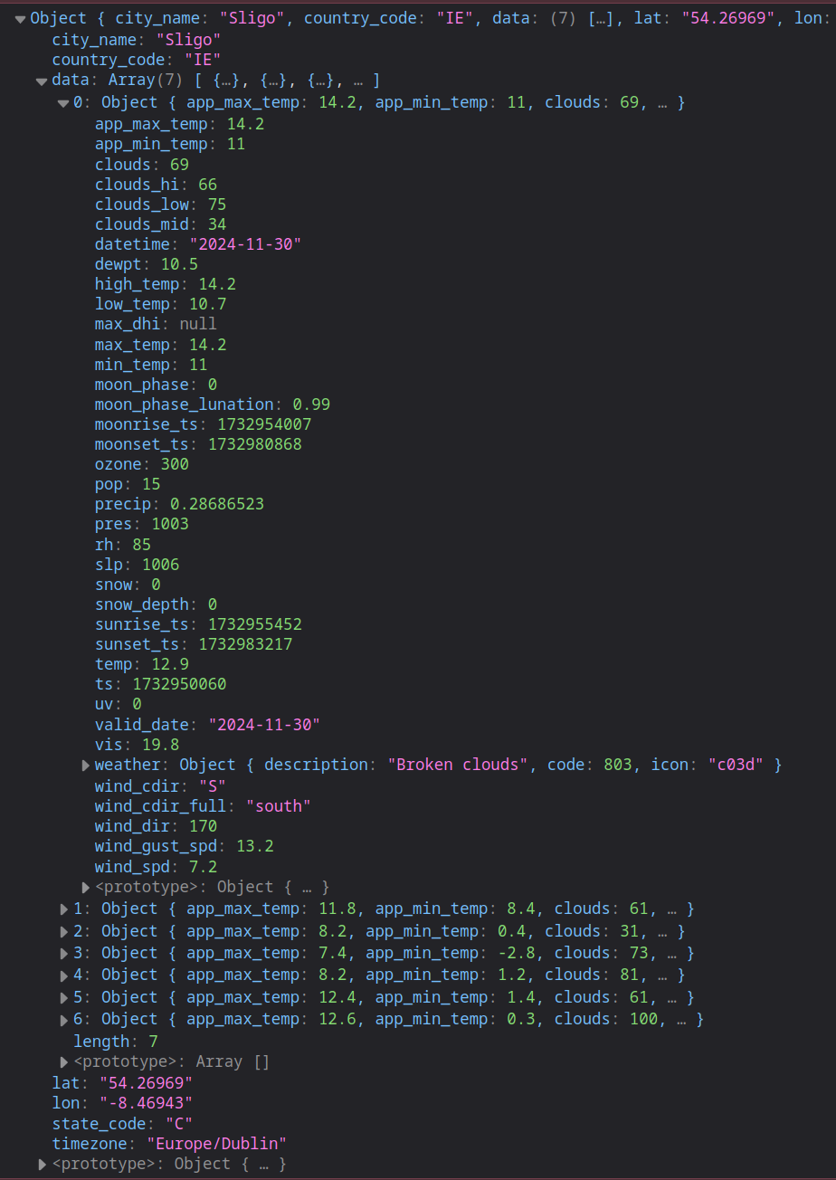

The Endpoints are: 1. Current weather information 2. 7 Day forecast

From current weather I will use:

city_name: City name

country_code: Country code

ob_time: Date and time

clouds: Cloud coverage (%)

temp: Temperature

app_temp: Feels like temp

wind_spd: Wind speed (m/s)

weather: (icon) for displaying weather icon

uv: UV Index (0-11+)

From Day Forecart I will use:

city_name: City name

country_code: Country code

data array: all elements: from each element I will use:

min_temp: Minimal temperature

max_temp: Maximum temperature

datetime: Date

weather: (icon) for displaying weather icon

sunrise_ts: timestamp to be converted to sunrise time

sunset_ts: timestamp to be converted to sunset time

Diagram:

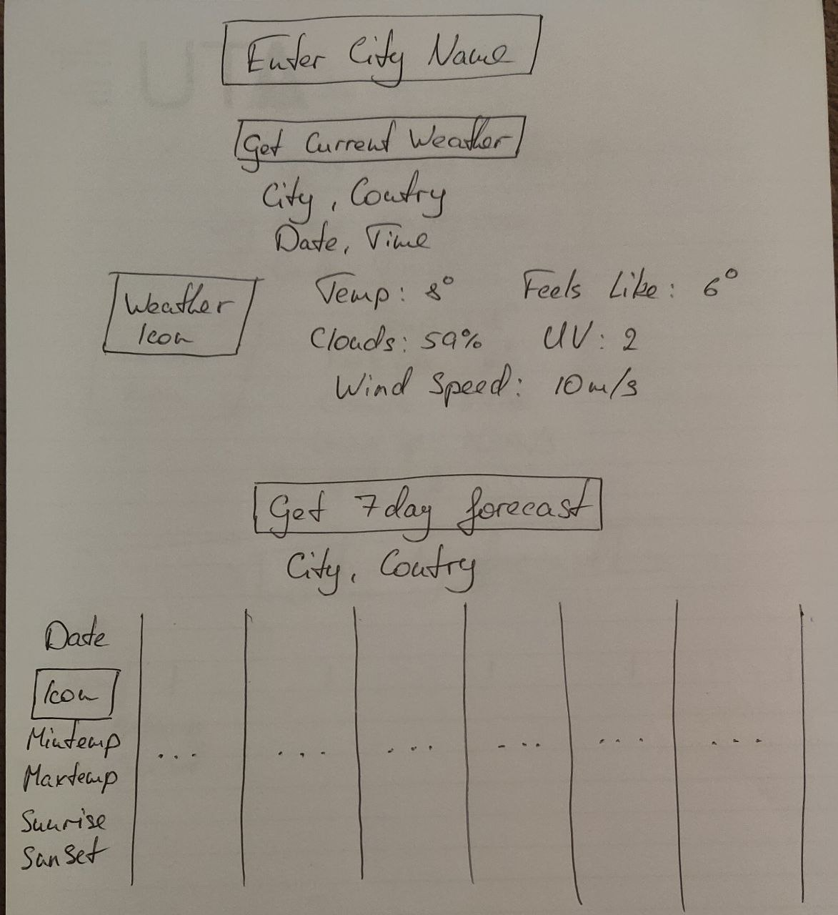

GitHub Link: <https://github.com/OleksandrDemkiv/ClientSideScriptingProject>