EPAM University Programs

DevOps external course

Module 2 Practical cloud beginning and AWS live demo.

TASK 3.1 Create a Simple Pipeline (CodeCommit Repository)

Create a CodeCommit Repository

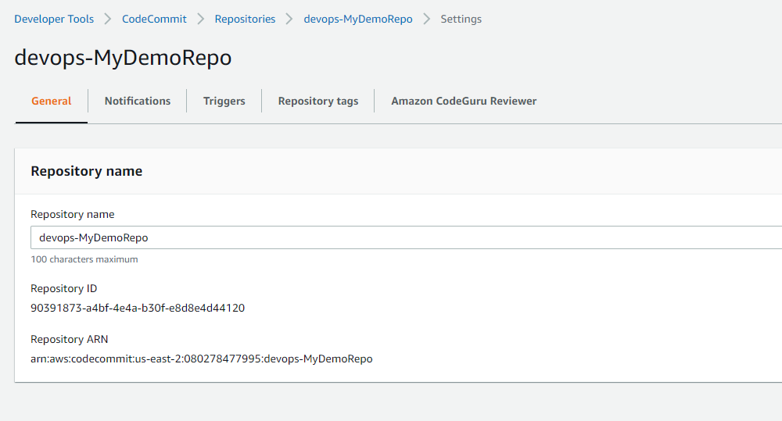

Add Sample Code to Your CodeCommit Repository

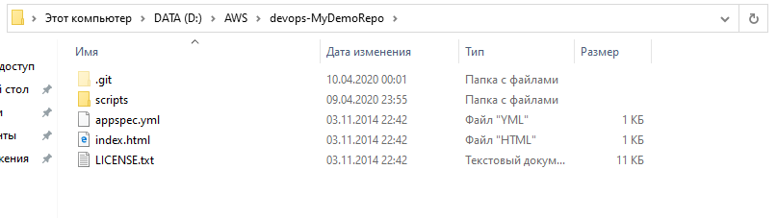

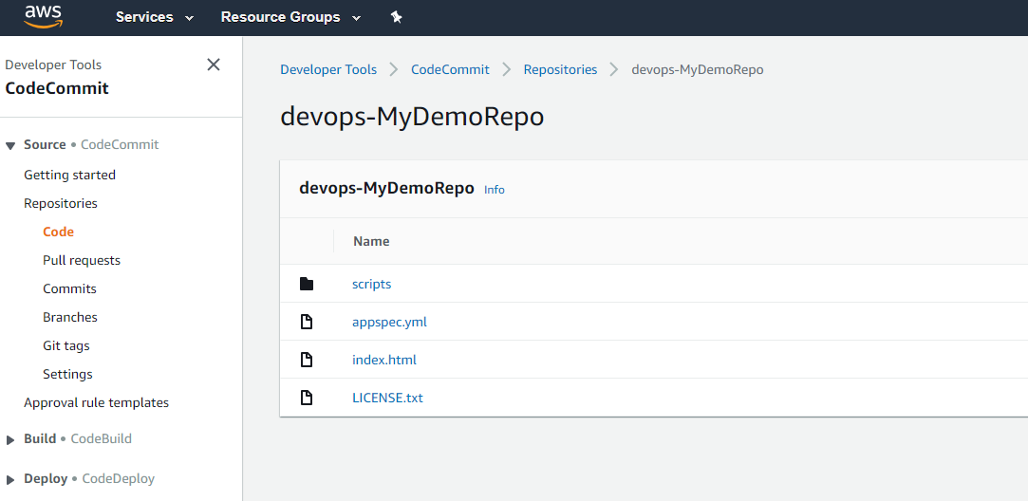

Create an EC2 Linux Instance and Install the CodeDeploy Agent

To create an instance role

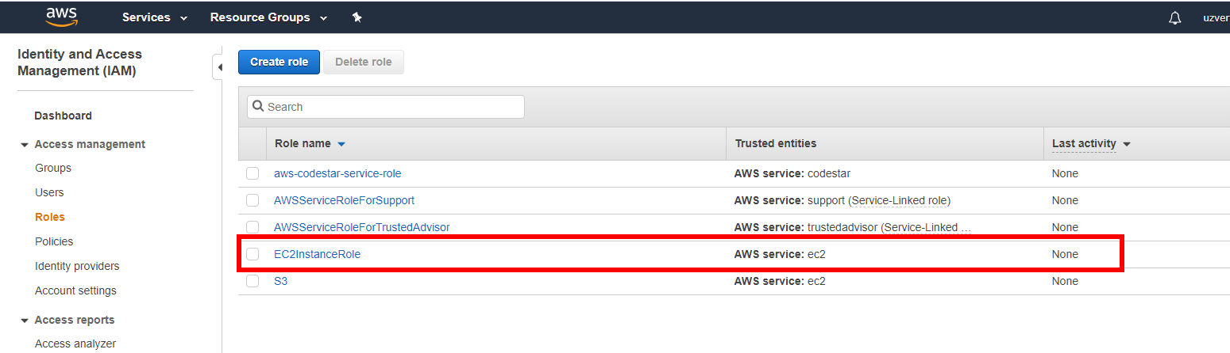

To launch an instance

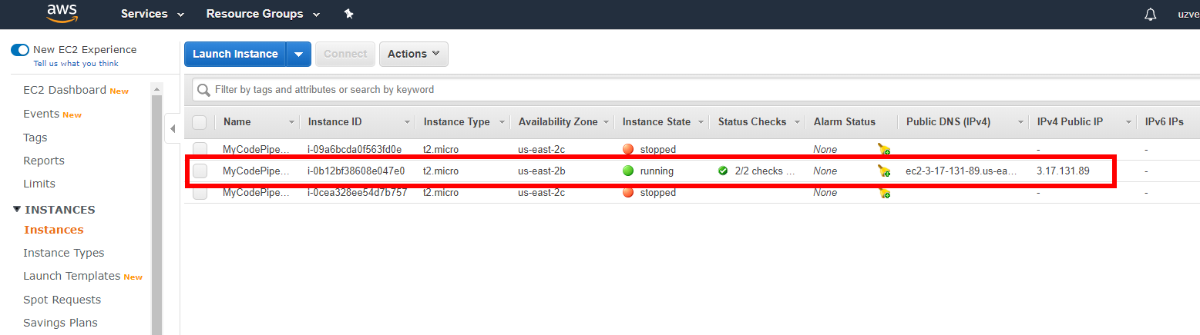

Create an Application in CodeDeploy

To create a CodeDeploy service role

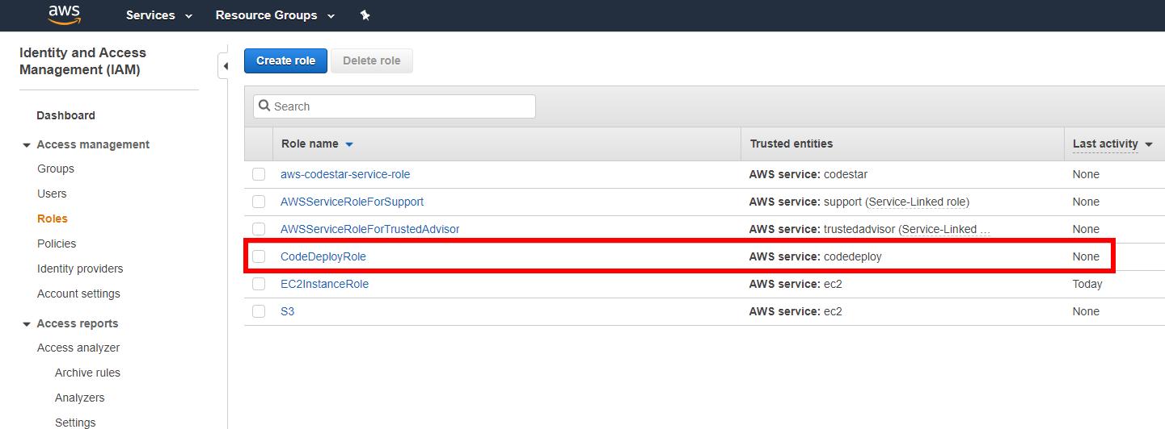

To create an application in CodeDeploy

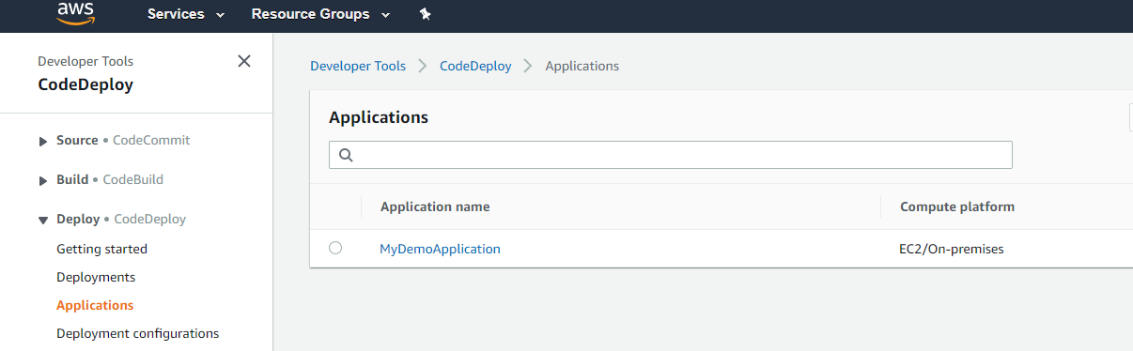

To create a deployment group in CodeDeploy

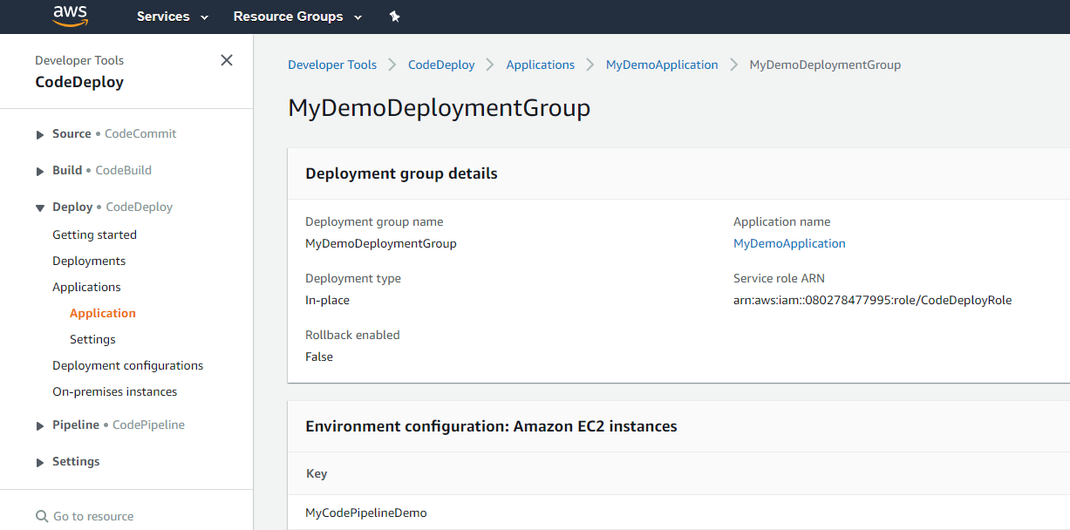

Create Your First Pipeline in CodePipeline

To create a CodePipeline pipeline

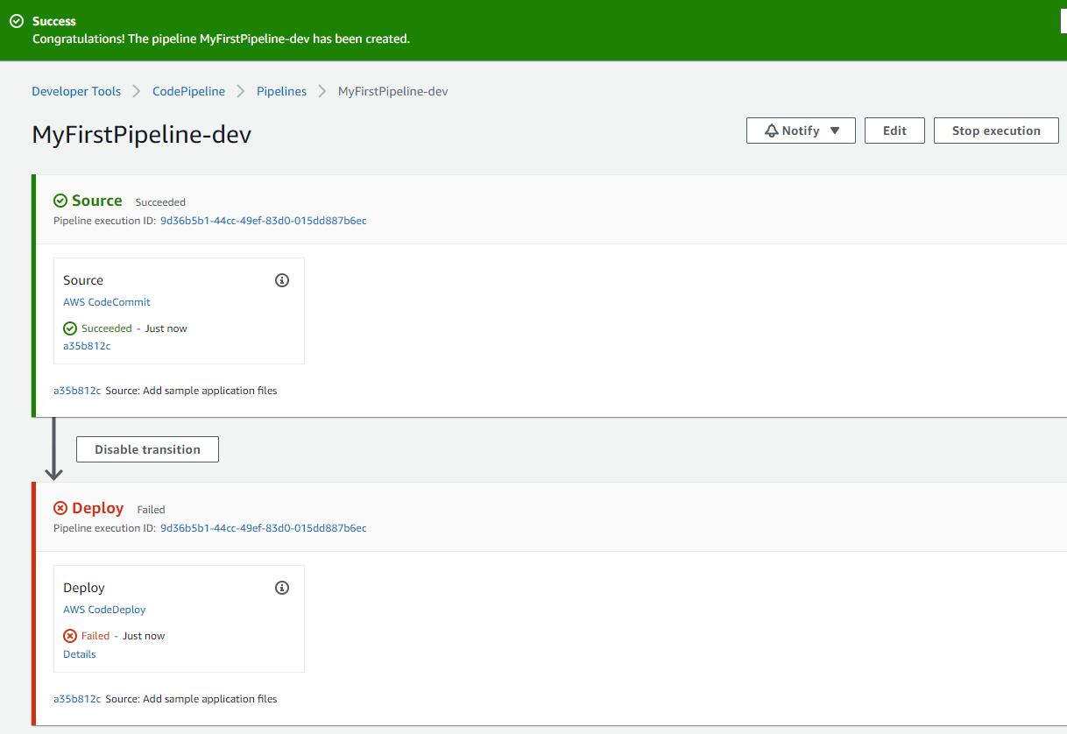

К сожалению, ошибку не могу решить самостоятельно. Буду гуглить дальше.

