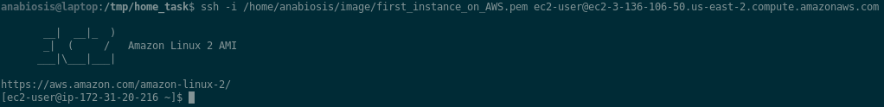Connect via SSH to AWS instance:

Instance in AWS

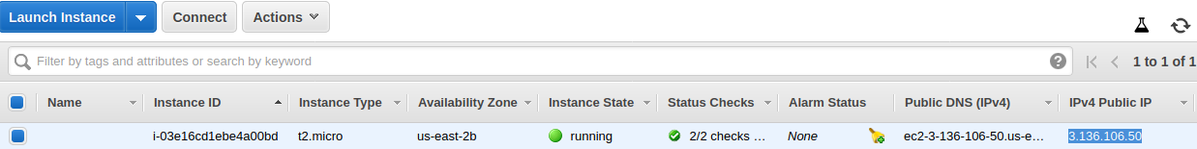

Result of Pipeline

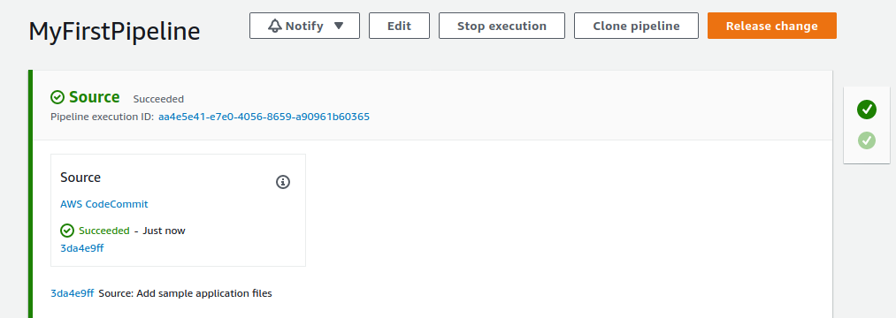

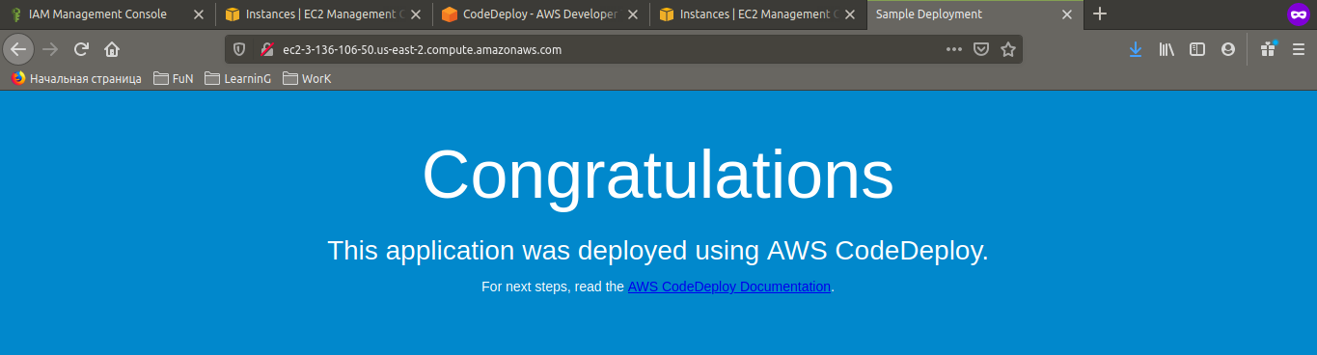

After making changes in index.html:

