EPAM University Programs   
DevOps external course   
Module 4 DevOps Introduction   
TASK 4.2

1. Set up Linux Virtual Machine in VirtualBox.

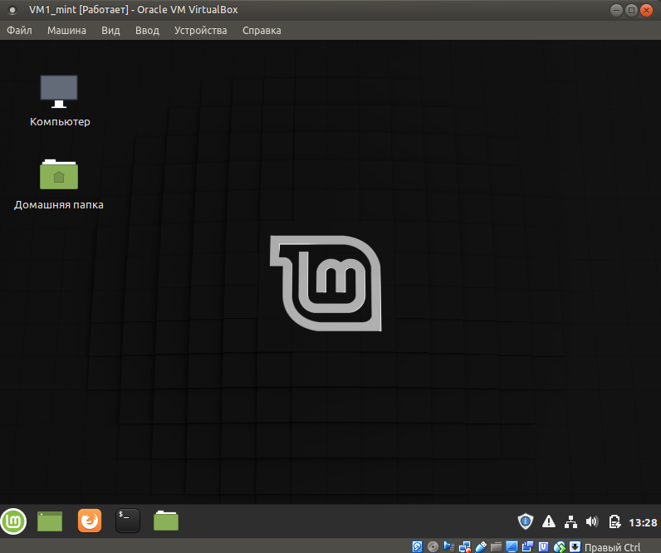

2. Familiarize yourself with the commands and utilities listed in the presentation (switching between virtual terminals (consoles); printenv; content of /etc/profile and ~/.bash_profile, $echo $HISTFILE $HISTSIZE $HISTFILESIZE, who, w, whoami, id). Make 5 screenshots.

To know which virtual terminals now is active: **ls /dev/tty?**

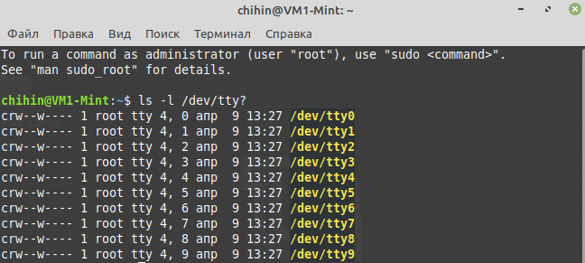

.profile - contains extension and / or overrides system-wide settings. Use **cat .profile** to see contents:

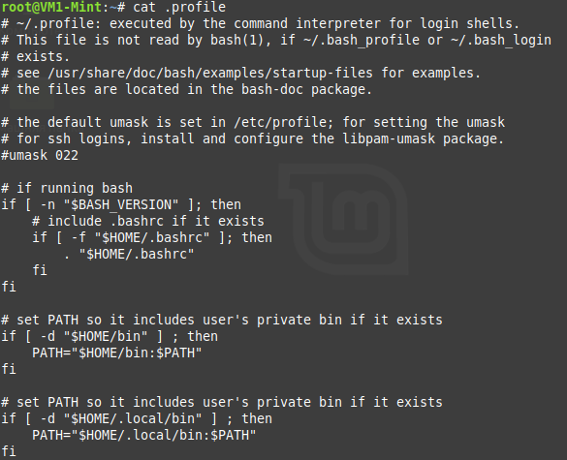

/etc/profile – contains a script that is used by all users. Use **cat /etc/profile** to see contents:

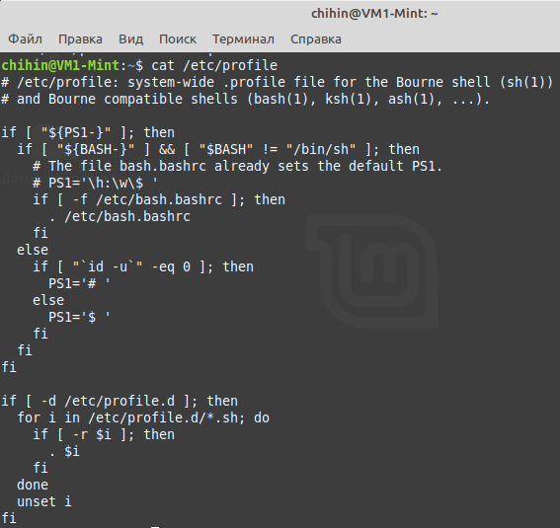

.bash_history – contains all the commands entered by the user. Use **cat .bash_history** to see contents:



who – shows authorized users and login time

w – shows who is logged in at the moment, time, uptime, cpu usage.

whoami – shows user name that associated with current id

id – shows information about user

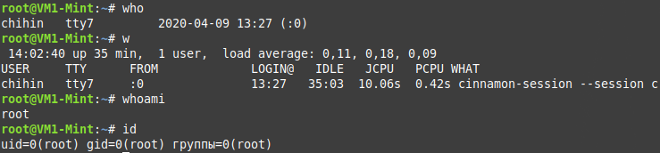

3. Familiarize yourself with the commands (***uname, hostname, uptime, shutdown, halt, reboot, init…***). Make 5 screenshots.

uname – print system information

uname -a – print all information

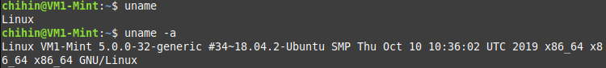

hostname – show or set the system's host name



uptime – display uptime



shutdown – halt, power-off or reboot machine



reboot - reboot the VM

4. Familiarize yourself with the help commands (***man, info, find, locate, whereis, less|zless in /usr/share/doc***). Make 5 screenshots.

man – contains manual and description of commands



Info - contains manual and description of commands

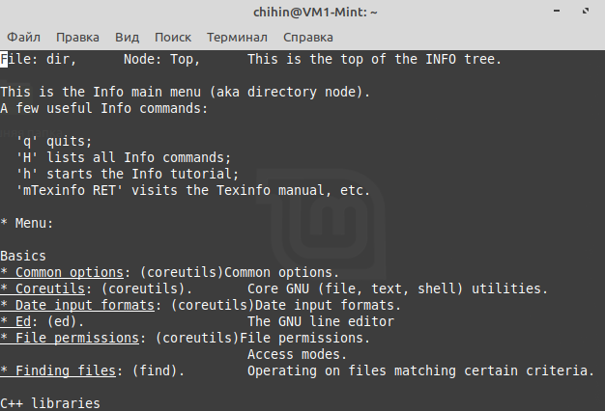

whereis – shows path to object that you want found, if it exist:



less - command that displays file contents or command output one page at a time in your terminal.

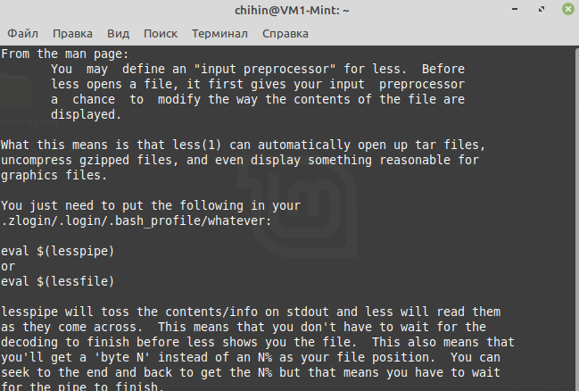

zless - is a filter which allows examination of compressed or plain text files one screenful at a time on a soft-copy terminal.

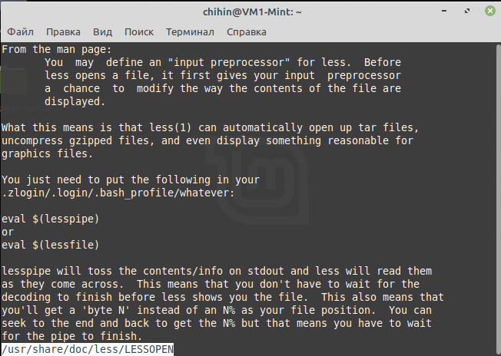

find - find all the files under /home directory

