Please check the project requirement for task 4.

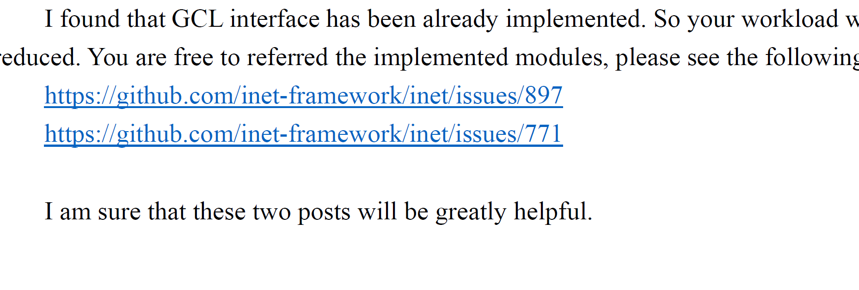

You are free to referred the implemented modules, please see the following posts:Please note that most parts of the configuration interface have already been implemented. So you can directly use it, please do not implement it from scratch (from the beginning).