hello, the simulation can not be executed.

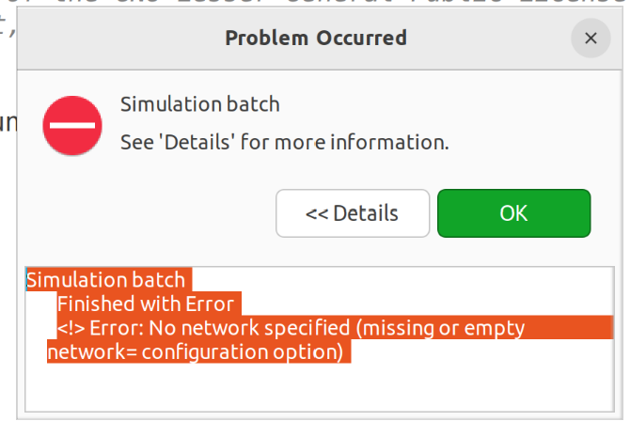

**We execute the simulation by the CMD mode, and then the error occurs.**

This is the error message:Starting...$ cd /home/tsn/project1WorkSpace/hybridNet2/simulations$ ../hybridNet2 -r 0 -m -u Cmdenv -n .:../src:../../inet4.5/examples:../../inet4.5/showcases:../../inet4.5/src:../../inet4.5/tests/validation:../../inet4.5/tests/networks:../../inet4.5/tutorials -x inet.common.selfdoc;inet.linklayer.configurator.gatescheduling.z3;inet.showcases.visualizer.osg;inet.showcases.emulation;inet.transportlayer.tcp_lwip;inet.applications.voipstream;inet.visualizer.osg;inet.examples.voipstream --image-path=../../inet4.5/images -l ../../inet4.5/src/INET omnetpp.iniOMNeT++ Discrete Event Simulation (C) 1992-2022 Andras Varga, OpenSim Ltd.Version: 6.0.2, build: 231006-7d5ca33dba, edition: Academic Public License -- NOT FOR COMMERCIAL USESee the license for distribution terms and warranty disclaimerSetting up Cmdenv...Loading NED files from .: 3Loading NED files from ../src: 20Loading NED files from ../../inet4.5/examples: 179Loading NED files from ../../inet4.5/showcases: 70Loading NED files from ../../inet4.5/src: 1153Loading NED files from ../../inet4.5/tests/validation: 5Loading NED files from ../../inet4.5/tests/networks: 6Loading NED files from ../../inet4.5/tutorials: 20Preparing for running configuration General, run #0...Assigned runID=General-0-20240213-14:57:25-5688<!> Error: No network specified (missing or empty network= configuration option)End.Simulation terminated with exit code: 1Working directory: /home/tsn/project1WorkSpace/hybridNet2/simulationsCommand line: ../hybridNet2 -r 0 -m -u Cmdenv -n .:../src:../../inet4.5/examples:../../inet4.5/showcases:../../inet4.5/src:../../inet4.5/tests/validation:../../inet4.5/tests/networks:../../inet4.5/tutorials -x inet.common.selfdoc;inet.linklayer.configurator.gatescheduling.z3;inet.showcases.visualizer.osg;inet.showcases.emulation;inet.transportlayer.tcp_lwip;inet.applications.voipstream;inet.visualizer.osg;inet.examples.voipstream --image-path=../../inet4.5/images -l ../../inet4.5/src/INET omnetpp.iniEnvironment variables:PATH=/home/tsn/omnetpp-6.0.2/bin::/home/tsn/project1WorkSpace/inet4.5/bin:/home/tsn/omnetpp-6.0.2/bin:/home/tsn/.local/bin:/usr/local/sbin:/usr/local/bin:/usr/sbin:/usr/bin:/sbin:/bin:/usr/games:/usr/local/games:/snap/bin:/snap/binLD_LIBRARY_PATH=/home/tsn/omnetpp-6.0.2/lib::/home/tsn/project1WorkSpace/inet4.5/src:OMNETPP_RELEASE=omnetpp-6.0.2OMNETPP_IMAGE_PATH=/home/tsn/omnetpp-6.0.2/images

**Then, we change the execution mode to "Qt", the simulation can be executed, but during a short time. The simulation is terminated abnormally.**

this is the error infomration when Qt is utilized:free(): double free detected in tcache 2Simulation terminated with exit code: 86Working directory: /home/tsn/project1WorkSpace/hybridNet2/simulationsCommand line: ../hybridNet2 -m -u Qtenv -n .:../src:../../inet4.5/examples:../../inet4.5/showcases:../../inet4.5/src:../../inet4.5/tests/validation:../../inet4.5/tests/networks:../../inet4.5/tutorials -x inet.common.selfdoc;inet.linklayer.configurator.gatescheduling.z3;inet.showcases.visualizer.osg;inet.showcases.emulation;inet.transportlayer.tcp_lwip;inet.applications.voipstream;inet.visualizer.osg;inet.examples.voipstream --image-path=../../inet4.5/images -l ../../inet4.5/src/INET omnetpp.iniEnvironment variables:PATH=/home/tsn/omnetpp-6.0.2/bin::/home/tsn/project1WorkSpace/inet4.5/bin:/home/tsn/omnetpp-6.0.2/bin:/home/tsn/.local/bin:/usr/local/sbin:/usr/local/bin:/usr/sbin:/usr/bin:/sbin:/bin:/usr/games:/usr/local/games:/snap/bin:/snap/binLD_LIBRARY_PATH=/home/tsn/omnetpp-6.0.2/lib::/home/tsn/project1WorkSpace/inet4.5/src:OMNETPP_RELEASE=omnetpp-6.0.2OMNETPP_IMAGE_PATH=/home/tsn/omnetpp-6.0.2/images

The simulation cannot be executed, the documnet summarize the current issues. please give us the corresponding resposne.

Please give me the response as soon as possbile, since this project was delayed too long time.