**Thank you for your efforts.**

**However, the following concerns should be addressed.**

Task1: the below figure is the screenshot of project requirement.

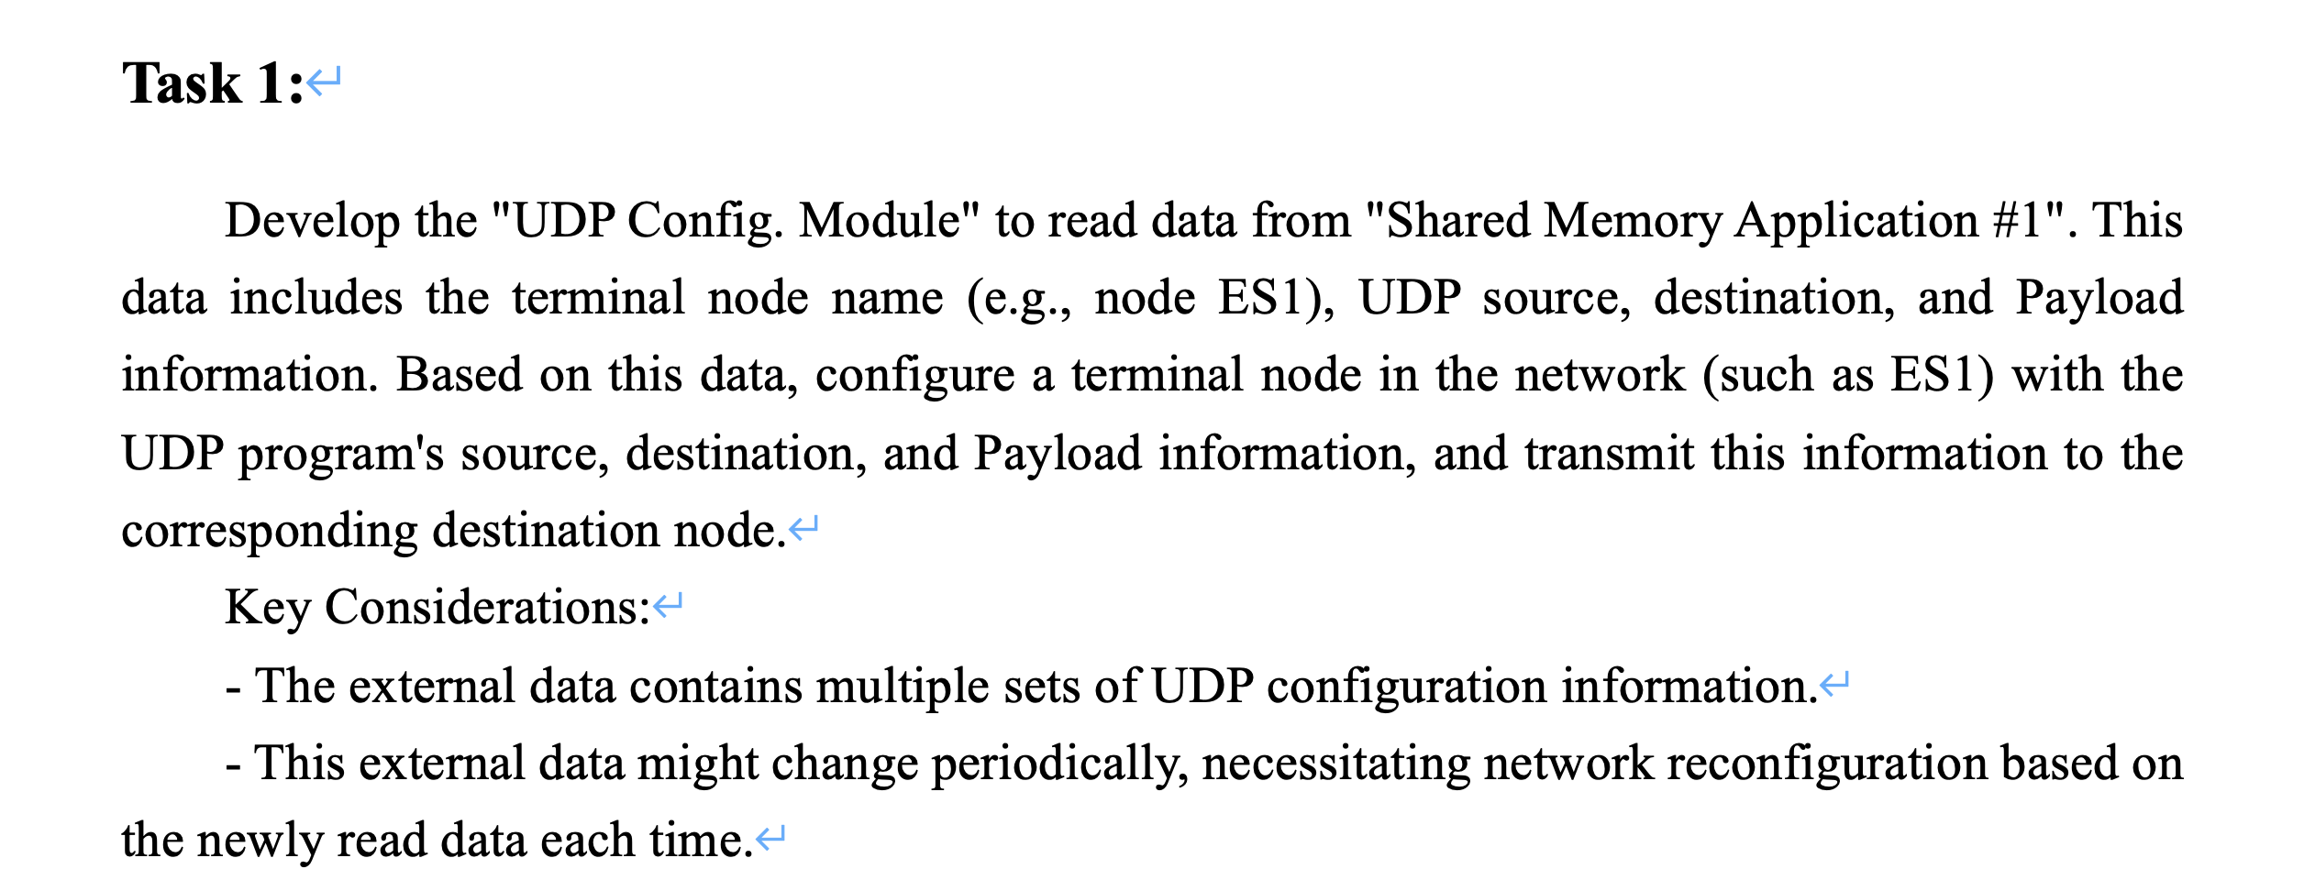



1. The **Payload** should be configured by user, however, the current codes do not contain this feature.
2. You should provide test cases for testing communication between wired nodes and wireless nodes. I run the simulation and the test fails
3. Can you provide test cases to prove that UDP parameters can be changed while the simulation is running? For example, UDP source, destination, length, paylod information. Also, the transmission interval is also an important parameter. The test case provided by you, only show the priority is changed.
4. What does the string in Sharememory1 mean? Why there are two a1ES3 in one line?

string udpConfData = "a1ES3,a1ES3:1000,a2ES1:1000,best-effort,10,10,0\n"

"a1ES3,a1ES3:2000,a2ES4:2000,video,10,20,4\n"

"a1ES4,a1ES4:1000,a2ES4:1000,best-effort,10,10,0\n"

"a2ES1,a2ES1:1000,a3ES1:1000,best-effort,10,10,0\n";

1. The topology discovery method (i.e., void GetNetInfo::updateNodeRuntimeInfo()) is not qualified, since it is almost as same as the “mixedNetMGT::updateAndPrintTopology()”. The below is a screenshot of the ReadMe file included in the project package (mixedNet) I first sent you.

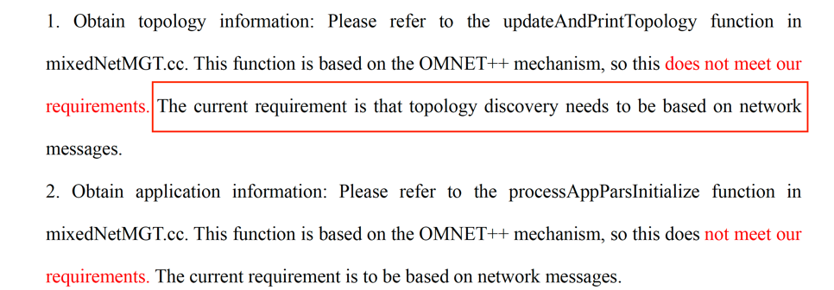

The reason why the topology discovery function you developed is not feasible is that it goes against the project development requirements:

“GetNetInfo” should sends messages including two parts: port connectivity information and application running information. These two kinds of messages will be sent to “Network Management Module”. And then, “Network Management Module” will process these data and construct the whole topology and apps. Such progress is similar to LLDP protocol. All the mentioned information is contained in the “Project requirement.”, please check every details of the project requirements.

If you think the functionality you develop combines the above requirements. So, please provide a screenshot:

1. GetNetInfo in each device will collect the current device information, package it into a message, and send it to the Network Management Module. Note that the message cannot be sent directly from the source to the destination, and requires intermediate nodes for routing. This process needs to be proven by screenshots.

1. I checked your JSON file, why all the gate is “111111”? you should get the gate status from the simulation, “11111111” means all gates are set to open. 1 means open and 0 means close.
2. The Figure 3 in “project requirement”, titled "Overview of Task 2," provides a conceptual diagram intended to aid in comprehension. It is not exhaustive, but serves as a guide to facilitate a deeper understanding of the task. **I encourage you to review all the details thoroughly, not solely relying on this figure. Should you have any questions or require further clarification, please do not hesitate to contact me directly for a collaborative discussion.**
3. For result statistics, you can refer to Chapter 12 of the omnet official manual. Statistics should be made for every UDP traffic in the network.
4. Currently, the gate status and routing table can be printed by terminal. But how do you ensure that the simulation has actually implemented this network configuration? Customers think that we only have the function of printing strings, but not the function of online configuration. We need to provide more convincing test cases.

**Last but not least, please check each requirement of the project requirements one by one. At the same time, please provide a more logical and complete report. Users will read the report first and check the source code only after they think there is no problem with the report. Reports need to provide convincing test cases.**