Report for "DemoDashboard"
Report period: 01.01.2024 to 01.01.2025
Hotel for animals "Pet Hotel Alabama"
Created by: John Doe
Creation date: 25.08.2025
This report contains analytical information and visualizations of key performance indicators. The sections for descriptions and recommendations are intended to be filled in by an analyst.

Metrics

1. Visits by animal type
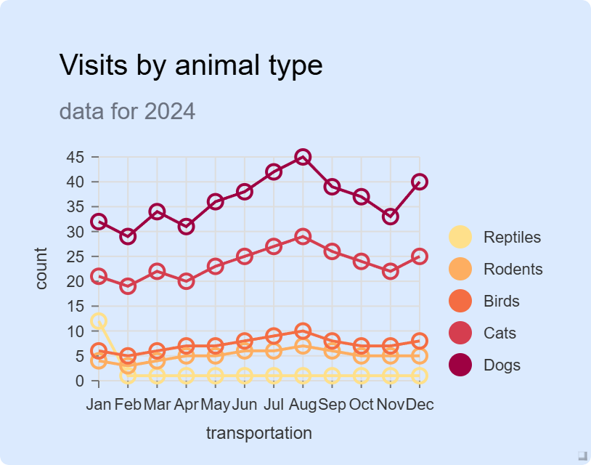
Chart 1. Visits by animal type
Description of the chart:
Here you should describe what this chart shows, reflecting the dynamics of growth/decline in values....
____________________________________________________________________________________________________
____________________________________________________________________________________________________
____________________________________________________________________________________________________
Key observations:
List the key trends, outliers, and patterns that are visible in the graph....
____________________________________________________________________________________________________
____________________________________________________________________________________________________
____________________________________________________________________________________________________
Recommendations:
Based on the data and the above sections, write practical recommendations for businesses...
____________________________________________________________________________________________________
____________________________________________________________________________________________________
____________________________________________________________________________________________________

2. Average feed consumption
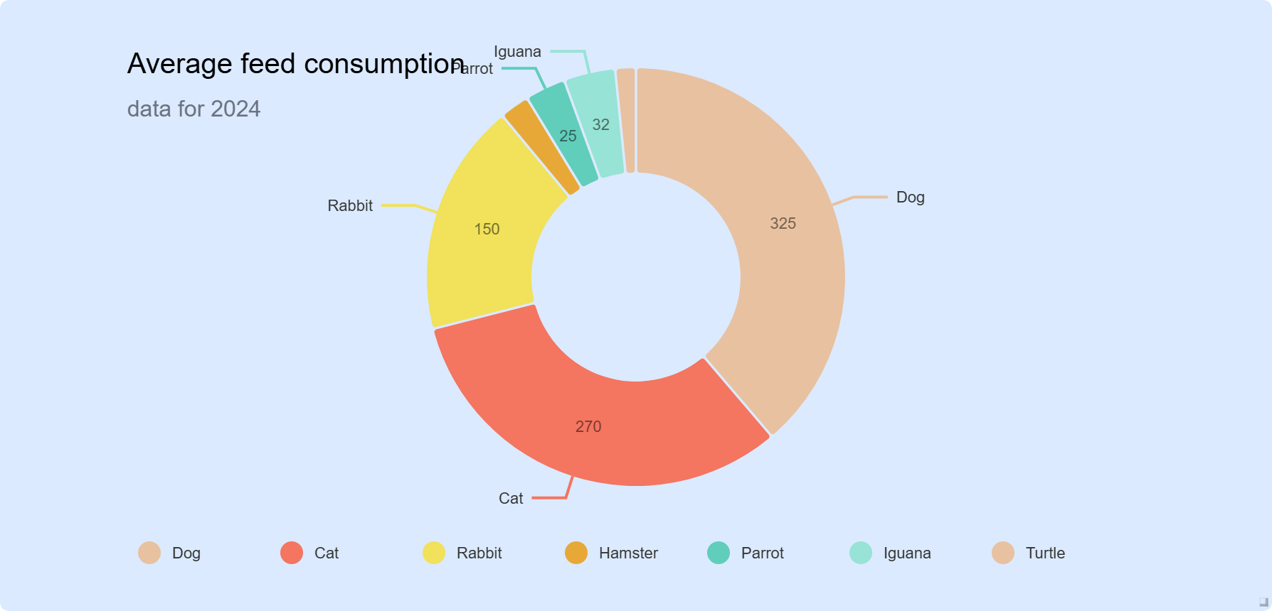
Chart 2. Average feed consumption
Description of the chart:
Here you should describe what this chart shows, reflecting the dynamics of growth/decline in values....
____________________________________________________________________________________________________
____________________________________________________________________________________________________
____________________________________________________________________________________________________
Key observations:
List the key trends, outliers, and patterns that are visible in the graph....
____________________________________________________________________________________________________
____________________________________________________________________________________________________
____________________________________________________________________________________________________
Recommendations:
Based on the data and the above sections, write practical recommendations for businesses...
____________________________________________________________________________________________________
____________________________________________________________________________________________________
____________________________________________________________________________________________________

3. Room profit
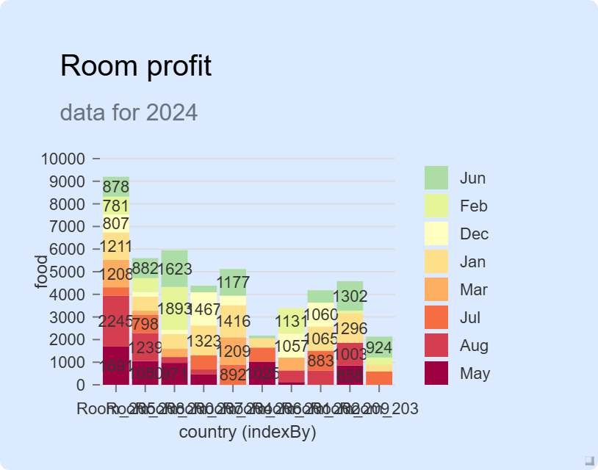
Chart 3. Room profit
Description of the chart:
Here you should describe what this chart shows, reflecting the dynamics of growth/decline in values....
____________________________________________________________________________________________________
____________________________________________________________________________________________________
____________________________________________________________________________________________________
Key observations:
List the key trends, outliers, and patterns that are visible in the graph....
____________________________________________________________________________________________________
____________________________________________________________________________________________________
____________________________________________________________________________________________________
Recommendations:
Based on the data and the above sections, write practical recommendations for businesses...
____________________________________________________________________________________________________
____________________________________________________________________________________________________
____________________________________________________________________________________________________

4. Room visits
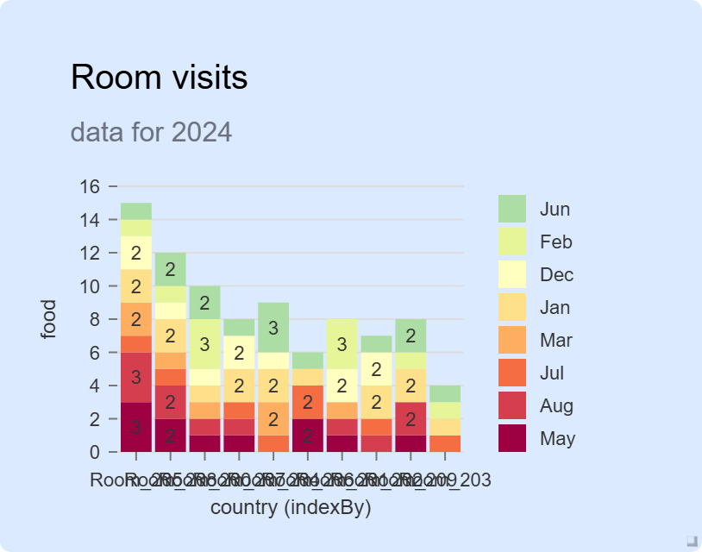
Chart 4. Room visits
Description of the chart:
Here you should describe what this chart shows, reflecting the dynamics of growth/decline in values....
____________________________________________________________________________________________________
____________________________________________________________________________________________________
____________________________________________________________________________________________________
Key observations:
List the key trends, outliers, and patterns that are visible in the graph....
____________________________________________________________________________________________________
____________________________________________________________________________________________________
____________________________________________________________________________________________________
Recommendations:
Based on the data and the above sections, write practical recommendations for businesses...
____________________________________________________________________________________________________
____________________________________________________________________________________________________
____________________________________________________________________________________________________

