**CREATIVE CODING 2 REPORT**

**Oleksandr Mustakaiev – N00202022**

***MY REPO GITHUB: https://github.com/OleksandrMustakaiev/Creative-Coding-2.git***

1. I added a custom font “Roboto” to my Project. To change font we need to:

let Font;

Function preload() {

Font = loadFont(‘location where it located in folder’);

}

After that, before text(), we can write textFont(Font) and it will change to a custom font.

For example, I used Roboto Bold Italic for a Title, and Roboto Bold for other text such as numbers / labels, legend, etc.

1. Data from excel file (.csv):

I create data in excel, then save it in excel file – to make changes and in CSV file to make written in VS and connect it to my Charts.

In data.js – we need to use 2 functions, first – preload(), to load Table (also font) and show that there is a header.

Second function called generateData(), in this function we want to read each row and also make a numbers from string to integer, to be able show this in Chart.

And the last thing to make it work, we need to call a function generateData(); in sketch.js in setup.

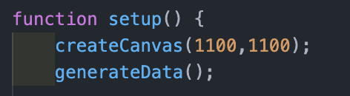

1. map(): this function accepts a parameter (number) and scales it using max value and chart height or width. I used this function in Bar Chart, Horizontal Bar Chart and Stacked Bar Chart, to scale data for chart size.

1. function updateValues(): this function used to calculate and update values, tick spacing, available height and bar height. Also we need in sketch.js in function draw() call it chart01.updateValues, so it will change values after changing size of chart, bar, etc. in console.

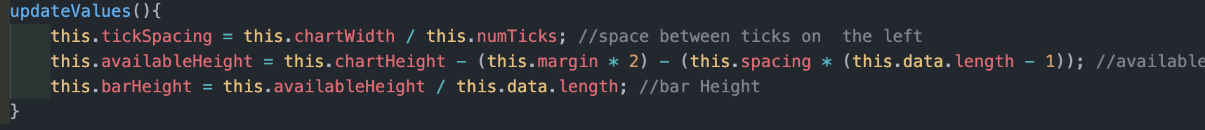

1. push() pop() , translate() and rotate(): the push() function saves the current drawing style settings and transformations, while pop() restores these settings.

translate() – specifies an amount to displace objects within the display window. The x parameter specifies left/right translation, the y parameter specifies up/down translation. For example, calling translate(0, 50) and then translate(0, 20) is the same as translate(0, 70).

rotate() – this allows us to rotate object up to 360 degrees, it also work if we use push() pop() to rotate or translate specific object / drawing.