**Own example of the corresponding sorting algorithm on an array of 10 numbers.**

|  |  |  |  |  |  |  |  |  |  |
| --- | --- | --- | --- | --- | --- | --- | --- | --- | --- |
| 2 | 4 | 8 | 5 | 6 | 1 | 10 | 7 | 9 | 3 |

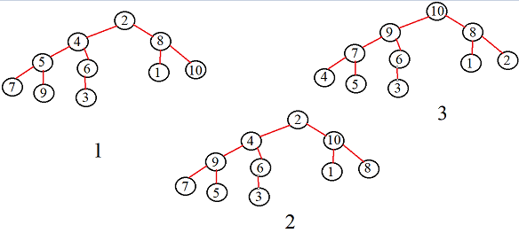

Figure 1 - Reconstruction of the sorting tree

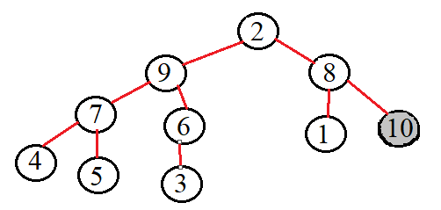

Figure 2 moving the largest element

**Repeat steps 2,3,4 until the array is sorted.**

**Sorting algorithm in graphical form.**

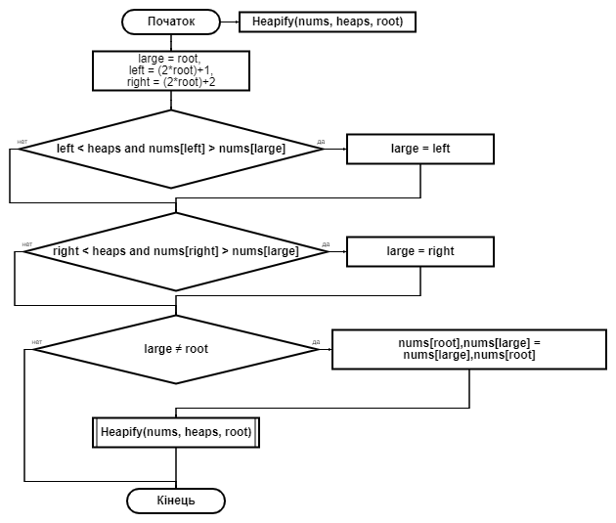

**The block diagram of the “heap_sort” function is shown in the figure.**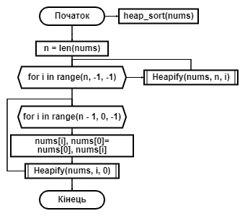

**The schedule in the average case**

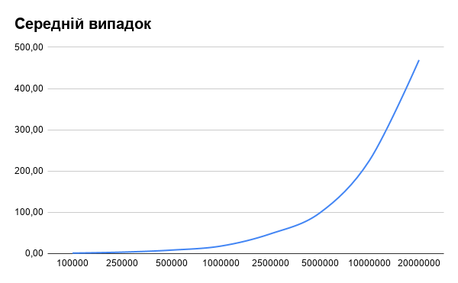

**Schedule at best**

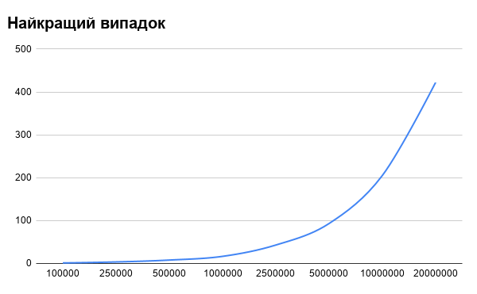

**Schedule at worst**

