Own example on an array of 10 elements

|  |  |  |  |  |  |  |  |  |  |
| --- | --- | --- | --- | --- | --- | --- | --- | --- | --- |
| 10 | 7 | 5 | 2 | 3 | 6 | 9 | 1 | 4 | 8 |

|  |  |  |  |  |  |  |  |  |  |
| --- | --- | --- | --- | --- | --- | --- | --- | --- | --- |
| 1 | 7 | 5 | 2 | 3 | 6 | 9 | 10 | 4 | 8 |

|  |  |  |  |  |  |  |  |  |  |
| --- | --- | --- | --- | --- | --- | --- | --- | --- | --- |
| 1 | 2 | 5 | 7 | 3 | 6 | 9 | 10 | 4 | 8 |

|  |  |  |  |  |  |  |  |  |  |
| --- | --- | --- | --- | --- | --- | --- | --- | --- | --- |
| 1 | 2 | 3 | 7 | 5 | 6 | 9 | 10 | 4 | 8 |

|  |  |  |  |  |  |  |  |  |  |
| --- | --- | --- | --- | --- | --- | --- | --- | --- | --- |
| 1 | 2 | 3 | 4 | 5 | 6 | 9 | 10 | 7 | 8 |

|  |  |  |  |  |  |  |  |  |  |
| --- | --- | --- | --- | --- | --- | --- | --- | --- | --- |
| 1 | 2 | 3 | 4 | 5 | 6 | 9 | 10 | 7 | 8 |

|  |  |  |  |  |  |  |  |  |  |
| --- | --- | --- | --- | --- | --- | --- | --- | --- | --- |
| 1 | 2 | 3 | 4 | 5 | 6 | 9 | 10 | 7 | 8 |
| 1 | 2 | 3 | 4 | 5 | 6 | 7 | 10 | 9 | 8 |

|  |  |  |  |  |  |  |  |  |  |
| --- | --- | --- | --- | --- | --- | --- | --- | --- | --- |
| 1 | 2 | 3 | 4 | 5 | 6 | 7 | 8 | 9 | 10 |

|  |  |  |  |  |  |  |  |  |  |
| --- | --- | --- | --- | --- | --- | --- | --- | --- | --- |
| 1 | 2 | 3 | 4 | 5 | 6 | 7 | 8 | 9 | 10 |

|  |  |  |  |  |  |  |  |  |  |
| --- | --- | --- | --- | --- | --- | --- | --- | --- | --- |
| 1 | 2 | 3 | 4 | 5 | 6 | 7 | 8 | 9 | 10 |

Graphic view of the algorithm

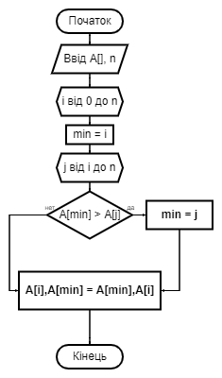

1. Theoretical assessment of the complexity of the algorithm: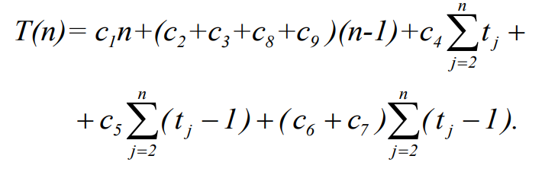

1.1. Best case:

In this case, the array is already sorted, so blocks 6 and 7 are not executed, so we will have the following form of time:



1.2. Worst case:

In the worst case, it is sorted in reverse order, so all blocks follow the order, then we will have the following form of time:

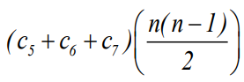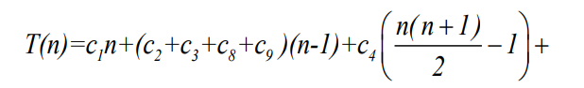Or: