**Own example of the corresponding sorting algorithm on an array of 10 numbers**

№1

|  |  |  |  |  |  |  |  |  |  |
| --- | --- | --- | --- | --- | --- | --- | --- | --- | --- |
| **5** | **7** | **3** | **1** | **2** | **2** | **5** | **6** | **3** | **7** |

№2

|  |  |  |  |  |  |  |  |
| --- | --- | --- | --- | --- | --- | --- | --- |
| **0** | **1** | **2** | **3** | **4** | **5** | **6** | **7** |
| **-1** | **1** | **2** | **2** | **0** | **2** | **1** | **2** |

№3

|  |  |  |  |  |  |  |  |  |  |
| --- | --- | --- | --- | --- | --- | --- | --- | --- | --- |
| **1** | **2** | **2** | **3** | **3** | **5** | **5** | **6** | **7** | **7** |

**Sorting algorithm in graphical form.**

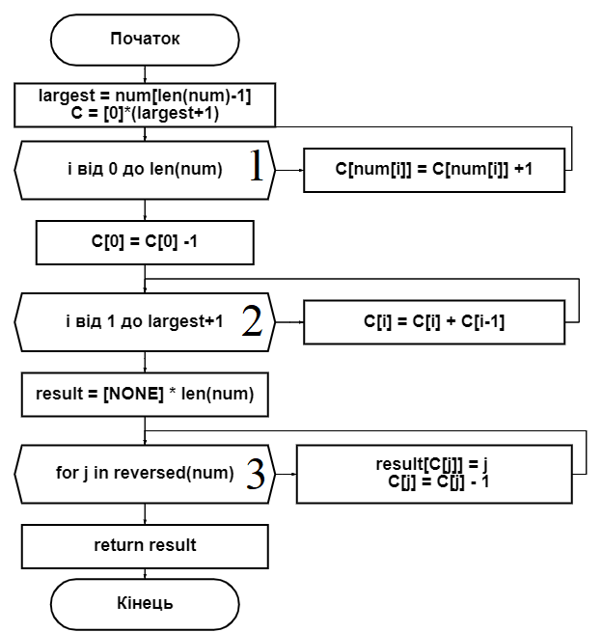

**The schedule in the average case**

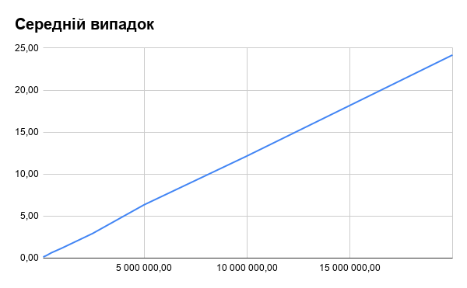

**Schedule at best**

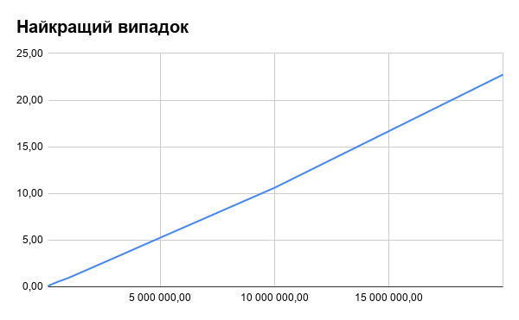

**Schedule at worst**

