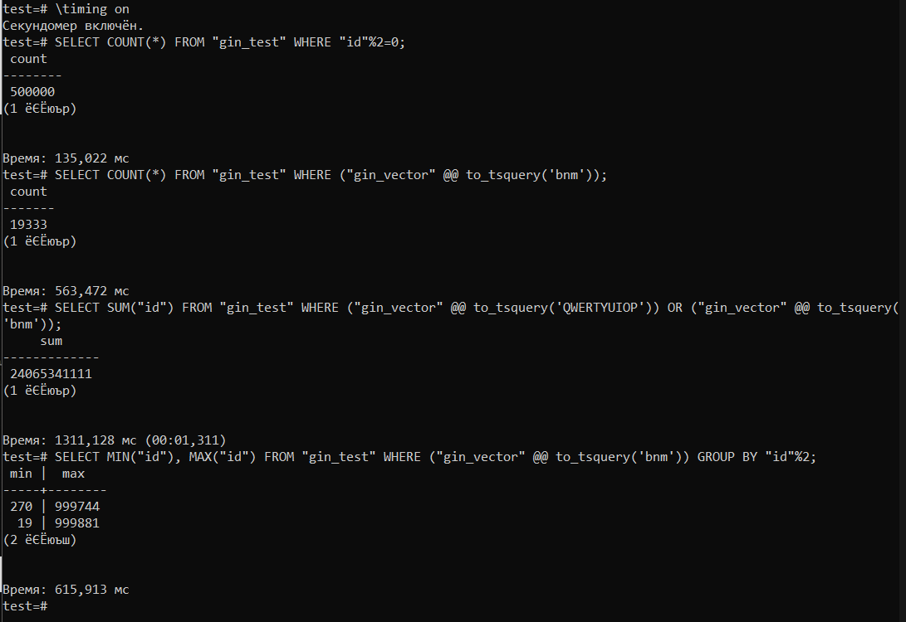

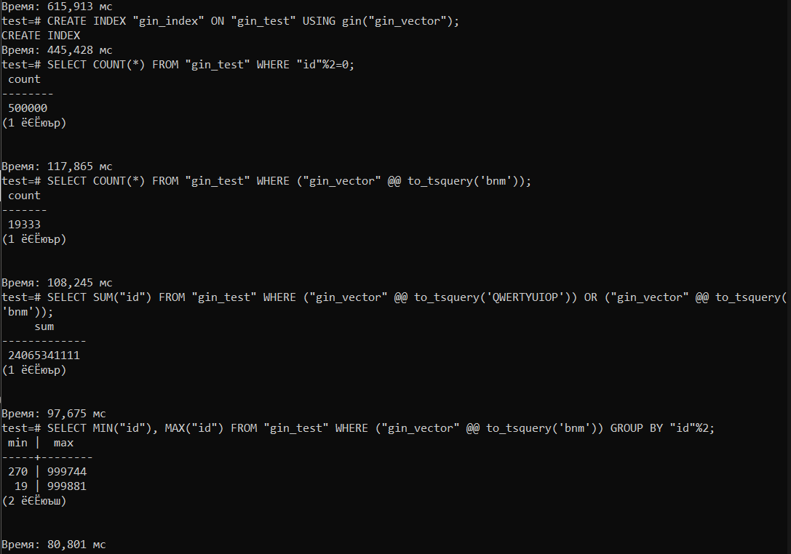

DROP TABLE IF EXISTS "gin_test";

CREATE TABLE "gin_test"("id" bigserial PRIMARY KEY, "string" text, "gin_vector" tsvector);

INSERT INTO "gin_test"("string") SELECT substr(characters, (random()*length(characters)+1)::integer, 10) FROM (VALUES('qwertyuiopasdfghjklzxcvbnmQWERTYUIOPASDFGHJKLZXCVBNM')) as symbols(characters), generate_series(1, 1000000) as q;

UPDATE "gin_test" set "gin_vector" = to_tsvector("string");

SELECT COUNT(*) FROM "gin_test" WHERE "id" % 2 = 0;

SELECT COUNT(*) FROM "gin_test" WHERE ("gin_vector" @@ to_tsquery('bnm'));

SELECT SUM("id") FROM "gin_test" WHERE ("gin_vector" @@ to_tsquery('QWERTYUIOP')) OR ("gin_vector" @@ to_tsquery('bnm'));

SELECT MIN("id"), MAX("id") FROM "gin_test" WHERE ("gin_vector" @@ to_tsquery('bnm')) GROUP BY "id" % 2;

**BTREE**

DROP TABLE IF EXISTS "btree_test";

CREATE TABLE "btree_test"("id" bigserial PRIMARY KEY, "time" timestamp);

INSERT INTO "btree_test"("time") SELECT (timestamp '2021-01-01' + random()*(timestamp '2020-01-01'-timestamp '2022-01-01')) FROM (VALUES('qwertyuiopasdfghjklzxcvbnmQWERTYUIOPASDFGHJKLZXCVBNM')) as symbols(characters), generate_series(1, 1000000) as q;

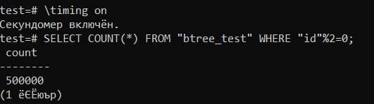

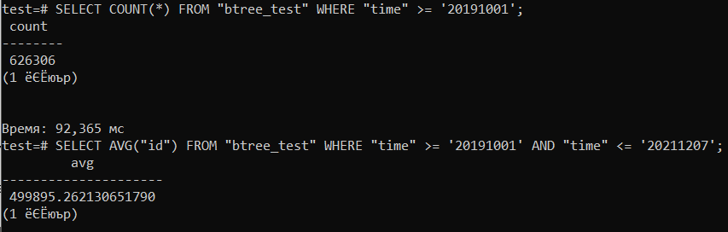

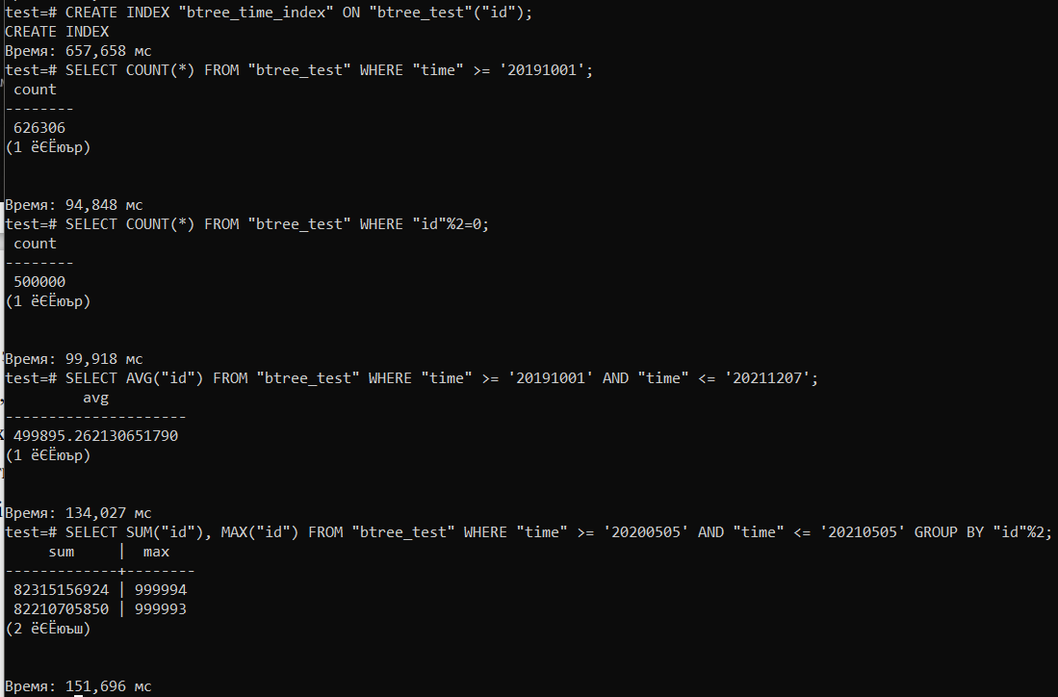

**TRIGGERS**

DROP TABLE IF EXISTS "trigger_test";

CREATE TABLE "trigger_test"(

"trigger_testID" bigserial PRIMARY KEY,

"trigger_testName" text

);

DROP TABLE IF EXISTS "trigger_test_log";

CREATE TABLE "trigger_test_log"(

"id" bigserial PRIMARY KEY,

"trigger_test_log_ID" bigint,

"trigger_test_log_name" text

);

INSERT INTO "trigger_test"("trigger_testName")

VALUES ('trigger_test1'), ('trigger_test2'), ('trigger_test3'), ('trigger_test4'), ('trigger_test5'), ('trigger_test6'), ('trigger_test7'), ('trigger_test8'), ('trigger_test9'), ('trigger_test10');

INSERT INTO "trigger_test_log"("trigger_test_log_name")

VALUES ('trigger_test1'), ('trigger_test2');

CREATE OR REPLACE FUNCTION after_insert_update_func() RETURNS TRIGGER as $trigger$

DECLARE

CURSOR_LOG CURSOR FOR SELECT * FROM "trigger_test_log";

row_ "trigger_test_log"%ROWTYPE;

BEGIN

IF NEW."trigger_testID"%2=0 THEN

IF NEW."trigger_testID"%3=0 THEN

RAISE NOTICE 'trigger_testID is multiple of 2 and 3';

FOR row_ IN CURSOR_LOG LOOP

UPDATE "trigger_test_log" SET "trigger_test_log_name"='_' || row_."trigger_test_log_name" || '_log' WHERE "id"=row_."id";

END LOOP;

RETURN NEW;

ELSE

RAISE NOTICE 'trigger_testID is even';

INSERT INTO "trigger_test_log"("trigger_test_log_ID", "trigger_test_log_name") VALUES (NEW."trigger_testID", NEW."trigger_testName");

UPDATE "trigger_test_log" SET "trigger_test_log_name" = trim(BOTH '_log' FROM "trigger_test_log_name");

RETURN NEW;

END IF;

ELSE

RAISE NOTICE 'trigger_testID is odd';

FOR row_ IN CURSOR_LOG LOOP

UPDATE "trigger_test_log" SET "trigger_test_log_name" = '_' || row_."trigger_test_log_name" || '_log' WHERE "id" = row_."id";

END LOOP;

RETURN NEW;

END IF;

END;

$trigger$ LANGUAGE plpgsql;

CREATE TRIGGER "after_insert_update_trigger"

AFTER INSERT OR UPDATE ON "trigger_test"

FOR EACH ROW

EXECUTE procedure after_insert_update_func();

INSERT INTO "trigger_test"("trigger_testName")

VALUES ('trigger_test11'), ('trigger_test12');

INSERT INTO "trigger_test_log"("trigger_test_log_name")

VALUES ('trigger_test_1'), ('trigger_test2');

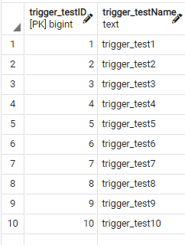

**UPDATED CODE**

DROP TABLE IF EXISTS "trigger_test";

CREATE TABLE "trigger_test"(

"trigger_testID" bigserial PRIMARY KEY,

"trigger_testName" text

);

DROP TABLE IF EXISTS "trigger_test_log";

CREATE TABLE "trigger_test_log"(

"id" bigserial PRIMARY KEY,

"trigger_test_log_ID" bigint,

"trigger_test_log_name" text

);

INSERT INTO trigger_test("trigger_testName") VALUES ('test1'), ('test2'), ('test3'), ('test4'), ('test5'), ('test6');

CREATE OR REPLACE FUNCTION after_insert_func() RETURNS TRIGGER AS $trigger$

DECLARE

CURSOR_LOG CURSOR FOR SELECT * FROM "trigger_test_log";

row_ "trigger_test_log"%ROWTYPE;

BEGIN

IF NEW."trigger_testID"%2=0 THEN

IF NEW."trigger_testID"%3=0 THEN

RAISE NOTICE 'trigger_testID is multiple of 2 and 3';

FOR row_ IN CURSOR_LOG LOOP

-- UPDATE "trigger_test_log" SET "trigger_test_log_name"='_' || row_."trigger_test_log_name" || '_log' WHERE "id"=row_."id";

INSERT INTO "trigger_test_log"("trigger_test_log_ID", "trigger_test_log_name") VALUES (NEW."trigger_testID", NEW."trigger_testName");

END LOOP;

RETURN NEW;

ELSE

RAISE NOTICE 'trigger_testID is even';

INSERT INTO "trigger_test_log"("trigger_test_log_ID", "trigger_test_log_name") VALUES (NEW."trigger_testID", NEW."trigger_testName");

UPDATE "trigger_test_log" SET "trigger_test_log_name" = trim(BOTH '_log' FROM "trigger_test_log_name");

RETURN NEW;

END IF;

ELSE

RAISE NOTICE 'trigger_testID is odd';

FOR row_ IN CURSOR_LOG LOOP

UPDATE "trigger_test_log" SET "trigger_test_log_name" = '_' || row_."trigger_test_log_name" || '_log' WHERE "id" = row_."id";

END LOOP;

RETURN NEW;

END IF;

END;

$trigger$ LANGUAGE plpgsql;

CREATE TRIGGER after_insert_test

AFTER INSERT OR UPDATE ON "trigger_test"

FOR EACH ROW EXECUTE PROCEDURE after_insert_func();

-- INSERT INTO trigger_test("trigger_testName") VALUES ('test1'), ('test2'), ('test3'), ('test4'), ('test5'), ('test6');

UPDATE "trigger_test" SET "trigger_testName" = "trigger_testName" || '_2' WHERE "trigger_testID"%2=0

**TRANSACTIONS**

DROP TABLE IF EXISTS "transactions";

CREATE TABLE "transactions"(

"id" bigserial PRIMARY KEY,

"numeric" bigint,

"text" text

);

INSERT INTO "transactions"("numeric", "text") VALUES (222, 'string1'), (223, 'string2'), (224, 'string3');

