UDC 004.89:004.852:519.86:37.018.43

OPTIMIZING FACTORS TO IMPROVE STUDENTS’ ADAPTABILITY
TO ONLINE EDUCATION
O. KUCHKOVSKA, O. LYSETSKA
Abstract. This paper introduces personalized, resource-efficient strategies to boost students’ adaptability in online education. Building on prior paper [1], we enhance the accuracy of the Random Forest classification model through refined feature engineering and hyperparameter tuning. Our framework integrates machine learning with mathematical optimization: the SHAP method quantifies feature contributions to adaptability levels, yielding weights for the objective function in an integer linear programming (ILP) formulation. The ILP model minimizes resource cost by optimizing feature adjustments, while incorporating penalties for implausible or illogical parameter combinations. This approach generates tailored adaptation scenarios aligned with individual student profiles, fostering explainable AI-driven recommendations. Empirical results demonstrate improved model scores and practical efficacy, with 18.1% of Low-adaptability students reclassified to Moderate or High levels via minimal interventions, advancing online education efficiency and offering a robust, evidence-based tool for targeted student support.
Keywords: online education, student adaptability, Random Forest, SHAP explainability, integer linear programming, resource optimization, explainable AI.

INTRODUCTION
The global shift toward online learning has elevated learners’ adaptability as a pivotal determinant of academic success. However, traditional universal support strategies, such as broad-scale technical upgrades, have proven inefficient and resource-intensive, overlooking individual needs, financial constraints, and initial conditions.
This underscores a pressing scientific and practical challenge: devising personalized, resource-efficient strategies for student support. Existing approaches predominantly rely on generalized interventions, which fail to address unique learner profiles. Consequently, resource allocation remains suboptimal, and intervention efficacy is limited, as intuitive or survey-based decisions cannot pinpoint the least-costly path to enhanced adaptability.
A critical gap persists in the absence of formalized, data-driven tools for generating economically justified, individualized recommendations. Our paper bridges this gap by proposing an integrated model that leverages quantitative feature impact weighs-derived via the SHAP (SHapley Additive exPlanations) method from a Random Forest classifier, to formulate an integer linear programming (ILP) problem. This optimization framework identifies the minimal set of targeted changes in the student characteristics, maximizing adaptability gains while minimizing costs and penalizing implausible combinations.
The aim of this article is to develop and validate this comprehensive approach, enabling transition from generic support to mathematically substantiated, personalized adaptation scenarios. By embedding explainable AI insights into systems analysis, our method offers a scalable tool for educational institutions, fostering an efficient online education ecosystem.

RELATED APPROACHES AND UNRESOLVED CHALLENGES IN STUDENT ADAPTABILITY MODELING
This paper synthesizes three important areas in contemporary systems analysis and educational informatics: machine learning for predicting student success, interpretability of “black box” models, and algorithmic recommendation. The foundational predictive stage leverages an existing Random Forest classifier introduced in [1], which efficacy is corroborated by extensive literature [2]. These works affirm that ensemble methods reliably forecast academic outcomes, validating their application in quantifying student adaptability levels within complex online learning systems.
Recent studies have also explored remote learning challenges, includings web accessibility [3], key trends and findings of the distance education [4], and the impact of online formats on student engagement and performance [5].
Advancing from prediction to causal insight necessitates interpretability techniques. A seminal advancement is the SHAP (SHapley Additive exPlanations) framework [8], grounded in cooperative game theory, which decomposes model predictions into feature-specific contributions. This enables granular analysis of adaptability drivers, bridging the opacity of machine learning with actionable systems-level understanding.
The culminating phase – translating explanations into personalized interventions – builds on the actionable recourse paradigm [8]. By formulating recourse as an optimization problem, this approach identifies minimal-cost perturbations to input features, providing a theoretical scaffold for deploying integer linear programming (ILP) to derive optimal adaptation strategies.
The novelty of our research resides in the holistic integration of machine learning, SHAP-derived feature weights, ILP objective function, which ensures us to get an explainable recommendation tailored to individual student profiles. Unlike prior studies, which use only one techniques: prediction [1, 2], education trend analysis [3 – 6], explanation [7], or optimization [8] – our unified model pioneers their confluence for educational systems analysis.
A literature review reveals a persistent gap between diagnostics and prescriptive actions. While existing papers adeptly identify risk factors, they seldom progress to formalized, cost-balanced intervention plans. This article addresses these deficiencies by dividing an integrated pipeline that operationalizes data-driven insights into resource-efficient, personalized scenarios.

DATA AND PREPROCESSING
This study employs a dataset [9] comprising respondent characteristics that influence adaptability to distance learning. The dataset integrates socio-demographic, technical, and personal factors, including gender, age, educational level, type of educational institution, place of residence, device type, internet connection quality, family financial condition, daily class duration, and availability of learning resources. It also incorporates a classification parameter for adaptability level (Low, Moderate, High), enabling respondent categorization. A detailed overview of the parameters and their values is presented in Figures 1-2.
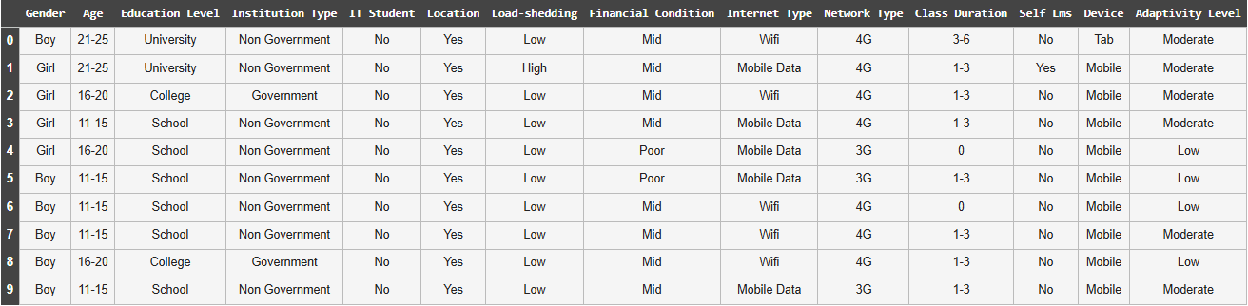
Fig. 1. Database
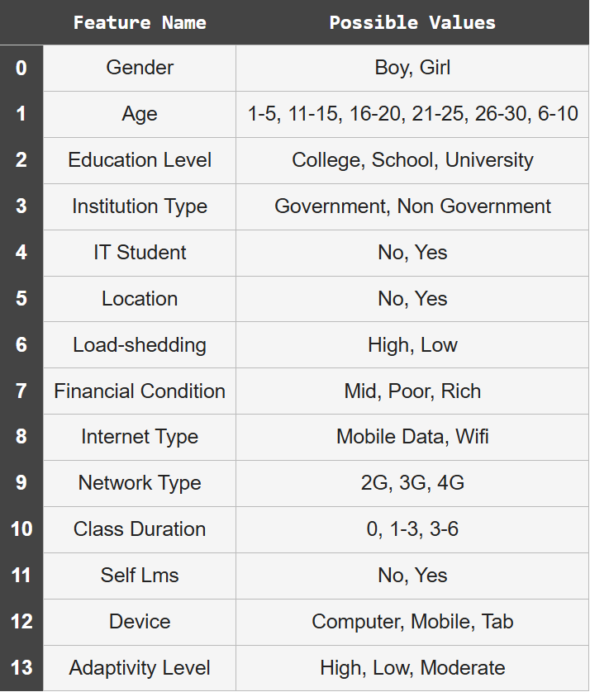
Fig. 2. Database Features
The key task is to determine the optimal changes in respondent characteristics necessary to elevate their adaptability to online education. This entails implementing minimal adjustments that most efficiently transition a respondent to a higher adaptability class, thereby enabling scientifically grounded recommendations for enhancing adaptation efficiency with minimal resource expenditure.
During the data preprocessing stage, missing values and outliers were verified (none were detected), and categorical features were encoded numerically using Ordinal Encoding.
The selection of characteristics for analysis drawn from factors deemed critically important in contemporary literature. Notably, paper [2] highlights that distance learning’s primary advantages – constant access to online materials (noted by 69% of students) and self-paced learning (64%) – are closely tied to technical support quality. Conversely, IT equipment issues (reported by 54% of respondents) rank among the chief barriers to successful adaptation.
Consequently, technical and infrastructural indicators were identified as pivotal in determining whether students leverage online format benefits or face its drawbacks. Five key adjustable characteristics were thus selected for optimization, directly reflecting these aspects: internet connection (Wi-Fi or mobile data), network connectivity type (4G, 3G, or 2G), daily class duration (0, 1-3, or 3-6 hours), availability of a learning management platform (Self LMS), and primary device for learning (tablet, smartphone, or computer). This focused selection facilitates quantitative assessment and targeted optimization of core distance learning elements.
Immutable characteristics – such as family financial condition, gender, age, and educational institution type – were treated as fixed parameters, exempt from adjustment. The study thus prioritizes variable factors amenable to intervention for bolstering respondents’ adaptability.

MODEL SELECTION, PREDICTION, AND FEATURE CONTRIBUTION
To prepare for the optimization problem, a classification model was developed to evaluate adaptability levels. Building on prior work [1], which applied a Random Forest classifier to the same dataset but overlooked class imbalance, the present model incorporates stratification to maintain class proportions across data splits.
Random Forest (RF), as introduced by Leo Breiman in [10], represents an ensemble learning method that aggregates predictions from multiple decision trees to enhance generalization and reduce overfitting. Each tree is constructed on bootstrap sample of the training data, with random subsets of features considered at each split, introducing variability that underpins the ensemble’s robustness. The margin function is a cornerstone of RF’s theoretical analysis, quantifying the confidence of a prediction for a given input $X$ and true label $Y$. It measures the “cushion” or separation between the predicted class and the nearest competing class, based on the proportion of trees voting for each class. A larger margin indicates higher prediction reliability, while negative margins signal misclassification risk.
The raw margin for a specific forest configuration $Θ$ (a random seed governing bootstrap sampling and feature subset) defined as:
$$mr\left(X,Y;Θ\right)=\frac{1}{B}\sum_{b=1}^{B}{I\left(h_{b}\left(X;Θ\right)=Y\right)}-\max_{j≠Y}{\frac{1}{B}\sum_{b=1}^{B}{I\left(h_{b}\left(X;Θ\right)=j\right)}},$$
where $B$ is the total number of trees in the forest, $h_{b}(X;Θ)$ is the prediction from the $b$-th tree, $I(⋅)$ is the indicator function (1 if true, 0 otherwise). The first term is the proportion of votes for correct class $Y$ and the second term is the maximum proportion of votes for any incorrect class $j$.
To account for the randomness in RF construction, the expected margin (or average margin) over all possible configurations $Θ$ is:
$\overline{mr}\left(X, Y\right)=E_{Θ}\left[mr\left(X,Y;Θ\right)\right]=P_{Θ}\left(h\left(X;Θ\right)=Y\right)-\max_{j≠Y}{P_{Θ}\left(h\left(X;Θ\right)=j\right)},$ (1)
where $h(X;Θ)$ denotes the aggregate forest prediction under $Θ$, and $P_{Θ}(⋅)$ is the probability over the random distribution of $Θ$.
The working principle of the Random Forest model is illustrated in Fig. 3 [11]. Consistent with [1], this study employs an ensemble-based technique to combine the predictions from multiple models, yielding greater accuracy than any single algorithm.

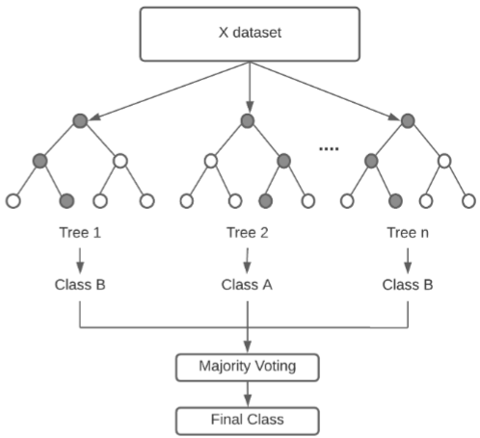
Fig. 3. Working Procedure of Random Forest Classifier
In [1] authors achieved baseline classification accuracy of 89.63% with stable performance. However, unlike [1], addressing class imbalance via stratification improved accuracy to 92.03% (see table 1). The model was trained with hyperparameters max_depth=20, n_estimators=100, and random_state=42, which optimized results among tested configurations. This refined approach ensures robust predictions, providing a reliable foundation for optimizing characteristics to enhance students’ adaptability in distance learning.
T a b l e 1. Result compare
Metric | Scores in [1] | Our Scores
Accuracy | 89.63% | 92.03%
Recall (Low adaptability) | 0.94 | 0.93
Precision (Low adaptability) | 0.89 | 0.92
F1-score (Low adaptability) | 0.92 | 0.93
Recall (Moderate adaptability) | 0.90 | 0.93
Precision (Moderate adaptability) | 0.90 | 0.92
F1-score (Moderate adaptability) | 0.90 | 0.93
Recall (High adaptability) | 0.65 | 0.80
Precision (High adaptability) | 0.88 | 0.88
F1-score (High adaptability) | 0.75 | 0.84

The classification report indicates robust overall performance, with balanced precision and recall across classes. However, the primary misclassification challenge occures at class boundaries, particularly Low and High adaptability instances being predicted as Moderate (the majority class). This is evident in the reduced recall for High adaptability (0.80 in CV, reflected here), where 15% of High cases are erroneously assigned to Moderate, alongside 4% of Low cases. Such errors stem from overlapping feature distributions and residual imbalance effects, despite stratification. The confusion matrix (see Fig. 4) visualizes these patterns, highlighting Moderate’s role as a default for ambiguous predictions. This motivates our ILP’s emphasis on target, minimal changes to resolve boundary cases.
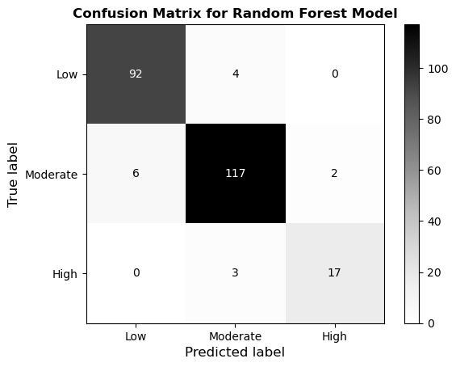
Fig. 4. Confusion Matrix of Random Forest Classifier
To ensure interpretability and practical recourse within the optimization model, the importance of each modifiable feature is derived using SHAP (Shapley Additive exPlanations). The SHAP concept, grounded in cooperative game theory, attributes a unique contribution value to each feature by interpreting the model’s prediction as a sum of feature effects [12].
For a trained classifier $f: R^{n}→R$, the SHAP value $ϕ_{j}\left(\vec{x}\right)$ for feature $j$ at instance $\vec{x}$ quantifies its marginal contribution to the prediction, computed as the average of all possible feature coalitions:
$ϕ_{j\left(f, \vec{x}\right)}= \sum_{S⊆N\backslash \{j\}}{\frac{\left|S\right|!⋅\left(\left|N\right|-\left|S\right|-1\right)!}{|N|!}}\left[f_{S∪\left\{j\right\}}\left({\vec{x}}_{S∪\left\{j\right\}}\right)-f_{S}\left({\vec{x}}_{S}\right)\right],$ (2)
where $N=\{1, …, n\}$ denotes the set of all features, and $f_{S}\left({\vec{x}}_{S}\right)$ is the model prediction restricted to the subset $S$.
METHODOLOGY OF OPTIMIZATION
To address the optimization of respondent characteristics for enhancing adaptability levels, an integer linear programming (ILP) model was selected. This approach minimizes changes to adjustable features while incorporating both their predictive importance (quantified via SHAP values derived from Random Forest classifier) and implementation complexity, modeled through penalty coefficients for implausible or resource-intensive adjustments.
Notably, the suitability of linear optimization is independent of linear correlation in the raw data. Preliminary analysis indicated weak linear relationships between individual features and adaptability levels, as reflected in low coefficients of determination ($R^{2}$; see Fig. 5). Such limitations pertain solely to simple linear regression for prediction and do not preclude ILP’s efficacy for decision-making.
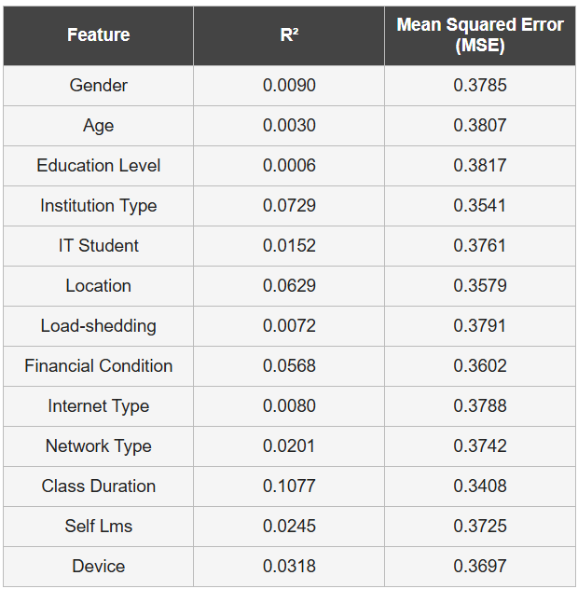
Fig. 5. Coefficients of Determination ($R^{2}$) and MSE for Individual Features
This concern is mitigated by sourcing objective function coefficients from the nonlinear Random Forest model via SHAP, which captures intricate, non-linear interactions among variables. Consequently, SHAP weights furnish a robust, feature-specific impact assessment, enabling the ILP to leverage complex data dynamics within a tractable linear framework [8, 12, 13].
The adoption of ILP is warranted on two fronts. First, the discrete nature of optimizable variables (e.g., internet connection type, device category) necessitates integer constraints to ensure realistic solutions. Second, the model’s linearity guarantees computational tractability and straightforward problem specification, facilitating efficient solving even for larger instances. This duality (nonlinear insights from SHAP integrated into a linear optimization scaffold) yields a balanced objective: minimizing total “cost” (effort and penalties) while maximizing projected adaptability gains.
Thus, the ILP formulation emerges as a potent instrument for the problem at hand, striking an optimal equilibrium between intervention costs and efficacy in elevating student adaptability within online education systems.
OPTIMIZATION MODEL
To identify the minimal set of feature modifications that elevate a student’s adaptability level, we formulate an Integer Linear Programming (ILP) model.
The optimization problem seeks a new feature vector $\vec{x^{'}}$ for a student that minimizes the total “cost” of transitioning from the initial vector $\vec{x}$, while ensuring reclassification to a higher adaptability category predicted by the trained Random Forest model.
Decision variables $y_{j}$. We introduce binary decision variables $y_{j}$ ($j=1, …, n$), which indicate whether feature $j$ was modified, as follows:
$y_{i}=\left\{\begin{aligned}1, if x_{j}^{'}≠x_{j}; \\ 0, otherwise.\end{aligned}\right.$ (3)
Objective function. The total cost of transition is defined as:
$Cost\left(\vec{x}→\vec{x^{'}}\right)=α\sum_{j=1}^{n}{y_{j}}+\sum_{j=1}^{n}{ω_{j}y_{j}}+Penalty\left(\vec{x^{'}}\right)⟶min,$ (4)
where:
- $α\sum_{j=1}^{n}{y_{j}}$ – penalize the total number of modifications, with $α$ as a tunable weight controlling overall intervention sparsity.
- $\sum_{j=1}^{n}{ω_{j}y_{j}}$ – weights changes by their predictive importance, with $ω_{j}$ denoting SHAP-derived impact values for feature $j$.
- $Penalty\left(\vec{x^{'}}\right)$ – discourages implausible feature combinations in $\vec{x'}$.

Parameter $α$. This coefficient balances the minimization of change count against impact. Its value is empirically calibrated in the computational experiments to ensure balance between intervention complexity and adaptability improvment.
Calculation of weights $ω_{j}$. Feature weights $ω_{j}, j=\overline{1,n}$, capturing each characteristic’s contribution to adaptability elevation, were computed using the SHAP method (2) on the improved Random Forest classifier (with stratification for class imbalance, achieving 92% accuracy). Specifically, SHAP values for the transition from Low to Moderate adaptability were prioritized. Analysis identified daily class duration as the dominant factor ($SHAP≈0.086$), followed by network type ($SHAP≈0.035$),internet type ($SHAP≈0.028$), LMS availability ($SHAP≈0.023$), and device type ($SHAP≈0.020$).
To integrate into the objective function, these values were scaled using Absolute Max Scaling, preserving relative ranking and ensuring non-zero contributions (unlike min-max scaling, which may zero marginal features). The maximum SHAP value (class duration) was normalized to 1, with others scaled proportionally (see Fig. 6). This yields interpretable, bounded weights $ω_{j}$ suitable for ILP.
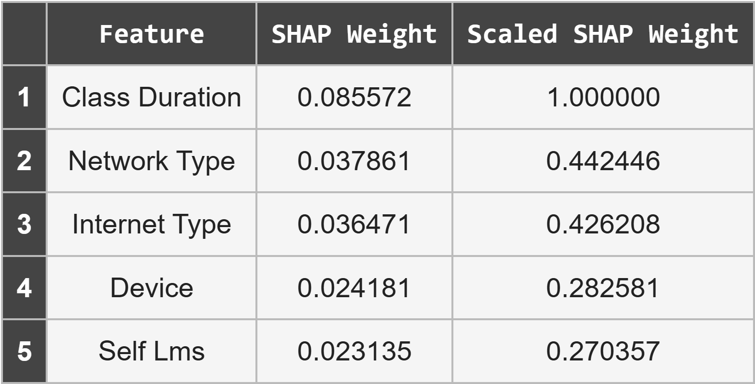
Fig. 6. Scaled SHAP Feature Importance
Determination of the Penalty Function. To prevent unrealistic or inconsistent feature combinations $\vec{x'}$, a penalty term was incorporated via the penalty method. It aggregates sanctions for predefined incompatible combinations:
$Penalty\left(\vec{x^{'}}\right)= \sum_{k∈K}{λ_{k}C_{k}\left(\vec{x^{'}}\right),}$ (5)
where:
- $K$ is the set of undesirable combinations (e.g., extended sessions on mobile device or 2G access with computer; full list in Fig. 7.)
- $C_{k}\left(\vec{x^{'}}\right)$ is a binary indicator, $C_{k}\left(\vec{x^{'}}\right)=\left\{\begin{aligned}1, if combination k occurs in \vec{x^{'}}; \\ 0, otherwise; \end{aligned}\right.$ ($k∈K$).
- $λ_{k}=1-p_{k}$ ($k∈K$) is an empirically set penalty, with $p_{k}$ as the empirical frequency of $k$ in the original dataset.
Rarer combinations incur steeper penalties, promoting data-aligned solutions.
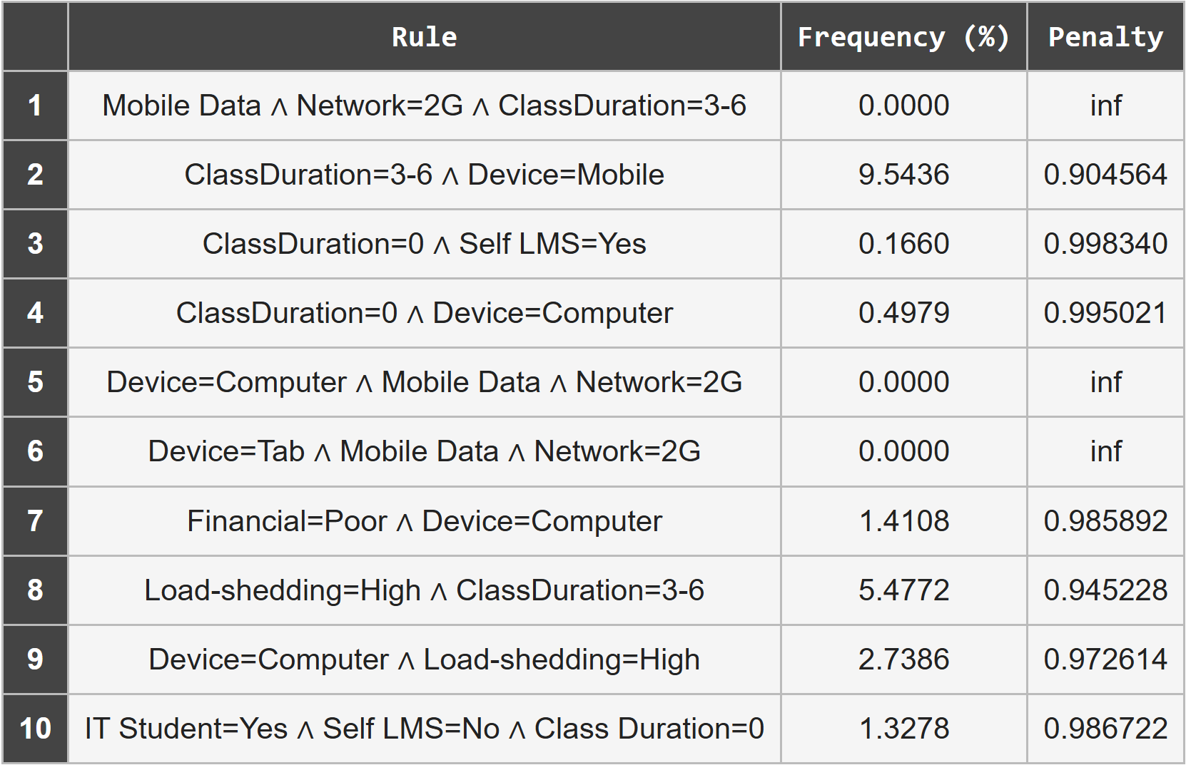
Fig. 7. Penalty Coefficients for Undesirable Feature Combinations
Constraints. Feasibility is ensured via:
$\left|x_{j}^{'}-x_{j}\right|≤M⋅y_{j}, ∀ j,$ (6)
where $M$ is a sufficiently large constant (Big-M method).
Additional constraints maintain categorical integrity:
$x_{j}^{'}∈\left\{v_{j1}, v_{j2}, …, v_{jm_{j}}\right\}, ∀j,$ (7)
where for each feature $x_{j}$
- $v_{j1}, v_{j2}, …, v_{jm_{j}}$ are all admissible values (the categories or discrete levels);
- $m_{j}$ represents the cardinality of this feasible set (i.e., the number of possible categorical states of feature $j$).
Finally, the model enforces an improved adaptability prediction:
$f\left(\vec{x^{'}}\right)≥f\left(\vec{x}\right)+δ$ (8)
with $f(⋅)$ corresponds to the expected margin function of Random Forest classifier (1) and $δ>0$ ensuring class uplift. The margin quantifies the confidence difference between the predicted class and its closest competing class. Consequently, the constraint (8) ensures that the optimized feature vector $\vec{x^{'}}$ yields a statistically more confident classification, i.e., a higher adaptability level.
Thus, the ILP model delivers parsimonious, explainable, and practically feasible adaptation pathways that are both cost-effective and realistically attainable.

COMPUTATIONS AND RESULTS
The culmination of this paper yields a fully operational framework for minimizing modifications to student characteristics while elevating adaptability to distance learning. All requisite parameters for the ILP objective function (3) have been derived: SHAP-based feature weights $ω_{j}$, penalty coefficients $λ_{k}$ for implausible combinations, and student-specific $α$ values. This facilitates tailored optimization, yielding the fewest viable changes under realism constraints.
As a result, the ILP model with objective function (4) using decision variables (3), penalty function (5), and constrains (6)–(8) was constructed:
$$Cost\left(\vec{x}→\vec{x^{'}}\right)=α\sum_{j=1}^{n}{y_{j}}+\sum_{j=1}^{n}{ω_{j}y_{j}}+\sum_{k∈K}{λ_{k}C_{k}\left(\vec{x^{'}}\right),}$$
$$\begin{matrix}x_{j}^{'}-x_{j}≤My_{j}, ∀j \\ x_{j}-x_{j}^{'}≤My_{j}, ∀j \\ x_{j}^{'}∈ \left\{v_{j1}, v_{j2}, …, v_{jm_{j}}\right\}, ∀j \\ f\left(x^{'}\right)≥f\left(x\right)+δ \\ y_{j}∈\left\{0,1\right\}, ∀j\end{matrix}$$
Thus, the cost for each scenario computed via the model (3) – (8) balancing sparsity ($α$-weighted changes), impact (SHAP-weighted), and feasibility (penalties).
Model (3)-(8) computations were conducted using two complementary approaches:
- a brute-force enumeration algorithm, and
- an Integer Linear Programming (ILP) solver based on the PuLP library in Python.
Both implementations are available in the project repository [14].
Each method aims to determine the minimal-cost transition $\vec{x}→\vec{x^{'}}$ that elevates a student’s predicted adaptability level. The enumeration algorithm exhaustively evaluates all feasible combinations of feature modifications within the discrete value space of the five actionable variables. Even though this approach is computationally expensive it guarantees global optimality for the limited feature set (180 possible configurations).
The ILP solver, in contrast, encode the same objective and constraints (3) – (8) into a formal mixed-integer optimization problem, which scales efficiently to larger feature spaces.
Computation of coefficient $α$. For brute-force algorithm, the parameter $α$ was tuned via an iterative grid search within the interval $[0.01, 1.0]$ with step 0.01 (Fig. 8). For each value of $α$, the optimization problem was solved to obtain top-5 optimal scenarios per student, and the average number of modified features was recorded. The optimal $α^{*}$ corresponds to the inflection point beyond which further increases yield negligible reductions in the average number of changes – signifying a balanced trade-off between intervention sparsity and adaptability improvement. Due to complexity of ILP-solver the $α^{*}$ for second approach was chosen to be equal to brute-force $α^{*}$. This tuning ensures comparability between the exhaustive and ILP methods.
The exhaustive algorithm evaluated all feasible combinations of the five actionable features for 480 students initially categorized as Low adaptability. Out of these, 87 students (18.1%) enhanced an adaptability level, including 8 students promoted to the High level.
Most transitions involved minimal feature modifications, confirming the model’s parsimony (Fig. 8). A typical optimized scenario involved upgrading Internet connectivity (e.g., ‘2G’ to ‘4G’ or ‘Mobile’ to ‘Wi-Fi’) and enabling LMS access, which jointly contributed to a predicted uplift from Low to Moderate adaptability at an average total cost of 0.33.
The ILP solver was executed on the same 480 student’s subset, using the PuLP/CBC backend. With penalties integrated into the objective function, the ILP achieved identical improvement coverage (the same 87 students, 18.1%) including 5 (out of 8 predicted by exhaustive algorithm) students upgraded to the Hight level. However, the structure of recommended changes differs slightly from exhaustive algorithm (see Fig. 8). The ILP model prioritized device and connectivity modifications over LMS-related changes, resulting in more consistent yet conservative interventions.
The mean objective cost across successful upgrades is 0.32, which is slightly lower than the brute-force average (0.33), demonstrating solver efficiency in balancing feature weights and penalty terms.
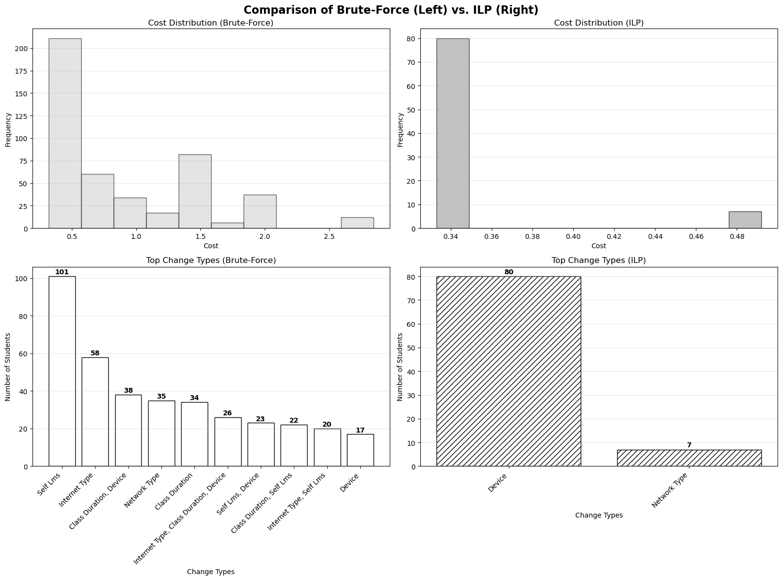
Fig. 8. Comparison of exhaustive and ILP optimization approaches
CONCLUSIONS
This paper successfully addresses the scientific and practical challenge of devising a toolkit for generating personalized, cost-minimal recommendations to enhance students’ adaptability in distance education. The proposed methodology synergistically integrates machine learning and mathematical optimization: SHAP-derived feature impact weights from Random Forest classifier (achieving 92% accuracy) are scaled and embedded as coefficients in an integer linear programming (ILP) objective function, augmented by a sparsity regulator ($α=0.05$, tuned via the elbow method) and penalties for implausible combinations to ensure realistic interventions.
The resulting algorithm produces ranked lists of optimal scenarios tailored to individual profiles, transforming ML diagnostics into actionable, evidence-based plans. Applied to 480 students with Low adaptability. both exhaustive brute-force enumeration and PuLP-solved ILP implementations identified the same set of 87 beneficiaries (18.1%), including (8 and 5, respectively) directly promoted to High adaptability, with average cost of 0.33 (brute-force) and 0.32 (ILP). This study bridges the persistent gap between adaptability analysis and resolution, providing educators with scalable, explainable tool for targeted support.
REFERENCES
- M. Hasan Suzan, N. A. Samir, A. A. Biswas, and A. Pramanik, “Students’ Adaptability Level Prediction in Online Education using Machine Learning Approaches,” 12th International Conference on Computing Communication and Networking Technologies (ICCCNT), Kharagpur, India, 2021, pp. 1-7. doi: https://doi.org/10.1109/ICCCNT51525.2021.9579741.
- F. A. Al-azazi and M. Ghurab, “ANN-LSTM: A deep learning model for early student performance prediction in MOOC,” Heliyon, vol. 9, no. 4, 2023, Art. no. e15382. doi: https://doi.org/10.1016/j.heliyon.2023.e15382.
- B. Kuzikov, P. Tytov, and O. Shovkoplias, “Analysis of web accessibility of Ukrainian higher education institutions’ websites,” System Research and Information Technologies, no. 2, pp. 139-150, 2025. doi: https://doi.org/10.20535/SRIT.2308-8893.2025.2.10.
- A. Palanci, R. M. Yilmaz, and Z. Turan, “Learning analytics in distance education: A systematic review study,” Educ. Inf. Technol., vol. 29, pp. 22629-22659, 2024. doi: https://doi.org/10.1007/s10639-024-12737-5.
- C. N. Akpen, S. Asaolu, S. Atobatele et al., “Impact of online learning on student’s performance and engagement: a systematic review,” Discov. Educ., vol. 3, 2024,
Art. no. 205. doi: https://doi.org/10.1007/s44217-024-00253-0.
- M . Bączek, M . Zagańczyk-Bączek, M . Szpringer, A. Jaroszyński, and B. Wożakowska-Kapłon, “Students' perception of online learning during the COVID-19 pandemic: A survey study of Polish medical students,” Medicine (Baltimore), vol. 100, no. 7, pp. e24821. doi: https://doi.org/10.1097/MD.0000000000024821.
- S. Lundberg, S.-I. Lee, “An Unified Approach to Interpreting Model Predictions,” in Proceedings of the 31st International Conference on Neural Information Processing Systems (NIPS'17). Curran Associates Inc., Red Hook, NY, USA, pp. 4768–4777, 2017.
- B. Ustun, A. Spangher, and Y. Liu, “Actionable Recourse in Linear Classification,” in Proceedings of the Conference on Fairness, Accountability, and Transparency (FAT* '19). Association for Computing Machinery, New York, NY, USA, pp. 10–19, 2019. https://doi.org/10.1145/3287560.3287566.
- M. M. H. Suzan, “Students adaptability level in online education”, Kaggle Dataset, 2021. [Online]. Aviable: https://www.kaggle.com/datasets/mdmahmudulhasansuzan/students-adaptability-level-in-online-education/data. (Accessesd : Sep. 15, 2025).
- L. Breiman, “Random forests,” Machine Learning, vol. 45, pp. 5-32, 2001. doi: https://doi.org/10.1023/A:1010933404324.
- A. A. Biswas, A. Majumder, M. J. Mia, I. Nowrin, and N. A. Ritu,“Predicting the enrollment and dropout of students in the post-graduationdegree using machine learning classifier,” International Journal of Innovative Technology and Exploring Engineering (IJITEE), vol. 8, no. 11, pp. 3083–3088, 2019. doi: https://doi.org/10.35940/ijitee.K2435.0981119.
- A. Géron, Hands-On Machine Learning with Scikit-Learn, Keras, and TensorFlow: Concepts, Tools, and Techniques to Build Intelligent Systems, 3rd ed. Sebastopol, CA, USA: O’Reilly Media, 2022. ISBN: 978-1098125974.
- C. Molnar, Interpretable Machine Learning: A Guide for Making Black Box Models Explainable, 2nd ed., ch. SHAP. Morrisville, NC, USA: Lulu Press, 2022. [Online]. Available: https://christophm.github.io/interpretable-ml-book/shapley.html. (Accessed: Oct. 14, 2025).
- REPOSITORY

INFORMATION OF THE ARTICLE
Olena V. Kuchkovska, Ivan Franko National University of Lviv, Ukraine, e-mail: olena.ky92@ukr,net
Oleksandra Yu. Lysetska, ORCID: 0009-0000-0730-7222, Ivan Franko National University of Lviv, Ukraine, email: oleksandra.lysetska@lnu.edu.ua
ОПТИМІЗАЦІЯ ФАКТОРІВ ДЛЯ ПІДВИЩЕННЯ АДАПТИВНОСТІ СТУДЕНТІВ ДО ОНЛАЙН-ОСВІТИ / О.В. Кучковська, О. Ю. Лисецька
Анотація. У статті запропоновано модель для підбору персоналізованих та ресурсоекономних стратегій для підвищення адаптивності студентів в онлайн-освіті. За допомогою удосконаленої обробки ознак (feature engineering) та налаштування гіперпараметрів було покращено точність класифікаційної моделі Random Forest запропонованої в [1]. Для побудови моделі було інтегровано методи машинного навчання та математичної оптимізації: метод SHAP кількісно оцінює внесок ознак при визначенні рівня адаптивності, надаючи ваги для цільової функції задачі цілочисельного лінійного програмування (ILP). Модель ILP мінімізує витрати ресурсів, оптимізуючи коригування ознак, враховуючи при цьому штрафи за нереалістичні чи нелогічні комбінації параметрів. Такий підхід дає змогу формувати персоналізовані сценарії адаптації, узгоджені з індивідуальними профілями студентів, забезпечуючи пояснювальні рекомендації на основі ШІ. Емпіричні результати підтверджують підвищення точності моделі та практичну ефективність запропонованого підходу (18.1% здобувачів освіти з низьким рівнем адаптивності були перекласифіковані до середнього чи високого рівня завдяки 1 або 2 доступним змінам у своїх профілях), що сприяє підвищенню ефективності онлайн-освіти та формуванню науково обґрунтованих рішень для цільової підтримки студентів.
Ключовi слова: онлайн-освіта, адаптивність студентів, Random Forest, SHAP ваги, цілочисельне лінійне програмування, оптимізація ресурсів, пояснювальний ШІ.

