7-2: Project Two
Oleksandra Kondieieva
Southern New Hampshire University
CS-320-12433-M01 Software Test, Automation QA
Prof. Toni Farley
October 20, 2024

Summary
My testing approach was directly aligned with the software requirements. The classes for each of the three features had required fields. Since the fields are required, they can’t be empty. Thus, my tests cover the null, empty, too long, and correct input. For instance, the test cases for the phone field in the Contact.java class check the correct input (10 characters), too long/short input at the boundaries (11 and 9 characters), correct length input but with extra white spaces, correct length but not all characters are digits. The task feature had to manage tasks, like adding, deleting, and changing existing tasks. TaskService.java manages all the manipulation that can be applied to the task. It checks the correctness of the generated task id and if it already exists in the system. Thus, my test covers the positive cases of adding/updating/deleting tasks and the negative tests that include – deleting a task with an id that’s not in the system, updating/adding tasks with invalid inputs, etc. When adding a new task, TaskServise.java also makes sure all the task-required fields, like id, name, and description, are given to add it to the system. For the appointment feature, I made sure the appointment date would be in the future. The test cases also cover the correctness of the appointment description field – positive and negative cases (including the boundaries). The JUnit tests also cover checking the uniqueness of generated id’s for all three features.
The JUnit tests I developed cover most cases of valid and invalid input. They have meaningful names and are grouped by the type of feature they check. I ran the test coverage to check what lines of code or branches were not covered by the tests. The test coverage for Contact.java is 98.3%, ContactService.java is 94.7%, Task.java is 96.6%, TaskService.java is 94.7%, Appointment.java is 94.9% and AppointmentService.java is 95.8%. For example, here is a screenshot of the test coverage for Contact.java:
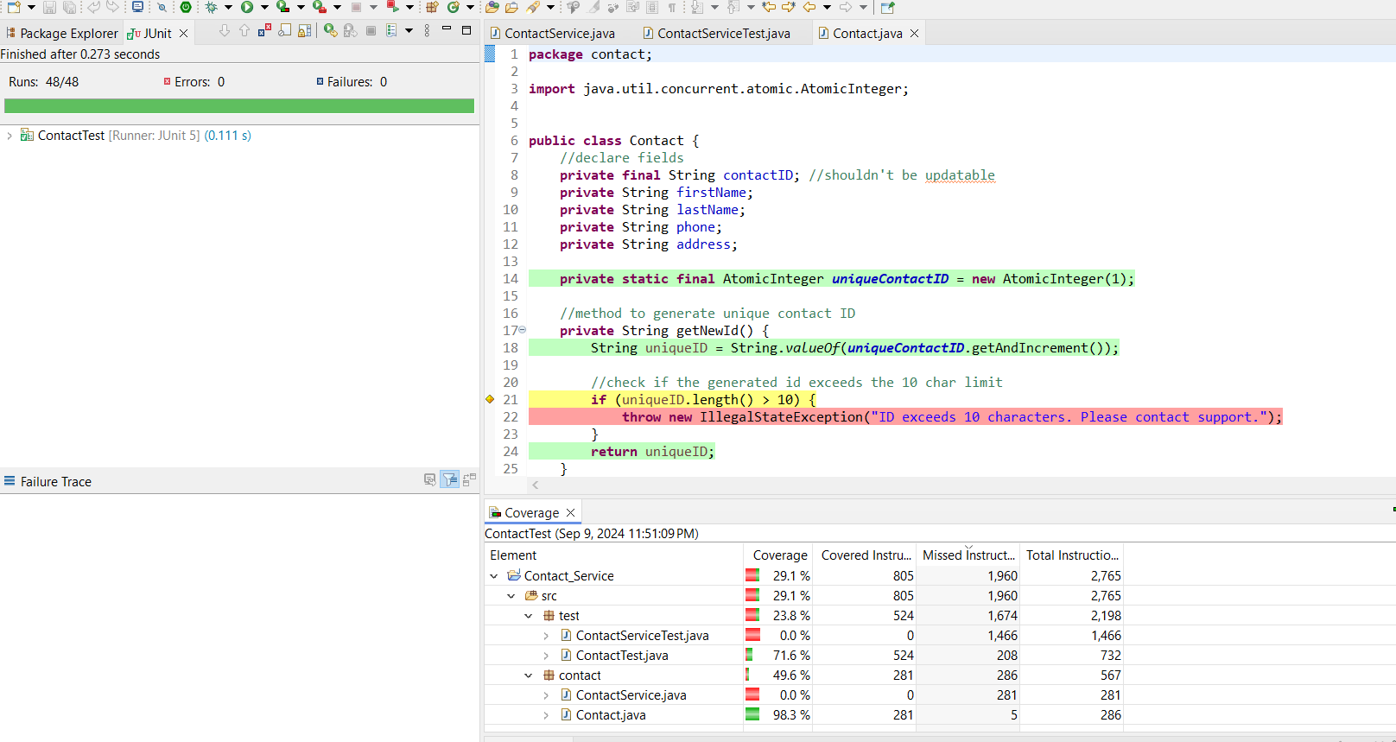
I made sure to follow the requirements. I needed some clarifications on some aspects, but I developed the code to the best of my knowledge. I ensured every function/field had comments if required.
Here is an example of checking the correctness of the phone input. To avoid clustering the constructor, I developed a method to check if the input is only digits. My code also trims the inputs to prevent the situation when leading or trailing white spaces make the program work incorrectly.

if (phone.isEmpty() || !isDigitsOnly(phone) || phone.length() != 10) {
throw new IllegalArgumentException("Phone is invalid. The phone number cannot be empty and should be 10 digits only.");
}
All the implemented features check the correctness of the input and ensure that it is trimmed before being used in any other part of the program. Here is an example of how a developed JUnit test checks if the system doesn’t throw any exception when the phone is of the correct length, but extra whites paces were added.
@Test
void testPhoneOverTheLimitWhitespaces() {
Assertions.assertDoesNotThrow(() -> {
new Contact("Johnathan", "Smith", "3653565885 ", "25 S Lane Yellow");
});
}

In all the features, I made sure that not only constructors were covered with the tests, but setters were as well. Here is an example from the TaskTest.java file:
@Test
void testTaskDescriptionIsEmptySetter() {
Assertions.assertThrows(IllegalArgumentException.class, () -> {
Task task = new Task("Kitchen", "Clean the room before guests arrive.");
task.setTaskDescription(" ");
});
}

To ensure that the code was efficient, I used possible valid and invalid inputs, boundaries, etc. The test coverage also helped ensure the tests covered a sufficient amount of code and worked as intended. The tests ensure that the missing parameter error when adding a contact/task/appointment is handled gracefully and that a meaningful exception is thrown. Here is an example from the task feature:
@Test
void testAddingInvalidTaskNoParameters() {
TaskService newTask = new TaskService();
Assertions.assertThrows(IllegalArgumentException.class, () -> {
newTask.addNewTask();
});
}

Reflection
Testing Techniques
I employed different test techniques for each milestone at the unit testing level. Some are white-box testing, statement and decision testing, integration testing, boundary testing, etc. Since I was the one who developed the code, I wrote the JUnit tests with the knowledge of the internal system (white-box testing), ensuring the logical branches and all statements were executed (statement and decision testing). For example, for the contact feature, I created four conditions for the phone number (it should be not null, not empty, trimmed, and consist only of digits). I ensured that JUnit tests would cover all the decision branches of this field. When using the boundary testing, I made sure that valid and invalid entered inputs for the check were on the boundary of valid/invalid. For instance, the task name shouldn’t be more than 20 characters in the Task class. I included the cases when the task name is strictly 20 and for the invalid input – 21. The integration testing was done while testing the AppointmentService.java class since it takes the information from the Appointment.java class. Static testing was also done when revising the requirements to ensure no ambiguity or missing information was present. The software testing techniques I used in this project helped me ensure the correctness of the developed code, identify the test coverage, and evaluate the efficiency of the developed features.
Although I have used multiple testing techniques, the testing techniques vary in an incredible range. Some of the techniques I didn’t use are security testing, acceptance testing, system and exploratory testing. Security testing focuses on adhering best security practices to ensure the security and data protection. This may include static and dynamic testing. Acceptance testing is done in the end of the iteration/cycle to ensure the system meets the requirements and is ready to be deployed. The system testing ensures that all components work together well. Exploratory testing was not possible since I was the one who developed the code.
All the techniques discussed above fulfill similar roles in the software development lifecycle. Each testing technique is meant for early bug detection, reducing development costs, increasing work effectiveness, and boosting software quality. For instance, security testing needs to find potential security loopholes. Also, different security regulations must be applied depending on the type of software. The type of software testing that each company adopts depends on their needs, risks, and the overall approach to developing software.

Mindset
As a software tester, I employed caution to a great extent. Although JUnit tests themselves don't alter the original code, the quality of the tests ensures the project's success in general. Early bug detection is one of the cornerstones of the successful software development process; thus, covering the base code with an efficient number of tests, including all functionalities, is crucial. The code's complexity and interrelationships should always be considered since they affect the outcome on different levels. For example, a poorly tested Contact.java class may lead to hard-to-catch bugs in the ContactService.java class that takes a lot of information from the Contact.java class, which proves the importance of unit testing. The error in the Task.java class in the id generation method may lead to faulty software. Starting tests from the small chunks of the code, like classes, helps to identify errors at the early stages and prevent more complex bugs later.
When it comes to limiting bias in the code review, I tried to follow the requirements only. I ensured that the test case coverage was more than 90 %. Biases are one of the main reasons why it is not always a good idea for developers to test their own code. Overconfidence or confirmation biases may influence the test quality. While writing test cases, I checked the exceptions that the code I created handled for sure. For example, my task feature lacked more positive test cases because I was sure that it worked as intended and one was enough. In this case, feedback was very helpful.
Adopting a discipline when developing a quality code is one of the crucial steps to success. A disciplined approach to creating and testing code benefits a software engineering professional and a company in many ways. It ensures a company’s reputation, future code maintenance, and avoiding bugs and defects. Cutting corners on either stage of the SDLC (developing or testing) won’t go unnoticed - the difference would be in just how many problems it will cause, and the time it will take to fix later. In order to avoid technical debt as a practitioner in the field, I plan to study the requirements thoroughly, clarify any ambitiousness or missing information, refactor code, add concise comments, and write extensive tests. For instance, in the Contact.java class, when the constructor method started to expand to check all the incorrect input cases, I created a separate method to check if the phone number consisted of the digits only and moved it outside the constructor for simplicity.

REFERENCES:
Morgan, P., Samaroo, A., Thompson, G., & Williams, P. (2019). Software testing : An istqb- bcs certified tester foundation guide - 4th edition. BCS Learning & Development Limited.

