The Metro Management Database Project


Contents
1 Business Description 3
1.1 Business background 3
1.2 Problems. Current Situation 3
1.3 The benefits of implementing a database. Project Vision 3
2 Model description 3
2.1 Definitions & Acronyms 3
2.2 Logical Scheme 3
2.3 Objects 3

Business Description

Business background
Modern metro systems are critical components of urban infrastructure, providing fast, affordable, and reliable transportation to millions of passengers daily. As metro networks expand, so does the need for effective management of data related to operations—such as scheduling, train assignments, staff management, and ticket sales.
Traditional paper-based or disconnected digital systems cannot efficiently handle the growing complexity of these operations. A unified, structured database is required to support operational accuracy, planning efficiency, and informed decision-making.

Problems. Current Situation
Currently, metro management processes face several issues:
1. Fragmented data management: Information about trains, crew, schedules, and tickets is often stored in separate systems.
2. Manual data entry and errors: Inconsistent data formats lead to duplication and inaccuracies.
3. Inefficient reporting: Generating performance or revenue reports requires manual consolidation.
4. Scheduling conflicts: Without centralized tracking, crew or train assignment overlaps can occur.
5. Limited analytical insight: Difficult to monitor passenger flow, optimize routes, or predict demand trends.

the Benefits of implementing a database. Project Vision
The Metro Management Database Project introduces a centralized system that integrates all operational data into a single platform.

Key Benefits:
- Centralized, consistent, and accurate data storage.
- Streamlined operations through relational links between key entities (stations, lines, trains, crew, schedules, passengers).
- Improved reporting and analytics capabilities.
- Reduction of human error through validation constraints.
- Real-time monitoring of schedules, train assignments, and passenger activity.

Project_Vision:
To establish a scalable, reliable, and normalized relational database that supports efficient, transparent, and data-driven metro management operations.

Model description

Definitions & Acronyms
Database Management System (DBMS) – software for managing and querying data.
Primary Key (PK) – unique identifier for table records.
Foreign Key (FK) – field linking one table to another.
Many-to-many relationship (M:N) – where multiple records in one table relate to multiple in another.
Schedule – operational plan defining train trips on a given line and date.
Crew –metro staff responsible for operating or maintaining trains.
Ticket – record of a passenger’s purchased journey.
Schema – logical structure of the database including tables, constraints, and relationships.

Logical Scheme
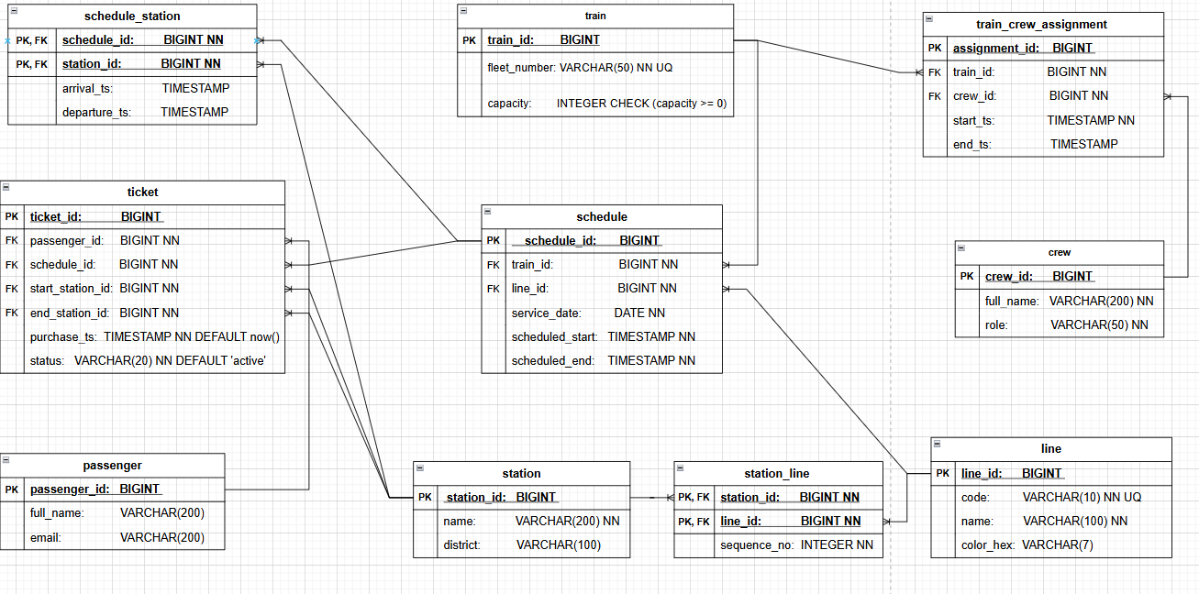

Objects
Below is a detailed description of each database table and its purpose.
Table Name | Field name | Field Description | Data Type
line | line_id | Unique system-generated identifier for each metro line, PK. | BIGINT
line | code | Short alphanumeric code representing the metro line, NOT NULL, UNIQUE. | VARCHAR(10)
line | name | Full descriptive name of the metro line, NOT NULL. | VARCHAR(100)
line | color_hex | Hexadecimal color code used for visually identifying the line on maps and interfaces. | VARCHAR(7)
Purpose: stores all information related to metro lines in the transport network.
Table Name | Field name | Field Description | Data Type
station | station_id | Unique system-generated identifier for each metro station, PK. | BIGINT
station | name | Full name of the metro station, NOT NULL. | VARCHAR(200)
station | district | Administrative or city district where the station is located. | VARCHAR(100)
Purpose: stores basic identifying and locational information about each metro station.

Table Name | Field name | Field Description | Data Type
station_line | station_id | Identifier of the station associated with the line, FK, part of composite PK, NOT NULL. | BIGINT
station_line | line_id | Identifier of the line that includes this station, FK, part of composite PK, NOT NULL. | BIGINT
station_line | sequence_no | Numerical order of the station along the line route, NOT NULL. | INTEGER
Purpose: defines the many-to-many relationship between stations and lines, and specifies the order of stations within each line.

Table Name | Field name | Field Description | Data Type
train | train_id | Unique identifier for each train in the metro fleet, PK. | BIGINT
train | fleet_number | Official fleet number or unique train identifier used by operations, NOT NULL, UNIQUE. | VARCHAR(50)
train | capacity | Maximum number of passengers the train can carry, CHECK (capacity >= 0) | INTEGER
Purpose: stores information about each train unit in the metro fleet, including operational identifiers and passenger capacity.

Table Name | Field name | Field Description | Data Type
crew | crew_id | Unique system-generated identifier for each crew member, PK. | BIGINT
crew | full_name | Full name of the metro employee, NOT NULL. | VARCHAR(200)
crew | role | Role or position of the crew member, NOT NULL. | VARCHAR(50)
Purpose: stores staff details for individuals working in operational or maintenance roles within the metro system.

Table Name | Field name | Field Description | Data Type
train_crew_assignment | assignment_id | Unique identifier for each crew assignment record, PK. | BIGINT
train_crew_assignment | train_id | Train to which the crew member is assigned, NOT NULL. | BIGINT
train_crew_assignment | crew_id | Crew member assigned to the train, NOT NULL. | BIGINT
train_crew_assignment | start_ts | Date and time when the crew assignment begins, NOT NULL. | TIMESTAMP
train_crew_assignment | end_ts | Date and time when the crew assignment ends. | TIMESTAMP
Purpose: tracks which crew members are assigned to which trains during specific operational periods.

Table Name | Field name | Field Description | Data Type
schedule | schedule_id | Unique identifier for each train schedule, PK. | BIGINT
schedule | train_id | Train operating this schedule, FK, NOT NULL. | BIGINT
schedule | line_id | Line on which the train operates during this schedule, FK, NOT NULL. | BIGINT
schedule | service_date | Date on which the schedule applies, NOT NULL. | DATE
schedule | scheduled_start | Planned start time of service, NOT NULL. | TIMESTAMP
schedule | scheduled_end | Planned end time of service, NOT NULL. | TIMESTAMP
Purpose: defines the operational timetable for trains on specific lines, linking train, line, and service date information.

Table Name | Field name | Field Description | Data Type
schedule_station | schedule_id | Identifier of the schedule this stop belongs to, FK, part of composite PK. | BIGINT
schedule_station | station_id | Identifier of the station in this schedule, FK, part of composite PK. | BIGINT
schedule_station | arrival_ts | Scheduled time of train arrival at the station. | TIMESTAMP
schedule_station | departure_ts | Scheduled time of train departure from the station. | TIMESTAMP
Purpose: lists all stops for a given schedule, including arrival and departure times for each station.

Table Name | Field name | Field Description | Data Type
passenger | passenger_id | Unique identifier for each registered passenger, PK. | BIGINT
passenger | full_name | Full name of the passenger. | VARCHAR(200)
passenger | email | Passenger’s contact email address. | VARCHAR(200)
Purpose: stores information about metro passengers for identification and ticket tracking.

Table Name | Field name | Field Description | Data Type
ticket | ticket_id | Unique identifier for each ticket purchase, PK. | BIGINT
ticket | passenger_id | Passenger who purchased the ticket, FK, NOT NULL. | BIGINT
ticket | schedule_id | Schedule associated with the ticketed journey, FK, NOT NULL. | BIGINT
ticket | start_station_id | Station where the journey begins, FK, NOT NULL. | BIGINT
ticket | end_station_id | Station where the journey ends, FK, NOT NULL. | BIGINT
ticket | purchase_ts | Date and time when the ticket was purchased, NOT NULL DEFAULT now(). | TIMESTAMP
ticket | status | Current status of the ticket, NOT NULL DEFAULT 'active'. | VARCHAR(20)
Purpose: records passenger ticket transactions, linking passengers, schedules, and station information for each trip.

Table relationships.
line ↔ station_line ↔ station
Type: Many-to-many relationship (via station_line)
Tables involved: line, station, station_line
Foreign keys:
- station_line.station_id → station.station_id
- station_line.line_id → line.line_id

train ↔ train_crew_assignment ↔ crew
Type: Many-to-many relationship (via train_crew_assignment)
Tables involved: train, crew, train_crew_assignment
Foreign keys:
- train_crew_assignment.train_id → train.train_id
- train_crew_assignment.crew_id → crew.crew_id

schedule ↔ train
Type: One-to-many relationship
Tables involved: schedule, train
Foreign key:
- schedule.train_id → train.train_id

schedule ↔ line
Type: One-to-many relationship
Tables involved: schedule, line
Foreign key:
- schedule.line_id → line.line_id

schedule ↔ schedule_station ↔ station
Type: Many-to-many relationship (via schedule_station)
Tables involved: schedule, station, schedule_station
Foreign keys:
- schedule_station.schedule_id → schedule.schedule_id
- schedule_station.station_id → station.station_id

passenger ↔ ticket
Type: One-to-many relationship
Tables involved: passenger, ticket
Foreign key:
- ticket.passenger_id → passenger.passenger_id

schedule ↔ ticket
Type: One-to-many relationship
Tables involved: schedule, ticket
Foreign key:
- ticket.schedule_id → schedule.schedule_id

station ↔ ticket (start_station_id, end_station_id)
Type: Two one-to-many relationships
Tables involved: ticket, station
Foreign keys:
- ticket.start_station_id → station.station_id
- ticket.end_station_id → station.station_id

Example with data.
Table: line
  line_id
  code
  name
  color_hex
1 | L1 | Central Line | #FF0000

Table: station
station_id
  name
  district
1 | Central Station | Downtown

Table: station_line
station_id
  line_id
  sequence_no
1 | 1 | 1

Table: train
train_id
  fleet_number
  capacity
1 | T1001 | 400

Table: crew
crew_id
  full_name
  role
1 | John Davis | Driver

Table: train_crew_assignment
 |  |  |  | end_ts
  assignment_id
  train_id
  crew_id
  start_ts
1 | 1 | 1 | 2025-10-20 06:00 | 2025-10-20 14:00

Table: schedule
 |  |  |  | scheduled_start | scheduled_end
  schedule_id
  train_id
  line_id
  service_date
1 | 1 | 1 | 2025-10-20 | 06:00 | 14:00

Table: schedule_station
 |  |  | departure_ts
  schedule_id
  station_id
  arrival_ts
1 | 1 | 06:00 | 06:05

Table: passenger
passenger_id
  full_name
  email
1 | Robert Smith | rsmith@gmail.com

Table: ticket
ticket_id | passenger_id | schedule_id | start_station_id | end_station_id | purchase_ts | status
1 | 1 | 1 | 1 | 2 | 2025-10-19 18:00 | active

