The Real Estate Agency Database Project


Contents

1 Business Description 3
1.1 Business background 3
1.2 Problems. Current Situation 3
1.3 The benefits of implementing a database. Project Vision 3
2 Model description 4
2.1 Definitions & Acronyms 4
2.2 Logical Scheme 5
2.3 Objects 6

Business Description

Business background
Real estate agencies manage a wide range of activities that support property transactions, from advertising listings and coordinating viewings to maintaining communication between clients and agents. As property markets become more dynamic and customer expectations rise, agencies handle growing amounts of information relating to properties, clients, pricing, and negotiations.

Relying on scattered spreadsheets, manual notes, or outdated systems often leads to inconsistencies, delays, and difficulties in tracking ongoing business processes. To operate effectively and stay competitive, a centralized database is essential. Such a system provides organized access to property details, client records, agent responsibilities, and transaction history, helping the agency improve service quality, streamline daily operations, and support strategic business decisions.

Problems. Current Situation
Currently, real estate agencies face several difficulties in managing day-to-day activities:

1. Uncentralized client interactions: Communication history, inquiries, and follow-ups are often scattered across emails, phone logs, and personal notes.

2. Outdated property information: Without a unified system, property updates—such as price changes or availability—are not always reflected consistently across marketing channels.

3. Inefficient document handling: Contracts, agreements, and property files are frequently stored in multiple locations, making retrieval slow and prone to mistakes.

4. Limited visibility into agent workload: Tracking which agents are responsible for which properties or clients is often unclear, reducing efficiency and accountability.

5. Difficulty monitoring business performance: Key metrics like sales progress, viewing frequency, or client conversion rates are hard to analyze without integrated reporting tools.

the Benefits of implementing a database. Project Vision
The Real Estate Agency Database Project introduces a centralized system that consolidates all operational information into one coherent platform, replacing fragmented records and disconnected tools.

Key Benefits:
- Unified and accurate data storage: Property listings, client records, agent information, and viewing schedules are maintained consistently in a single system.
- Streamlined daily operations: Relational links between clients, agents, properties, listings, and viewings improve coordination and reduce administrative workload.
- Enhanced reporting and analysis: Managers can quickly generate insights on sales performance, property demand, agent productivity, and client engagement.
- Reduced risk of errors: Standardized data entry rules and validation constraints help maintain reliable, up-to-date information.
- Better operational visibility: Real-time access to listing status, agent assignments, and viewing activity supports timely decision-making.

Project Vision:
To develop a scalable, reliable, and well-structured relational database that enables efficient, transparent, and data-driven management of real estate operations, improving service quality and supporting long-term business growth.

Model description

Definitions & Acronyms
Database Management System (DBMS) – software for managing and querying data.
Primary Key (PK) – unique identifier for table records.
Foreign Key (FK) – field linking one table to another.
Many-to-many relationship (M:N) – where multiple records in one table relate to multiple in another.
Schema – the logical structure of the database that defines tables, their attributes, constraints, and the relationships that ensure data consistency across the system.
Agent – a representative of the real estate agency responsible for managing property listings, communicating with clients, and facilitating transactions.
Client – an individual or organization interested in buying, selling, or renting a property, whose interactions and preferences are tracked by the agency.
Property – a residential or commercial real estate asset listed by the agency, with details such as location, price, type, and current status.
Listing – a formal record of a property being offered on the market, including the listing date, asking price, and the agent responsible for managing it.
Viewing – a scheduled appointment in which a client visits a property, allowing the agency to track viewing activity and client interest.
Agent_Property – a relational table representing the many-to-many association between agents and properties, identifying which agents are authorized to handle specific listings.

Logical Scheme
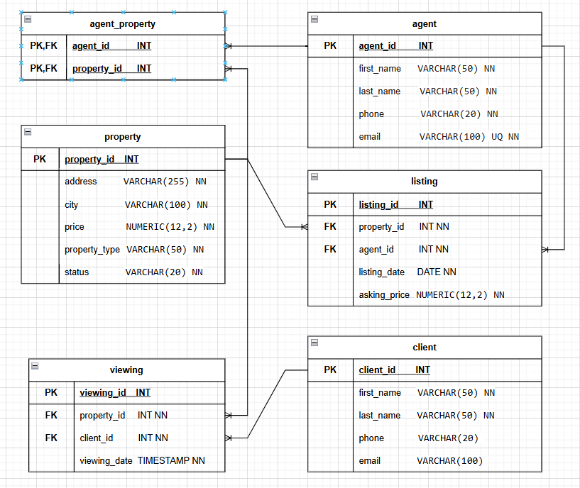

Objects
Below is a detailed description of each database table and its purpose.
Table Name | Field name | Field Description | Data Type
agent | agent_id | Unique system-generated identifier for each agent, PK. | INT
 | first_name | Agent’s given name, NOT NULL. | VARCHAR(50)
 | last_name | Agent’s family name, NOT NULL. | VARCHAR(50)
 | phone | Contact phone number for the agent. | VARCHAR(20)
 | email | Unique email address used for  communication, NOT NULL, UNIQUE. | VARCHAR(100)
Purpose: stores personal and contact information for agents employed by the real estate agency.

Table Name | Field name | Field Description | Data Type
client | client_id | Unique system-generated identifier for each client, PK. | INT
 | first_name | Client’s given name, NOT NULL. | VARCHAR(50)
 | last_name | Client’s family name, NOT NULL. | VARCHAR(50)
 | phone | Contact phone number for the client. | VARCHAR(20)
 | email | Client email address (optional). | VARCHAR(100)
Purpose: stores contact details and personal information of clients interacting with the agency.

Table Name | Field name | Field Description | Data Type
property | property_id | Unique system-generated identifier for each property, PK. | INT
 | address | Full physical address of the property, NOT NULL. | VARCHAR(255)
 | city | City or locality where the property is located, NOT NULL. | VARCHAR(100)
 | price | Current market or listing price of the property, NOT NULL. | NUMERIC(12,2)
 | property_type | Type of property (e.g., house, apartment, office), NOT NULL. | VARCHAR(50)
 | status | Current property status (available, sold, rented, etc.), NOT NULL. | VARCHAR(20)
Purpose: stores core data describing each real estate property managed by the agency.

Table Name | Field name | Field Description | Data Type
listing | listing_id | Unique system-generated identifier for each property listing, PK. | INT
 | property_id | FK referencing the associated property, NOT NULL. | INT
 | agent_id | FK referencing the agent responsible for the listing, NOT NULL. | INT
 | listing_date | Date the property was officially listed, NOT NULL. | DATE
 | asking_price | The price at which the property is offered on the market, NOT NULL. | NUMERIC(12,2)
Purpose: records formal property listings and links them to the responsible agent and property.

Table Name | Field name | Field Description | Data Type
viewing | viewing_id | Unique system-generated identifier for each scheduled viewing, PK. | INT
 | property_id | FK referencing the property being viewed, NOT NULL. | INT
 | client_id | FK referencing the client attending the viewing, NOT NULL. | INT
 | viewing_date | Date and time when the viewing is scheduled, NOT NULL. | TIMESTAMP
Purpose: tracks client appointments for viewing properties, supporting scheduling and activity monitoring.

Table Name | Field name | Field Description | Data Type
agent_property | agent_id | FK referencing an agent authorized to manage the property, PK part. | INT
 | property_id | FK referencing a property assigned to the agent, PK part. | INT
Purpose: models the many-to-many relationship between agents and properties, identifying which agents are associated with which properties.

Table relationships.
agent ↔ agent_property ↔ property
Type: Many-to-many relationship (via agent_property)
Tables involved: agent, property, agent_property
Foreign keys:
• agent_property.agent_id → agent.agent_id
• agent_property.property_id → property.property_id

property ↔ listing
Type: One-to-many relationship
Tables involved: property, listing
Foreign key:
• listing.property_id → property.property_id
agent ↔ listing
Type: One-to-many relationship
Tables involved: agent, listing
Foreign key:
• listing.agent_id → agent.agent_id
property ↔ viewing
Type: One-to-many relationship
Tables involved: property, viewing
Foreign key:
• viewing.property_id → property.property_id
client ↔ viewing
Type: One-to-many relationship
Tables involved: client, viewing
Foreign key:
• viewing.client_id → client.client_id

Example with data.
Table: agent
agent_id | first_name | last_name | phone | email
1 | John | Smith | 123-45-67 | john.sm@email.com

Table: client
client_id | first_name | last_name | phone | email
1 | Alice | Johnson | 555-11-22 | alice.j@gmail.com

Table: property
property_id | address | city | price | property_type | status
1 | 123 Main St | New York | 350000.00 | Apartment | Available

Table: listing
listing_id | property_id | agent_id | listing_date | asking_price
1 | 1 | 1 | 2025-12-10 | 350000.00

Table: viewing
viewing_id | property_id | client_id | viewing_date
1 | 1 | 1 | 2025-12-15 10:00

Table: agent_property
agent_id | property_id
1 | 1

